LaBSE Indic-Indic Alignment Benchmark
FLORES-200 and Samanantar-EnglishPivot Evaluation

1. Executive Summary
This report documents a LaBSE-based Indic-Indic sentence alignment benchmark. The experiment evaluates whether LaBSE embeddings in translated sentences from different Indic languages close to each other in a shared vector space. Two benchmark tracks are used: a clean FLORES-200 row-aligned benchmark and a Samanantar-EnglishPivot benchmark created by joining English-Indic Samanantar samples through the same English sentence.
- FLORES-200 gives near-perfect retrieval results, showing that LaBSE performs very strongly when the benchmark data is clean and multi-way aligned.
- Samanantar-EnglishPivot gives slightly lower but still strong retrieval results, indicating that the English-pivot construction introduces additional noise and makes the task more challenging.
- The cosine gap is high in both tracks, which means correct translation pairs are clearly separated from random incorrect pairs in the embedding space.
- The main bottleneck is not only the embedding model but also the quality and directness of the Indic-Indic parallel data used for evaluation.
Dataset | Pair construction | Pairs evaluated | Examples per pair | Main role in study
FLORES-200 | Clean row-aligned dev + devtest splits | 110 directed pairs | 2,009 | Reference benchmark for clean multilingual alignment
Samanantar-EnglishPivot | English-Indic samples joined using normalized English text as pivot | 110 directed pairs | 1,000 target examples per direction | Noisier real-world/pivot-based Indic-Indic benchmark

2. Language Coverage
The notebook uses the 11 Indic languages available in the Samanantar Indic-Indic matrix and maps each language to its corresponding FLORES-200 code. Directed pairs are formed as all source-target combinations where source and target are different, resulting in 11 × 10 = 110 directions.
Short code | Language | FLORES-200 code
as | Assamese | asm_Beng
bn | Bengali | ben_Beng
gu | Gujarati | guj_Gujr
hi | Hindi | hin_Deva
kn | Kannada | kan_Knda
ml | Malayalam | mal_Mlym
mr | Marathi | mar_Deva
or | Odia | ory_Orya
pa | Punjabi | pan_Guru
ta | Tamil | tam_Taml
te | Telugu | tel_Telu

3. Experimental Setup
Parameter | Value used in notebook
Model | sentence-transformers/LaBSE
Embedding size | 768 dimensions in the saved .npy cache files
Maximum token length | 128
Batch size | 32
Random seed | 42
Device in recorded run | CPU
FLORES splits | dev + devtest
FLORES examples | 2,009 per language after combining splits
Samanantar final target per direction | 1,000 Indic-Indic pairs
Pivot mode | English-pivot mode; direct Indic-Indic directory was not provided

4. Dataset Construction

4.1 FLORES-200 benchmark
FLORES-200 is used as the clean benchmark track. The notebook downloads the FLORES-200 dataset, reads the dev and devtest files for each language, and concatenates both splits. Each language contains 997 dev examples and 1,012 devtest examples, giving 2,009 aligned sentences per language. Because FLORES is multi-way aligned, row i in each language represents the same underlying sentence meaning. This makes source row i and target row i the gold translation pair for retrieval evaluation.

4.2 Samanantar-EnglishPivot benchmark
The public Samanantar setup used by the notebook is English-Indic. To evaluate Indic-Indic directions, the we constructs source-target pairs using English as a pivot. For each Indic language, it loads or streams an English-Indic sample, normalizes the English sentence, removes duplicate normalized English rows, and keeps the corresponding Indic sentence. For each source-target direction, the source language dataframe and target language dataframe are joined on the normalized English text. The resulting pair is treated as an Indic-Indic translation pair.
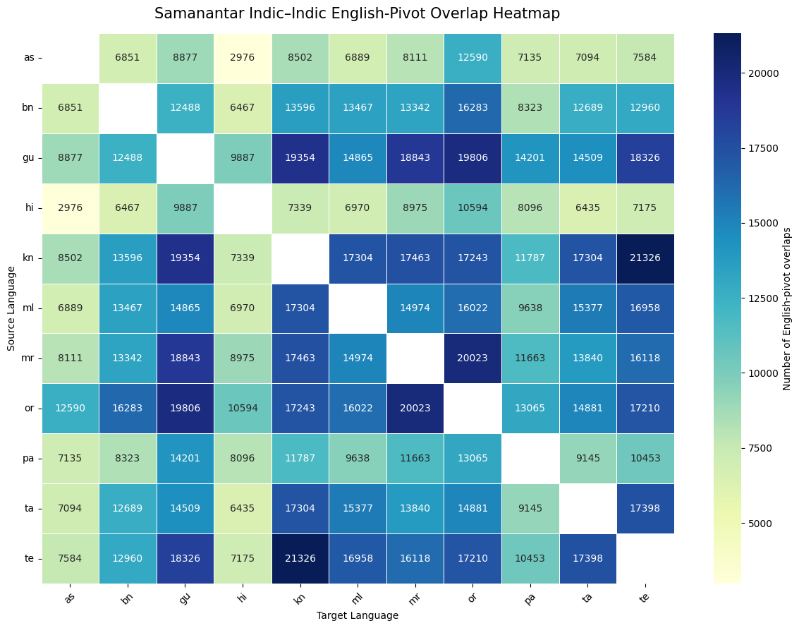
Important interpretation: Samanantar-EnglishPivot is expected to be noisier than FLORES because the Indic-Indic pair is not necessarily a manually verified direct translation. It is inferred through a shared English sentence. This makes it a more realistic but less controlled benchmark.

5. Evaluation Metrics
For a source-target pair with n aligned rows, the notebook computes an n × n cosine similarity matrix. The diagonal entries represent gold translation-pair similarity. Off-diagonal candidates represent possible incorrect neighbours.
Metric | Meaning
mean_gold_cosine | Average cosine similarity of correct source-target translation pairs. Higher means better alignment.
pct_gt_0_80 | Fraction of gold pairs with cosine similarity greater than 0.80. This is a threshold-style alignment score.
random_cosine_mean | Average similarity between a source sentence and a random incorrect target sentence. This is used as a baseline.
cosine_gap | mean_gold_cosine - random_cosine_mean. Larger gap means stronger separation between correct and incorrect pairs.

6. Main Results
The following table is the dataset-level summary saved by the notebook in labse_DATASET_SUMMARY_INDIC_INDIC.csv. Values are averages across all 110 directed language pairs for each dataset.
Dataset | Mean gold cosine | % > 0.80 | Cosine gap | Random cosine mean
FLORES-200 | 0.847733 | 0.775818 | 0.565966 | 0.281767
Samanantar-EnglishPivot | 0.787345 | 0.549273 | 0.501755 | 0.285590
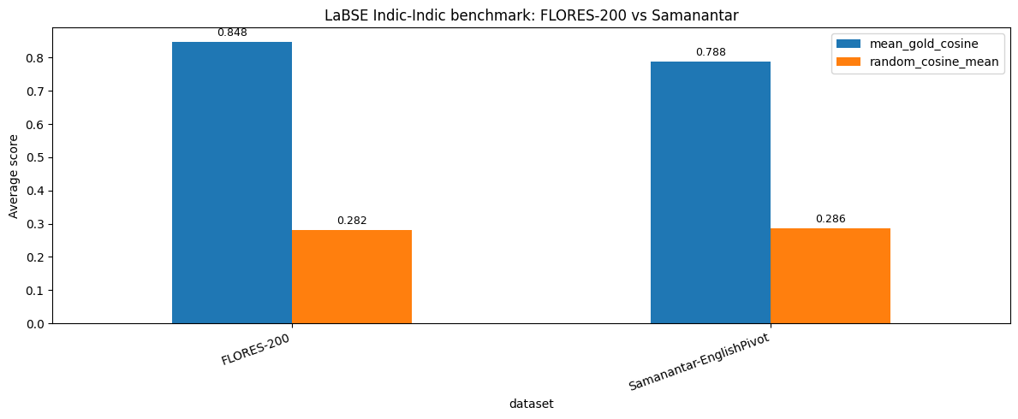
Figure 1. Dataset-level comparison between FLORES-200 and Samanantar-EnglishPivot across the main metrics.

7. Visual Analysis
The notebook generates heatmaps for, mean gold cosine for both datasets. These visualizations make it easier to see whether performance is uniform across language pairs or concentrated in a few strong directions.
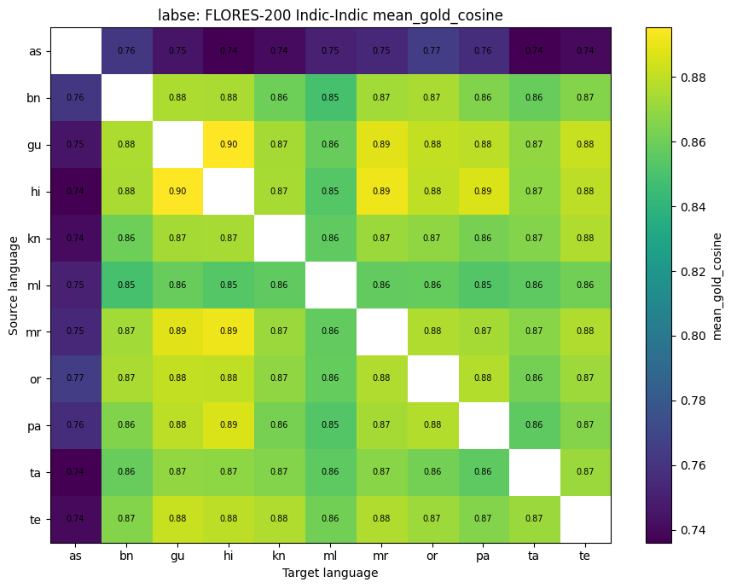
Figure 4. FLORES-200 mean gold cosine heatmap.
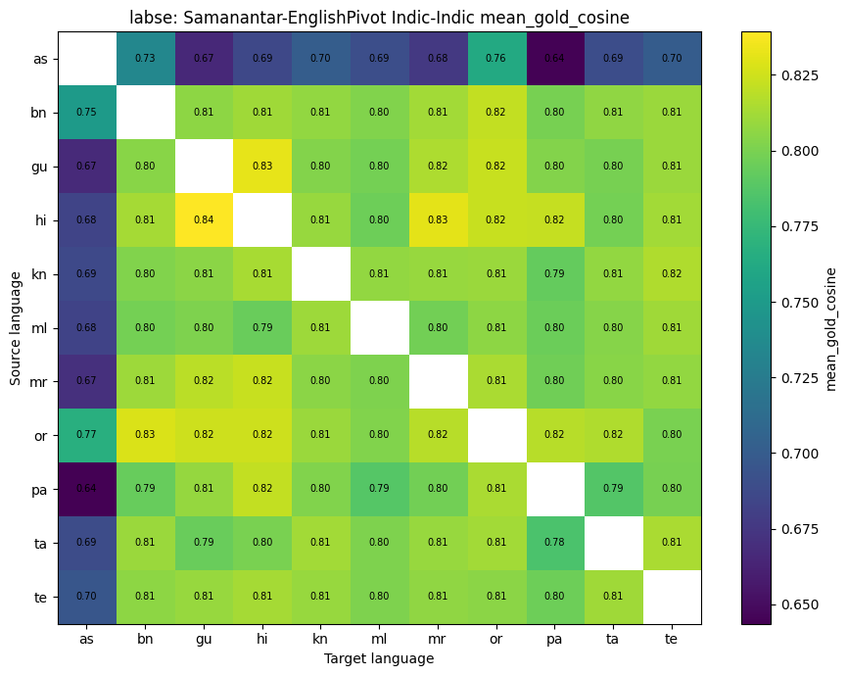
Figure 5. Samanantar-EnglishPivot mean gold cosine heatmap..

8. Conclusion
The notebook demonstrates that LaBSE is a strong baseline for Indic-Indic sentence alignment. On FLORES-200, the model achieves avg of 80% cosine sim, confirming that it can map clean translations from different Indic languages into a shared embedding space. On Samanantar-EnglishPivot, the model still performs well but shows a clear drop due to pivot-based corpus

