|  |  |
| --- | --- |
| AEROSPACE CYBERSECURITY EVENT AND CONFERENCE 2023 |  |

|  |  |  |  |  |  |
| --- | --- | --- | --- | --- | --- |
| **DATE** | **TIME** | **EVENT** | **SPEAKERS** | **MODE** | **ACTIVITY** |
| August 22 (Tuesday) | 4:30PM -6:00PM | Aerospace Cybersecurity  Workshop | * Soorya Subramani (21Z258) * Aaditya Rengarajan (21Z202) * Dhanush Gowdhaman  (20Z214) * S Karun Vikhash (21Z247) | Offline | * Aerospace Cybersecurity Overview with Coimbatore Airport Case Study * Drone Technology and Security * GitHub and Repositories * Phishing Attacks * Linux Environment |
| August 23 (Wednesday) | 7:30PM | Workshop | * Soorya Subramani (21Z258) * Aaditya Rengarajan (21Z202) * S Karun Vikhash (21Z247) | Online | * Secure Coding * Vulnerabilities in Commercial Aviation and Embedded Systems * GitHub and GitGuardian * SDR and ADS-B Technology |
| August 24 (Thursday) | 5:00PM | MCQs for Coding Stream,  Workshop for Hacking Stream | * Dhanush Gowdhaman (20Z214) | Online | Online MCQs on Kahoot Platform |
| August 27 – 29 | 12AM - 11:59PM | Hackathon | * Ashwant Krishna R (21Z211): Coordinator for Coding Stream * Dhanush G (20Z214): Coordinator for Hacking Stream | Online | Hackathon Takes Place |
| August 30 (Wednesday) |  | Judging Hackathon Submissions | **Judges**   * Faculty Advisors (Dr. Gopikarani N, Dr. Vijayalakshmi S)   **Student Judges**   * Ashwant Krishna R (Coding Stream) * Dhanush Gowdhaman (Hacking Stream) | Online | |
| September 1 (Friday) |  | Winners Announcement |  | Online | |

**Prize Pool**: INR 12,000

For each stream:

* **First Prize**: INR 3,000
* **Second Prize:** INR 2,000
* **Third Prize:** INR 1,000

**Images from the Event**

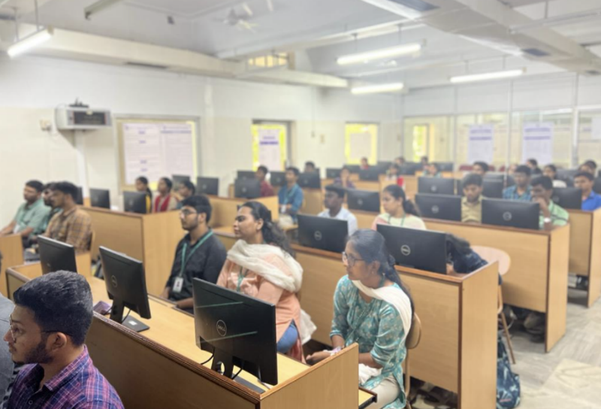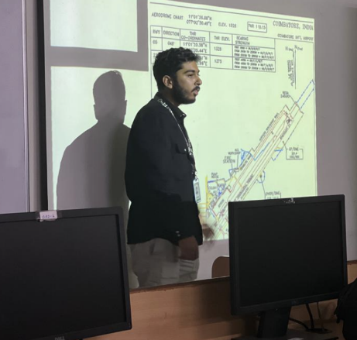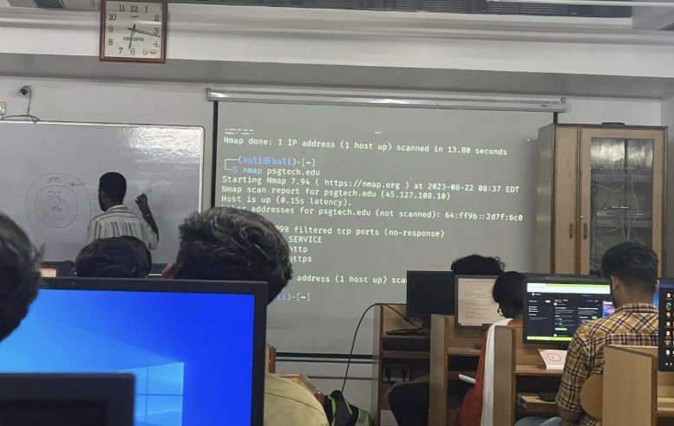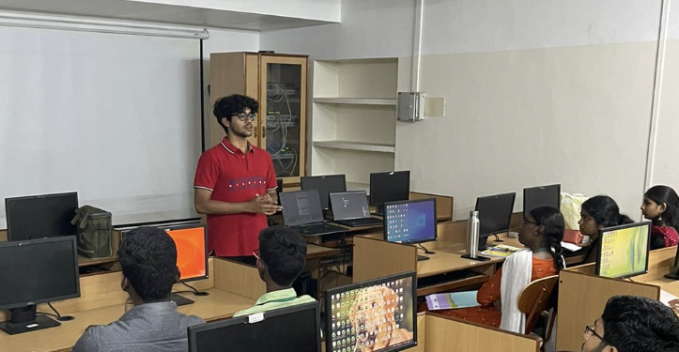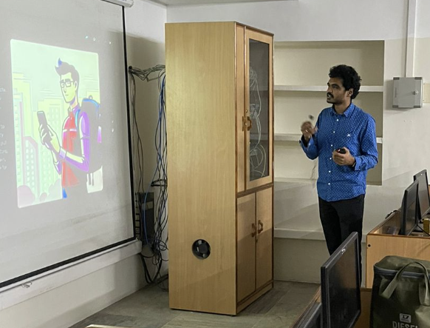

**Attendees and Winners**

|  |  |
| --- | --- |
| **# of Registrants** | **150** |
| **Day 1 Attendees (Offline)** | **48** |
| **Day 2 Attendees (Online)** | **35** |
| **# of Hackathon Participants** | **53** |

**Hackathon Winners**

