**Exchange Rate Approach document**

**Prerequisite:**

Storage Account:

Create Storage account to place source file to be ingested.

Source Data in Azure Blob Storage

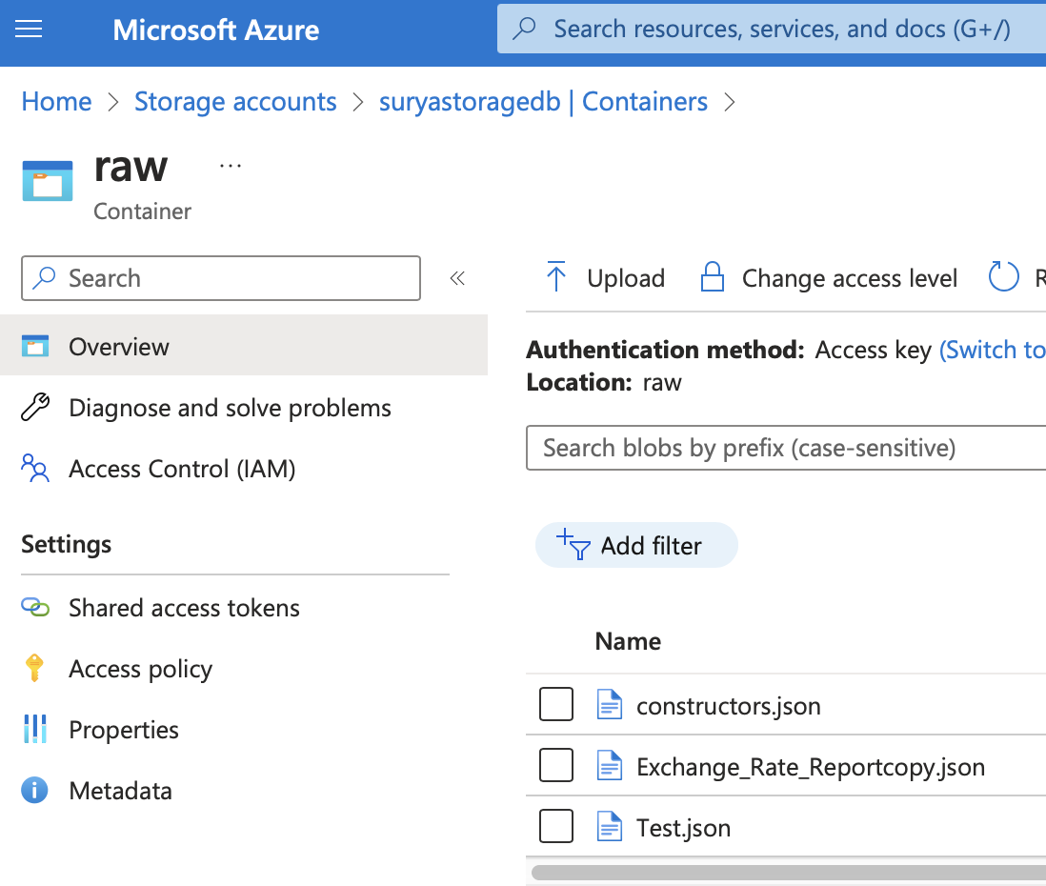

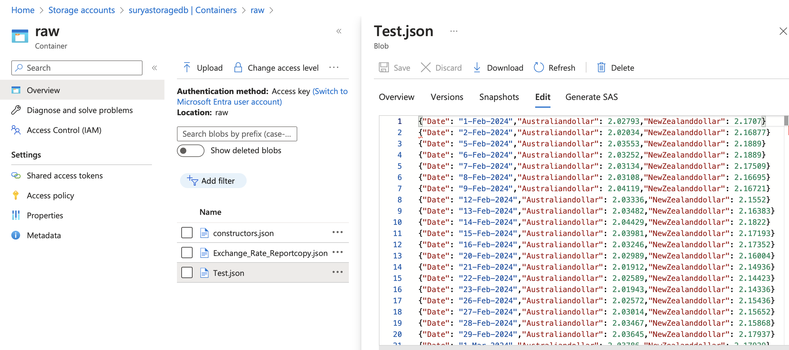

**Data Ingestion:**

**Source File**

* Importing sql functions
* Defining Schema
* Config setup to access file in Azure Blob Storage

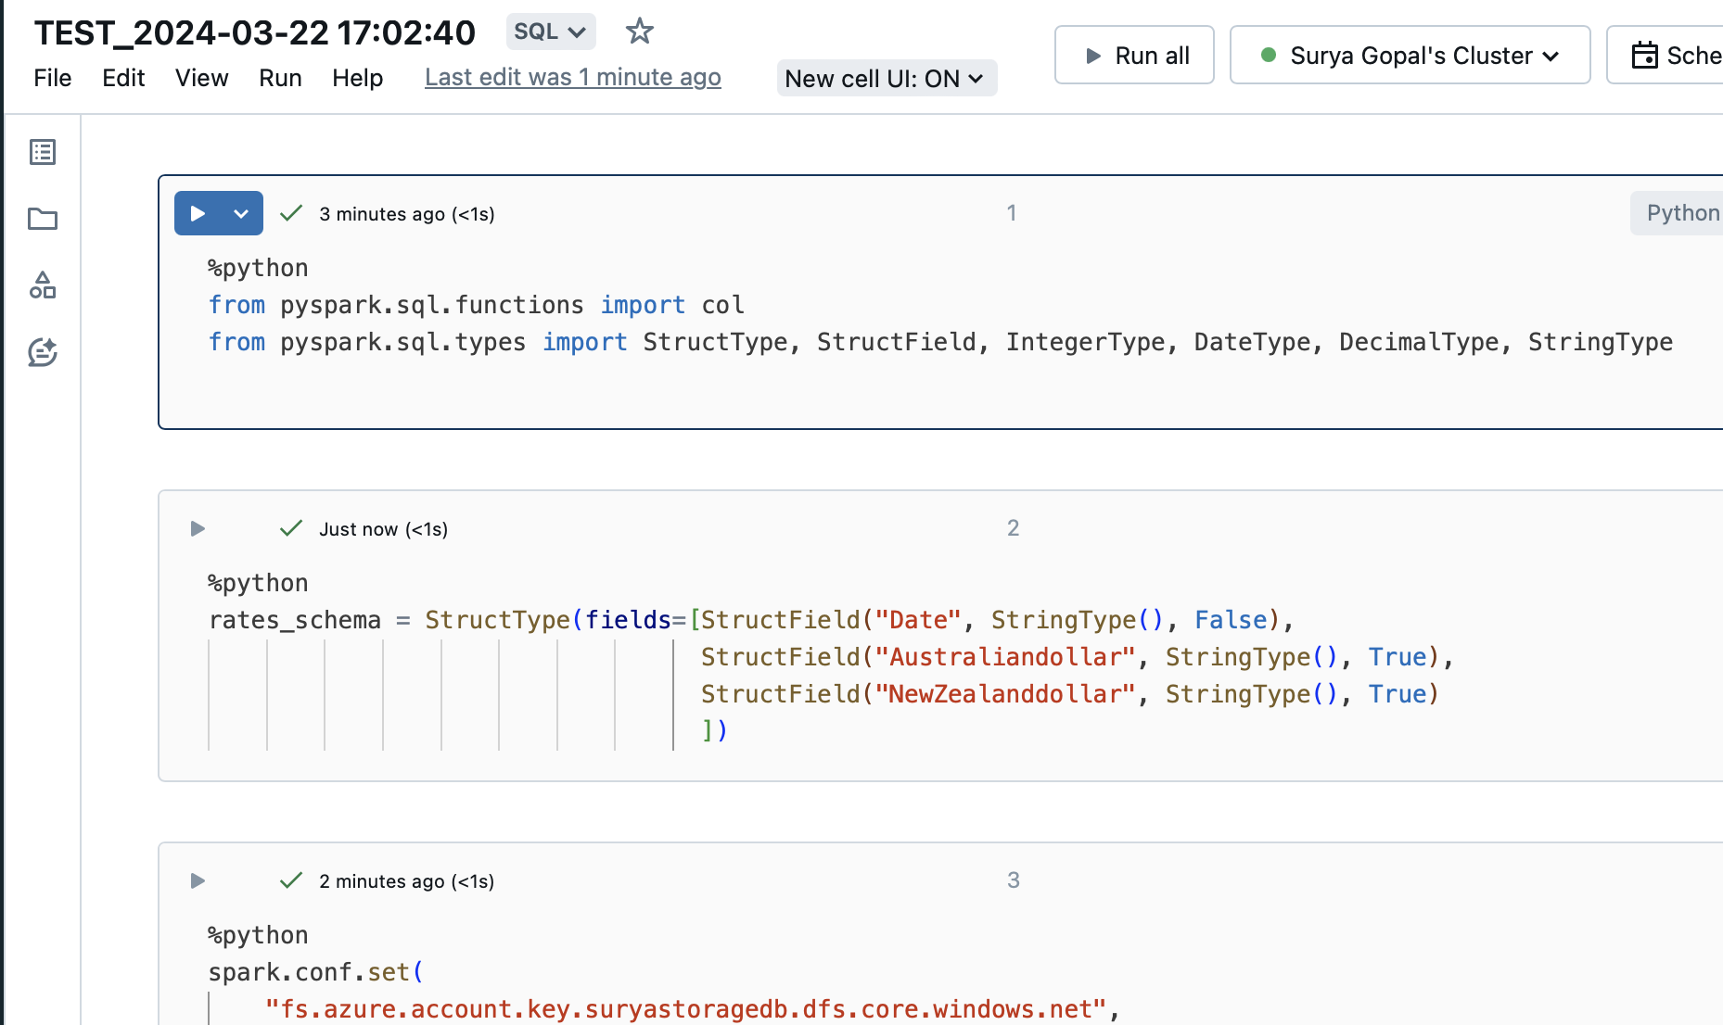

Files present in Azure Storage:

Reading the Source File:  
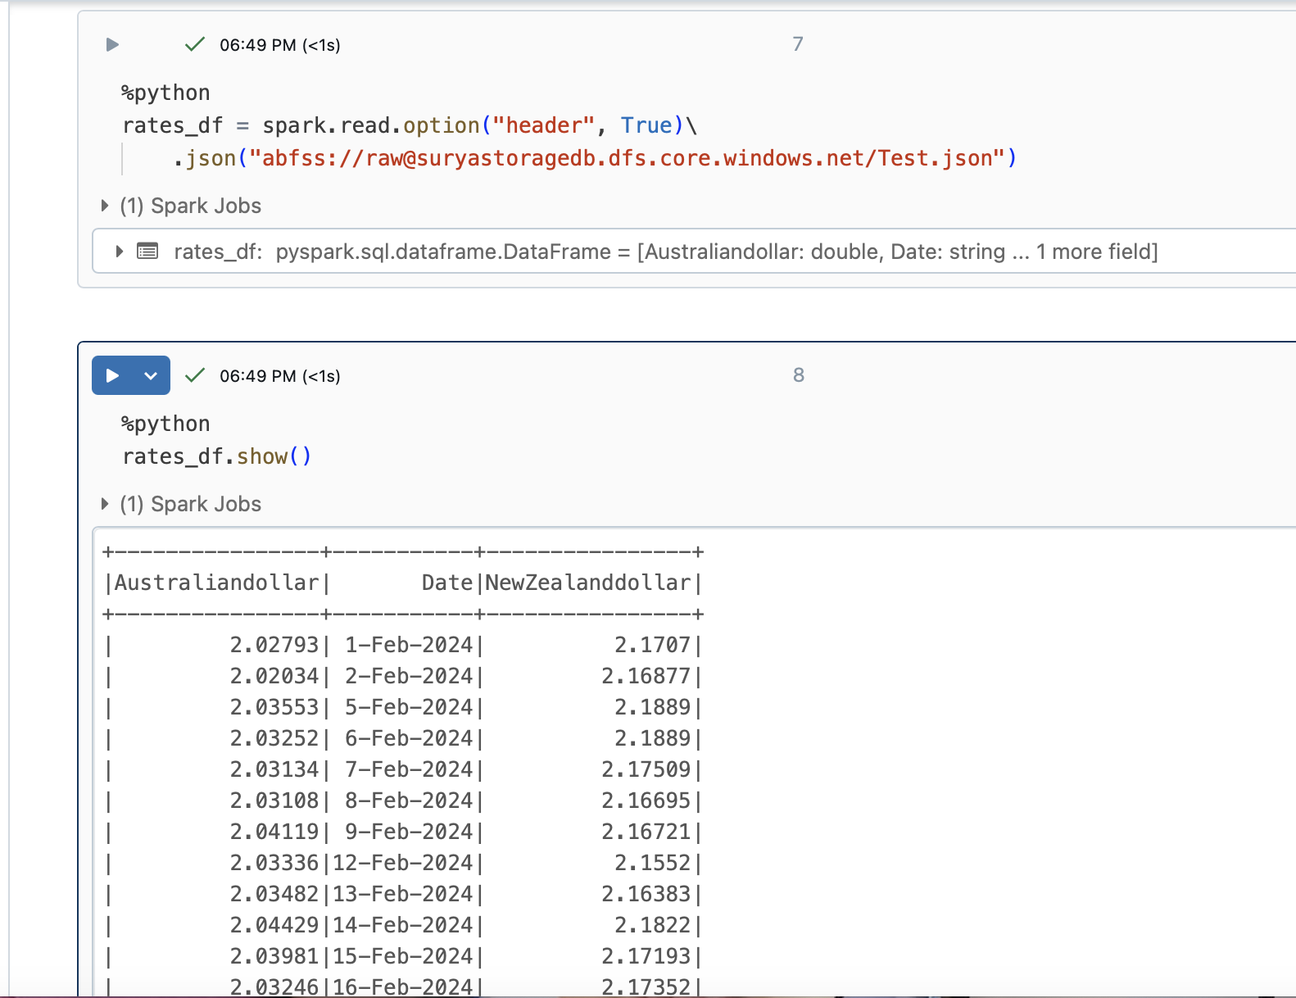

Renaming the Columns:

Method1:

Method2:

Pre-process the Source File:

Removing Duplicates  
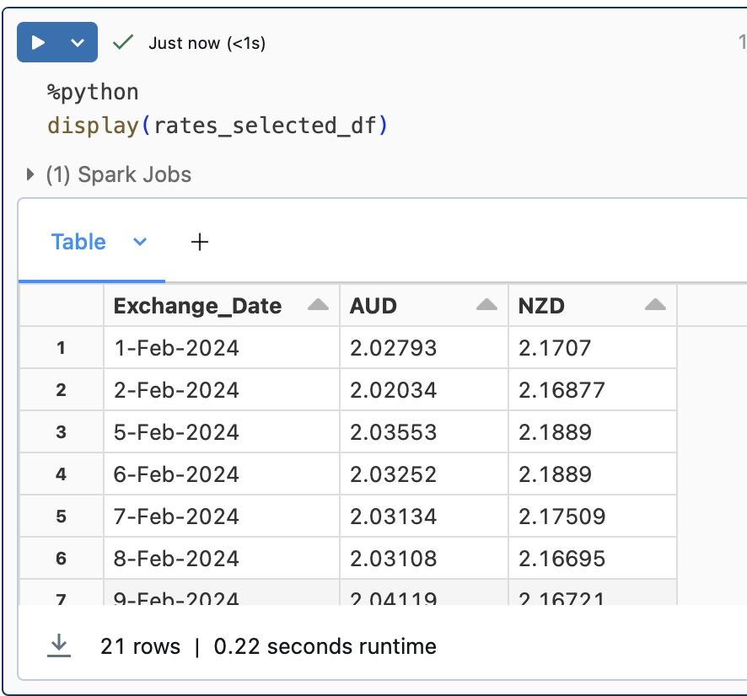

Writing the Data:

Create Database  
  
Setting Current Database:

Finding Best, Worst and Avg Exchange Rate from February to March

Check if the period has got same exchange rate

