**Exchange Rate**

**Document Purpose**

This document specifies the High-Level Design for Exchange Rates of Australia to New Zealand project. This document will be used as input for detailed design, development, testing phase of the project.

This document has been produced to do below analysis on Exchange Rate of Australia to New Zealand,

* Pre-process the Data
* To find best exchange rate for the period from February to March 2024
* To find worst exchange rate for the period from February to March 2024

**Document Scope**

The scope of this document is to define the high-level solution that will be implemented as part of the project.

**Audience**

Architect

TechLead

Developers

Testing Team

Vendors

**Business Scope Inclusions**

|  |  |
| --- | --- |
| **No** | **In Scope** |
| 1 | Tool to cater for Data Ingestion, Transformation, Data Reconciliation - Databricks |
| 2 | Repository for Code check in - GITHUB |

**Solution Context**

The solution context diagram highlights the data flow from source to Databricks.

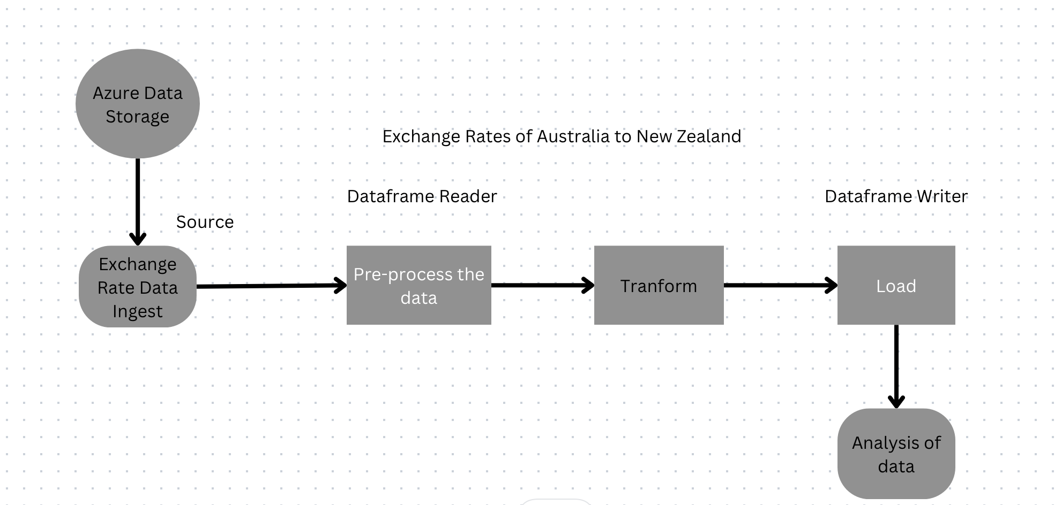

**Azure Blob Storage**

Exchange rate source file has been uploaded to container in Azure Blob Storage.

**Ingest Source File**

Ingest the source data into data bricks from Azure data container by using access key to access the files in container.

**Pre-process**

Check for Duplicates.  
Counts of Source data.

**Transform**

Transformations on data.

**Analysis**Best Exchange Rate.  
Worst Exchange Rate.  
Average Exchange Rate.

**Reconciliations**

Count Match with Source and Target