**Coding and Testing scenarios:**

Test results:  
Source data:  
  
  
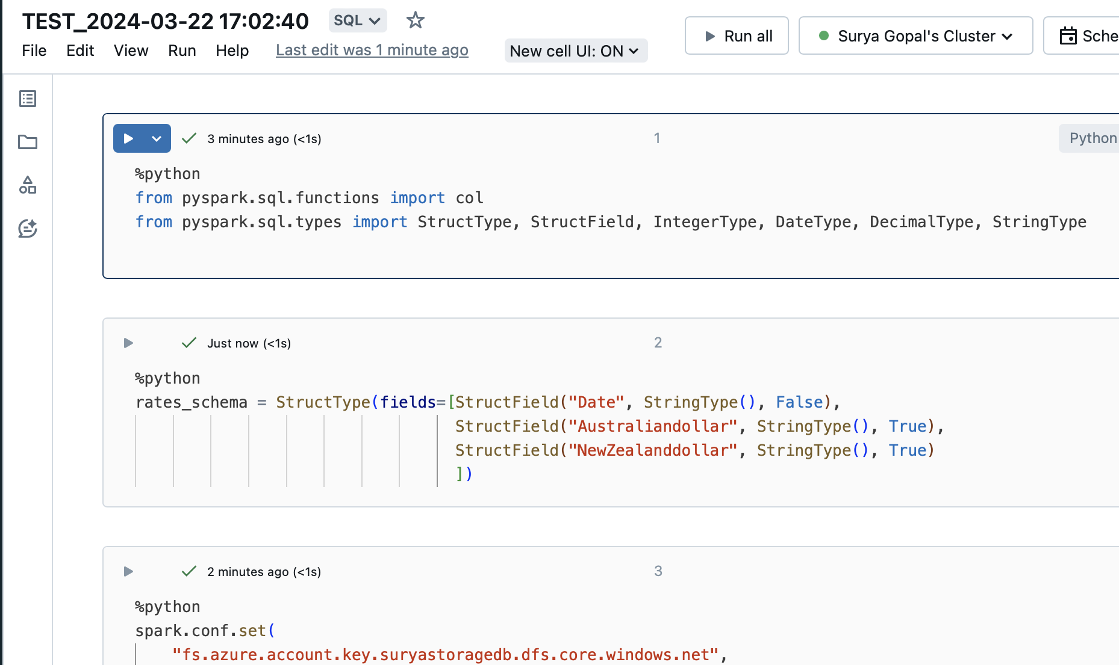

Reading Source Data:

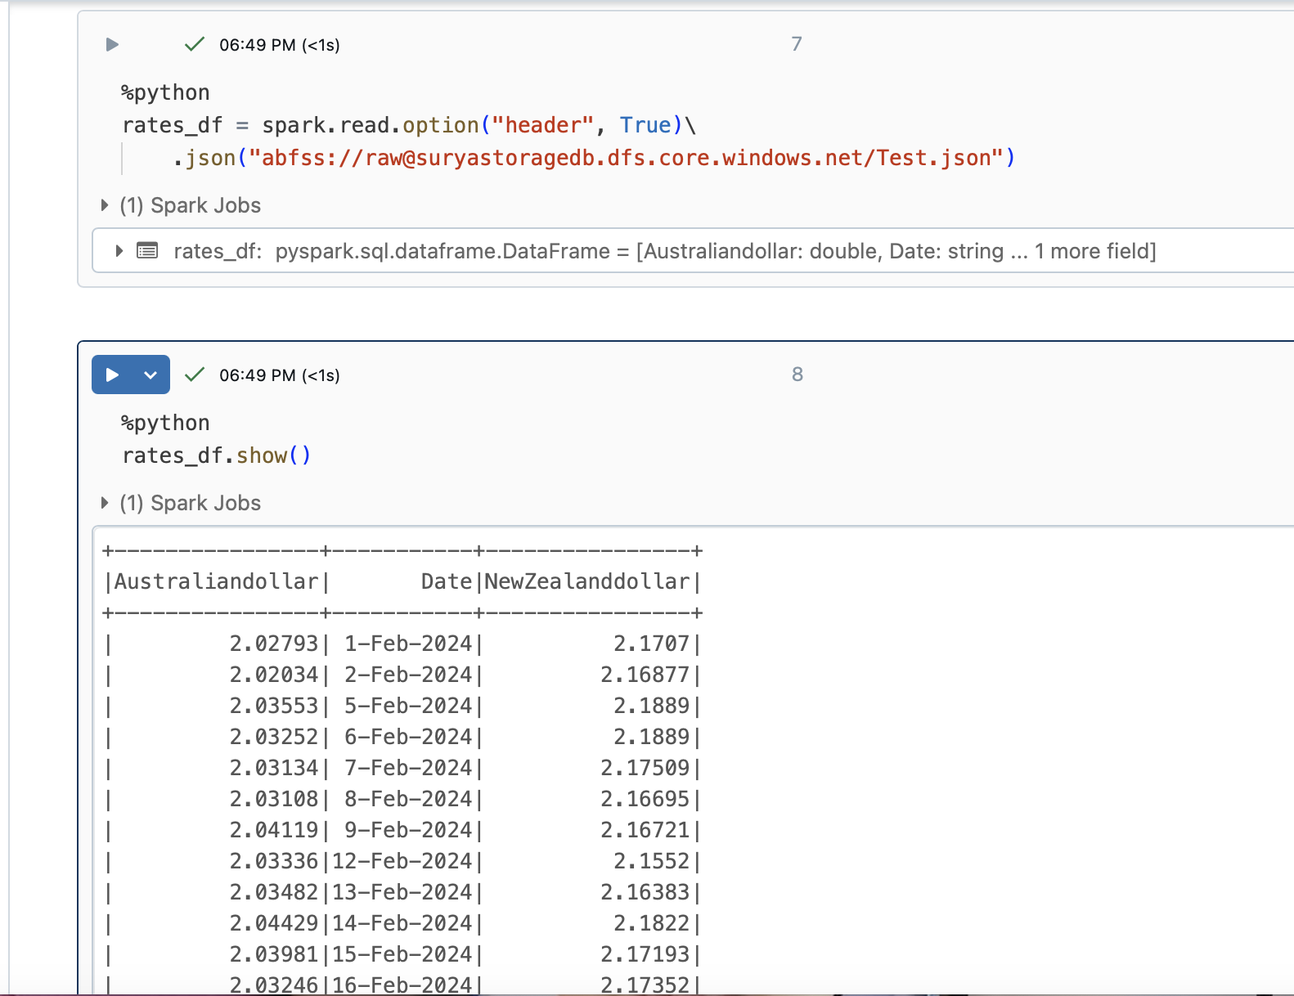

Count in Source:

Remove Duplicates:

Count in Source data before removing duplicates

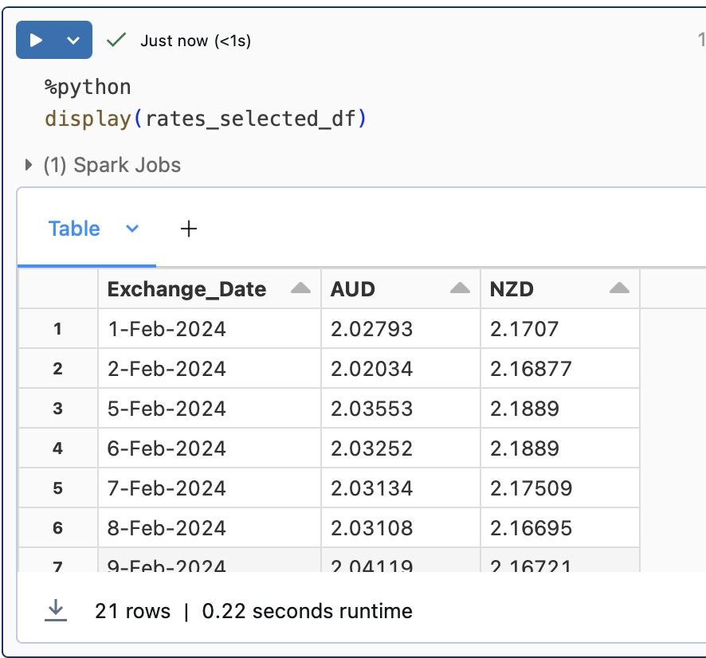

Source data after removing duplicates

Create Database:

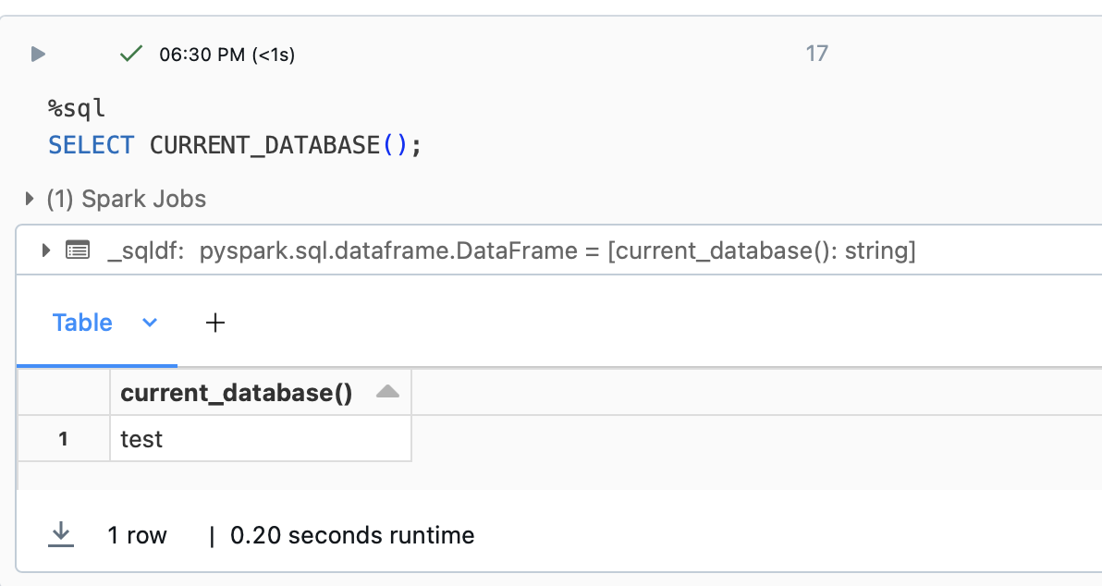

Best, Worst and Avg Exchange Rate:  
