**Task 2: Predicting Customer Booking**

**Objective**

The goal of this task was to build a predictive model that determines the likelihood of a customer completing a flight booking. The analysis helps British Airways better understand customer behavior and supports more targeted marketing and resource planning.

## **Dataset Description**

The dataset used for this modeling task, customer_booking (1).csv, contains detailed records of customer booking requests and related flight information for British Airways. Each row represents a single booking inquiry, with both customer and flight attributes included. The dataset is designed to help understand the factors influencing whether a customer completes a booking.

### ****Process Overview****

1. **Data Exploration & Preparation**
   * Loaded the provided customer_booking dataset.
   * Explored key variables such as number of passengers, sales channel, trip type, booking lead time, length of stay, flight details, booking origin, and various customer preferences.
   * Checked for missing values and duplicates; encoded categorical features using one-hot encoding.
2. **Feature Engineering**
   * Converted all relevant categorical columns to numeric format to enable modeling.
   * Retained and engineered features such as purchase_lead, flight_hour, and travel preferences, as they were expected to impact booking behavior.
3. **Model Development**
   * Used a Random Forest Classifier for its strong performance and ability to measure feature importance.
   * Split the data into training and test sets for proper evaluation.
   * Trained the model to predict the target variable: booking_complete (whether a booking was made or not).
4. **Model Evaluation**
   * Achieved an accuracy of approximately **86%** on the test set.
   * Evaluated the model using classification metrics such as precision, recall, and F1-score.
5. **Feature Importance Analysis**
   * Identified the most influential features for predicting bookings:
     + **Purchase lead** (how early the booking was made)
     + **Flight hour** (departure time)
     + **Length of stay**
     + **Number of passengers**
     + **Flight duration**
     + Booking origin and customer preferences (meals, seat)
   * Visualized the top 10 features using a bar chart.
6. **Findings & Recommendations**
   * Customers booking earlier, traveling for longer stays, and selecting specific departure times are more likely to complete bookings.
   * Preferences such as requesting meals, preferred seats, and the country of booking origin also play a role.
   * **Recommendation:** British Airways can improve conversion rates by targeting marketing efforts based on these signals.

**Output**

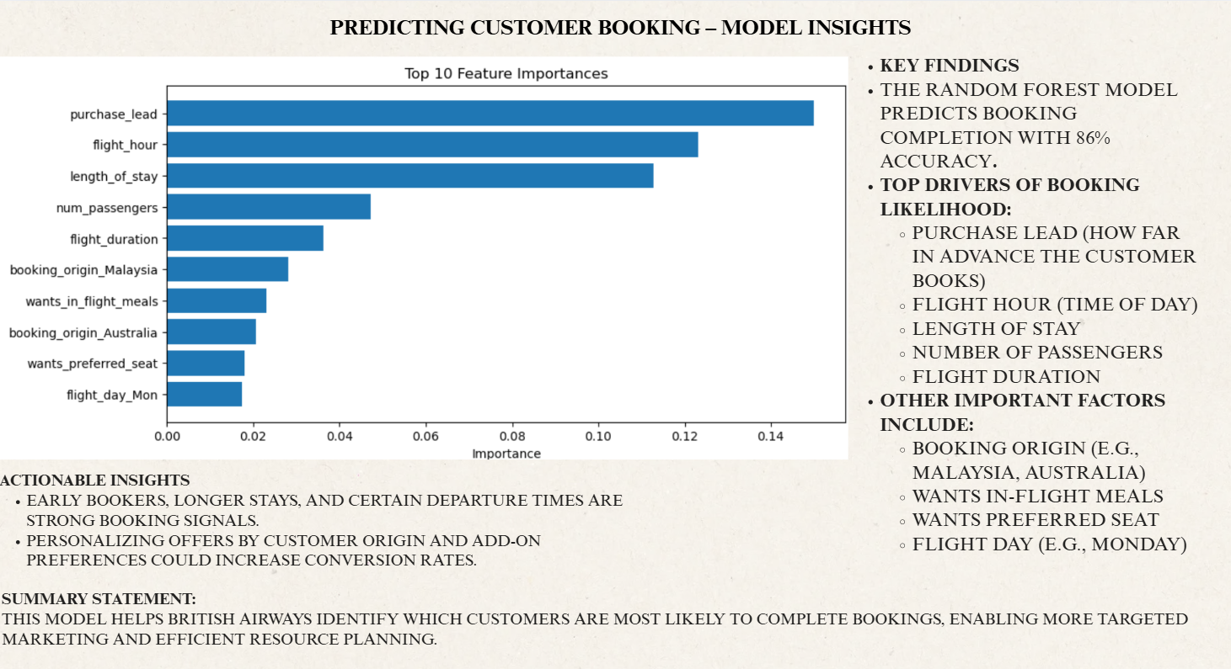

Prepared a single summary slide including key metrics, top feature drivers, actionable insights, and the feature importance chart for manager review.