**Task 1: Modeling lounge eligibility at Heathrow Terminal 3**

**Detailed Dataset Description:**

The British Airways Summer Schedule dataset provides a comprehensive view of all scheduled BA flights departing from Heathrow Terminal 3 during the summer period. Each row in the dataset represents a single flight, with the following key fields included:

* **Flight Information:**
  + **FLIGHT_DATE** and **FLIGHT_TIME** specify the scheduled departure date and time for each flight.
  + **AIRLINE_CD** and **FLIGHT_NO** provide the airline code and unique flight number.
  + **DEPARTURE_STATION_CD** and **ARRIVAL_STATION_CD** indicate the airport codes for both departure and arrival locations.
* **Route & Region Details:**
  + **ARRIVAL_COUNTRY** and **ARRIVAL_REGION** categorize each flight’s final destination by country and broader world region (e.g., Europe, North America, Asia, Middle East).
  + **Route type** is specified as either “Short-haul” or “Long-haul,” based on the destination.
* **Seating Capacity:**
  + For each flight, the number of available seats in each cabin is listed:
    - **FIRST_CLASS_SEATS**
    - **BUSINESS_CLASS_SEATS**
    - **ECONOMY_SEATS**
  + This allows for precise estimation of total passenger capacity per flight and across flight groups.
* **Time of Day:**
  + The **TIME_OF_DAY** column allows further analysis of flight scheduling patterns (morning, afternoon, evening).
* **Lounge Eligibility (if included):**
  + Some columns may reflect pre-estimated numbers of passengers eligible for Tier 1, Tier 2, and Tier 3 lounges.

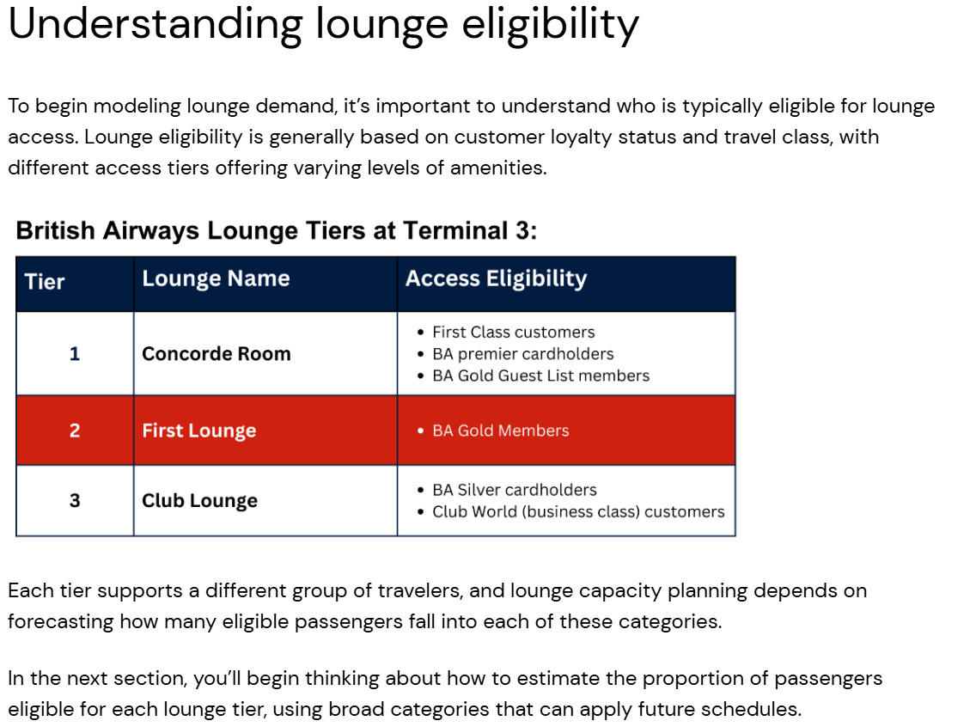

### ****Task 1: Process Summary****

To estimate future lounge demand at Heathrow Terminal 3, I started by sorting all flights using two simple, scalable categories: **route type** (short-haul vs. long-haul) and **region** (Europe, North America, Asia, or Middle East). This approach reflects the key differences in passenger types and status for each group.

For each group, I summed up the total number of seats (first, business, and economy) to estimate overall passenger volume. Using typical industry benchmarks, I assigned a percentage of passengers likely to qualify for each lounge tier. These percentages were then entered into a lookup table, creating a reusable tool for BA planners.

Finally, I answered the justification questions to clearly explain my grouping choices, logic, and how the model can easily be applied to future schedules. This ensures BA can estimate lounge demand quickly and adjust the model as real-world needs change.

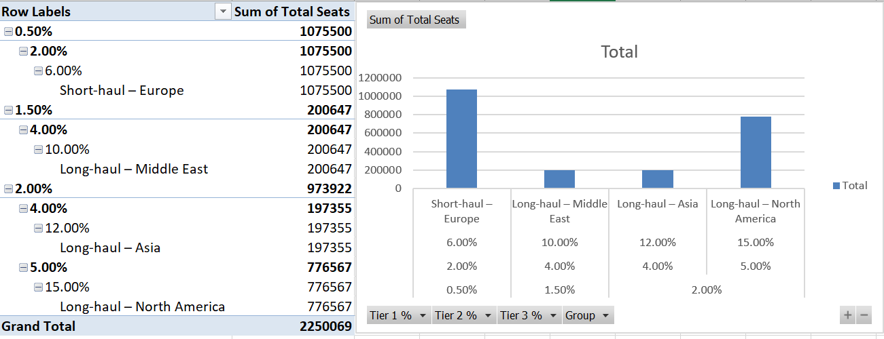

The chart shows that Short-haul Europe has the highest total seat volume, followed by Long-haul North America. Lounge eligibility percentages are highest for long-haul routes, especially to North America, reflecting more premium and status travelers on those flights. Short-haul routes have lower eligibility, matching expectations for more leisure travel and fewer premium seats.

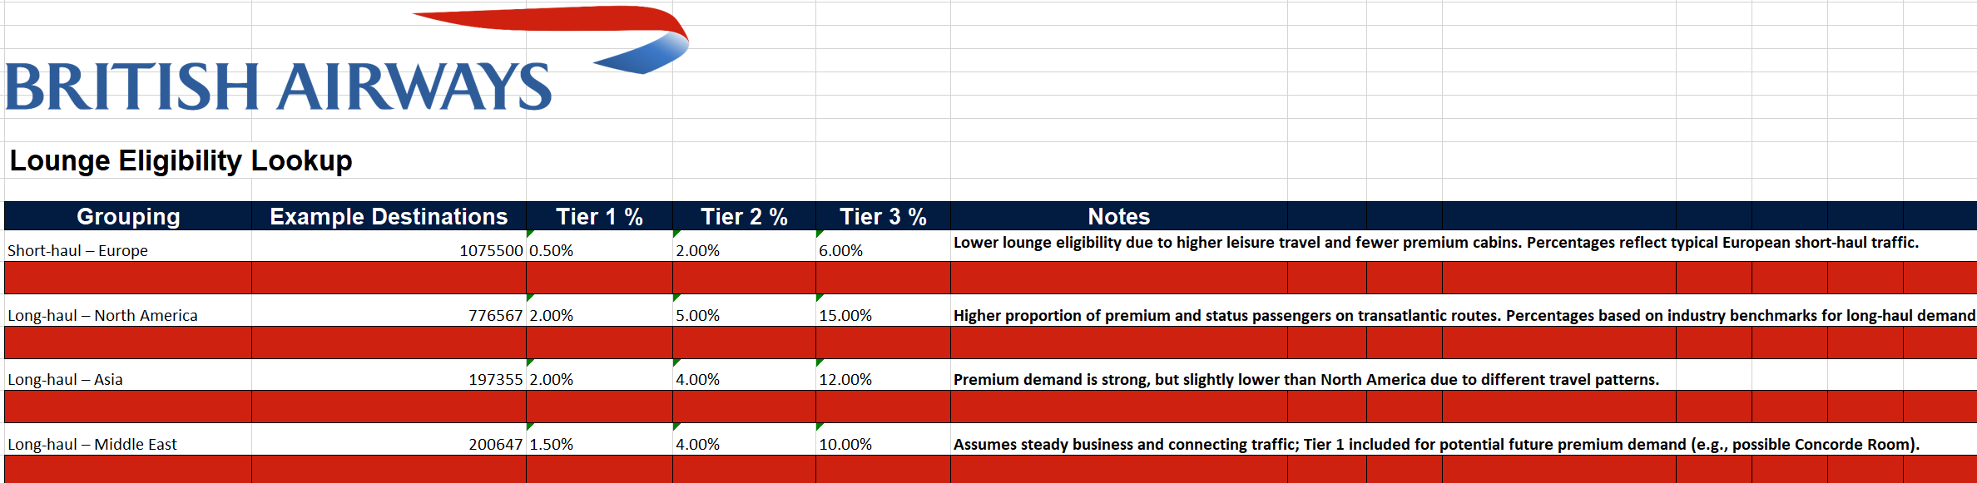**Lounge Eligibility Lookup**

|  |  |
| --- | --- |
|  |  |
| **Justification:** |  |
| **Prompt** | **Your Response** |
| **1. How did you group the flights in your table?** | **I grouped flights by Route Type**  **(Short-haul, Long-haul) and Region**  **(Europe, North America, Asia, Middle**  **East) because these factors strongly**  **influence the passenger mix and**  **likelihood of lounge eligibility.** |
| **2. Why did you choose that grouping method?** | **Route Type and Region are standard**  **ways airlines analyze passenger**  **demographics and travel patterns.**  **Premium and frequent flyer traffic is**  **much higher on long-haul routes and**  **varies greatly by region, so this grouping**  **allows British Airways to capture these**  **demand differences effectively.** |
| **3. What assumptions did you make about passenger eligibility ?** | **Assumptions were made about the percentage of**  **passengers eligible for each lounge tier in each group,**  **based on typical industry ratios: higher percentages for**  **long-haul and intercontinental routes, and lower for**  **short-haul Europe. Percentages are kept simple and**  **easy to adjust in the future as more data becomes**  **available.** |
| **4. How can your model apply to future or changing flight schedules?** | **The lookup table is based on broad**  **categories, not individual flight details. This means**  **BA can easily apply the percentages to any future**  **flight schedule by simply grouping flights as shown**  **and multiplying by the relevant percentages.** |

**Conclusion:**  
This modeling approach gives British Airways a practical, scalable way to forecast lounge demand at Heathrow Terminal 3. By grouping flights based on route type and region, and applying logical eligibility percentages, BA can quickly estimate how many passengers are likely to use each lounge tier—even as flight schedules change. This flexible lookup table supports smart planning for lounge space, staffing, and future investment, helping BA continue to deliver a high-quality experience for premium and loyal customers.