Potfolio Task 5: Cluster Analysis

Introduction
This report presents a segmentation analysis conducted on a UK bank's customer dataset using hierarchical and two-step clustering techniques. The objective was to identify homogeneous customer groups to support the development of targeted financial products and services.

Data Preparation
The dataset consisted of 425 customer records, including variables such as account balances, demographic details, and customer tenure. For the purpose of clustering, five continuous variables were selected: Current Account, Savings Account, Months Customer, Months Employed, and Age. These variables were standardized using z-scores to ensure equal weight in distance calculations.
Hierarchical Clustering Analysis
Hierarchical clustering was performed using Ward’s method and squared Euclidean distance. This method was chosen for its ability to form compact, spherical clusters. Based on the dendrogram, an optimal solution of 4 clusters was identified.


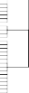

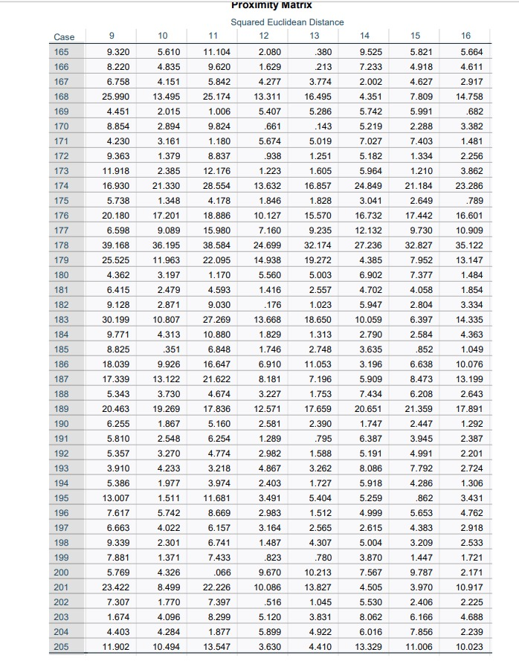

The algorithm schedule and dendrogram clearly indicated four major group separations, particularly where the linkage distance showed a sharp jump. These clusters represent meaningful differences in customer financial profiles.
Two-Step Cluster Analysis
To validate the hierarchical findings, Two-Step clustering was applied using the same standardized variables. The distance measure was Euclidean, and the number of clusters was set to four to enable comparison.
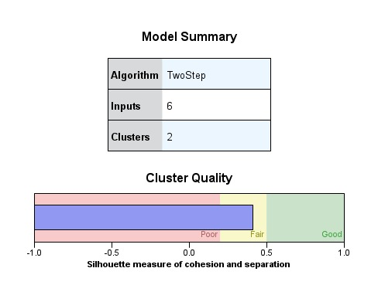

The model summary indicated a cluster quality of “Fair”, and cluster sizes were relatively balanced, suggesting a reasonably stable solution. The Two-Step method confirmed the hierarchical results and additionally provided insights into the importance of each variable in cluster formation—Savings Account and Customer Tenure appeared as primary drivers.
Cluster Profiling
A comparison of mean values for each standardized variable across clusters was conducted to interpret the characteristics of each segment.
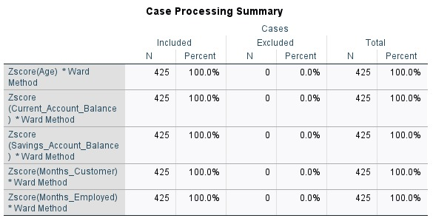

Cluster 1: Younger customers with low account balances and short employment history
Cluster 2: Mature, long-tenured customers with high savings and current account balances
Cluster 3: Mid-aged customers with moderate balances and stable employment
Cluster 4: Customers with high current accounts but low tenure or savings

Comparison of Methods
Both clustering techniques produced comparable results. Hierarchical clustering provided a clear visual confirmation via the dendrogram, while Two-Step clustering validated the grouping and offered additional interpretative metrics like cluster quality and variable importance.
Strategic Implications
- Cluster 2 can be targeted for premium services such as wealth management
- Cluster 1 could benefit from beginner-friendly financial tools and digital-first solutions
- Cluster 3 presents potential for credit offers or long-term savings products
- Cluster 4 may require engagement strategies to improve retention and upsell
Conclusion:
This analysis successfully segmented the UK bank’s customers into four distinct clusters using both hierarchical and two-step clustering techniques. The results highlight clear differences in financial behavior and customer profiles across the segments. While hierarchical clustering provided a strong visual basis for determining the number of clusters, Two-Step clustering offered greater insight into the importance of individual variables. Together, these methods provided a reliable foundation for strategic targeting. The bank can now tailor its financial products and marketing strategies to each segment, ultimately improving customer satisfaction and profitability.

