Task performed for DevOps Assessment

1. **Kubectl installation**



**minikube installation using docker container**

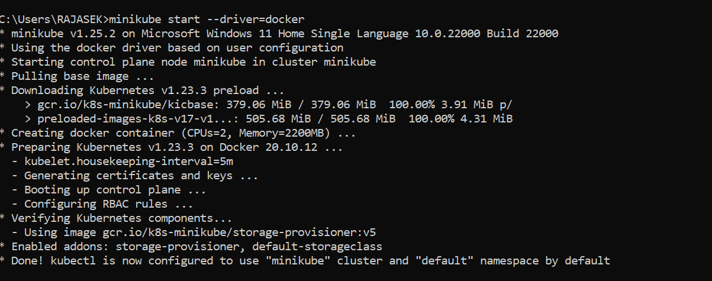

**Helm Installation**

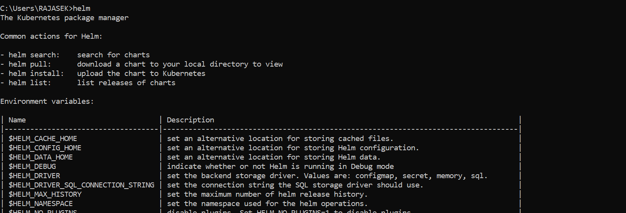

**Installing and running docker**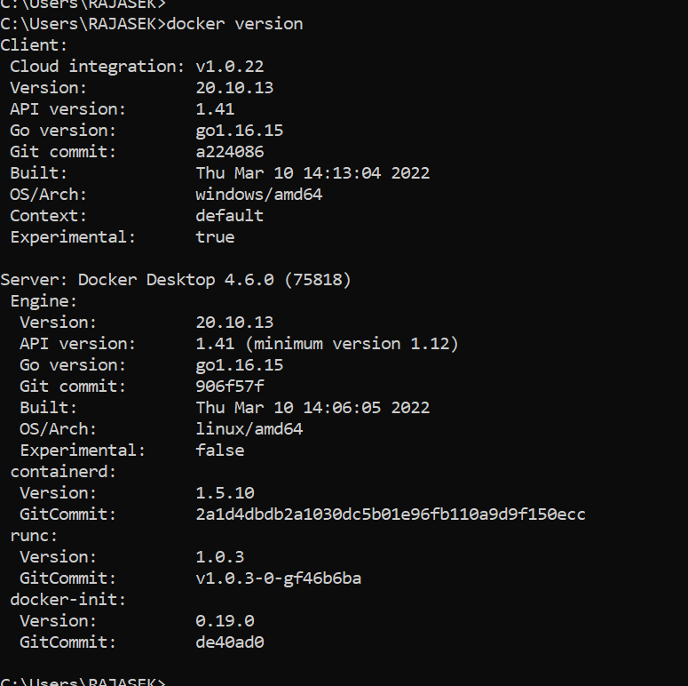

1. Create a Git repo that creates a basic web app

**Git Repo:** [**https://github.com/SuryaRE/hello-world-master.git**](https://github.com/SuryaRE/hello-world-master.git)

1. **Create a Docker file that exposes the basic webapp folder**

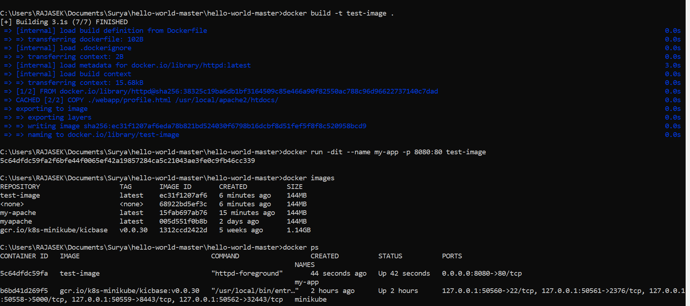

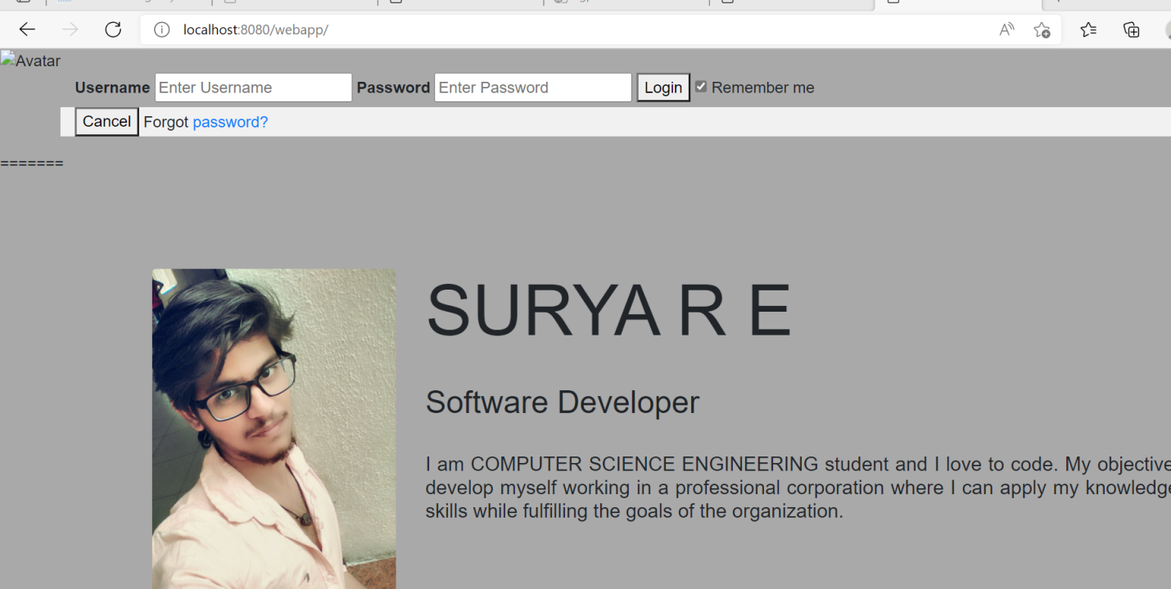

1. Builds your Dockerfile and publishes it to your DockerHub Account

**Git Repo**: **https://github.com/SuryaRE/helloWorld_Devops.git**

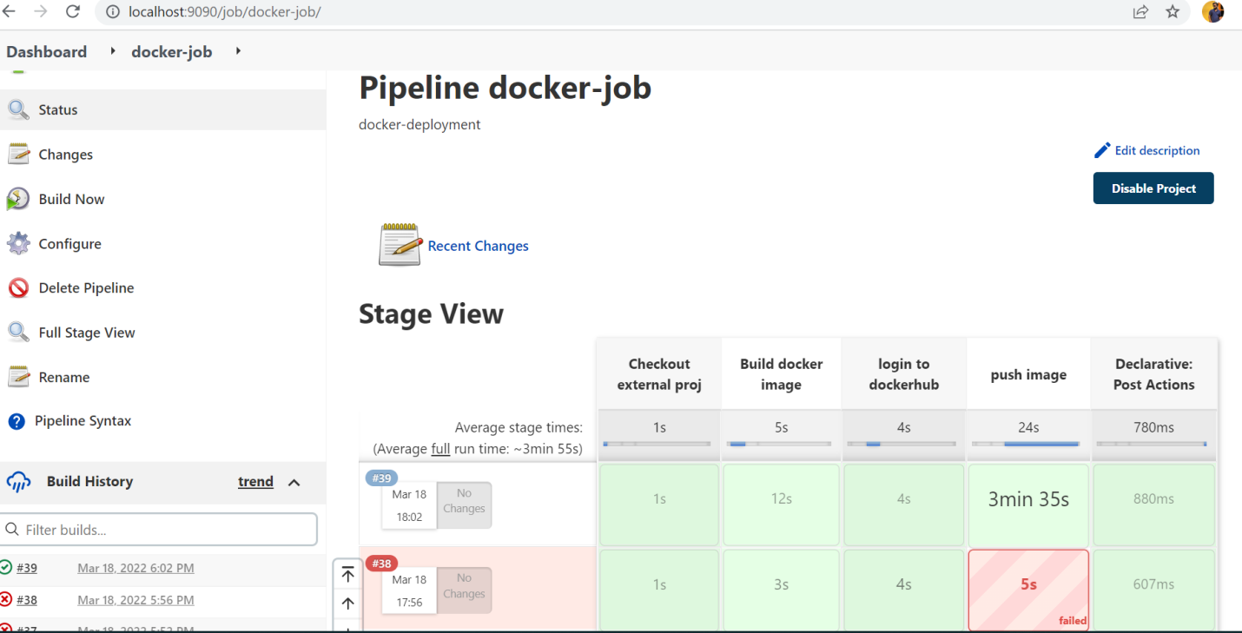

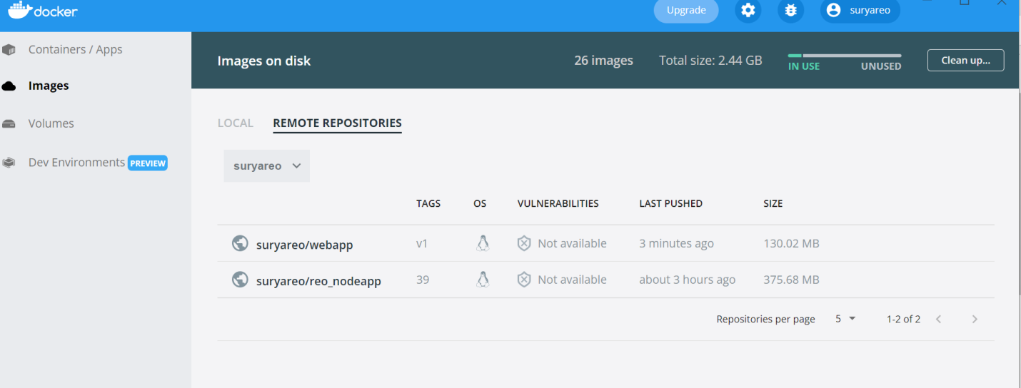

1. Start the docker container created in the pipeline and send one command to interact with the container

**Git Repo**: **https://github.com/SuryaRE/helloWorld_Devops.git**

