Software Requirements Specification (SRS)

Project: Smart Expense and Budget Management Application
Version: 4.0
Authors: Taran S, PES2UG24CS555 | Suryatej Vojjala, PES2UG24CS541 | Sujay P Nayak, PES2UG24CS533 | Surya Raju Naik, PES2UG24CS540
Date: 11/10/2026
Status: Draft (pending re-approval)

Revision history
Version | Date | Author | Change summary | Approval
1.0 | 07/08/2026 | Taran S | Initial draft of SRS | Approved
2.0 | 07/08/2026 | Taran S | Added UML Diagrams | Approved
3.0 | 08/09/2026 | Taran S | Added ER Diagram | Approved
4.0 | 11/10/2026 | Taran S | Itemized requirements in 4.3-4.6; expanded RTM to all Req IDs | Pending

Approvals
Role | Name | Signature / Email
Course Coordinator | Niveditha Reddy | nivedithareddy@pes.edu
Team Lead | Taran S, PES2UG24CS555 | taranshivanna@gmail.com
Team Member | Suryatej Vojjala, PES2UG24CS541 | suryatejvojjala@gmail.com
Team Member | Sujay P Nayak, PES2UG24CS533 | sujaypnayak@gmail.com
Team Member | Surya Raju Naik, PES2UG24CS540 | naiksurya7899@gmail.com

Team members & suggested module ownership
This is a 4-member team project. Suggested split of ownership across modules (adjust as agreed by the team):
Student | Primary module(s) | Related requirement IDs
Suryatej Vojjala  PES2UG24CS541 | Registration & Authentication | SEBM-F-001..003, SEBM-SR-002, SEBM-SR-004
Taran S  PES2UG24CS555 | Expense/Income Tracking & Accounts | SEBM-F-010..013, SEBM-F-030..031
Sujay P Nayak  PES2UG24CS533 | Budget Management & Reports/Analytics | SEBM-F-020..022, SEBM-F-040..042
Surya Raju Naik  PES2UG24CS540 | Notifications & Security/NFRs | SEBM-F-050..051, SEBM-NF-001..005, SEBM-SR-001, SEBM-SR-003, SEBM-SR-005

Table of Contents
1. Introduction
2. Overall description
3. External interfaces
4. System features (detailed)
5. Non-functional requirements (detailed)
6. Quality attributes & Acceptance tests
7. System models and diagrams
8. Requirements Traceability Matrix (RTM)

1. Introduction
1.1 Purpose
This document is a Software Requirements Specification (SRS) for the Smart Expense and Budget Management Application. It defines the functional and non-functional requirements, interfaces, and verification criteria for a mobile/web application that helps individual users record expenses and income, set budgets, and track their personal finances.
1.2 Scope
Covers user registration and authentication, manual and semi-automated expense/income entry, category-wise and overall budget management, alerts and reminders, reporting and analytics, and multi-account tracking (cash, bank, wallet). Excludes direct integration with core banking transaction processing and investment/tax-filing functionality, which are considered future scope.
1.3 Audience
Developers, QA Engineers/Testers, UI/UX Designers, Project Supervisor, and Assessment Evaluators.
1.4 Definitions
List of acronyms: SEBM (Smart Expense and Budget Management), UI (User Interface), API (Application Programming Interface), OTP (One-Time Password), CSV (Comma-Separated Values), PDF (Portable Document Format), AES (Advanced Encryption Standard), TLS (Transport Layer Security), RBAC (Role-Based Access Control), WCAG (Web Content Accessibility Guidelines).

2. Overall description
2.1 Product perspective
The Smart Expense and Budget Management Application is a standalone mobile/web application that lets users manage personal finances independently of any specific bank. It comprises a client application (mobile and/or web), a backend service with a database, and optional integrations with notification services (email/SMS/push) and cloud storage for receipt images.
2.2 Major product functions (detailed)
- User registration, login, and profile management
- Add, edit, and delete expense and income entries
- Categorize transactions (predefined and custom categories)
- Attach receipt images/photos to transactions
- Create and track monthly/category-wise budgets
- Multi-account management (cash, bank, digital wallet)
- Generate spending/income reports and visual analytics (charts)
- Export reports as PDF/CSV
- Budget threshold alerts and bill payment reminders
2.3 User roles and characteristics (expanded)
- End User (Individual): general smartphone/computer literacy; wants a fast, simple way to log expenses and understand spending patterns.
- Admin (App Administrator): manages categories, monitors system health, and handles user support/escalations.
- Guest (optional): limited access to explore app features before registering.
2.4 Operating environment
Android/iOS mobile client and/or responsive web client; cloud-hosted backend (e.g., a managed cloud platform) with a relational or NoSQL database; requires internet connectivity for sync, with limited offline entry capability.
2.5 Constraints
Must comply with applicable data protection regulations for personal financial data, use secure storage for credentials (no plaintext passwords), rely on third-party notification/email services for alerts, and target common mobile OS versions in use at development time.

3. External interface requirements
3.1 User interfaces
Primary UI: mobile-first, clean dashboard showing balance, recent transactions, and budget status. Accessibility: screen-reader friendly labels and high-contrast/dark mode support.
3.2 Hardware interfaces
- Device camera (for scanning/attaching receipt images)
- Device biometric sensor (optional, for app lock via fingerprint/face unlock)
3.3 Software interfaces
- Backend REST API (JSON over HTTPS) for authentication, transactions, budgets, and reports
- Notification service API (email/SMS/push) for alerts and reminders
- Cloud storage API for storing receipt images
- Optional bank/SMS-parsing integration for semi-automated transaction capture (future scope)
3.4 Communications
- TLS 1.2+ enforced for all client-server communication
- Retry/backoff strategy for failed sync attempts; local queuing of entries created while offline
<< This SRS includes 17 FRs across the project, 5 NFRs, 3 security objectives, and 5 security requirements, must adjust counts/content as the design evolves. >>

4. System features (detailed)
Each requirement below includes acceptance criteria and a reference test case. IDs follow SEBM-F-###.

4.1 User Registration & Authentication
Description: Allow users to securely create an account, log in, and recover access to their account.
Req ID | Requirement (shall...) | Type | Priority | Source/Stakeholder | Acceptance criteria / Test case ref | Comments / Dependencies
SEBM-F-001 | The system shall allow a new user to register using email and password, validating a unique email address. | Functional | High | End User | AC-SEBM-F-001: Registration succeeds with a unique, valid email and a password meeting complexity rules. Test: TC-Reg-01 | Requires email verification service
SEBM-F-002 | The system shall authenticate users via email/password login and support session persistence. | Functional | High | End User | AC-SEBM-F-002: Valid credentials grant access to the dashboard; invalid credentials are rejected with an error message. Test: TC-Auth-01 | -
SEBM-F-003 | The system shall allow a user to reset a forgotten password via a time-limited email link or OTP. | Functional | High | End User | AC-SEBM-F-003: Reset link/OTP expires after a configured time; successful reset allows login with the new password. Test: TC-Auth-02 | Requires email/OTP service

4.2 Expense & Income Tracking
Description: Allow users to record, edit, and organize financial transactions.
Req ID | Requirement (shall...) | Type | Priority | Source/Stakeholder | Acceptance criteria / Test case ref | Comments / Dependencies
SEBM-F-010 | The system shall allow a user to add an expense/income entry with amount, category, date, account, and optional notes. | Functional | High | End User | AC-SEBM-F-010: Entry is saved and appears in the transaction list and updates the relevant account balance. Test: TC-Exp-01 | -
SEBM-F-011 | The system shall allow a user to edit or delete an existing transaction. | Functional | High | End User | AC-SEBM-F-011: Edited/deleted transaction is reflected immediately in balances and reports. Test: TC-Exp-02 | -
SEBM-F-012 | The system shall allow a user to attach a receipt photo to a transaction using the device camera or gallery. | Functional | Medium | End User | AC-SEBM-F-012: Attached image is stored and viewable from the transaction detail screen. Test: TC-Exp-03 | Requires cloud storage integration
SEBM-F-013 | The system shall provide predefined categories and allow the user to create custom categories. | Functional | Medium | End User | AC-SEBM-F-013: New custom category is available for selection when adding future transactions. Test: TC-Exp-04 | -

4.3 Budget Management
Description: Allow users to set spending limits and track progress against them in real time.
Req ID | Requirement (shall...) | Type | Priority | Source/Stakeholder | Acceptance criteria / Test case ref | Comments / Dependencies
SEBM-F-020 | The system shall allow a user to create a budget for a specific category or an overall monthly budget, specifying a limit amount and period. | Functional | High | End User | AC-SEBM-F-020: Budget is saved and appears in the user's budget list with the correct category/period and limit amount. Test: TC-Bud-01 | -
SEBM-F-021 | The system shall track and display actual spending against each active budget in real time as matching transactions are recorded. | Functional | High | End User | AC-SEBM-F-021: Spent amount updates immediately after a matching transaction is added, edited, or deleted. Test: TC-Bud-02 | Depends on SEBM-F-010/011
SEBM-F-022 | The system shall warn the user when spending reaches a configurable threshold of a budget's limit, and again when the limit is exceeded. | Functional | Medium | End User | AC-SEBM-F-022: Warning triggers at the configured threshold percentage and again at 100% of the limit; no warning triggers below threshold. Test: TC-Bud-03 | Requires SEBM-F-050 for notification delivery

4.4 Accounts & Income Sources
Description: Allow users to manage multiple financial accounts and move funds between them.
Req ID | Requirement (shall...) | Type | Priority | Source/Stakeholder | Acceptance criteria / Test case ref | Comments / Dependencies
SEBM-F-030 | The system shall allow a user to create and manage multiple accounts (e.g., cash, bank, digital wallet), each with its own balance. | Functional | High | End User | AC-SEBM-F-030: New account appears in the account list with an initial balance of zero or a user-specified opening balance. Test: TC-Acc-01 | -
SEBM-F-031 | The system shall allow a user to record a transfer of funds between two of their own accounts, updating both balances atomically. | Functional | Medium | End User | AC-SEBM-F-031: Source account is debited and destination account is credited by the same amount; transfer is rejected if the source balance is insufficient. Test: TC-Acc-02 | Depends on SEBM-F-030

4.5 Reports & Analytics
Description: Give users visual and exportable insight into their spending and income patterns.
Req ID | Requirement (shall...) | Type | Priority | Source/Stakeholder | Acceptance criteria / Test case ref | Comments / Dependencies
SEBM-F-040 | The system shall generate weekly and monthly spending/income reports with charts summarizing transactions by category. | Functional | High | End User | AC-SEBM-F-040: Report reflects only non-deleted transactions in the selected period, correctly grouped by category. Test: TC-Rep-01 | Depends on SEBM-F-010/011
SEBM-F-041 | The system shall allow a user to export a generated report as a PDF or CSV file. | Functional | Medium | End User | AC-SEBM-F-041: Exported file content matches the on-screen report for the selected date range. Test: TC-Rep-02 | Depends on SEBM-F-040
SEBM-F-042 | The system shall allow a user to compare spending/income across two different time periods and view the percentage change. | Functional | Low | End User | AC-SEBM-F-042: Percentage change is calculated correctly for the two selected periods. Test: TC-Rep-03 | Depends on SEBM-F-040

4.6 Notifications & Reminders
Description: Keep users informed of budget status and upcoming bill payments.
Req ID | Requirement (shall...) | Type | Priority | Source/Stakeholder | Acceptance criteria / Test case ref | Comments / Dependencies
SEBM-F-050 | The system shall send the user a notification (push and/or email) when a budget-threshold warning or limit-exceeded event occurs. | Functional | Medium | End User | AC-SEBM-F-050: Notification is delivered within an acceptable delay of the triggering event and is visible in the user's notification history. Test: TC-Notif-01 | Depends on SEBM-F-022; requires notification provider integration
SEBM-F-051 | The system shall allow a user to set a bill payment reminder with a due date, and notify the user before the due date. | Functional | Low | End User | AC-SEBM-F-051: Reminder notification is sent at the configured lead time before the due date. Test: TC-Notif-02 | Requires notification provider integration

5. Non-functional requirements (detailed)
NFRs below are measurable and tied to test plans. IDs SEBM-NF-###.
Req ID | Requirement | Category | Priority | Acceptance criteria / Measurement
SEBM-NF-001 | Screen load and transaction save operations shall complete within 2 seconds for 90% of requests under normal load. | Performance | High | 90th percentile ≤ 2s in production-like test. Test: TC-Perf-01
SEBM-NF-002 | The backend service shall provide 99.5% availability monthly, excluding scheduled maintenance windows. | Reliability | High | Uptime reports show ≥99.5% per month. Test: Ops reports.
SEBM-NF-003 | All user financial and personal data shall be encrypted in transit and at rest. | Security/Compliance | High | Security audit checklist pass; no plaintext sensitive data found. Test: TC-Sec-01
SEBM-NF-004 | The application UI shall conform to WCAG 2.1 AA accessibility guidelines where applicable. | Usability/Accessibility | Medium | Accessibility audit pass. Test: TC-UX-01
SEBM-NF-005 | The backend architecture shall support scaling to at least 10,000 concurrent users without redesign. | Scalability | Medium | Load test sustains target concurrency within performance targets. Test: TC-Scale-01

5.1 Security

5.1.1 Security Objectives
- Protect the confidentiality of users' personal and financial data from unauthorized access or disclosure.
- Ensure the integrity of transaction, budget, and account data against unauthorized modification.
- Ensure the application remains available to legitimate users while preventing unauthorized or malicious access.

5.1.2 Security Requirements
Req ID | Requirement (shall...) | Type | Priority | Acceptance criteria / Test case ref
SEBM-SR-001 | TLS 1.2+ shall be mandatory for all network connections between client and server. | Security | High | AC-SEBM-SR-001: Connections on TLS < 1.2 are rejected. Test: TC-Sec-02
SEBM-SR-002 | User passwords shall be stored using a salted, industry-standard hashing algorithm (e.g., bcrypt/Argon2). | Security | High | AC-SEBM-SR-002: Database inspection confirms no plaintext or reversibly-encrypted passwords. Test: TC-Sec-03
SEBM-SR-003 | Sensitive stored data (e.g., linked account identifiers) shall be encrypted at rest using AES-256 or equivalent. | Security | High | AC-SEBM-SR-003: Data-at-rest encryption verified via configuration/audit review. Test: TC-Sec-04
SEBM-SR-004 | The system shall automatically log out a user session after a configurable period of inactivity. | Security | Medium | AC-SEBM-SR-004: Session expires and requires re-authentication after the configured timeout. Test: TC-Sec-05
SEBM-SR-005 | The system shall enforce role-based access control (RBAC) so only Admin users can access administrative functions. | Security | High | AC-SEBM-SR-005: Non-admin accounts are denied access to admin endpoints/screens. Test: TC-Sec-06

6. Quality attributes & Acceptance tests
- Exit criteria for acceptance: All high-priority functional requirements implemented and verified, no critical NFR failures, and RTM shows all test cases passed.
- Acceptance test suites: Registration & Authentication, Expense/Income Tracking, Budget Management, Accounts, Reports & Analytics, Notifications, Performance, Security, and Accessibility tests.

7. System models and diagrams

7.1 UML Use-Case diagram
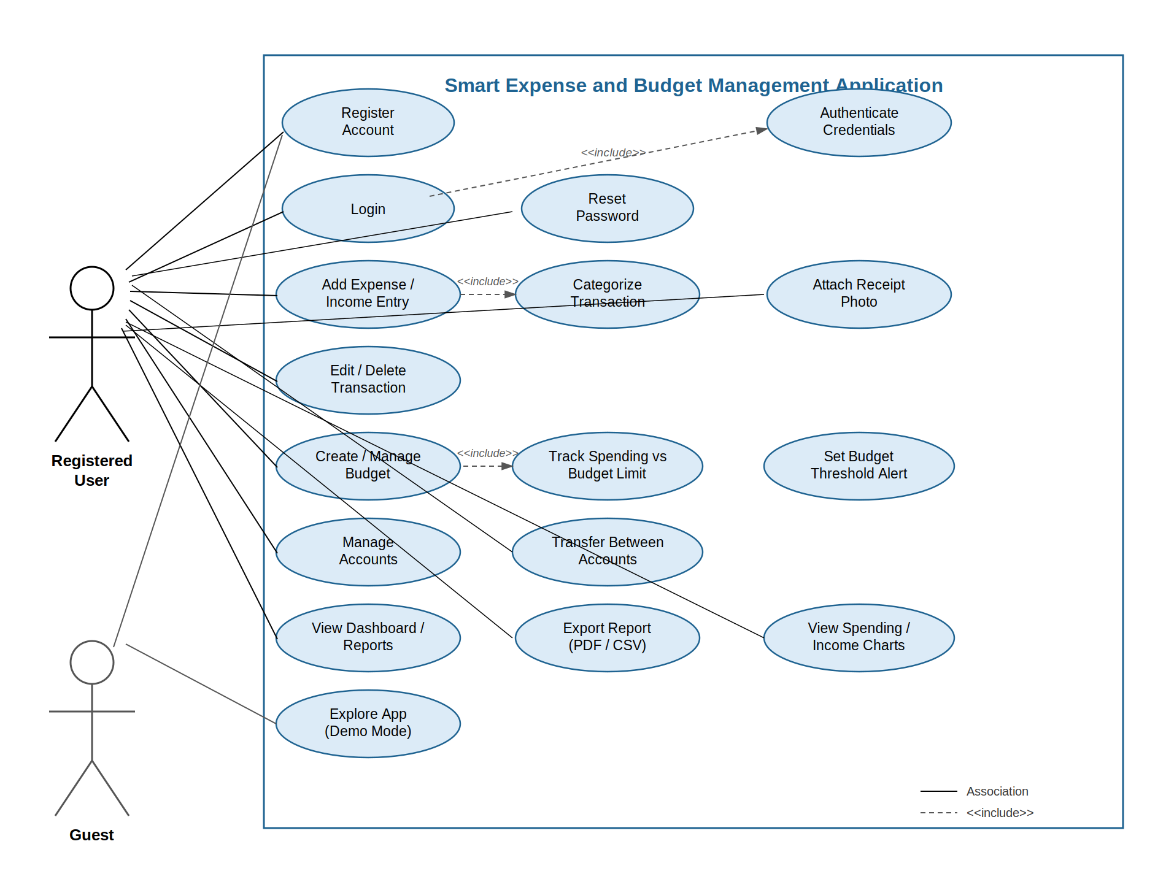
Diagram 1: End User (Registered User) and Guest use cases - Smart Expense and Budget Management Application

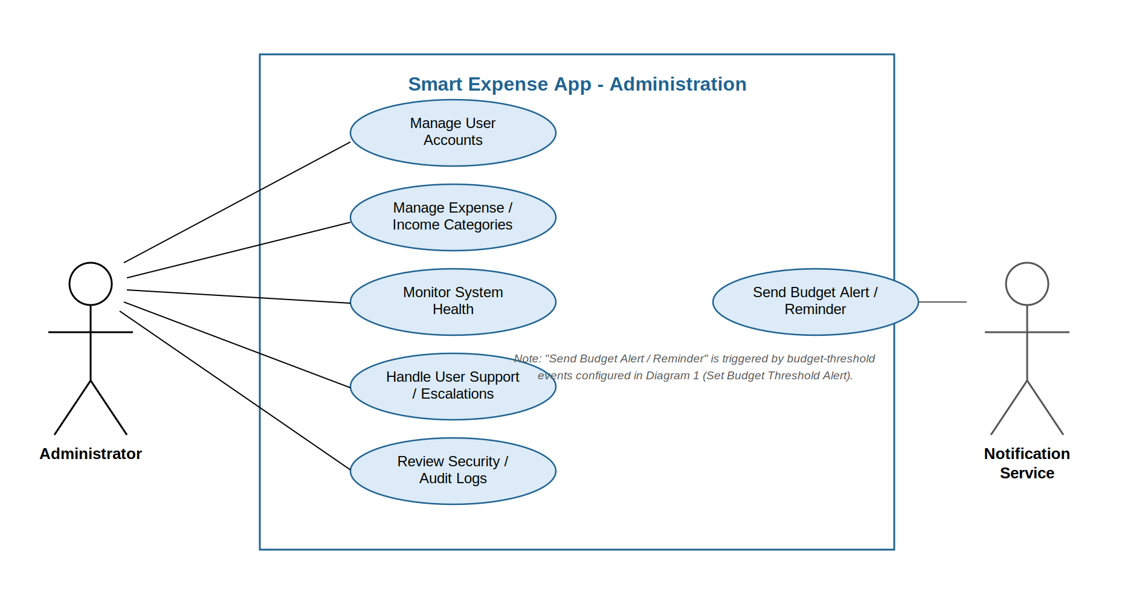
Diagram 2: Administrator use cases, with the Notification Service actor - Smart Expense App Administration

7.2 Other diagrams
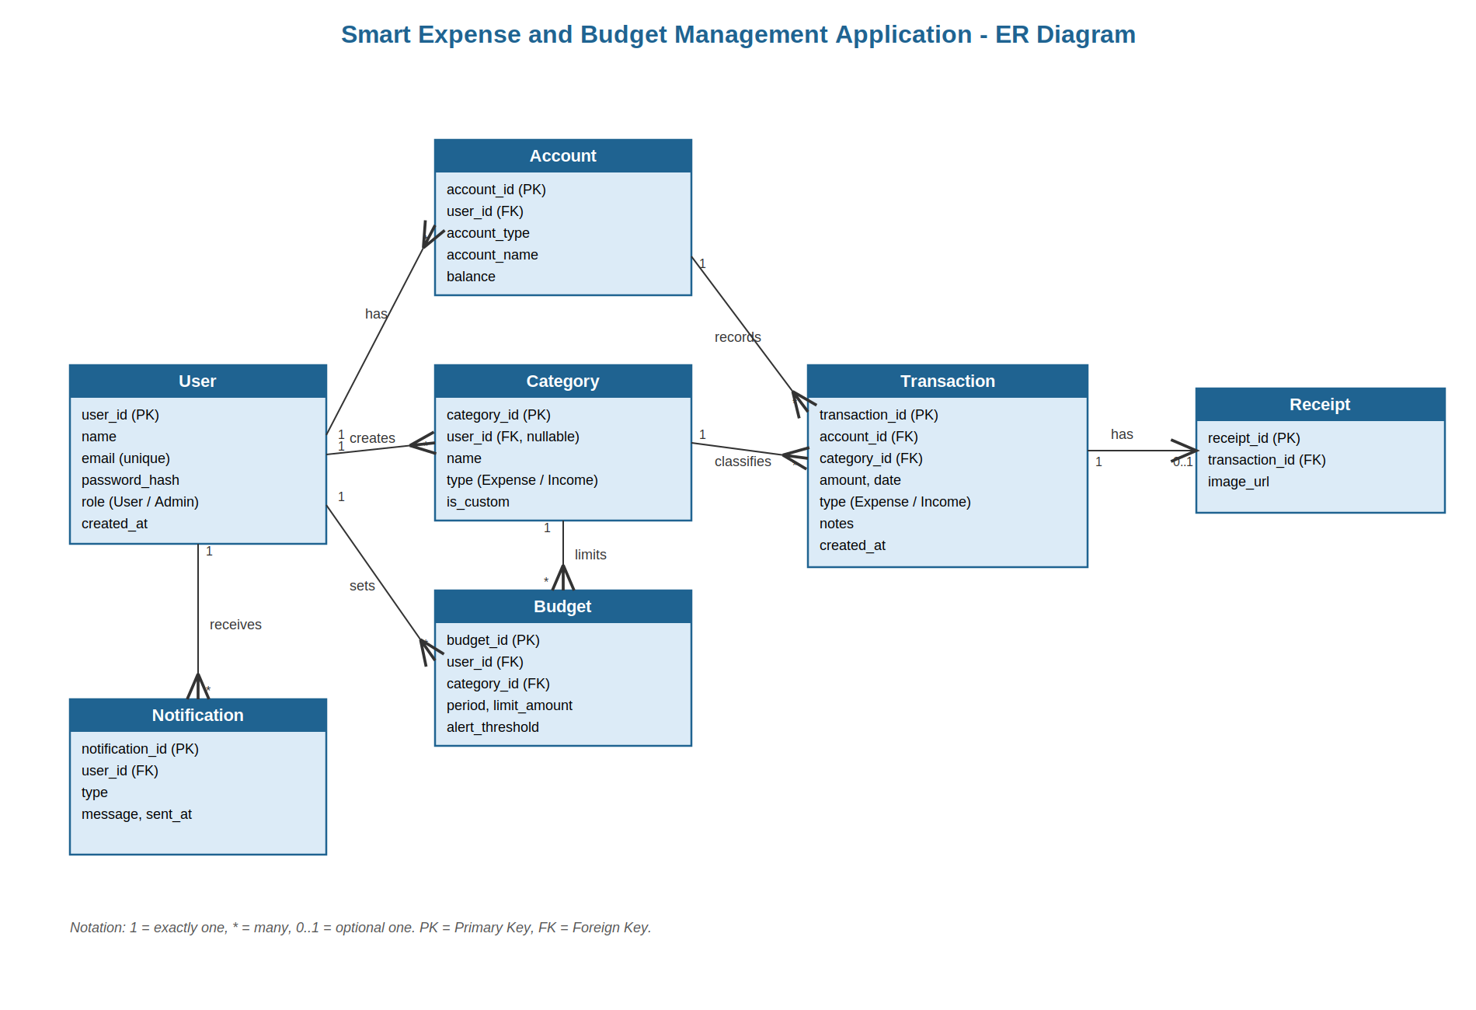
Diagram 3: Entity-Relationship diagram - Smart Expense and Budget Management Application

8. Requirements Traceability Matrix (RTM)
Req ID | Requirement short | Section ref / Design Spec | Module | Test case(s) | Status (N/P/A) | Comments
SEBM-F-001 | User registration | 4.1 / DS-Auth-01 | AuthModule | TC-Reg-01 | N | -
SEBM-F-002 | Login / authentication | 4.1 / DS-Auth-02 | AuthModule | TC-Auth-01 | N | -
SEBM-F-003 | Password reset | 4.1 / DS-Auth-03 | AuthModule | TC-Auth-02 | N | -
SEBM-F-010 | Add transaction | 4.2 / DS-Txn-01 | TransactionModule | TC-Exp-01 | N | -
SEBM-F-011 | Edit/delete transaction | 4.2 / DS-Txn-02 | TransactionModule | TC-Exp-02 | N | -
SEBM-F-012 | Attach receipt photo | 4.2 / DS-Txn-03 | TransactionModule | TC-Exp-03 | N | -
SEBM-F-013 | Predefined & custom categories | 4.2 / DS-Txn-04 | TransactionModule | TC-Exp-04 | N | -
SEBM-F-020 | Create budget | 4.3 / DS-Budget-01 | BudgetModule | TC-Bud-01 | N | -
SEBM-F-021 | Track spend vs budget | 4.3 / DS-Budget-02 | BudgetModule | TC-Bud-02 | N | -
SEBM-F-022 | Budget threshold warning | 4.3 / DS-Budget-03 | BudgetModule | TC-Bud-03 | N | -
SEBM-F-030 | Multi-account management | 4.4 / DS-Acc-01 | AccountModule | TC-Acc-01 | N | -
SEBM-F-031 | Account-to-account transfer | 4.4 / DS-Acc-02 | AccountModule | TC-Acc-02 | N | -
SEBM-F-040 | Generate report | 4.5 / DS-Report-01 | ReportModule | TC-Rep-01 | N | -
SEBM-F-041 | Export report (PDF/CSV) | 4.5 / DS-Report-02 | ReportModule | TC-Rep-02 | N | -
SEBM-F-042 | Period-over-period comparison | 4.5 / DS-Report-03 | ReportModule | TC-Rep-03 | N | -
SEBM-F-050 | Budget-threshold alert notification | 4.6 / DS-Notif-01 | NotificationModule | TC-Notif-01 | N | -
SEBM-F-051 | Bill payment reminder | 4.6 / DS-Notif-02 | NotificationModule | TC-Notif-02 | N | -
SEBM-NF-001 | Response time target | 5 / DS-Perf-01 | Client / Backend API | TC-Perf-01 | N | -
SEBM-NF-002 | Monthly availability | 5 / DS-Ops-01 | Infrastructure | Ops reports | N | -
SEBM-NF-003 | Encryption in transit & at rest | 5 / DS-Sec-01 | NetworkLayer / Database | TC-Sec-01 | N | -
SEBM-NF-004 | WCAG 2.1 AA accessibility | 5 / DS-UX-01 | Client Applications | TC-UX-01 | N | -
SEBM-NF-005 | Scalability (10,000 concurrent users) | 5 / DS-Scale-01 | Backend / Infrastructure | TC-Scale-01 | N | -
SEBM-SR-001 | TLS enforcement | 5.1.2 / DS-Sec-01 | NetworkLayer | TC-Sec-02 | N | -
SEBM-SR-002 | Password hashing | 5.1.2 / DS-Sec-02 | AuthModule | TC-Sec-03 | N | -
SEBM-SR-003 | Data-at-rest encryption | 5.1.2 / DS-Sec-03 | Database | TC-Sec-04 | N | -
SEBM-SR-004 | Session timeout | 5.1.2 / DS-Sec-04 | AuthModule | TC-Sec-05 | N | -
SEBM-SR-005 | RBAC for admin functions | 5.1.2 / DS-Sec-05 | AuthModule / AdminModule | TC-Sec-06 | N | -

