Software Architecture and Design Specification
Project: Smart Expense and Budget Management Application (SEBM)
Version: 1.0
Authors: Taran S (PES2UG24CS555), Suryatej Vojjala (PES2UG24CS541), Sujay P Nayak (PES2UG24CS533), Surya Raju Naik (PES2UG24CS540)
Date: 15-09-2026
Status: Draft

Revision History
Version | Date | Author | Change Summary
1.0 | 15-09-2026 | Taran S | Initial draft of the Software Architecture and Design Specification, based on SRS v3.0

Approvals
Role | Name | Signature / Date
Course Coordinator | Niveditha Reddy
Team Lead | Taran S, PES2UG24CS555
Team Member | Suryatej Vojjala, PES2UG24CS541
Team Member | Sujay P Nayak, PES2UG24CS533
Team Member | Surya Raju Naik, PES2UG24CS540

1. Introduction

1.1 Purpose
This document specifies the software architecture and design of the Smart Expense and Budget Management Application (SEBM). It translates the approved SEBM Software Requirements Specification (SRS v3.0) into a concrete system architecture, component design, and interface definitions to guide implementation.

1.2 Scope
Covers the end-to-end application architecture: client applications (mobile/web), the backend REST API, core service modules (Auth, Transaction, Budget, Account, Report, Notification, Admin), data storage, and integrations with external notification and cloud-storage providers. Excludes core banking transaction-processing integration and investment/tax-filing functionality, which remain future scope per the SRS.

1.3 Audience
Developers, QA engineers, security reviewers, the Course Coordinator/Project Supervisor, and future maintainers.

1.4 Definitions
SEBM (Smart Expense and Budget Management), UI (User Interface), API (Application Programming Interface), OTP (One-Time Password), CSV (Comma-Separated Values), PDF (Portable Document Format), AES (Advanced Encryption Standard), TLS (Transport Layer Security), RBAC (Role-Based Access Control), WCAG (Web Content Accessibility Guidelines), JWT (JSON Web Token), ADR (Architecture Decision Record), STRIDE (Spoofing, Tampering, Repudiation, Information disclosure, Denial of service, Elevation of privilege).

2. Document Overview

2.1 How to use this document
Provides the architectural deliverables for SEBM: a component diagram, sequence diagrams for key flows, chosen technology stack, API design, and the security/threat model. It should be read alongside the SRS and Test Plan for full requirement and verification context.

2.2 Related Documents
- SEBM Software Requirements Specification (SRS) v3.0 - Approved
- SEBM Software Test Plan (STP) v1.0
- SEBM UML Use-Case Diagrams (Diagrams 1-2, SRS Section 7.1)
- SEBM Entity-Relationship Diagram (Diagram 3, SRS Section 7.2)

3. Architecture

3.1 Goals & Constraints
Goals: Secure handling of personal financial data; 99.5% monthly availability (SEBM-NF-002); response time ≤ 2s for 90% of requests (SEBM-NF-001); support scaling to at least 10,000 concurrent users without redesign (SEBM-NF-005); WCAG 2.1 AA accessibility (SEBM-NF-004).
Constraints: Must comply with applicable data-protection regulations for personal financial data; no plaintext password storage; reliance on third-party notification/email services for alerts; must target common mobile OS versions in use at development time; delivered by a 4-member student team within a capstone timeline.

3.2 Stakeholders & Concerns
- End Users: data privacy, ease of use, accurate balances and budgets
- Admin: manageability of categories/users, visibility into system health and support escalations
- Course Coordinator / Evaluators: adherence to the approved SRS, demonstrable architecture quality
- Developers (project team): modularity, maintainability, and clear per-module ownership

3.3 Component (UML) Diagram
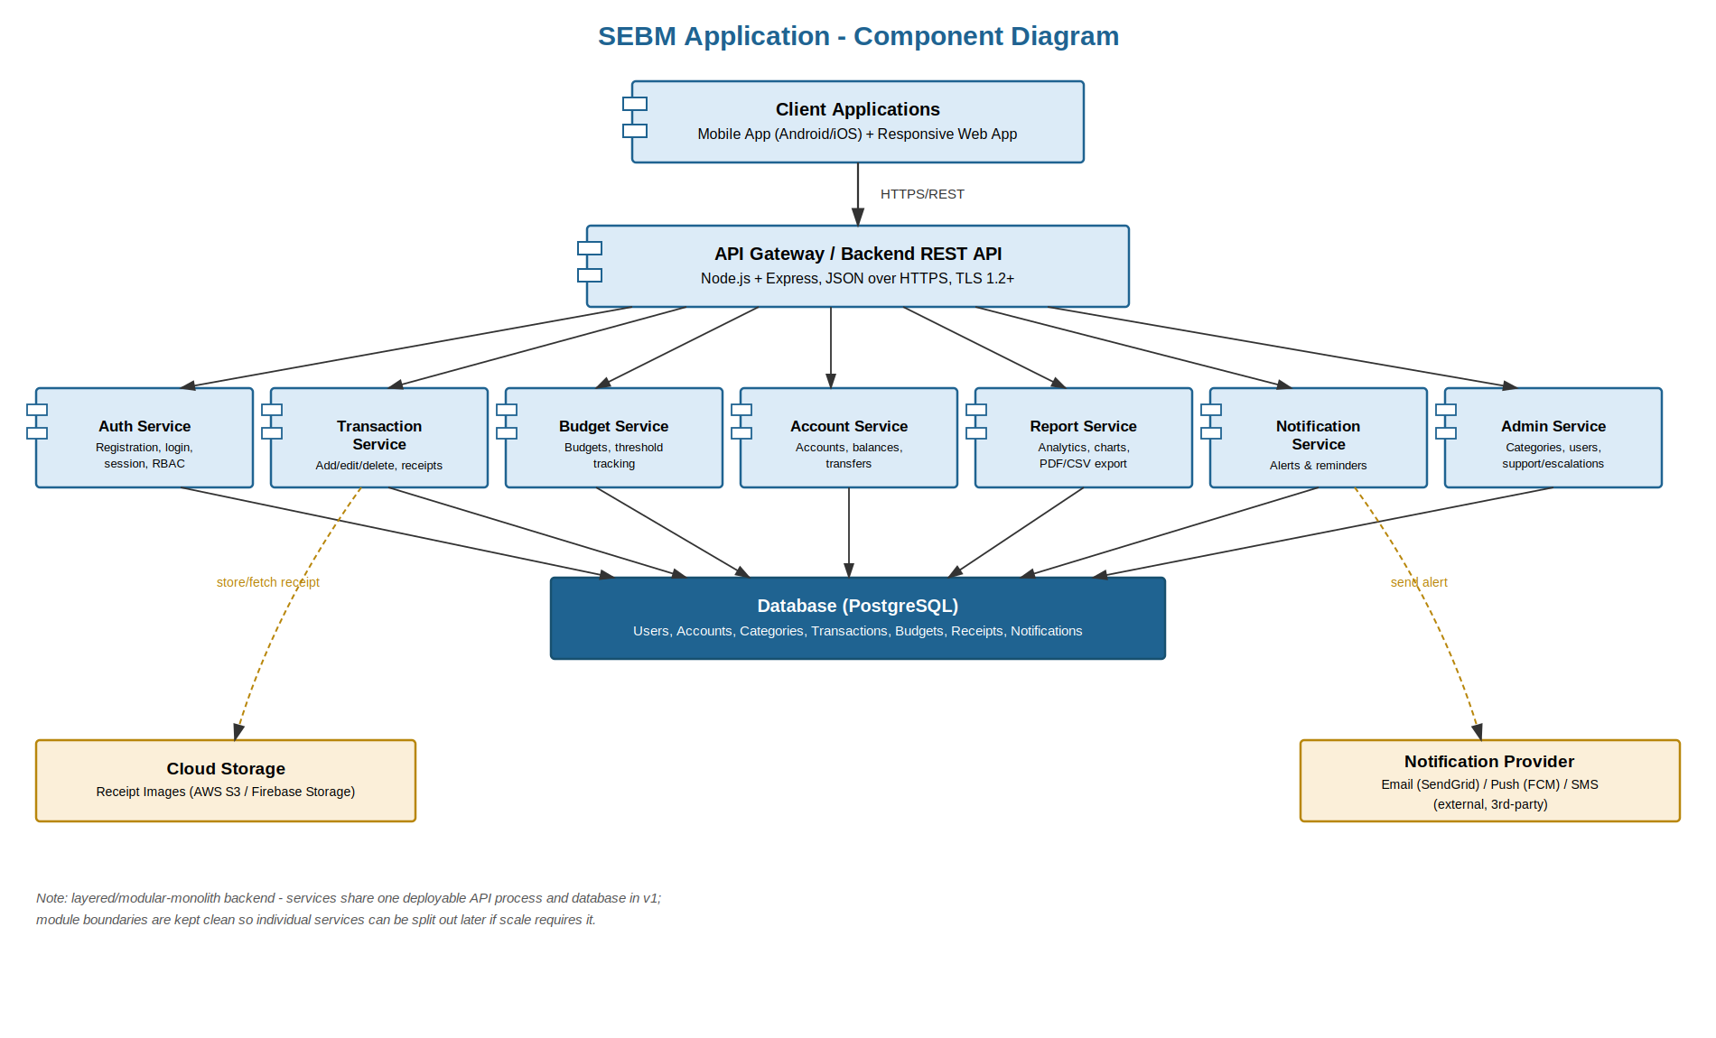
Diagram 1: SEBM Application - Component Diagram

3.4 Component Descriptions
- Client Applications: mobile (Android/iOS) and responsive web clients; dashboard, transaction entry, and budget views.
- API Gateway / Backend REST API: single entry point for all client requests; enforces TLS and authentication, and routes requests to service modules.
- Auth Service: registration, login, password reset, session management, and RBAC enforcement (SEBM-F-001..003, SEBM-SR-002/004/005).
- Transaction Service: add/edit/delete transactions and receipt-photo attachment (SEBM-F-010..013).
- Budget Service: budget creation and real-time threshold tracking; triggers alerts (SEBM-F-020..022).
- Account Service: multi-account management and transfers between accounts (SEBM-F-030..031).
- Report Service: spending/income analytics, charts, and PDF/CSV export (SEBM-F-040..042).
- Notification Service: dispatches budget-threshold alerts and bill reminders via push/email/SMS (SEBM-F-050..051).
- Admin Service: category management, user administration, and support escalations.
- Database (PostgreSQL): persistent storage for all entities (Users, Accounts, Categories, Transactions, Budgets, Receipts, Notifications).
- Cloud Storage: stores receipt images, referenced by the Transaction Service (SEBM-F-012).
- Notification Provider: external email/push/SMS delivery used by the Notification Service.

3.5 Chosen Architecture Pattern and Rationale
A layered / modular-monolith architecture was chosen: a single backend deployable organized into clearly bounded service modules (Auth, Transaction, Budget, Account, Report, Notification, Admin), each internally layered as controller → service → repository. This gives the team clear module ownership that mirrors the SRS's per-student module split, while avoiding the operational overhead of full microservices - rejected as unnecessary complexity for a capstone-scale application sharing a single database. Module boundaries are kept deliberately clean so that individual services could be extracted into independent deployables later if the 10,000-concurrent-user scalability target (SEBM-NF-005) requires it.

3.6 Technology Stack & Data Stores
- Backend: Node.js + Express REST API, organized into Auth/Transaction/Budget/Account/Report/Notification/Admin modules
- Database: PostgreSQL (relational, enforces the FK constraints defined in the SEBM ER diagram)
- Mobile client: React Native (single codebase for Android and iOS)
- Web client: React (responsive, mobile-first dashboard)
- Authentication: JWT-based sessions; passwords hashed with bcrypt/Argon2 (SEBM-SR-002)
- Receipt storage: AWS S3 / Firebase Storage via a Cloud Storage API (SEBM-F-012)
- Notifications: Firebase Cloud Messaging (push), SendGrid (email), optional SMS gateway (SEBM-F-050..051)
- Transport security: TLS 1.2+ enforced on all client-server connections (SEBM-SR-001)
- Deployment: containerized (Docker) on a managed cloud platform, enabling horizontal scaling of the API layer

3.7 Risks & Mitigations
Risk | Mitigation
Third-party notification provider outage or rate-limiting | Queue + retry with backoff; provider-abstraction layer so the provider can be swapped
Shared single database becomes a bottleneck at scale | Connection pooling / read replicas; clean module boundaries allow splitting services out later
Cloud storage dependency for receipt images | Asynchronous upload with local queuing; graceful degradation if storage is temporarily unavailable
Session or credential compromise | TLS everywhere, salted password hashing, short-lived JWTs with refresh tokens, RBAC

3.8 Traceability to Requirements
Req ID(s) | Component
SEBM-F-001..003 | Auth Service
SEBM-F-010..013 | Transaction Service
SEBM-F-020..022 | Budget Service
SEBM-F-030..031 | Account Service
SEBM-F-040..042 | Report Service
SEBM-F-050..051 | Notification Service
SEBM-NF-001, SEBM-NF-005 | API Gateway + Database (performance / scalability)
SEBM-NF-002 | Deployment / Infrastructure (availability)
SEBM-NF-003, SEBM-SR-001, SEBM-SR-003 | TLS layer + Database encryption at rest
SEBM-NF-004 | Client Applications (accessibility)
SEBM-SR-005 | Auth Service (RBAC) + Admin Service

3.9 Security Architecture
Threat modeling (STRIDE):
- Spoofing → JWT-based authentication plus email/OTP verification at registration (SEBM-F-003, SEBM-SR-002)
- Tampering → TLS 1.2+ in transit, server-side validation of all inputs, AES-256 encryption at rest for sensitive fields (SEBM-SR-001/003)
- Repudiation → server-side audit logging of authentication and admin actions
- Information Disclosure → TLS everywhere, encryption at rest, least-privilege database access, no sensitive data written to logs
- Denial of Service → rate limiting at the API Gateway, backend auto-scaling (SEBM-NF-005)
- Elevation of Privilege → RBAC enforced at the API Gateway and Auth Service; only the Admin role can reach admin endpoints (SEBM-SR-005)

4. Design

4.1 Design Overview
SEBM is designed as a layered, modular backend behind a single API Gateway, with thin client applications (mobile/web) that call REST endpoints for all state changes. Each service module encapsulates its own data-access logic against PostgreSQL, keeping transaction, budget, and account consistency logic centralized rather than duplicated across clients.

4.2 UML Sequence Diagrams
Two sequence diagrams covering flows specific to SEBM:
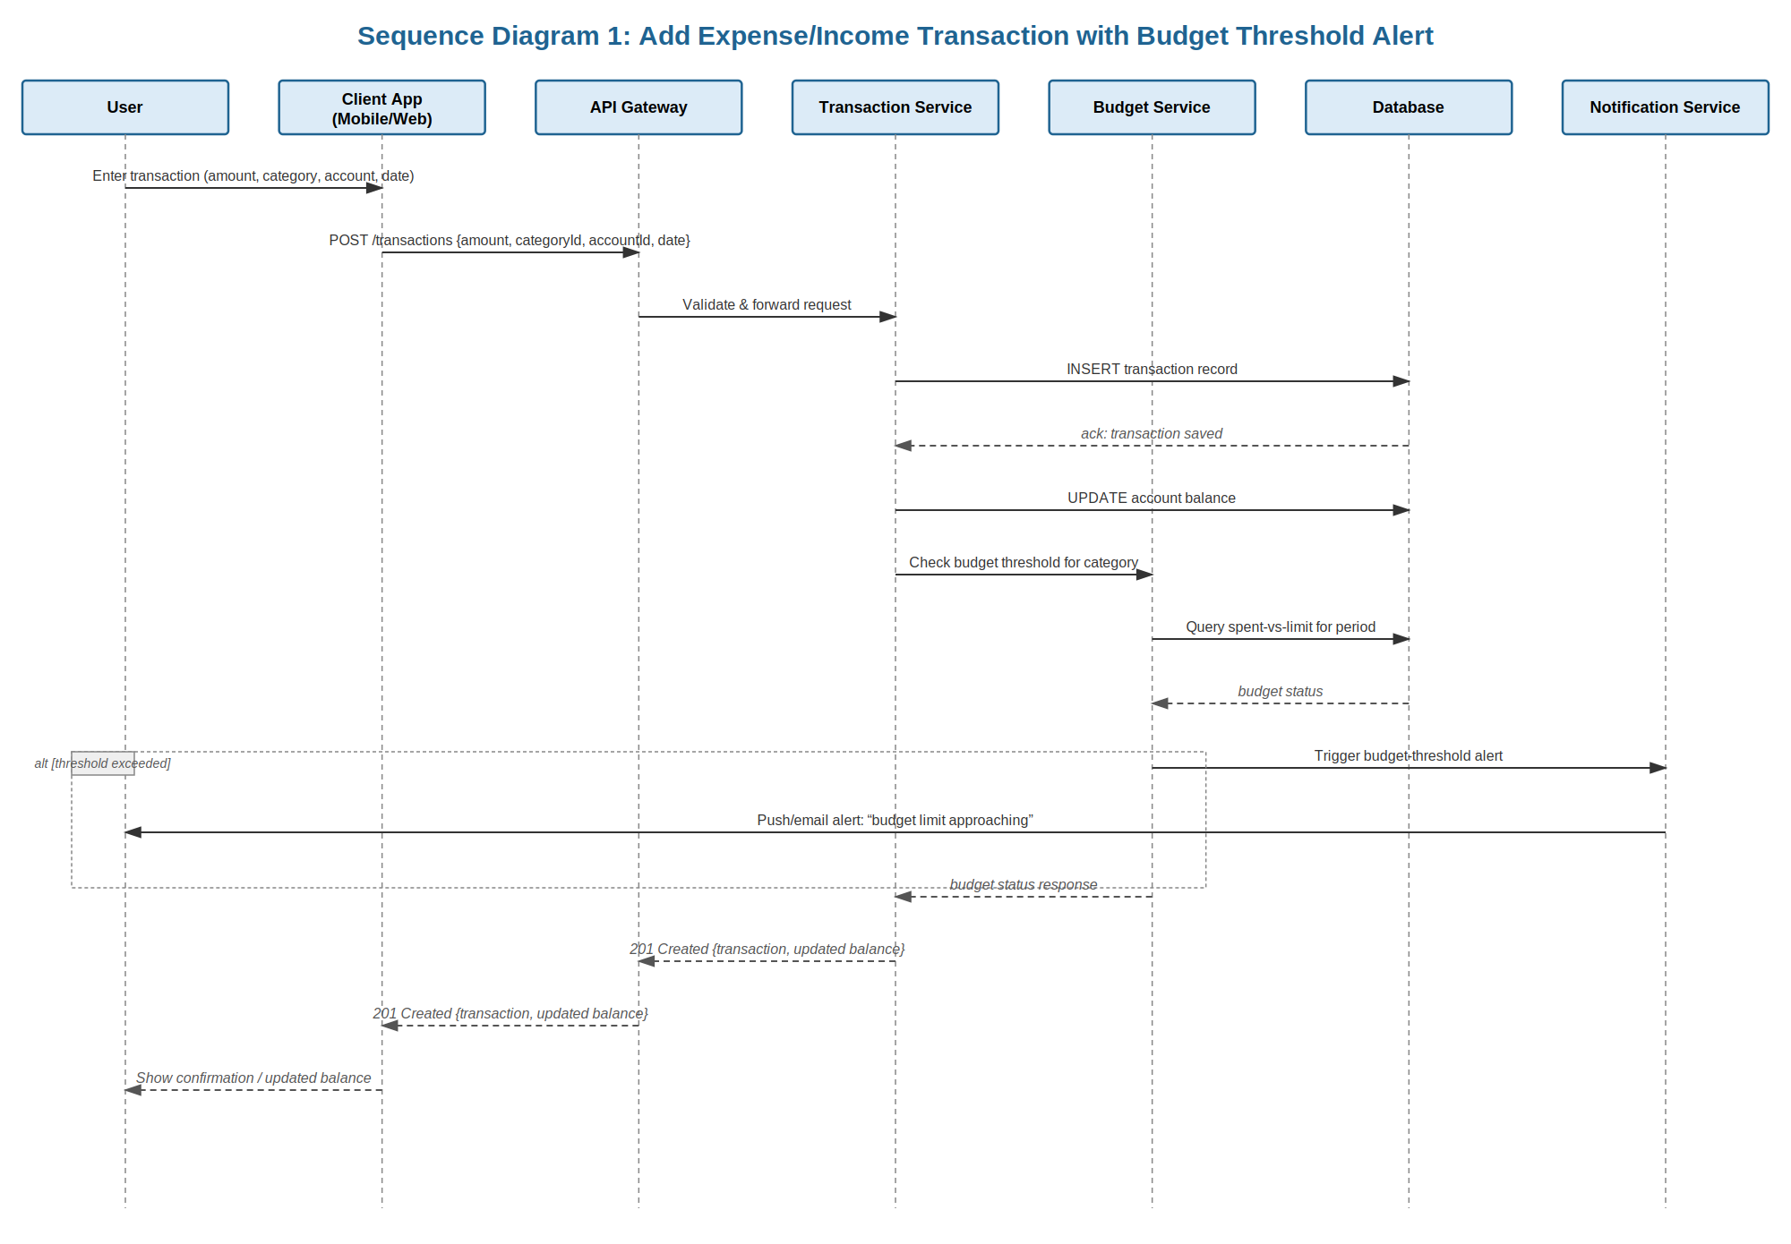
Diagram 2: Add Expense/Income Transaction with Budget Threshold Alert (SEBM-F-010, SEBM-F-020/022, SEBM-F-050)
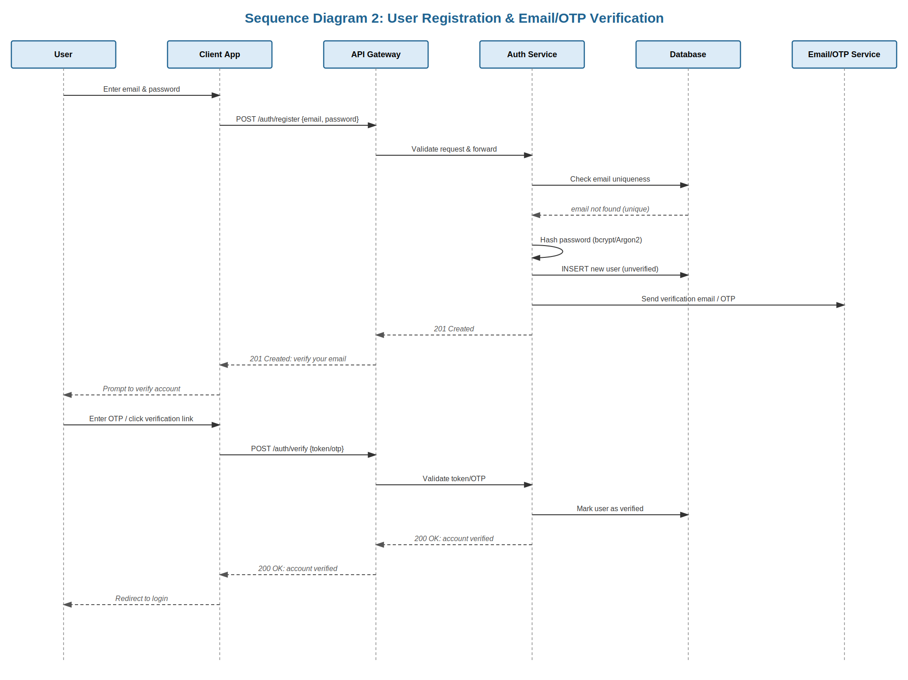
Diagram 3: User Registration & Email/OTP Verification (SEBM-F-001, SEBM-F-003, SEBM-SR-002)

4.3 API Design
Interface definitions for the Transaction, Budget, and Account services:
Endpoint: POST /transactions
Request: { accountId, categoryId, amount, type, date, notes? }
Response: { transactionId, accountId, newBalance, createdAt }
Errors: 400 Invalid amount/category, 401 Unauthorized, 404 Account not found
Endpoint: POST /budgets
Request: { categoryId, period, limitAmount, alertThreshold }
Response: { budgetId, categoryId, period, limitAmount, alertThreshold }
Errors: 400 Invalid period/limit, 401 Unauthorized, 409 Budget already exists for category and period
Endpoint: POST /accounts/transfer
Request: { fromAccountId, toAccountId, amount, notes? }
Response: { transferId, fromAccountBalance, toAccountBalance }
Errors: 400 Insufficient funds, 401 Unauthorized, 404 Account not found

4.4 Error Handling, Logging & Monitoring
A standardized JSON error envelope ({ error: { code, message } }) is used across all endpoints. No sensitive data (passwords, full account identifiers, receipt contents) is written to logs. Logging is centralized with a correlation ID per request. Monitoring covers: API response-time percentiles (SEBM-NF-001), error rate per endpoint, budget-alert delivery success rate, backend uptime (SEBM-NF-002), and failed-login attempt rate as a security signal.

4.5 UX Design
Mobile-first dashboard showing balance, recent transactions, and budget status at a glance. Screen-reader-friendly labels and high-contrast/dark-mode support, targeting WCAG 2.1 AA (SEBM-NF-004). A quick-add transaction flow is optimized for a minimal number of taps, with category icons for fast visual scanning and clear red/amber/green budget-status indicators.

4.6 Open Issues & Next Steps
- Bank/SMS-parsing semi-automated transaction capture (future scope per SRS)
- Investment and tax-filing modules (future scope per SRS)
- Biometric app-lock using the device biometric sensor
- Splitting service modules into independent deployables if scale requires it beyond the current modular monolith

5. Appendices

5.1 Glossary
SEBM, UI, API, OTP, CSV, PDF, AES, TLS, RBAC, WCAG, JWT, ADR, STRIDE.

5.2 References
- IEEE 42010 (Systems and software engineering - Architecture description)
- OWASP Application Security Verification Standard (ASVS)
- NIST SP 800-160 (Systems Security Engineering)
- SEBM SRS v3.0 (Approved)
- SEBM Software Test Plan v1.0

5.3 Tools
- PlantUML / draw.io - for future diagram revisions
- Postman - API testing
- Swagger / OpenAPI - API documentation
- Docker - containerized deployment

