BrightCart – Scalable Serverless E-Commerce Platform on AWS

Prepared by: Surya Ravichandran

Date: April 13, 2025

# Executive Summary

BrightCart Retail Group, a fictional online retailer, required a modern, scalable cloud-based e-commerce solution to address peak-traffic outages and scaling issues with their legacy monolithic platform. This project outlines a fully serverless AWS architecture that leverages S3, CloudFront, API Gateway, Lambda, DynamoDB, Cognito, and other services to ensure performance, cost-efficiency, and security.

# Architecture Overview

The architecture uses a decoupled serverless design. Static assets are hosted on Amazon S3 and distributed via CloudFront. API Gateway routes HTTP requests to AWS Lambda functions, which handle business logic. Data is stored in Amazon DynamoDB. Cognito handles authentication, WAF protects against web exploits, and CloudWatch + SNS handle monitoring and alerts.

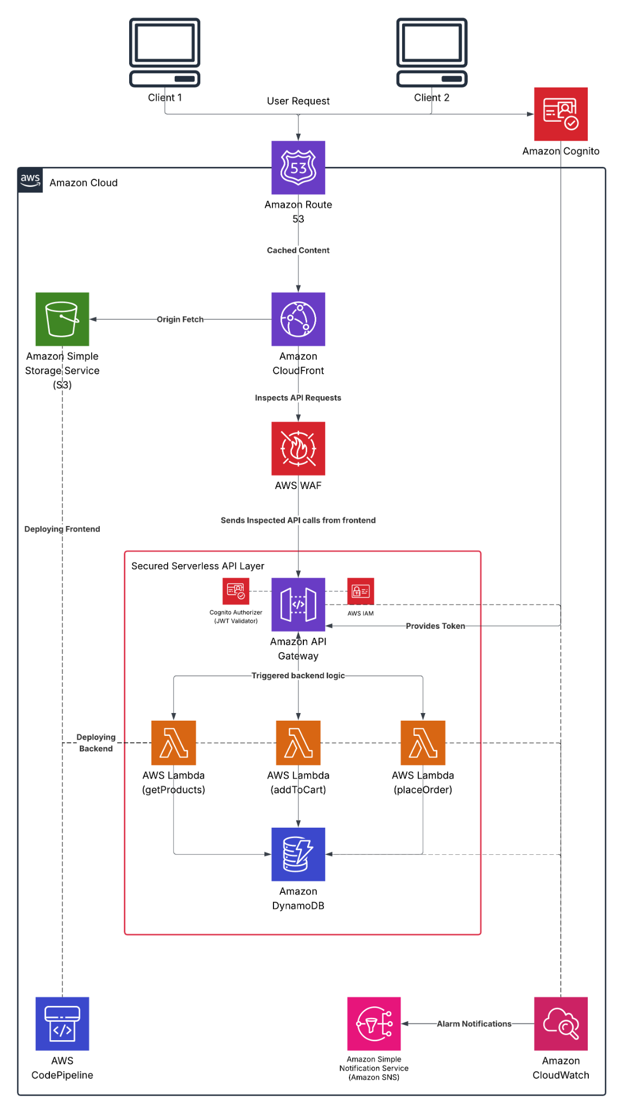

Figure: High-level architecture diagram for BrightCart's serverless e-commerce platform.

# Key AWS Services Used

* Frontend: Amazon S3, CloudFront, Route 53
* Security: AWS WAF, AWS Shield, Amazon Cognito, IAM
* API Layer: Amazon API Gateway, AWS Lambda
* Database: Amazon DynamoDB
* Monitoring: Amazon CloudWatch, AWS X-Ray, Amazon SNS
* CI/CD: AWS CodePipeline, AWS CodeBuild

# Cost Summary (Estimates)

Estimated monthly cost under moderate traffic (~5M requests/month):

* Amazon S3: $1.15
* CloudFront: $50
* API Gateway: $19
* Lambda: ~$2
* DynamoDB: ~$3
* Cognito: $0 (under 50k MAUs)
* WAF: $16
* CloudWatch + SNS: ~$10
* CodePipeline: ~$2
* Total: ~$100/month

# Security Features

* Cognito-based JWT authentication
* HTTPS with ACM TLS certificates
* WAF for OWASP protection
* IAM least privilege for all roles
* Data encryption in transit and at rest
* Monitoring via CloudWatch & GuardDuty
* IAM Access Analyzer for misconfiguration alerts

# Future Roadmap

* Disaster Recovery with multi-region setup
* Search capability using Amazon OpenSearch
* ML-based product recommendations via Amazon Personalize
* Personalized edge delivery with Lambda@Edge
* Read optimization via DynamoDB Accelerator (DAX)
* Synthetic monitoring using CloudWatch Synthetics

# Learning Highlights

This project showcases expertise in AWS solution architecture including serverless compute, secure API design, identity management, CI/CD, monitoring, and cost-efficient cloud architecture for enterprise-grade e-commerce systems.

# Author

Surya Ravichandran

Cloud Solutions Architect & Analytics Enthusiast

Email: Suryaravichandran0108@gmail.com

LinkedIn: https://www.linkedin.com/in/surya-ravichandran/