WEEK-12

MONGODB EXERCISE

1. Create Operation:

- Create a new database named "library" and switch to it.

 //It helps to create a database or change from database to another “**by use databasename**”

- Create a collection named "books" with fields: title, author, and published_year.

 // It creates a collection for storing data in the database

- Insert a document into the "books" collection with the details of your favorite book.

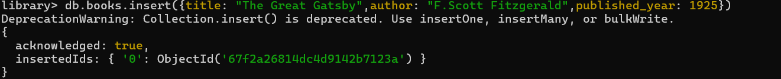

//Inserting a record as objects

2. Read Operation:

- Retrieve all documents from the "books" collection.

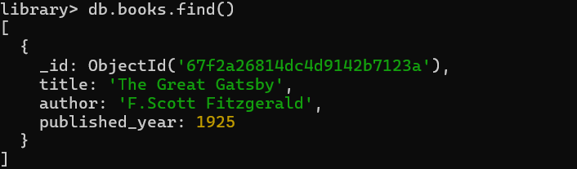 //by find() method it retrieves all data under the collection by “**db.collectionName.find()**”.

- Find and display only the documents where the author is "J.K. Rowling".

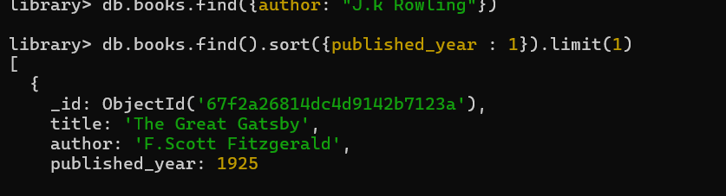 //It didn’t display the details because no data macthes in the author name as J.K.Rowling ,it shows empty

3. Update Operation:

- Update the published year of the book with the title "The Catcher in the Rye" to the current year.

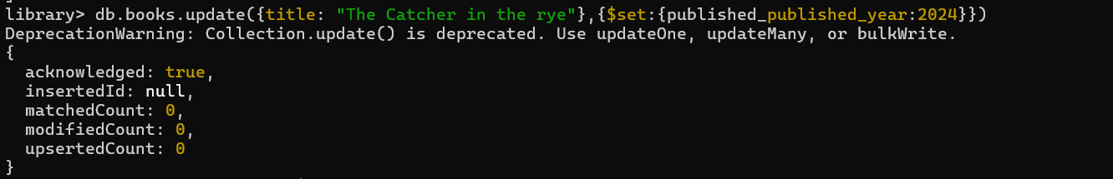 - Add a new field "genre" with the value "Mystery" to all documents in the "books" collection

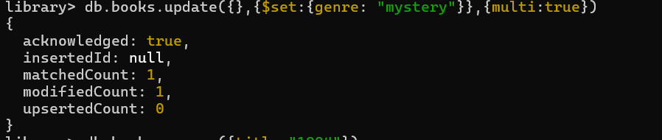

4. Delete Operation:

- Remove the document with the title "1984" from the "books" collection.



- Delete all documents from the "books" collection where the published year is before 2000

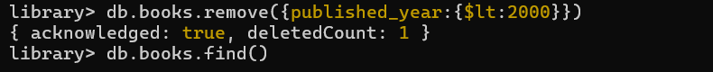

5. Advanced Query:

- Find and display the top 3 recently published books from the "books" collection.

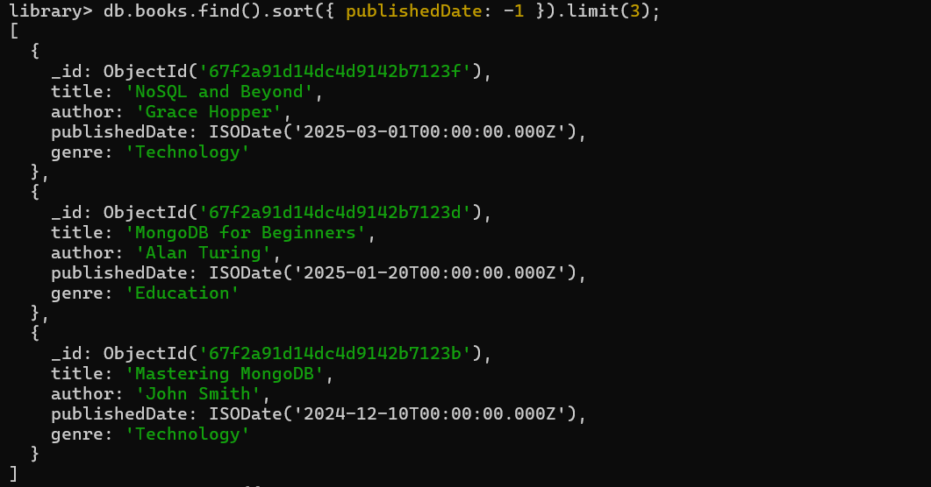

- Retrieve documents from the "books" collection where the title contains the word "MongoDB" or "NoSQL".

