Comprehensive Explanation of the ACXNet Paper for EEG-Based Mental Workload Estimation
Paper Overview
Authors: G. Abinaya & K. Dinakaran
Published in: Scientific Reports (2025)
Dataset Used: STEW Dataset (Simultaneous Task EEG Workload)
1.Data Pre-processing
Step 1: Band-Pass Filtering - This removes frequencies outside the range of interest (typically 4-30 Hz for mental workload).
Step 2: Artifact Removal with ICA (Independent Components Analysis) – removes eye blinks, muscle movements, heat beats.
Step 3: Normalization (Min-Max Scaling) – scale all values to the range [0,1].
Step 4: Segmentation - convert this long signal into small fixed-size samples that the model can learn from.
2. Features Extracted:
Temporal Features: Mean amplitude, RMS, Standard Deviation, skewness, zero-crossing rate.
Spectral features: power in delta, alpha, theta, beta regions, spectral entropy and peak frequency.
Task related features: Task condition, Task duration.
Non-linear Dynamic Features: Approximate Entropy, Fractal Dimension, Hurst Exponent.
3. ACXNet Pipeline:
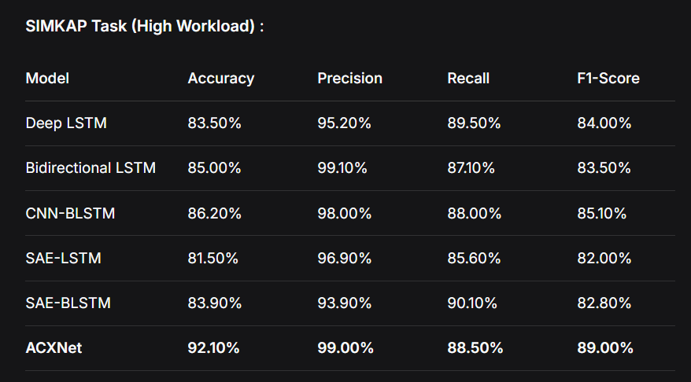
Raw EEG (3584 features) → Autoencoder (128 features) → CNN → XGBoost → Classification

Important Features: Cross Dataset Validation (DEAP, OpenBCI N-Back)
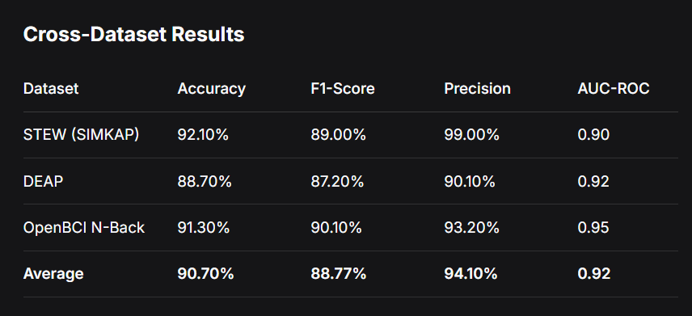

Research Gaps:
1.Binary Classification Only – Low vs High workload only
2. Homogeneous Subject pool – The STEW dataset contains 48 male participants. No mixed Generalization
3. Advanced Auto Encoders can be used (Transformers can be used).
4. EEG signals change continuously over time (LSTM etc can be used).

Cognitive load detection through EEG leads wise feature optimization and ensemble classification
Authors: JammisettyYedukondalu, Kalyani Sunkara, Vankayalapati Radhika,
Sivakrishna Kondaveeti, MuraliAnumothu & Yadadavalli Murali Krishna
Published In: Scientific Reports (2025)
Data set: STEW (Simultaneous Task EEG Workload), MAT (Mental Arithmetic Task)
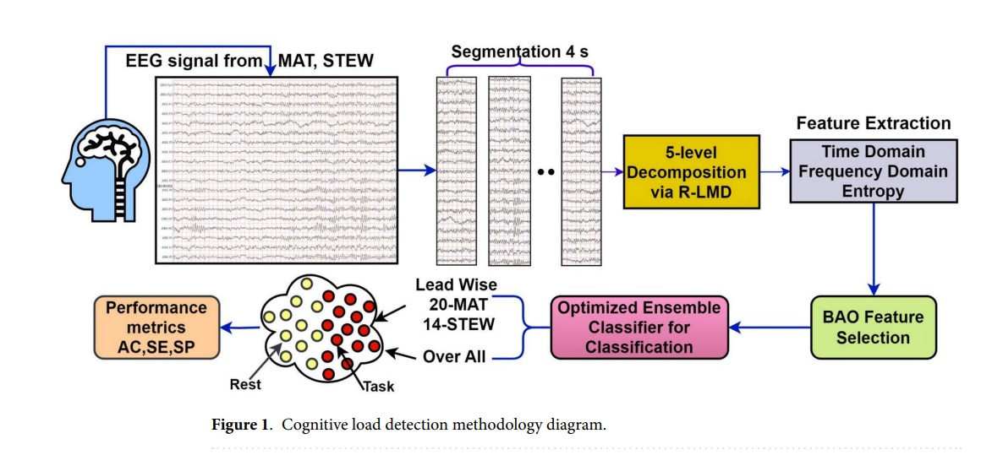
1. Data Preprocessing:
- Removal of Drift (< 1Hz) and Noise (>50 Hz).
- Segmentation
2. R-LMD Decomposition (Robust Local Mean Decomposition)
EEG Signals -> IMF (Intrinsic Mode Functions)
Decomposed into 5 modes
3. Feature Extraction
Time Domain Features : Skewness, Kurtosis
Frequency Domain Features: PSD
Entropy Based Features: Fuzzy Entropy, Renyi Entropy, Differential Entropy
4.BAO Feature Selection (Binary Arithmetic Optimization)
5. 10 folds cross validation
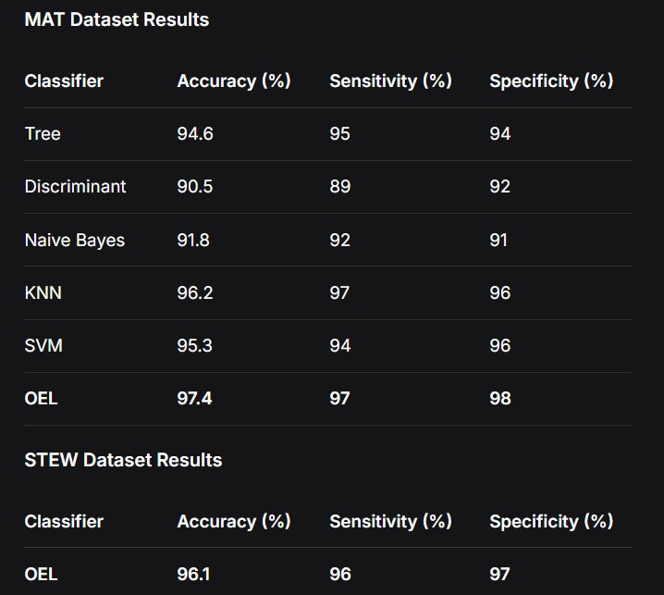

6. LEAD WISE ANALYSIS RESULTS: F3(left frontal region) has showed the best accuracy (94%)
Research Gaps:
- Binary classification only (rest vs. task) - no multi-level workload assessment
- Complex preprocessing pipeline - may be difficult to implement
- Computationally intensive - R-LMD + BAO + OEL requires significant resources
- No cross-task validation - doesn't test generalization across different task types
- No deep learning comparison - only ML classifiers used
- Limited temporal analysis - focuses more on spatial features

Lobe-wise cognitive load detection using empirical Fourier decomposition and optimized machine learning
Authors: Kunamneni Chervitha, Lakhan Dev Sharma
Journal: Frontiers in Physiology (2026)
Datasets: MAT (Mental Arithmetic Task), STEW (Simultaneous Task EEG Workload)
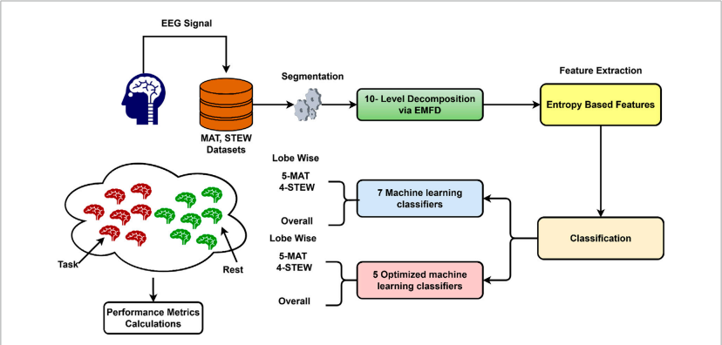
1.Data Preprocessing:
- Filtering
  - For MAT dataset : High-pass filter (0.5 Hz), Low-pass filter (45 Hz)
  - For STEW dataset: High-pass filter (1 Hz), line noise removal, re-referencing using data averaging
- Segmentation : 4-second windows for both datasets
2.Empirical Fourier Mode Decomposition (EMFD)
To decompose EEG signals into intrinsic mode functions (IMFs). Each IMF represents a specific frequency component of brain activity.
EMFD consists of:
- Improved Discrete Sine Transform (IDST) for adaptive frequency segmentation.
- Zero-Phase Filter Bank (ZPFB) to avoid phase distortion.
3.Feature Extraction
Entropy Based Features : Fuzzy(Fe), Approximate(Ae), Differential(De), Renyi’s Entropy(Re), Fractal Dimension Entropy(FDe)
4.Classification and Validation
The extracted features were classified using multiple machine learning algorithms including decision trees, support vector machines, and K-nearest neighbour models.
An Optimizable Ensemble Model (OML) achieved the best performance by combining multiple classifiers and automatically tuning hyperparameters.
10-fold cross-validation was used to evaluate performance and prevent overfitting.
Highest performance observed in Frontal Lobe: 97.8% (MAT), 96.08% (STEW)
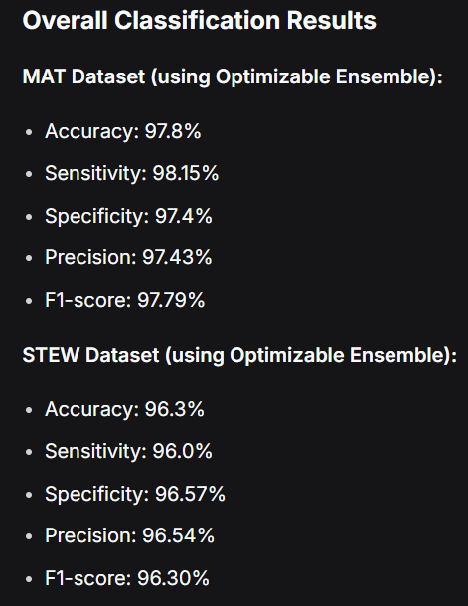

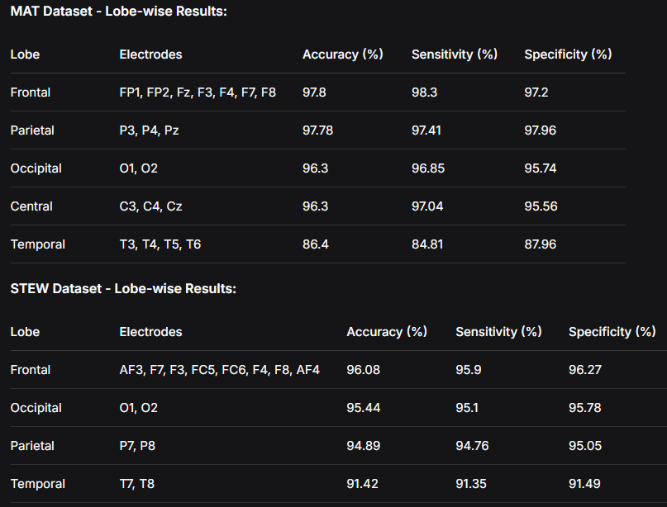
5.Research Gaps
- Binary classification only - no multi-level workload assessment
- Dependence on manually engineered features
- Limited dataset diversity.
- Lack of neurophysiological interpretability
- Complex preprocessing pipeline in existing methods
- Limited spatial analysis in previous work - Lobe-wise analysis provides spatial information about brain activity

