SMART-CAFETERIA-MANAGEMENT AND TOKEN BASED QUEUE OPTIMIZATION

1. Module Details
Module Name: Authentication & Core Utilities (Backend)
Backend Files Covered:
- utils/tokenGenerator.js
- config/db.js
- models/User.js
- middleware/auth.js
- middleware/roleCheck.js
- controllers/authController.js
- routes/auth.js
Prepared By: Ch Sai Rithivik – CB.SC.U4CSE23411

2. Testing Environment
- Language: JavaScript (Node.js)
- Testing Framework: Jest
- Database: MongoDB

3. Files Covered and Test Case Distribution
S.No | File Name | No. of Test Cases
1 | utils/tokenGenerator.js | 3
2 | config/db.js | 2
3 | models/User.js | 5
4 | middleware/auth.js | 4
5 | middleware/roleCheck.js | 3
6 | controllers/authController.js | 5
7 | routes/auth.js | 3
 | Total | 25

File: utils/tokenGenerator.js
- TC_01: Generated correct token for existing bookings → Pass
- TC_02: Generated initial token when booking count is zero → Pass
- TC_03: Generated correct token prefix for different slot → Pass
File: config/db.js
- TC_04: Successfully connected to database with valid URI → Pass
- TC_05: Handled failed database connection correctly → Pass
File: models/User.js
- TC_06: Validation error triggered for missing required fields → Pass
- TC_07: Accepted valid role assignment (admin) → Pass
- TC_08: Rejected invalid role assignment (superadmin) → Pass
- TC_09: Correct password comparison returned true → Pass
- TC_10: Incorrect password comparison returned false → Pass
File: middleware/auth.js
- TC_11: Allowed access with valid token → Pass
- TC_12: Denied access when token is missing → Pass
- TC_13: Denied access for invalid token → Pass
- TC_14: Denied access when user not found → Pass
File: middleware/roleCheck.js
- TC_15: Allowed access for authorized role (admin) → Pass
- TC_16: Denied access when user is not logged in → Pass
- TC_17: Denied access for unauthorized role (student) → Pass
File: controllers/authController.js
- TC_18: Successfully registered new student → Pass
- TC_19: Prevented duplicate email registration → Pass
- TC_20: Successfully logged in with valid credentials → Pass
- TC_21: Rejected login with invalid credentials → Pass
- TC_22: Successfully retrieved authenticated user profile → Pass
File: routes/auth.js
- TC_23: POST /register endpoint returned expected response → Pass
- TC_24: POST /login endpoint returned expected response → Pass
- TC_25: GET /me endpoint returned expected response → Pass

5. Summary
- Total Files Tested: 7
- Total Test Cases Executed: 25
- Total Passed: 25
- Total Failed: 0
- Module Status: Ready
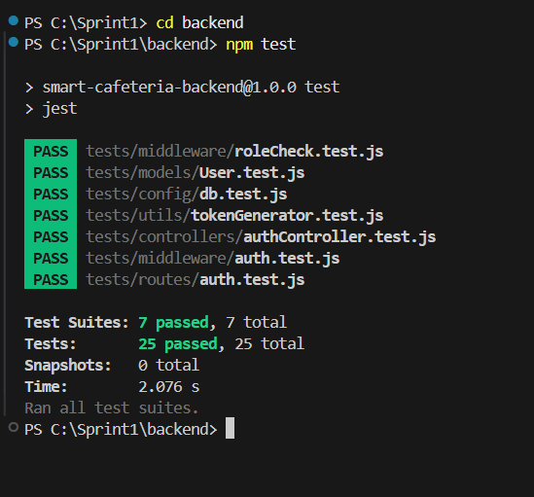

1. Module Details
Module Name: Authentication & Core Services (Frontend)
Frontend Files Covered:
- src/services/api.js
- src/context/AuthContext.js
- src/screens/auth/LoginScreen.js
- src/screens/auth/RegisterScreen.js
Prepared By:
Ch Sai Rithivik – CB.SC.U4CSE23411

2. Testing Environment
- Language: JavaScript (React Native)
- Testing Framework: Jest, React Native Testing Library

3. Files Covered and Test Case Distribution

S.No | File Name | No. of Test Cases
1 | src/services/api.js | 5
2 | src/context/AuthContext.js | 4
3 | src/screens/auth/LoginScreen.js | 4
4 | src/screens/auth/RegisterScreen.js | 5
 | Total | 18

4. Detailed Test Cases
File: src/services/api.js
- TC_01: Successfully calls login endpoint with correct data – Pass
- TC_02: Successfully calls register endpoint with correct data – Pass
- TC_03: Successfully calls create booking endpoint – Pass
- TC_04: Successfully calls get my tokens endpoint – Pass
- TC_05: Successfully fetches all slots (Menu API) – Pass

File: src/context/AuthContext.js
- TC_06: Loads user from secure storage on startup – Pass
- TC_07: Handles login success and stores token – Pass
- TC_08: Handles login failure and sets error message – Pass
- TC_09: Handles logout and clears secure storage – Pass

File: src/screens/auth/LoginScreen.js
- TC_10: Renders all input fields and buttons correctly – Pass
- TC_11: Shows error message when fields are empty – Pass
- TC_12: Calls login function when form is valid – Pass
- TC_13: Navigates to Register screen when link is pressed – Pass

File: src/screens/auth/RegisterScreen.js
- TC_14: Renders all registration fields correctly – Pass
- TC_15: Validates that password and confirm password match – Pass
- TC_16: Calls register function on valid input – Pass
- TC_17: Navigates to Login screen when link is pressed – Pass
- TC_18: Renders navigation elements correctly – Pass

5. Summary
- Total Files Tested: 4
- Total Test Cases Executed: 18
- Total Passed: 18
- Total Failed: 0
- Module Status: Ready

