Smart Cafeteria Demand Forecasting and Token-Based Queue Optimisation System
Technical Project Report
1.Abstract
Traditional cafeteria management systems in educational institutions and corporate campuses often suffer from operational inefficiencies, including long waiting queues, poor demand estimation, and significant food wastage. These challenges arise due to the lack of digital coordination and predictive planning mechanisms.
The Smart Cafeteria Management System is an intelligent full-stack digital platform designed to streamline food ordering, reduce queue congestion, and enable data-driven cafeteria operations. The system integrates a token-based queue management mechanism with Machine Learning–based demand forecasting to enhance both user convenience and operational efficiency.
The proposed system provides a seamless experience for students through mobile-based meal booking and real-time crowd monitoring, while also enabling cafeteria staff to manage orders efficiently through a digital queue system. Additionally, administrators gain access to analytical dashboards that provide insights into cafeteria performance and food consumption patterns.
A dedicated Machine Learning service utilizes XGBoost and Long Short-Term Memory (LSTM), SARIMA models to analyse historical booking data and forecast future meal demand. This predictive capability enables cafeterias to optimize food preparation, significantly reducing food wastage while promoting sustainable dining practices.
2. Introduction
2.1 Problem statement
The following challenges are commonly observed in traditional cafeteria systems:
- Queue Congestion
Manual queue systems create significant congestion during peak hours, leading to long waiting times and inefficient serving processes.
- Food Wastage
Due to the absence of predictive demand analysis, cafeterias often prepare excess food, leading to large amounts of food waste and increased operational costs.
- Lack of Real-Time Information
Students have no visibility into current crowd levels or expected waiting times before visiting the cafeteria.
- Operational Inefficiency
Cafeteria staff lack digital tools to efficiently manage orders, track queue progress, or optimize serving speed during rush hours.
2.2 Objectives of the Project
The primary objectives of the project are:
- To implement a First-In-First-Serve (FIFS) token-based queue system that ensures fair and organized meal allocation.
- To provide real-time crowd monitoring that allows students to check cafeteria occupancy before visiting.
- To integrate Machine Learning-based demand forecasting that predicts future meal demand using historical data.
- To reduce food wastage through intelligent demand prediction and optimized food preparation.
- To provide role-based dashboards tailored for Students, Cafeteria Staff, and Administrators.

3.System Architecture
Frontend:
The Frontend is developed using React Native with Expo. The application provides an intuitive interface for students to browse menus, book meals, and track token status in real time.
The frontend utilizes:
- React Navigation for navigation management
- Context API for state management
- Axios for communication with backend APIs
Backend:
The backend service is built using Node.js and Express.js, functioning as the primary API gateway of the system.
Key responsibilities include:
- User authentication and authorization using JSON Web Tokens (JWT)
- Role-based access control for students, staff, and administrators
- Token generation and queue management
- Meal booking and order tracking
- Communication with the Machine Learning service

Machine Learning Service:
dedicated Python Flask microservice performs demand forecasting operations. The service loads pre-trained machine learning models and generates demand predictions based on historical booking data.
The ML service is responsible for:
- Loading trained .pkl model files
- Processing input data from the backend
- Generating meal demand forecasts
- Returning predictions through REST API endpoints
Database:
The system utilizes MongoDB Atlas, a cloud-based NoSQL database service, for storing application data.
The database stores:
- User profiles
- Menu items
- Meal bookings
- Token status records
- Historical consumption data
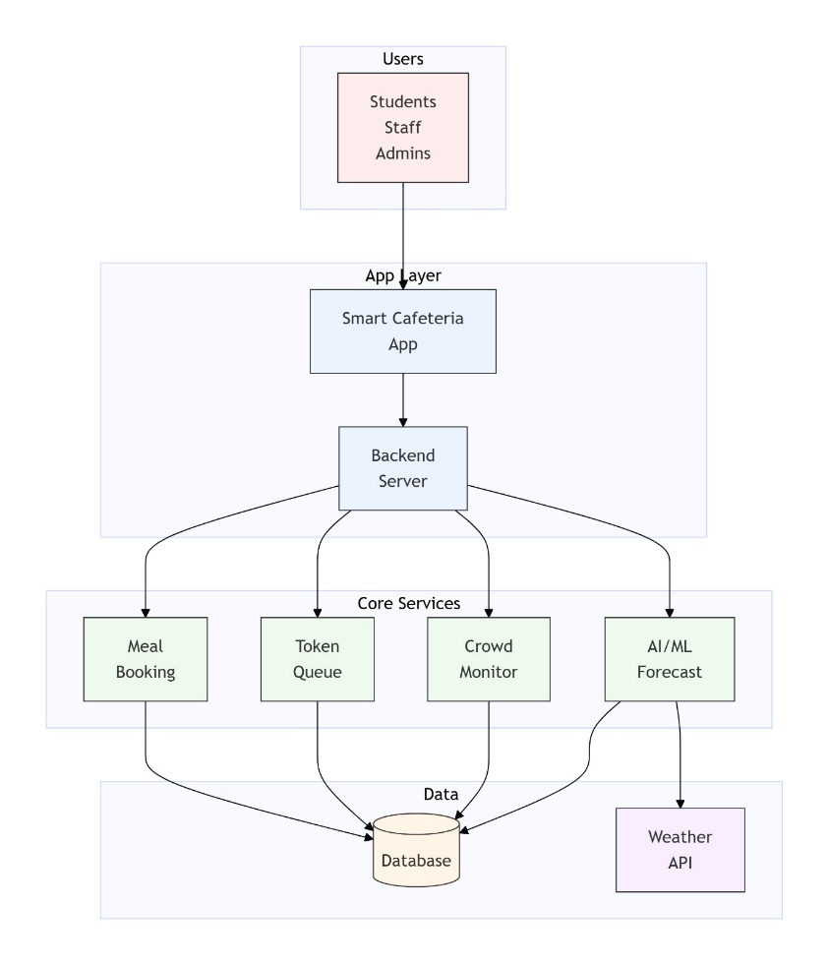
The Mongoose ODM library is used to manage schema definitions and database interactions.

4.Core Modules Description:
4.1 Student Module
The student module provides a user-friendly interface for meal booking and queue monitoring.
- Menu Browsing and Booking
Students can view the daily cafeteria menu, check meal prices, and reserve meals for specific time slots such as breakfast, lunch, or dinner.
- Live Crowd Monitoring
Before booking, students can view the current occupancy level of the cafeteria along with estimated waiting times.
- Token Management
Each booking generates a unique alphanumeric token (e.g., L025 for Lunch). Token statuses update dynamically as the order progresses through stages such as: Pending, Served, Serving, Expired.
4.2 Staff Module
The staff dashboard provides tools for managing the meal preparation and serving process.
- Live Order Queue
Staff members can view a digital queue displaying all pending tokens sorted according to their queue position.
- Order Status Management
Staff can update order status through simple actions such as calling the next token or marking an order as served.
- Serving Speed Optimization
The system analyses current queue length and crowd levels to provide recommendations on optimal serving speed.
4.3 Admin Module
The administrator module provides centralized control and analytical insights for cafeteria management.
- Menu and Inventory Management
Administrators can add, update, or remove menu items and control their availability.
- User Management
Admin users can register and manage both student and staff accounts.
- Analytics Dashboard
The dashboard presents visual analytics including:
  - Daily booking statistics
  - Slot-wise demand trends
  - Revenue analysis
  - Waste reduction metrics
  - Alert history

5.Machine Learning Integration
5.1 Demand Forecasting Models
Three types of ML models were trained:
- XGBoost
- LSTM
- SARIMA
The model with the best performance for the data was choose to make the predictions. The models were evaluated on the standard evaluation metrics.

6. Implementation and Technologies Used
Category | Technologies
Frontend | React Native Expo
Backend | Node.js, Express.js
ML | Python, Flask, Pandas, TensorFlow
Database | MongoDB Atlas
Security | JSON web tokens (JWT), bycryptjs
Deployment | GitHub, Render, Vercel

7.Testing Strategy:
Multiple levels of testing were conducted during the development process to validate both individual components and the overall system behaviour
7.1 Unit Testing
Unit testing was performed to verify the functionality of individual modules and components of the system in isolation. Each module was tested independently to ensure that it performs its intended operations correctly before being integrated with other system components.
7.2 Integration Testing
After validating individual modules through unit testing, integration testing was performed to ensure proper interaction between interconnected components.

7.3 End-to-End Testing
End-to-End (E2E) testing was conducted to validate the complete workflow of the system from the perspective of real users. This testing ensured that all system components worked together correctly in a real operational environment.
7.4 Regression Testing
Regression testing was performed after implementing new features or fixing bugs to ensure that previously working functionalities remained unaffected.
8.CI-CD Pipeline
This project uses GitHub Actions for automated testing and deployment. Pipeline Workflow
- Code Push / Pull Request
- Continuous Integration
  - Backend tests
  - ML service tests
  - Frontend build validation
- Build Stage
  - Install dependencies
  - Run lint checks
- Deployment Stage
  - Backend deployed to Render
  - ML service deployed to Render
  - Frontend deployed to Vercel
9.Deployment
Frontend
Platform: Vercel
https://smart-cafeteria-web-deployment.vercel.app/
Backend
Platform: Render
https://backend-api-rxpg.onrender.com/api
ML Service
Platform: Render
https://ml-service-azkv.onrender.com/

10. Conclusion and Future Scope
10.1 Conclusion
The Smart Cafeteria Management System successfully modernizes traditional cafeteria operations through digital queue management and predictive analytics.
By integrating mobile technology, scalable backend services, and machine learning models, the system enhances user convenience while enabling data-driven decision-making for cafeteria administrators.
The platform demonstrates how intelligent systems can transform everyday campus facilities into efficient and sustainable services.

10.2 Future Enhancements
Several improvements can be implemented in future versions of the system:
- Digital Payment Integration
Integration with campus wallets or UPI payments for seamless in-app meal transactions.
- Nutritional Tracking
Providing nutritional insights such as calorie counts and dietary recommendations based on user meal history.
- AI Based recommendations
AI based personal meal recommendations for every user based on their past history.
- Continuous Model Retraining
Feeding real-world food consumption and waste metrics back into the machine learning pipeline to improve prediction accuracy over time.

