Smart Cafeteria Management - User Documentation
Welcome to the Smart Cafeteria Management System This guide will help you understand how to use our platform to make your dining experience smoother, faster, and more sustainable.
The Smart Cafeteria Management System is a digital platform designed to simplify cafeteria operations and improve the dining experience for students, staff, and administrators. The system allows users to pre-book meals, monitor queue status, and manage orders efficiently through a mobile/web interface.
By integrating real-time updates and token-based queue management, the system reduces waiting time and ensures a smoother cafeteria workflow.

ROLE 1: Student Guide
As a student, the app is your companion for planning and enjoying your meals without the stress of long queues.
1. Booking a Meal
Browse Menu: View the daily specials and regular items with prices and descriptions. Choose a specific time slot for your meal (e.g., Lunch (12.00-18.00)).
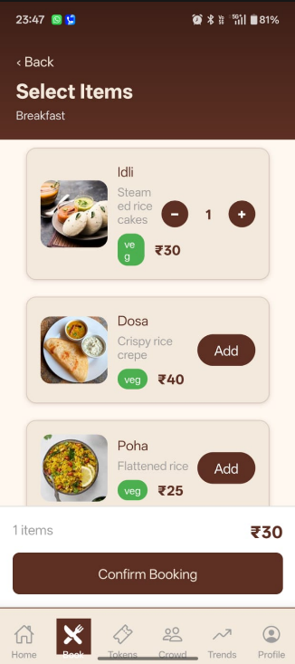

Generate Token: Once you book, you’ll receive a unique Token Number (e.g., L025). This determines your place in the queue.
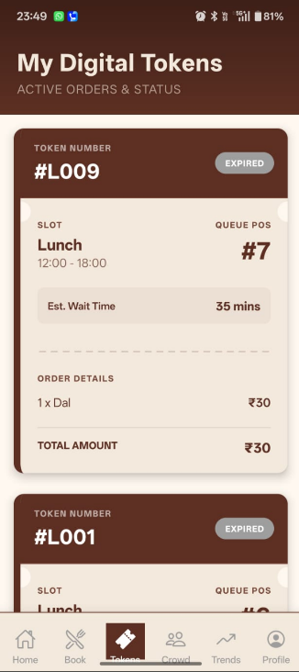

2. Monitoring the Crowd
Crowd Monitor: Check the Crowd Monitor to see how busy the cafeteria is right no
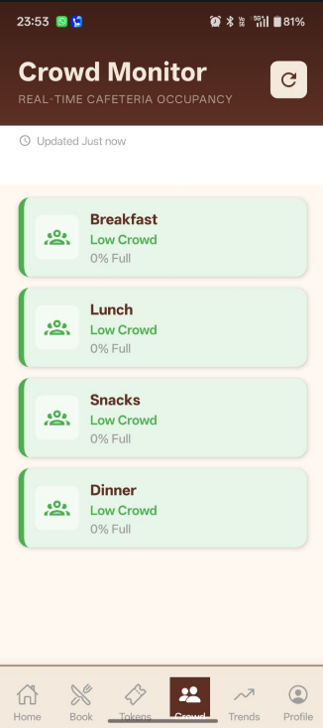

Crowd Patterns: View hourly graphs of the last 7 days to decide the best time to visit.
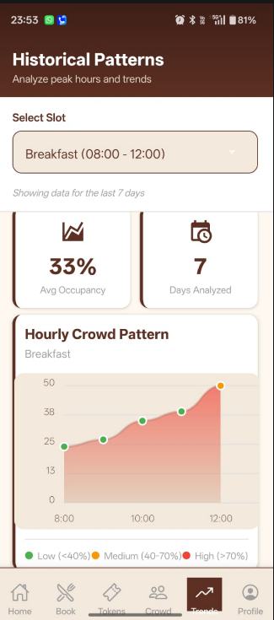

3. Managing Your Orders
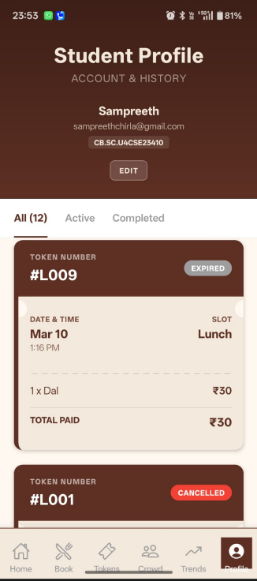
My Tokens: View all your active and past tokens Track your order from "Pending" to “Serving” to "Served".

Profile: Update your registration details and view your dining history.
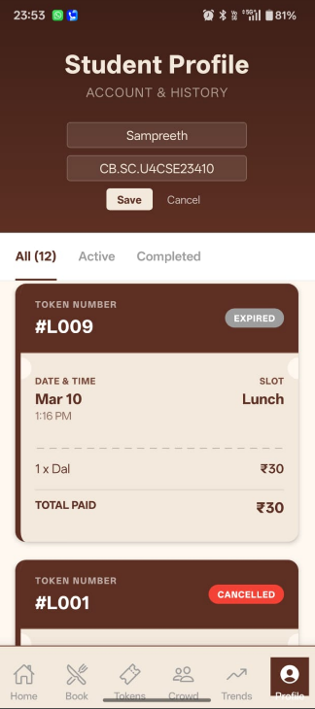

Role 2: Cafeteria Staff Guide
The staff module helps you manage the kitchen and serving counter efficiently using real-time demand data.
1. Queue Management
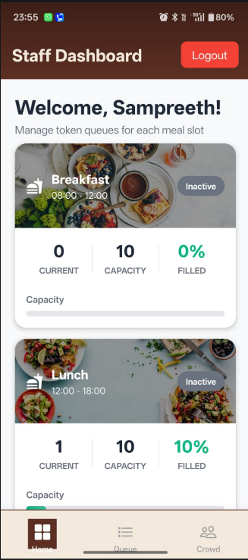
Dashboard: View the list of active tokens for the current slot.

Call Next: Tap "Call Next Token" to notify the next student in line.
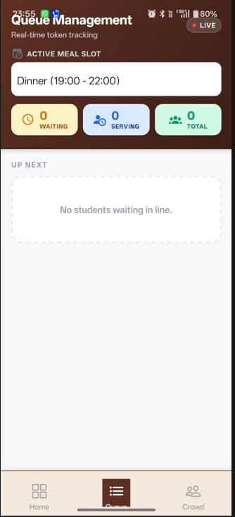

2. Operational Insights
Crowd Alerts: Receive notifications if the cafeteria reaches peak capacity. View recommendations on how fast to process orders based on the incoming crowd
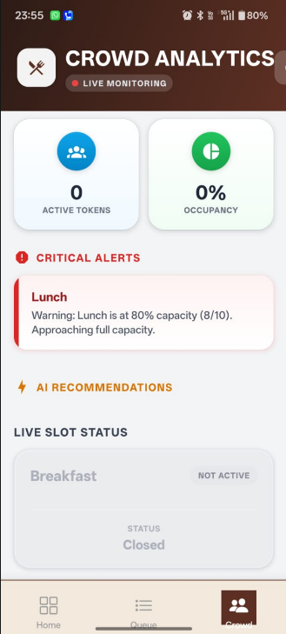

Role 3: Administrator Guide

Administrators have full oversight of the system to ensure smooth operations across the board.
1. Menu & Staff Management
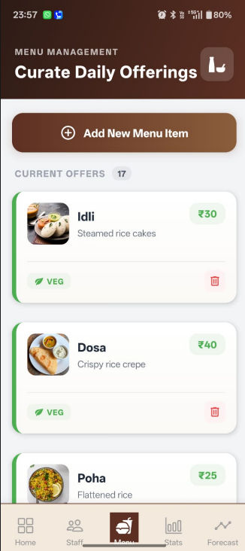
Menu Control: Add new items, update prices, change availability, or upload appetizing images.

Staff Registration: Create and manage accounts for new cafeteria personnel.
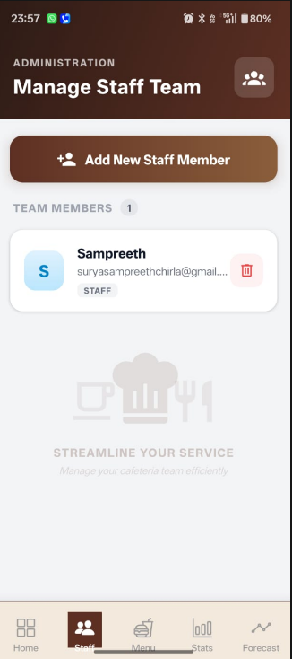

2. Analytics Dashboard
Revenue Tracking: Monitor daily revenue.
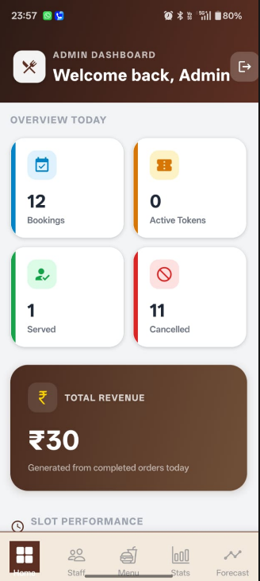

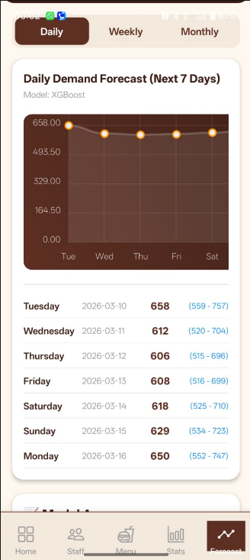
Demand Forecasting: View AI-generated predictions for the next 7 days to plan food preparation and reduce waste.

3. Live Crowd Alerts and System Pulse
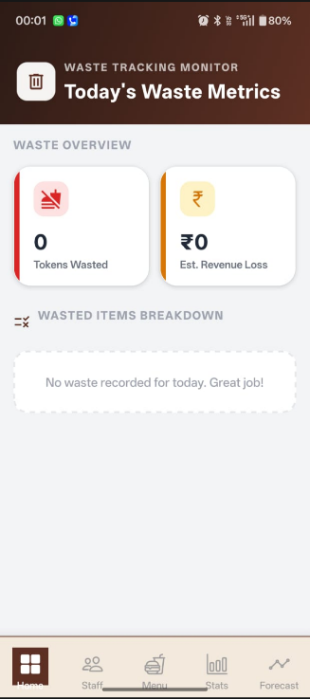
Alerts – See overcrowding alerts and mark them as resolved after taking action.

4.Waste and Sustainability Tracking Reports
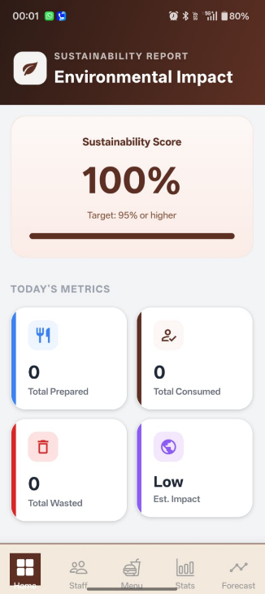
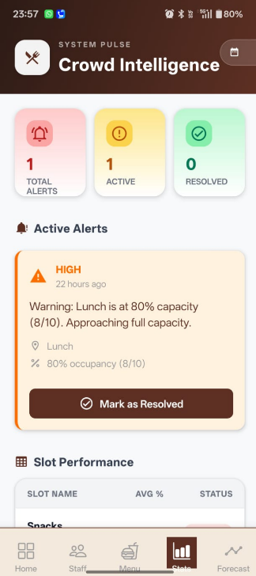
Sustainability Reports: Access detailed reports on waste reduction and resource efficiency based on demand accuracy.

Login & Registration:
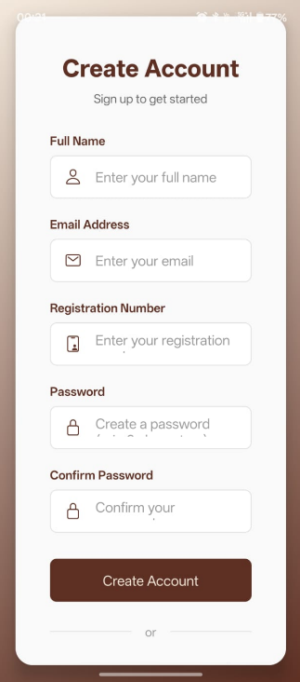
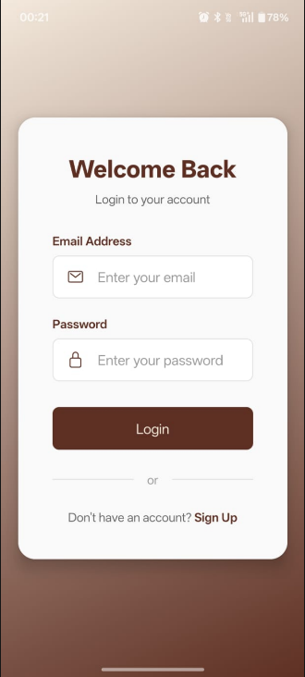

Frequently Asked Questions (FAQ)

1. How do I register as a student?
Click the "Register" link on the login screen, fill in your name, email, registration number, and password. You will be automatically logged in upon successful registration.
2. My token says "Expired". What does this mean?
Tokens are strictly bound to their selected time slots. If you do not collect your meal before the slot ends, the token expires to allow the next slot's queue to begin.
3. How is the "Crowd Level" calculated?
The crowd level is determined by real-time snapshots of active tokens and occupancy rates, updated every 2 minutes by our background tracking service.
4. Can I change my time slot after booking?
You cannot change a slot directly. You must cancel your existing booking (if not yet "Preparing") and create a new booking for the desired time slot.
5. How do I know when my food is ready?
Keep an eye on the "My Tokens" screen. The status will update from "Pending" to "Preparing" and finally to "Ready" when it's time to head to the counter.
6. Can I see my previous bookings?
Yes, your full booking history is available in the "Profile" section, showing dates, items ordered, and token statuses.
9. What happens if the cafeteria reaches "Peak Capacity"?
The system will notify staff to increase serving speed. The system will trigger over Crowding alerts for the admin and the staff.
10. Is the app available on Mobile?
Yes! Our app is built with Expo, Android, and Web browsers. You can use the web version or the mobile app via the APK.

11. Can I book a meal for a friend using my account?
The system is designed for individual use to maintain queue integrity. Each student should book through their own account to ensure they receive a unique token for their specific meal. But your friend can go to the canteen with your token.

12. What happens if I miss my time slot?
If you miss your slot, your token will be marked as "Expired". You will need to make a new booking for an available future slot, provided the cafeteria is still serving.
13. Are there different tokens for different meal types?
Yes. For example, breakfast tokens start with 'B' (e.g., B005), lunch with 'L' (e.g., L012), and dinner with 'D' (e.g., D001). This helps staff identify the order type instantly.
14. How does the "Serving Speed Recommendation" work for staff?
The system analyses the current number of pending tokens against the available cafeteria capacity and recommends an optimal processing rate.
15. Is my data secure in the app?
Yes. We use industry-standard JWT encryption for all user sessions and bcrypt for secure password hashing. Your registration details are kept confidential and used only for cafeteria operations.
16. Can I use the app without an internet connection?
An active internet connection is required to sync your bookings with the server and receive live crowd updates. If you lose connection, your previously generated token may still be viewable if saved.
17. Where can I find the Sustainability Reports?
Sustainability and waste tracking reports are accessible only to the Administrator through the main dashboard. They provide insights into how effectively demand forecasting is reducing food waste.

---
*Thank you for using Smart Cafeteria. Let's make dining smarter! *

