Smart Cafeteria Management – Testing Document

1.Integration Testing:
Date: 2026-03-04T06:02:15.718Z
Duration: 15.16s
Server: http://localhost:5000
Section 1: System components Identifies
Backend stack:
- Runtime: Node.js + Express.js
- Database: MongoDB (Mongoose ODM) via Atlas
- Authentication: JWT (jsonwebtoken) + bcryptjs
Frontend Stack:
- Framework: React Native (Expo)
- HTTPClient: Axios
Database Models:
- User
- Booking
- Slot
- slotTemplates
- MenuItem
- Menu
- CrowdData
- CrowdPrediction
- AlertLog
- DemandForecast
SECTION 2: INTEGRATION POINTS
- Auth -> User Model -> JWT Middleware
- Frontend -> Axios -> Express Routes
- Routes -> Controllers -> MongoDB
- Role Middleware -> Protected APIs

SECTION 3: TEST EXECUTION RESULTS
Summary:
- Total Tests: 70
- Passed:70
- Failed:0
- PassRate:100%
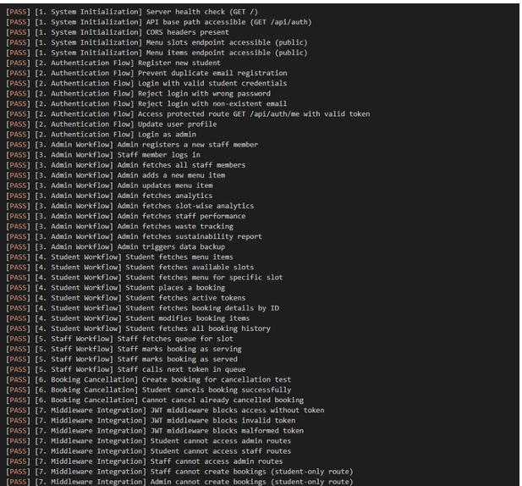
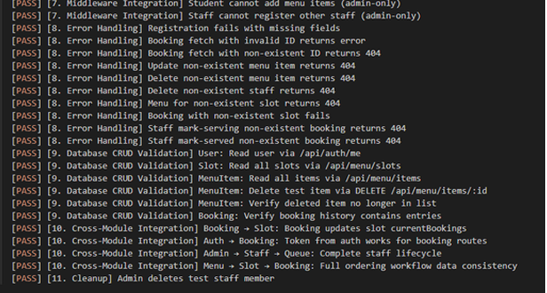

2.END to END Testing

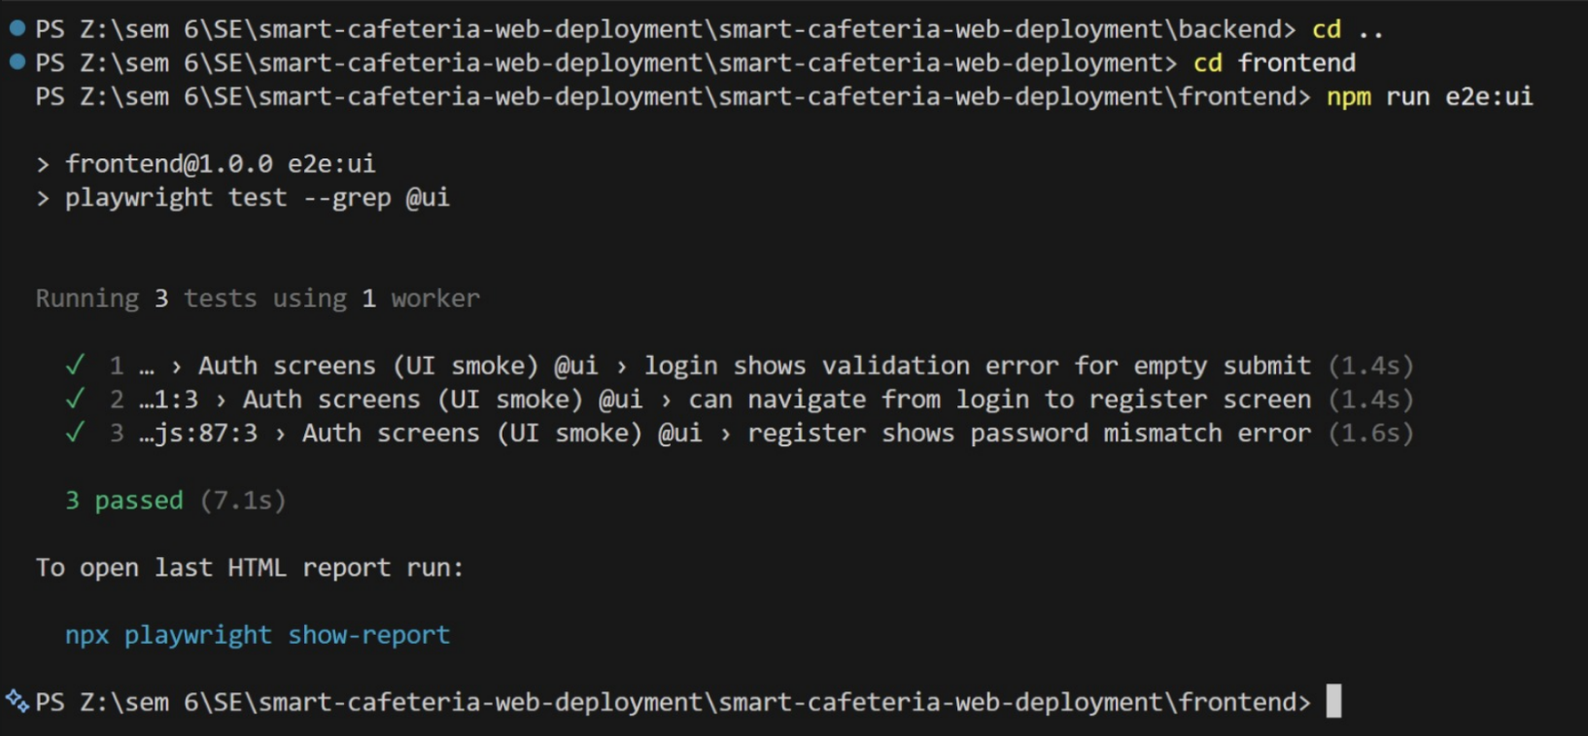

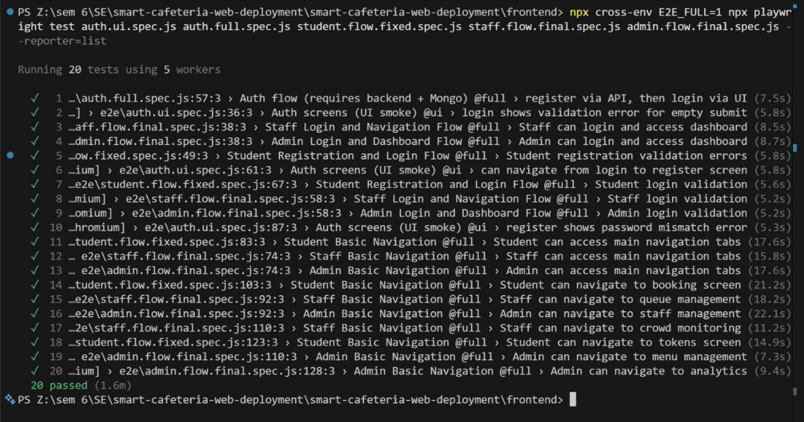

### Environment Setup

```bash
# Navigate to frontend directory
cd frontend

# Install dependencies
npm install

# Install Playwright browsers
npx playwright install
```

### Running Tests

#### Quick Smoke Tests (UI Only)
Tests authentication UI without backend:
```bash
npm run e2e:ui
```

#### Full End-to-End Tests
Complete tests with backend integration:
```bash
npm run e2e:full
```

#### Specific Test Suites
```bash
# Run only student flow tests
npx playwright test student.flow.spec.js

# Run only authentication tests
npx playwright test auth.*.spec.js

# Run tests with specific tags
npx playwright test --grep @ui
npx playwright test --grep @full
```

#### Debug Mode
Run tests in headed browser for debugging:
```bash
npm run e2e:headed
# or
npm run e2e:debug
```

### Environment Variables

Configure test environment with these variables:

```bash
# Web application URL
E2E_WEB_BASE_URL=http://localhost:8081

# API base URL
E2E_API_BASE_URL=http://localhost:5000/api

# Run full tests (backend required)
E2E_FULL=1

3.Regression Testing
Date: 2026-03-10T18:13:55.000Z
Server: http://localhost:5000
ML Service: http://localhost:5001

Frontend Stack:
- Framework: React Native (Expo)
- HTTP Client: Axios
- State Mgmt: React Context (AuthContext)
- Config: EXPO_PUBLIC_API_URL -> /api
Backend Stack:
- Runtime: Node.js + Express.js
- Database: MongoDB (Mongoose ODM) via Atlas
- Authentication: JWT (jsonwebtoken) + bcryptjs
- Validation: express-validator
- CORS: cors middleware enabled
ML Service Stack:
- Runtime: Python 3.13 + Flask ML
- Models: XGBoost, SARIMA, LSTM (TensorFlow)
- Libraries: scikit-learn, pandas, numpy, joblib Database
Models: -
- User
- Booking
- Slot
- SlotTemplate
- MenuItem
- Menu
- CrowdData
- CrowdPrediction
- AlertLog
- DemandForecast
