**CMAKE**

add.cpp

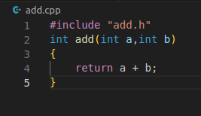

add.h

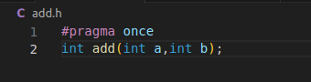

main.cpp

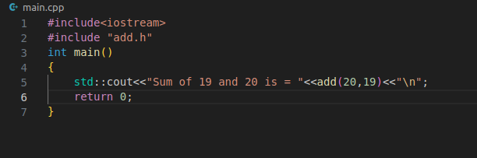

CMakeLists.txt

