Customer Behavior Analysis

Alfido Tech Data Analyst Internship
Name: Musini Eswara Surya Teja
Project: Customer Behavior Analysis
GitHub Repository:
https://github.com/SuryaTeja525/Customer-Behavior-Analysis
Dataset:
Customer Behavior Analysis Dataset (Kaggle)

Executive Summary
This project analyzes customer purchasing behavior using Python, Pandas, Matplotlib, and Seaborn. The dataset was cleaned and explored through Exploratory Data Analysis (EDA) to understand customer demographics, purchasing patterns, payment preferences, product performance, returns, and customer churn.
RFM (Recency, Frequency, Monetary) Analysis was performed to segment customers into High Value, Loyal, Regular, and At Risk groups. The insights generated from this analysis help businesses improve customer retention, optimize marketing strategies, and increase overall revenue.

Tools & Technologies
- Python
- Pandas
- NumPy
- Matplotlib
- Seaborn
- Jupyter Notebook
- GitHub

Visualizations

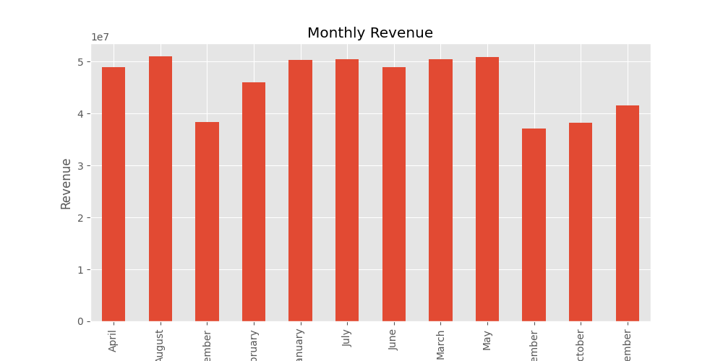

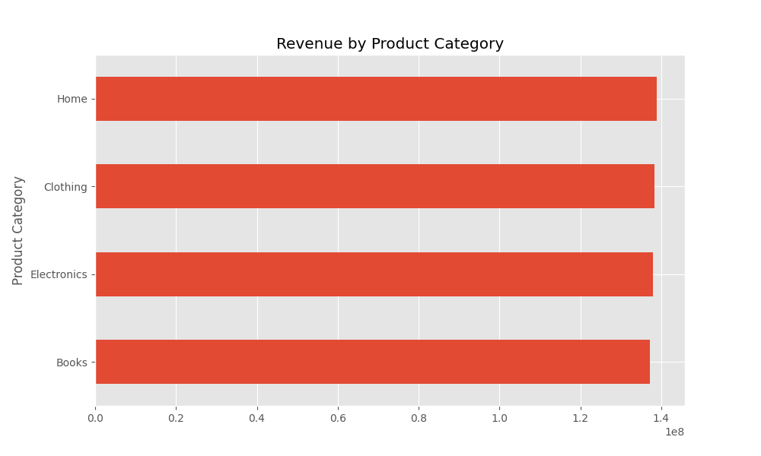

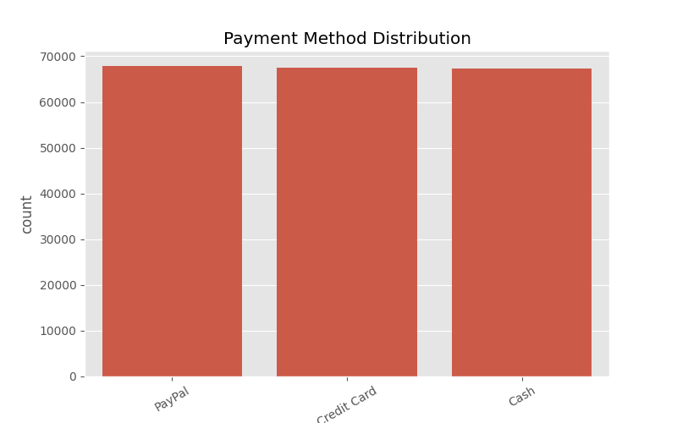

Key Business Insights
- High-value customers contribute significantly to overall revenue.
- Monthly revenue trends reveal seasonal purchasing patterns.
- Customer segmentation helps identify loyal and at-risk customers.
- Product category analysis highlights top-performing products.

Code & Project Links
GitHub Repository:
https://github.com/SuryaTeja525/Customer-Behavior-Analysis
Dataset:
https://www.kaggle.com/datasets/bhanupratapbiswas/customer-behavior-analysis

