SUPERSTORE SALES PERFORMANCE ANALYSIS

Name: Musini Eswara Surya Teja
Project: Sales Performace Analysis
Organization: Alfido Tech Data Analyst Internship

Objective
The objective of this project is to analyze Superstore sales data to understand business performance across regions, categories, products, and time. The analysis focuses on identifying sales trends, top-performing products, and seasonal patterns to support data-driven decision making.

EXECUTIVE SUMMARY
This project presents a comprehensive analysis of Superstore sales data to understand business performance across regions, categories, products, and time periods. The objective was to identify key sales trends, top-performing segments, and seasonal patterns to support data-driven decision-making.
The analysis was performed using Python libraries such as Pandas, Matplotlib, and Seaborn. The dataset included order-level sales information such as Order Date, Region, Category, Sub-Category, Product Name, and Sales values. Since profit-related data was not available, the study focused entirely on sales-based performance metrics.
Key performance indicators such as Total Sales, Total Orders, and Average Order Value were calculated to evaluate overall business performance. Visual analysis revealed that sales vary significantly across regions and categories, with certain sub-categories contributing disproportionately to revenue. Seasonal trends were also observed, indicating fluctuations in monthly sales patterns.
The study also identified top-performing products and regions, highlighting areas that drive the majority of revenue. Based on the analysis, five tactical recommendations were provided, including focusing on high-performing categories, improving weak regions, optimizing discount strategies, strengthening inventory planning, and leveraging seasonal trends.
Overall, this project demonstrates how data analysis can transform raw sales data into meaningful business insights that can help improve strategic decision-making and operational efficiency.

Dataset Overview
The dataset contains information about orders, customers, products, regions, and sales. Key fields include Order_Date, Region, Category, Sub_Category, Product_Name, and Sales.
Note: Profit data is not available; therefore, analysis is based only on Sales metrics.

Key Performance Indicators (KPIs)
- Total Sales (Revenue)
- Total Orders
- Average Order Value (AOV)
These KPIs help measure overall business performance and customer purchasing behavior.

Visualizations
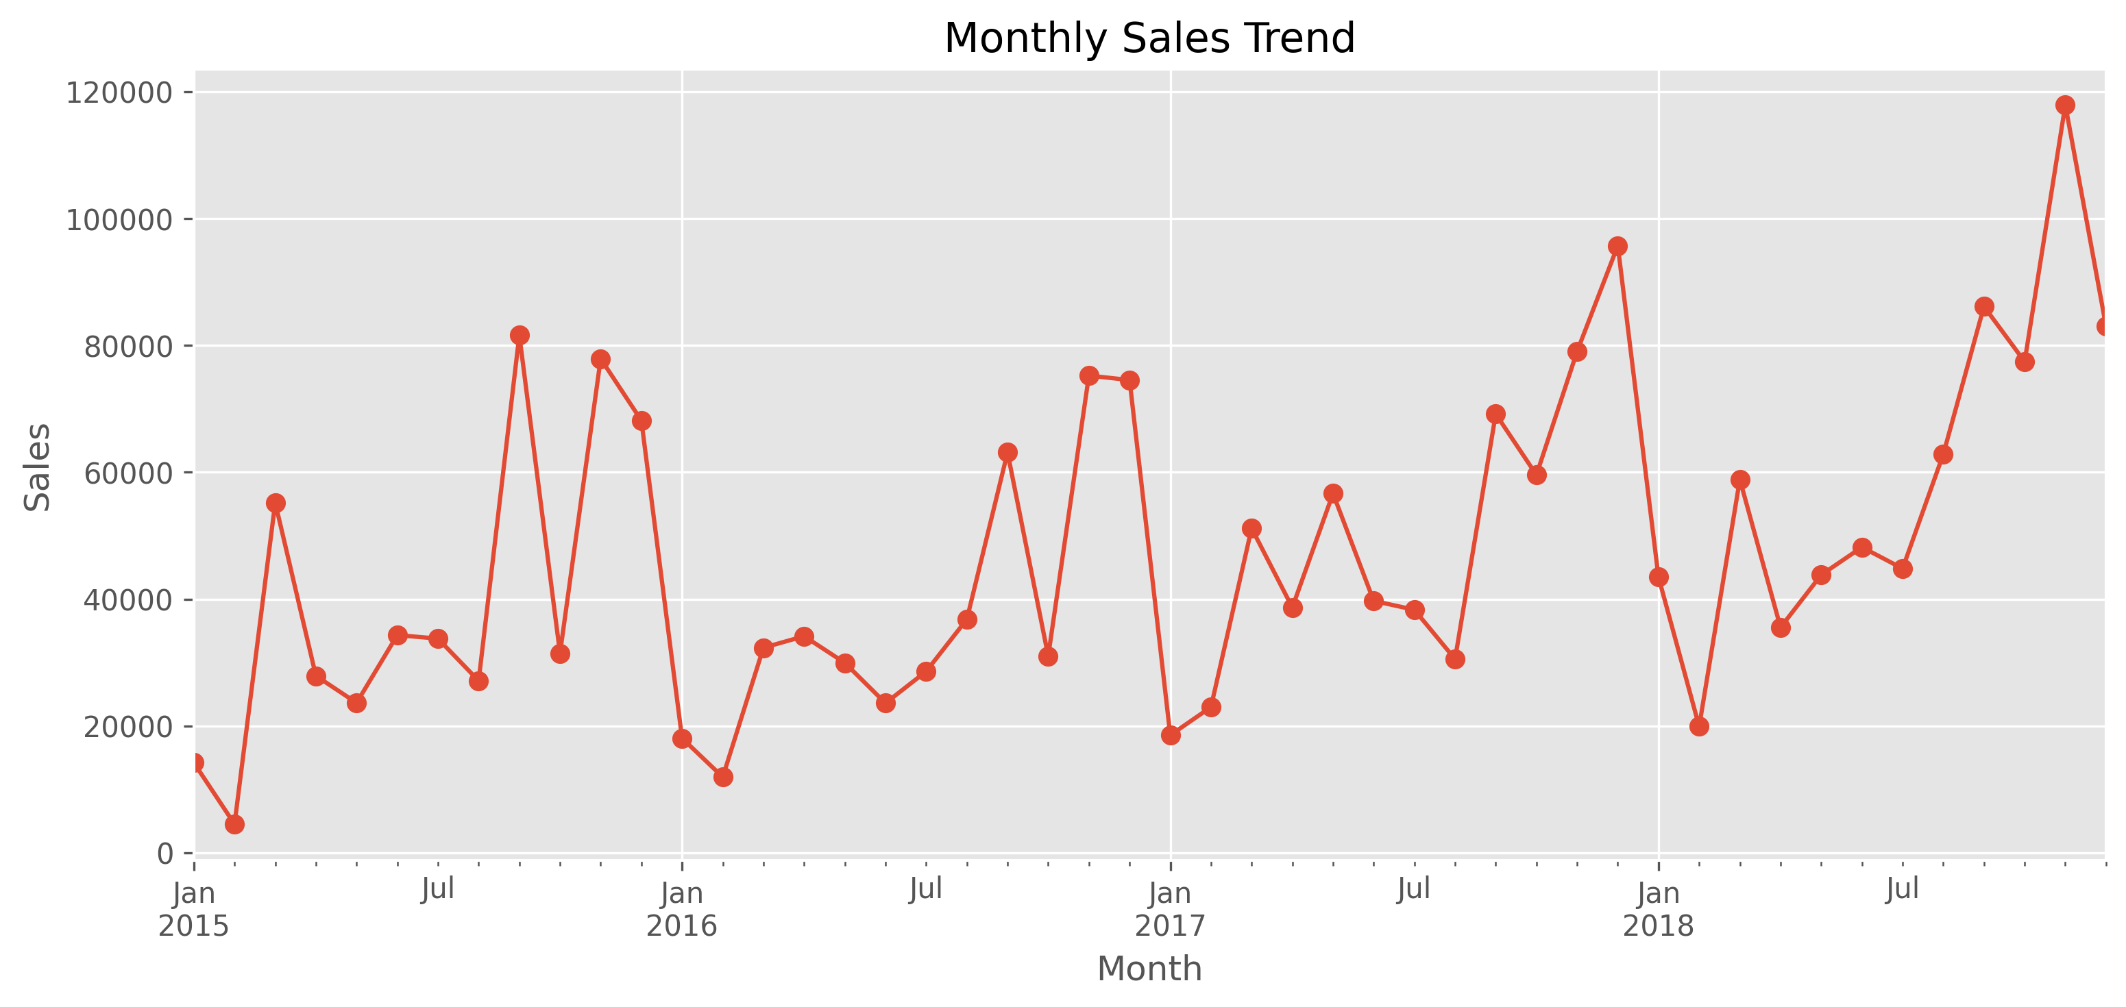
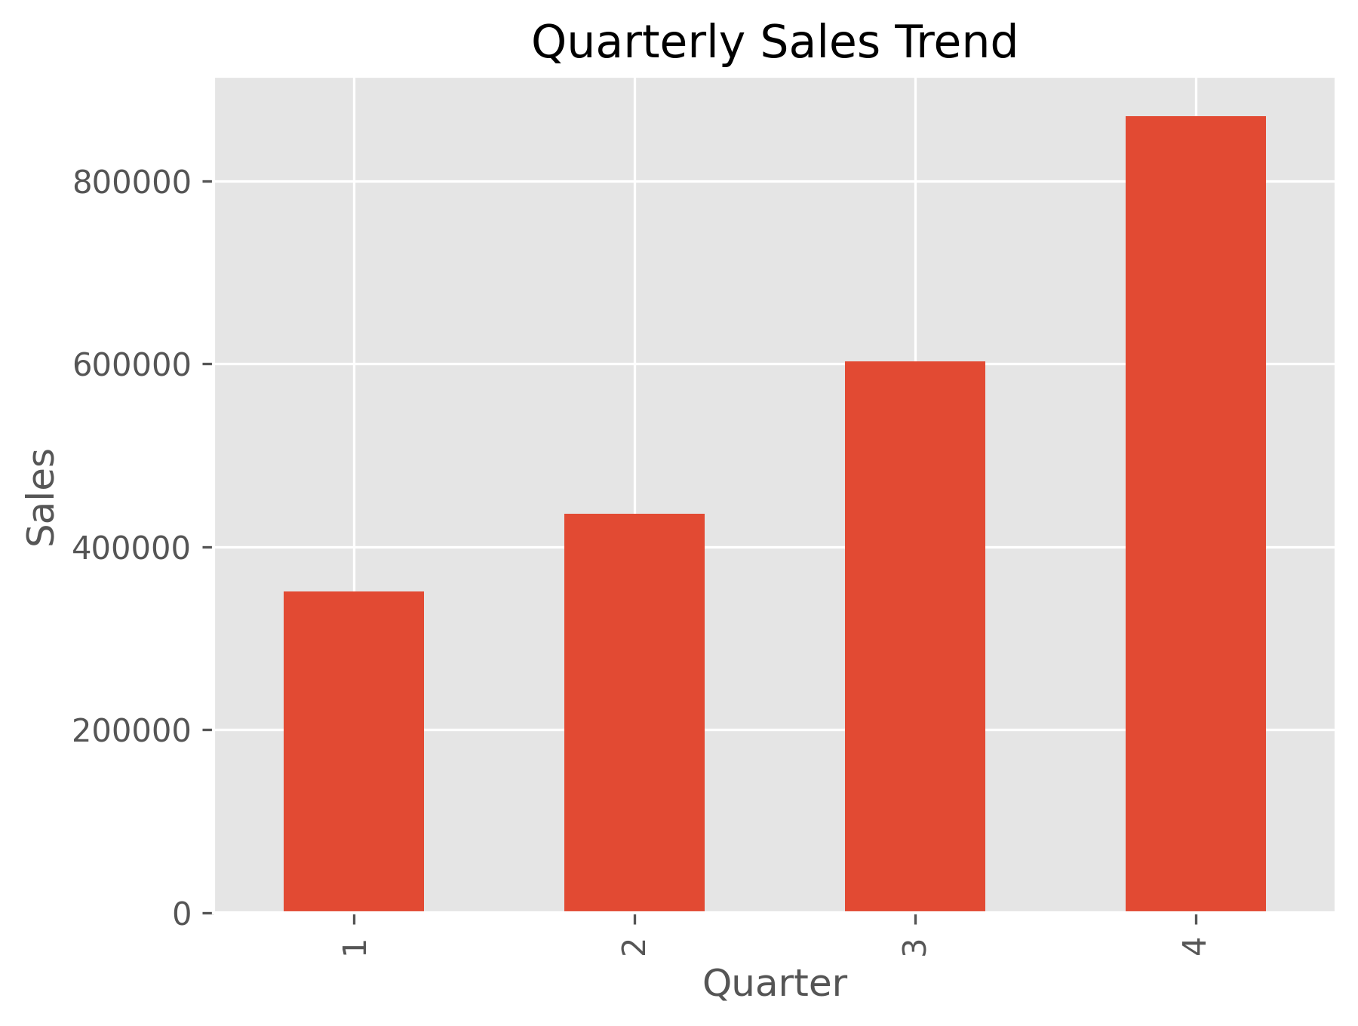

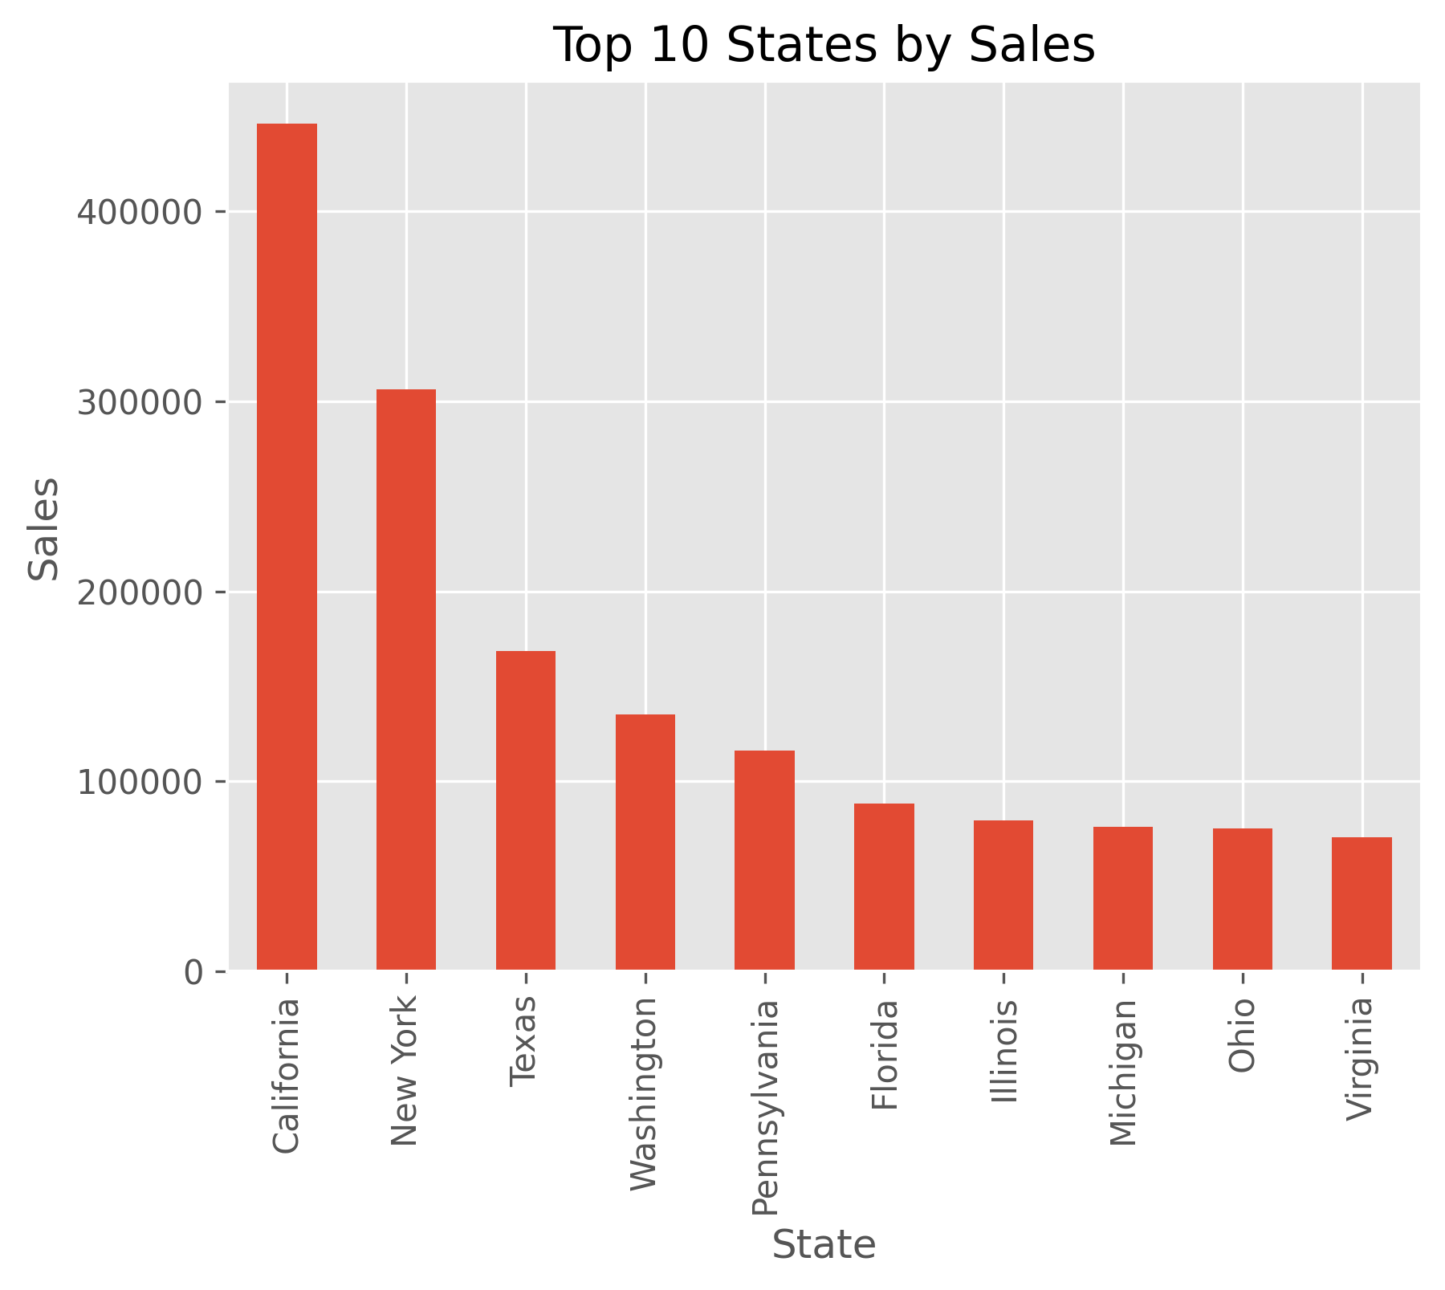

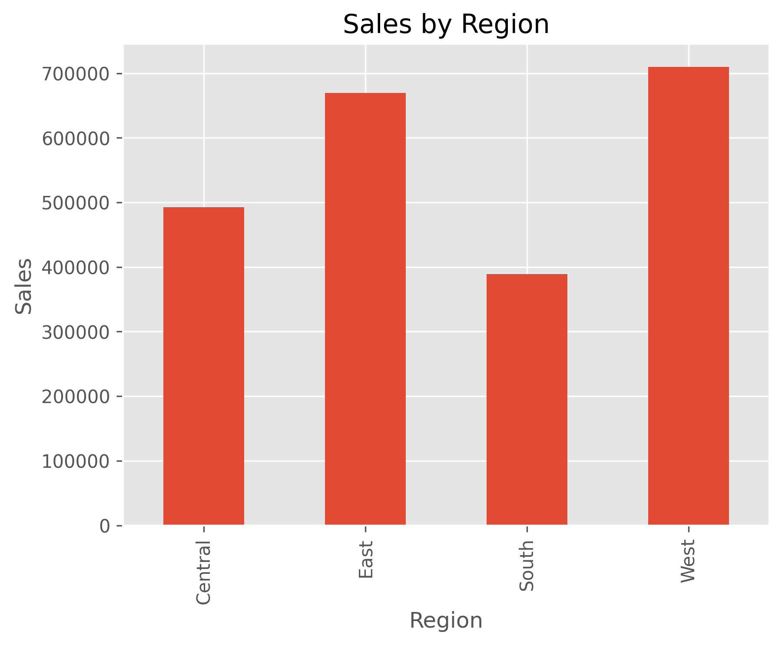

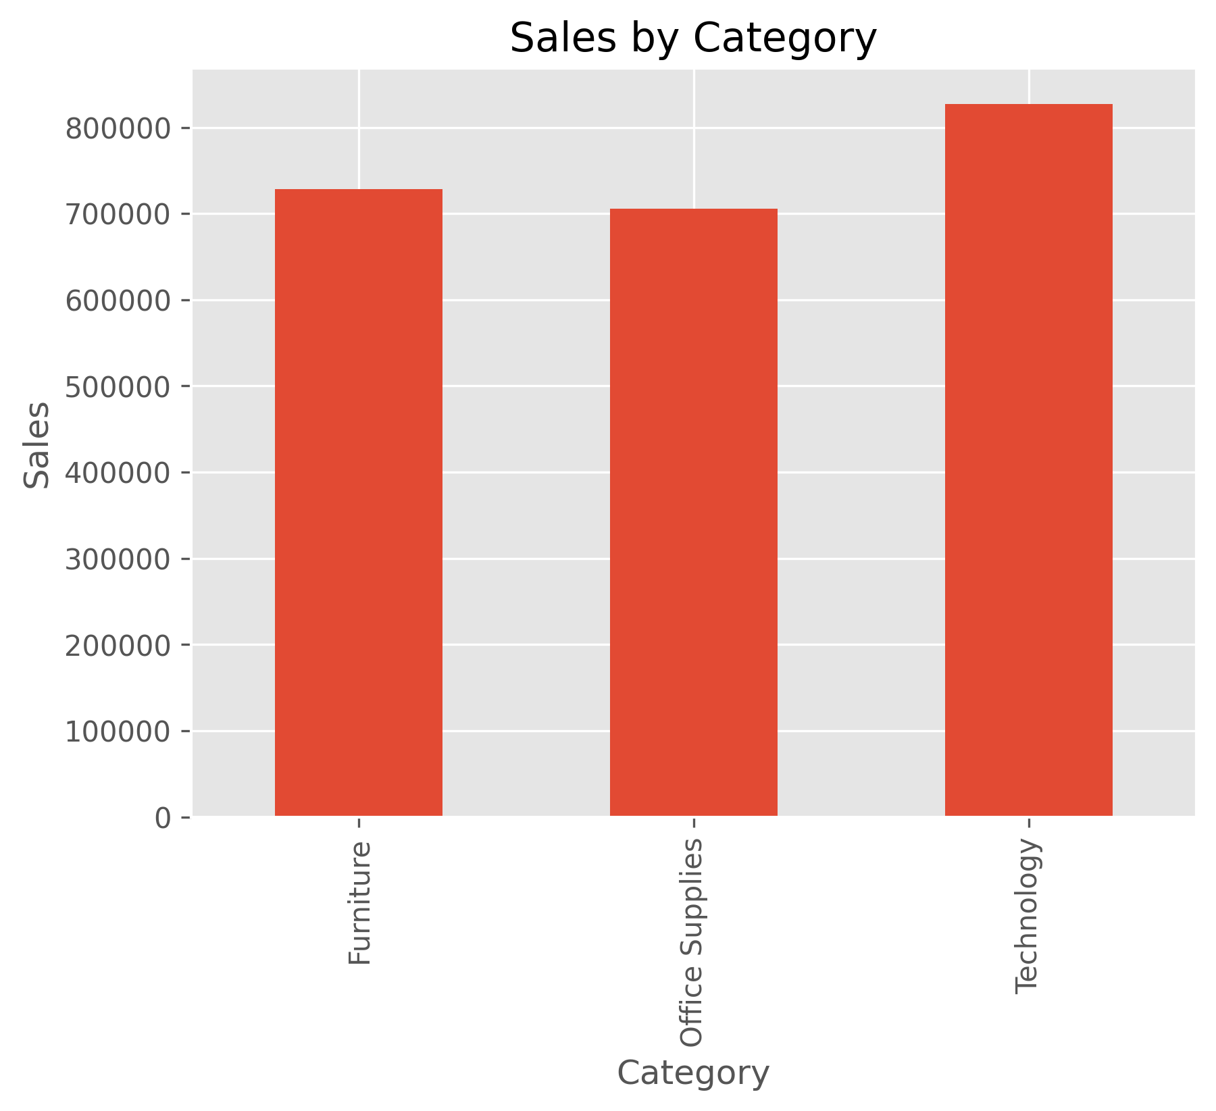

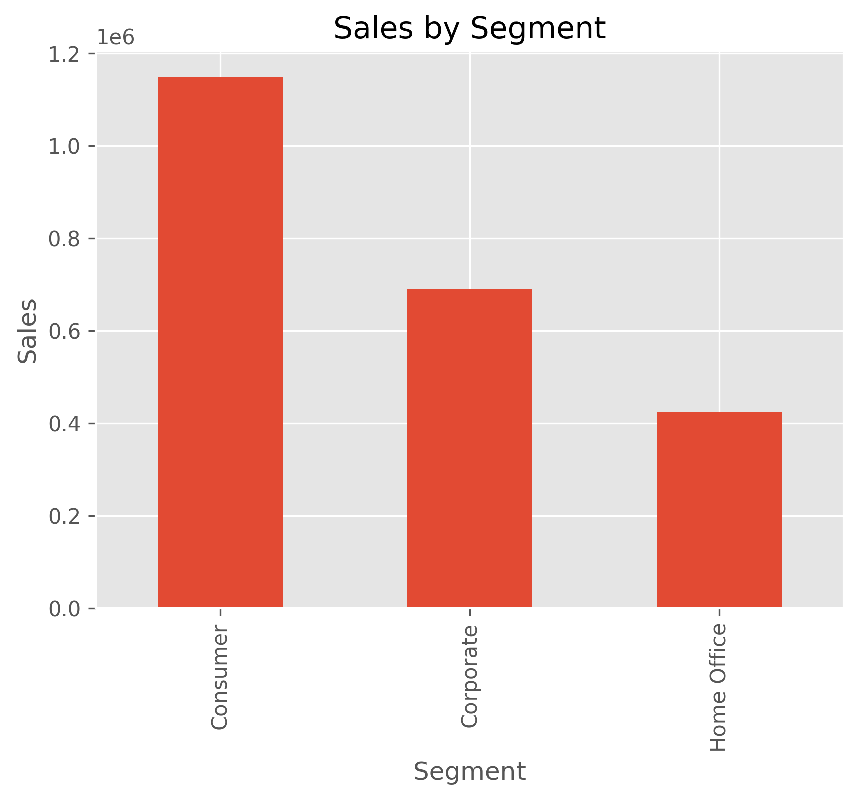

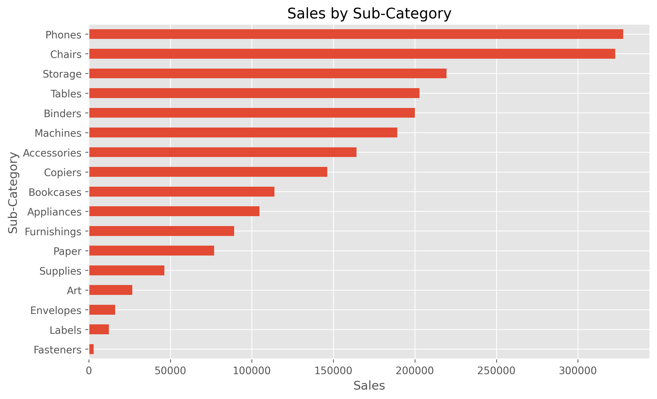

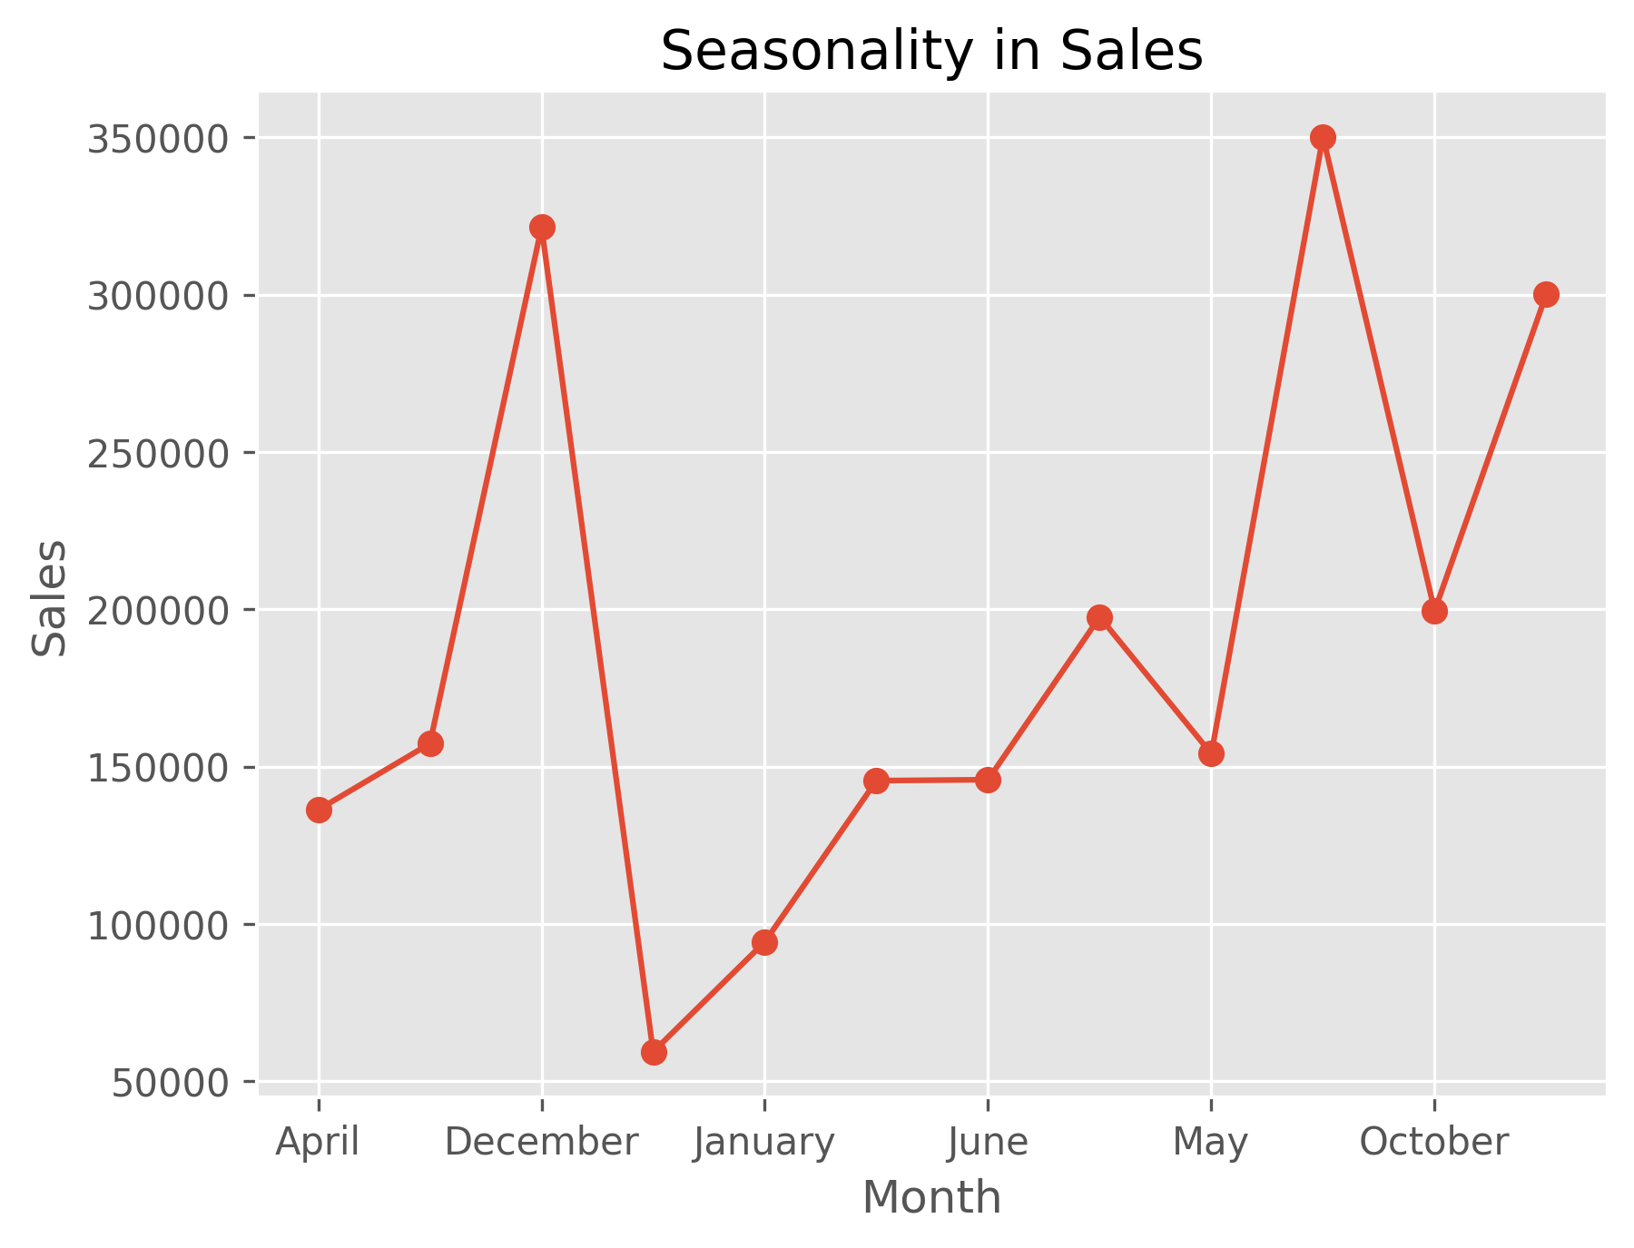

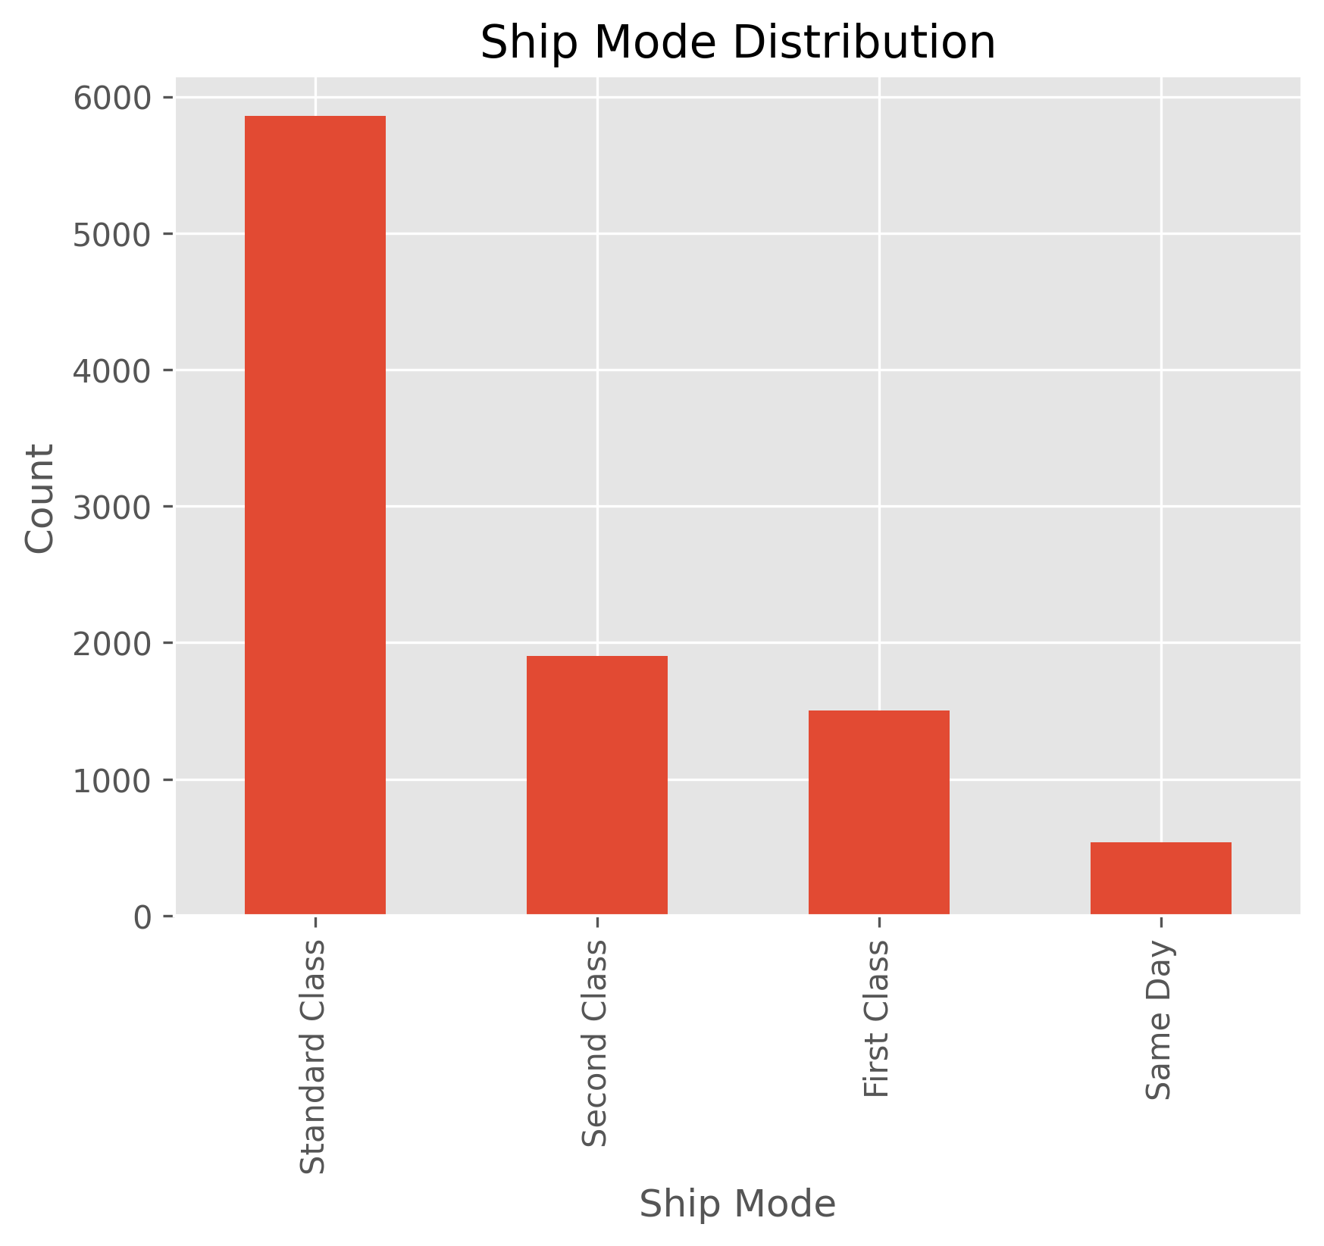

Key Insights
- Sales vary significantly across different regions
- Certain categories contribute most to total revenue
- Sub-categories like Phones and Chairs are top performers
- Monthly sales show clear seasonal trends
- Discounts influence sales but require optimization

Best Performing Areas
- High-performing regions contribute major revenue share
- A few products generate majority of total sales
- Category-wise performance is uneven, with some dominating overall sales

5 Tactical Improvements
- Focus on high-performing categories to increase revenue
- Improve marketing in low-performing regions
- Optimize discount strategies to maximize profitability
- Strengthen inventory for best-selling products
- Use seasonal trends for better planning and forecasting

Project Links
GitHub Repository:
https://github.com/SuryaTeja525/Sales_Performance_Analysis
Dataset:
https://www.kaggle.com/datasets/bhanupratapbiswas/superstore-sales

Conclusion
The analysis provides valuable insights into sales performance across regions, categories, and time periods. These insights can help improve sales strategy, optimize operations, and support better business decisions.

