
A
Project report on
DIWALI EVENT REGISTRATION
Submitted in fulfilment of the award of the
Bachelor of Technology
in
Department of Computer Science and Engineering
By
Nimmagadda Suryachandra
Konka Sree Rakshitha
251U1R2059
251U1R1046
Under the esteemed guidance of
Dr.V.Aruna
Dean -School of Engineering & Professor, Department of CSE
DEPARTMENT OF COMPUTER SCIENCE AND ENGINEERING
SCHOOL OF ENGINEERING

AURORA HIGHER EDUCATION AND RESEARCH ACEDAMY
(Deemed to be University)
Parvathapur, Uppal, Hyderabad-500 098
(2023-24)

CERTIFICATE
This is to certify that the project report entitled “DIWALI EVENT REGISTRATION” has been submitted by “Nimmagadda Suryachandra, Konka Sree Rakshitha” holding roll no ”251U1R2059, 251U1R2065 ” in fulfilment for project in PYTHON PROGRAMMING is a record of bonafide work carried out by them under my guidance and supervision.

 | Dr.V.Harsha
Date: | Professor
Hyderabad | Department of CSE

Acknowledgement
We profoundly grateful to express our deep sense of gratitude and respect towards our guide, Dr.V.Harsha, Department of CSE, School of Engineering, Aurora Deemed-to-be University, Parvathapur, for her excellent guidance right from selection of project and her valuable suggestions throughout the project work. We are thankful to him for giving us the opportunity to work in the laboratory at any time. His constant encouragement and support has been the cause for us to succeed in completing this project in university. He has given us tremendous support on both the technical and moral front.
We are thankful to Dr.V.Harsha, for their valuable suggestions and support in completion of the project.
We are thankful to Dr.B.Viswanadham, Registrar, Dr. Srilatha Chepure, Vice Chancellor, AURORA UNIVERSITY for the support during and till the completion of the project.
We extend our thanks to University Management for their support and encouragement for the success of our project.

ABSTRACT
This project focuses on creating a simple and well-structured event management website using only HTML and CSS. The idea is to design a website that can clearly display event details, allow users to explore different activities, and complete registration in an easy and comfortable way. Today, almost every event needs an online presence, and even a basic website can help people access information without confusion. With this thought, the project “Diwali Bash 2025 – Event Management Website” was developed as a small but complete demonstration of how front-end development can support event handling.
The website contains four connected pages: a Home Page, an Events Page, a Registration Page, and a Thank You Page. Each page plays a specific role. The Home Page works like a welcoming digital invitation with the festival design, date, and venue. The Events Page displays the list of activities using attractive cards with images and hover effects so users can see everything clearly. The Registration Page includes a simple form where participants can enter their details, and after submitting, the Thank You Page confirms successful registration. These pages together show the working flow of a real event registration system even without using backend programming.
The project mainly uses clean HTML for structure and CSS for styling, colors, gradients, spacing, layout, animations, and effects. Even though no advanced tools were used, the website still provides a neat and modern look. Warm colors like yellow and orange are used to match the Diwali theme, giving a festive and positive appearance. The intention was to prove that with basic web skills, students can create a working mini-project that looks good and functions well.
Finally, the website is hosted using GitHub Pages so that it can be accessed directly from a link without installing anything. Hosting the project online also shows how real websites are shared and viewed by users. This makes the project more practical and complete. Overall, the work demonstrates how basic web technologies can be used to create a functional event website that is simple, user-friendly, and useful for real-life situations.

Table of contents
S. No. | Title | Page No.
1 | Introduction | 6
2 | Literature Review | 7
3 | Methodology | 8-9
4 | Design & Requirements | 10
5 | Implementation | 11-12
6 | Results | 13
7 | Bibliography | 14-16

INTRODUCTION:

The Diwali Event Registration Website is a simple yet well-structured multi-page web application developed using HTML and CSS. The aim of the project is to provide a festive, easy-to-use interface where users can view Diwali event details and complete a basic registration process. This website reflects the concepts learned during the 10-week Web Designing course, which mainly covered HTML tags, CSS styling, layout design, forms, and page linking.
The design of the website uses Diwali-themed colors, animations, and decorative elements to create a festive look. The project demonstrates how front-end technologies can be combined to design an appealing, functional, and informative event website without using JavaScript or backend technologies.

1.1 Background & Objectives
- Background: Research and development have grown significantly in recent years. With increasing demand for cultural event organization, there is a need to design solutions that are efficient, user-friendly, and adaptable.
- Objectives:
  - To design and develop a system that addresses event registration and information dissemination
  - To enhance accessibility and user experience through structured design and interactive features.
  - To evaluate the effectiveness of the proposed solution in meeting user needs.

1.2 Scope of the Study
- The study focuses on developing a web-based event registration and information portal for Diwali celebrations.
- It includes:
- To create a small web-based Diwali event website with pages for invitation, event details, registration, and confirmation.
- To provide a simple registration form where users can enter their details easily without login or backend.
- To design the website with a Diwali theme using colors, images, and a clean layout for a better user experience.
It does not cover:
- Large-scale deployment beyond the university setting.
- Integration with advanced payment systems or external event platforms.

1.3 Need / Problem Statement
- Traditional methods of event communication (posters, word-of-mouth, manual registration) are often inefficient, time-consuming, and prone to errors.
- Students and participants face challenges such as:
  - Lack of centralized information about event schedules and activities.
  - Difficulty in registering quickly and securely.
  - Limited engagement features to make the event more interactive.
- Therefore, there is a need for a digital solution that:
  - Provides clear, accessible event information.
  - Simplifies registration and confirmation processes.
  - Enhances participant engagement through interactive design.

2.1 Related Work
- Web-Based Event Management Systems A study on college event management systems highlights how web applications simplify event planning and participation, offering remote access and centralized control.
https://ieeexplore.ieee.org/document/9985774

- Cloud-Driven Event Platforms Research emphasizes cloud-based event systems that enhance accessibility and scalability, making them suitable for both community and global events.
https://ijcrt.org/papers/IJCRT24A4126.pdf

- Critical Review of Online Event Systems A comprehensive review discusses features, benefits, and challenges of online event management systems, stressing the importance of usability and participant engagement.
https://ijies.net/finial-docs/finial-pdf/220624953.pdf

- Interactive Web Design for Cultural Events Interactive technologies in cultural heritage contexts (like museums and festivals) enhance user engagement through participatory design.

https://dl.acm.org/doi/fullHtml/10.1145/3701571.3703597

- Festive Event Portals Articles on festive web design highlight how cultural themes (like Diwali) enhance user engagement and emotional connection.

https://www.subframe.com/tips/festival-website-design-examples

- Web Applications for Indian Culture A project demonstrates how web applications can preserve and promote cultural traditions, integrating multimedia and responsive design.

https://www.jetir.org/papers/JETIRGW06076.pdf

2.2 Gap Analysis
- Cultural Specificity: Most event portals are generic; few embed festival-specific themes. Your Diwali system addresses this gap with diyas, rangoli, and festive colors.
- Integrated Flow: Existing systems often separate invitation, event details, and registration. Your project unifies them into a seamless journey (invitation → events → registration → thank-you).
- Interactive Features: Prior work focuses on information delivery, but lacks animations, hover effects, and pop-up forms. Your design introduces these for engagement.
- Accessibility: Many systems require logins or external tools. Your project emphasizes simplicity and direct access.
- University Context: Literature often covers large-scale or commercial events. Your project is tailored to student communities, filling a niche gap.

3: Methodology

3.1 Existing Methodology

- Manual Event Communication: Traditionally, event details are shared through posters, word-of-mouth, or social media posts. Registration is often handled manually using paper forms or spreadsheets, which can lead to inefficiency, duplication, and errors.
- Generic Event Portals: Some institutions use basic event management systems, but these are often generic and lack cultural customization. They provide schedules and registration but fail to capture the festive spirit of cultural events like Diwali.
- Fragmented User Experience: In existing systems, invitations, event details, and registration are hosted separately. This creates confusion and reduces participant engagement, as users must navigate multiple platforms.
- Limited Interactivity: Most traditional portals provide static content (text and images) without interactive features such as animations, hover effects, or pop-up forms. This limits user excitement and engagement.

3.2 Proposed Methodology

Diwali Event Web System introduces a structured, interactive, and culturally themed methodology:
- Integrated Flow Across Pages:
  - Invitation Page (index.html): Presents a festive welcome with event highlights, date, venue, and a direct link to registration.
  - Event Information Pages (events.html): Showcase detailed activities (diya lighting, rangoli, dance, food stalls, music, photobooths) with images, animations, and hover effects.
  - Registration Page (register.html): Provides a simple, user-friendly form to collect participant details (name, phone, email, student ID).
  - Confirmation Page (thankyou.html): Displays a personalized thank-you message and navigation back to events.
• Interactive Features:
- Animated event cards with hover effects.
- Pop-up registration in a new page.
- Thematic design with Diwali colors, icons (🪔, 🎶, 💃), and festive backgrounds.
• User-Centric Design:
- Responsive layout for accessibility across devices.
- Clear navigation flow from invitation → events → registration → confirmation.
- Minimal barriers (no login required, direct access to forms).
• Cultural Embedding:
- Use of Diwali-specific motifs (diyas, rangoli, sweets, music).
- Traditional and colorful dress code highlighted in the invitation.
- Emotional resonance through festive greetings (“Shubh Deepavali”).
- Efficiency & Engagement:
  - Automates registration and confirmation, reducing manual errors.
  - Enhances participant excitement with interactive design.
  - Provides a centralized platform for all event-related information.

4: Design & Requirements

4.1 Software Requirements
The system is lightweight and primarily web-based, requiring only basic web technologies:
- Frontend Technologies:
  - HTML5 – for structuring web pages (invitation, events, registration, thank-you).
  - CSS3 – for styling, animations, hover effects, and responsive design.
• Browser Compatibility:
- Works on modern browsers (Google Chrome, Mozilla Firefox, Microsoft Edge, Safari).
- Requires support for CSS animations and responsive layouts.
• Operating System:
- Cross-platform (Windows, macOS, Linux).
- Mobile compatibility (Android, iOS) through responsive design.
• Additional Tools (optional):
- Image editing software (for event posters and icons).
- Hosting platform (local server or university intranet).

4.2 Hardware Requirements
Since this is a simple web-based system, hardware requirements are minimal:
- Client-Side (User Device):
  - Processor: Intel i3 or equivalent (minimum).
  - RAM: 4 GB or higher.
  - Storage: 500 MB free space (for browser cache and temporary files).
  - Display: 1024x768 resolution or higher for proper rendering.
  - Internet connectivity for accessing hosted pages.
- Server-Side (if deployed online):
  - Processor: Intel i5 or higher.
  - RAM: 8 GB or higher.

- Storage: 20 GB (to host HTML, CSS, images, and user registration data).
- Web server software (Apache, Nginx, or university server).
4.3 Design
The design of the system emphasizes simplicity, interactivity, and cultural embedding:
System Flow:
- Invitation Page (index.html):
- Presents the festival theme with bright Diwali colors, greeting text, and event details.
- Displays date, venue, and a welcoming message to create a positive first impression.
- Contains a “View Events” button that directs the user to the Events List.index.html
<html>
<head>
<title>Diwali Event Invitation</title>
<style>
body {
font-family: Arial, sans-serif;
background: linear-gradient(to right, #440000, #880505);
display: flex;
justify-content: center;
align-items: center;
height: 100vh;
margin: 0;
overflow: hidden;
}

.card {
background-color: #fff8dc;
border: 7px solid gold;
border-radius: 15px;
box-shadow: 0 8px 20px rgba(0,0,0,0.4);
padding: 25px;
max-width: 450px;
text-align: center;
animation: fadeIn 2s ease-in-out;
position: relative;
z-index: 2;
}

h1 {
color: #d74400;
margin-bottom: 15px;
font-size: 28px;
animation: glow 2s infinite alternate;
}

p {
margin: 8px 0;
font-size: 17px;
color: #333;
}

.highlight {
color: #ff4500;
font-weight: bold;
}

.btn {
display: inline-block;
margin-top: 20px;
padding: 12px 25px;
background: linear-gradient(to right, #ff4500, #ffcc00);
color: white;
text-decoration: none;
border-radius: 8px;
font-weight: bold;
transition: transform 0.3s ease,
}

.btn:hover {
transform: scale(1.1);
background: linear-gradient(to right, gold, orange);
color: black;
}

@keyframes glow {
from { text-shadow: 0 0 10px gold, 0 0 20px orange; }
to { text-shadow: 0 0 20px white, 0 0 30px gold; }
}

@keyframes fadeIn {
0% { opacity: 0; transform: scale(0.8); }
100% { opacity: 1; transform: scale(1); }
}

.diya {
position: absolute;
width: 20px;
height: 20px;
background: gold;
border-radius: 50%;
animation: floatUp 5s infinite ease-in-out;
opacity: 0.7;
}

.diya:nth-child(1) { left: 10%; animation-delay: 0s; }
.diya:nth-child(2) { left: 30%; animation-delay: 2s; }
.diya:nth-child(3) { left: 50%; animation-delay: 4s; }
.diya:nth-child(4) { left: 70%; animation-delay: 1s; }
.diya:nth-child(5) { left: 90%; animation-delay: 3s; }

@keyframes floatUp {
0% { bottom: -20px; opacity: 0; }
50% { opacity: 1; }
100% { bottom: 100vh; opacity: 0; }
}
</style>
</head>
<body>

<div class="diya"></div>
<div class="diya"></div>
<div class="diya"></div>
<div class="diya"></div>
<div class="diya"></div>

<div class="card">
<h1>✨ DIWALI EVENT ✨</h1>
<p>You are warmly invited to our <span class="highlight">Diwali Celebration Night</span>!</p>
<p>Join us for a festive evening filled with radiance, laughter and lights!</p>
<p>Food stalls, photobooths, dance floor and much more!</p>
<p><strong>Date:</strong> Saturday, 1 November 2025</p>
<p><strong>Time:</strong> 6:00 PM - 10:00 PM</p>
<p><strong>Venue:</strong> Aurora University, Uppal, Hyderabad</p>
<p><strong>Dress Code:</strong> Traditional & Colorful</p>
<p>🎶 Enjoy diya lighting, rangoli, music, dance, and sweets 🎶</p>
<p style="margin-top:15px;">Wishing you joy and prosperity — <span class="highlight">Shubh Deepavali!</span></p>
<a href="events.html" class="btn">Click here to register!</a>
</div>
</body>
</html>
- Event Information Pages (events.html):

- Showcase activities (diya lighting, rangoli, dance, food stalls, music, photobooths).
- Uses event cards with images, titles, and short descriptions.
- Hover effects, shadows, and animations make the interface attractive and lively.
- Every card contains a “Register” button that takes the user to the Registration page.di.html
<html>
<head>
<title>Diwali Celebration Events</title>
<style>
body {
font-family: Arial, sans-serif;
background: linear-gradient(to right, #ffe4b5, #ffdab9);
margin: 0;
padding: 0;
}

h1 {
text-align: center;
background-color: darkred;
color: rgb(244, 228, 137);
padding: 20px;
margin: 0;
}

.container {
display: flex;
flex-wrap: wrap;
justify-content: center;
gap: 25px;
padding: 30px;
}

.card {
background-color: white;
border: 3px solid gold;
border-radius: 12px;
box-shadow: 0 4px 10px rgba(0,0,0,0.2);
width: 280px;
text-align: center;
transition: transform 0.3s ease, box-shadow 0.3s ease;
}

.card:hover {
transform: translateY(-8px);
box-shadow: 0 12px 24px rgba(0,0,0,0.3);
}

.card img {
width: 100%;
height: 180px;
object-fit: cover;
border-radius: 8px 8px 0 0;
}

.card h3 {
margin: 12px 0;
color: darkblue;
}

.card p {
padding: 0 12px;
font-size: 15px;
color: #333;
}

.register-btn {
display: inline-block;
margin: 15px 0;
padding: 10px 18px;
background: linear-gradient(to right, #ff4500, #ffcc00);
color: white;
text-decoration: none;
border-radius: 8px;
font-weight: bold;
transition: transform 0.3s ease;
}

.register-btn:hover {
background: gold;
color: black;
transform: scale(1.1);
}

@media (max-width: 600px) {
.card { width: 90%; }
}
</style>
</head>
<body>
<h1>✨ Diwali Celebration Events ✨</h1>

<div class="container">
<div class="card">
<img src="diya.jpg" alt="Diya Lighting">
<h3>Diya Lighting Ceremony</h3>
<p>Illuminate the night with joy and tradition.</p>
<a href="register.html" class="register-btn">Register</a>
</div>

<div class="card">
<img src="rangoli.jpg" alt="Rangoli">
<h3>Rangoli Competition</h3>
<p>Showcase your creativity with vibrant rangoli designs.</p>
<a href="register.html" class="register-btn">Register</a>
</div>

<div class="card">
<img src="dance.jpg" alt="Dance">
<h3>Cultural Dance</h3>
<p>Experience traditional and contemporary dance performances.</p>
<a href="register.html" class="register-btn">Register</a>
</div>

<div class="card">
<img src="food.avif" alt="Food Stalls">
<h3>Food Stalls</h3>
<p>Savor festive treats and Diwali sweets.</p>
<a href="register.html" class="register-btn">Register</a>
</div>

<div class="card">
<img src="music.jpg" alt="Live Music">
<h3>Live Music</h3>
<p>Enjoy soulful tunes and festive rhythms.</p>
<a href="register.html" class="register-btn">Register</a>
</div>

<div class="card">
<img src="photobooth.avif" alt="Photobooths">
<h3>Photobooths</h3>
<p>Capture memories with themed photobooths.</p>
<a href="register.html" class="register-btn">Register</a>
</div>
</div>
</body>
</html>

- Registration Page (register.html):

- Simple form with fields for Name, Mobile Number, and Email Address.
- CSS-styled layout that is clean, centered, and responsive.
- "Register Now" button that leads to the Thank You page after submission.

<html>
<head>
<title>Event Registration</title>
<style>
body {
font-family: Arial, sans-serif;
background: linear-gradient(rgb(255, 149, 0), rgb(255, 230, 128)); ;
display: flex;
justify-content: center;
align-items: center;
height: 100vh;
margin: 0;
}
.form-box {
background-color: white;
border: 8px solid gold;
border-radius: 12px;
padding: 20px;
box-shadow: 0 4px 12px rgba(0,0,0,0.3);
width: 500px;
height : 400px;

}
.form-box input {
width: 100%;
padding: 8px;
margin: 8px 0;
border: 1px solid #ccc;
border-radius: 6px;
}
.form-box button {
background-color: rgb(224, 65, 17);
color: white;
padding: 8px 16px;
border: none;
border-radius: 6px;
cursor: pointer;
margin-top: 10px;
}
.form-box button:hover { background-color: gold; }
</style>
</head>
<body>
<div class="form-box">
<h2>Event Registration</h2>
<form action="thankyou.html" method="get">
<label>Name:</label>
<input type="text" placeholder="Enter your name" required>
<label>Phone Number:</label>
<input type="tel" placeholder="Enter your phone number" required>
<label>Email:</label>
<input type="email" placeholder="Enter your email" required>
<button type="submit">Submit</button>
</form>
</div>
</body>
</html>
- Thank You Page (thankyou.html)

- Shows a confirmation message that the registration is complete.
- Encourages users by thanking them for joining the event.
- Provides a “Back to Home” button that takes them to the first page again.
<html>
<head>
<title>Thank You</title>
<style>
body {
font-family: Arial, sans-serif;
background: linear-gradient(#d34300,rgb(255, 187, 0));
display: flex;
justify-content: center;
align-items: center;
height: 100vh;
margin: 0;
}
.thankyou-box {
background-color: rgb(236, 248, 164);
border: 8px solid gold;
border-radius: 12px;
padding: 30px;
box-shadow: 0 4px 12px rgba(0,0,0,0.3);
text-align: center;
max-width: 400px;
animation: bounceIn 1.5s ease;}

h2 {
color: black;
margin-bottom: 15px;
}
p {
font-size: 18px;
color: black;
}

a.btn {
display: inline-block;
margin-top: 20px;
padding: 10px 20px;
background: linear-gradient(180deg, #ff2a00 0%, #ffa200 100%);
color: white;
text-decoration: none;
border-radius: 6px;
transition: transform 0.2s ease, background-color 0.2s ease, color 0.2s ease;
box-shadow: 0 4px 8px rgba(0,0,0,0.15);
font-weight: 600;
}
a.btn:hover {
background: rgb(255, 98, 0);
color: black;
transform: scale(1.05);
}

@keyframes bounceIn {
0% { transform: scale(0.5); opacity: 0; }
60% { transform: scale(1.2); opacity: 1; }
80% { transform: scale(0.9); }
100% { transform: scale(1); }
}

</style>
</head>
<body>
<div class="thankyou-box">
<h2>🎉 Thank You for Registering! 🎉</h2>
<p>We look forward to seeing you at the Diwali Celebration Night!</p>
<a href="eve.html" class="btn">Back to events</a>
</div>
</body>
</html>

• User Interface (UI) Design:
- Color Scheme: Festive tones (gold, red, orange, deep blue) to reflect Diwali.
- Typography: Clear fonts (Arial, sans-serif) for readability.
- Icons & Symbols: Diwali motifs (🪔 diyas, 🎶 music, 💃 dance).
- Animations: Floating cards, hover scaling, and pop-up registration form.
• Functional Design:
- Centralized navigation flow (invitation → events → registration → thank-you).
- Responsive layout for desktop and mobile.
- Minimal barriers (no login required).

5.IMPLEMENTATION:

5.1 Development Environment & Setup

The website was developed using basic web technologies such as HTML and CSS, since the project mainly focused on designing a simple and attractive event management system. The development work was carried out on a normal laptop with a standard operating system, and no advanced hardware or software was required. The coding was done in VS Code, which provided a comfortable environment with features like syntax highlighting and live preview. The files were saved with the .html extension and placed in a single folder for better organization.

To make the project accessible online, GitHub Pages was used. A new GitHub repository was created and all the website files were uploaded. GitHub Pages automatically hosted the website without needing any server installation. This helped me open and test the website on different devices like mobile and laptop to check how each page looked. Hosting the project on GitHub also made it easy to share the link with classmates and teachers. The setup was simple and took only a few steps: create repository → upload files → enable GitHub Pages → project goes live.

The project consists of four main files:

- index.html – Invitation and welcome page

- events.html – Event list with cards

- register.html – Registration form

- thankyou.html – Final confirmation page

All the styling is written inside <style> tags in each HTML file. This keeps the folder structure clean and helps in loading the website faster. Each page follows the same yellow-orange Diwali theme so that the overall website looks connected and uniform.

5.2 Module-wise Implementation & Code Overview

The whole system is divided into four modules. Each module represents one important part of the event management flow. Below is a detailed explanation of how each module works.

Module 1: Home / Invitation Page (index.html)
This is the first page that opens when the website is loaded. It welcomes the user with a bright Diwali theme using a yellow–orange gradient. A white invitation box is placed at the center, showing event details such as the date and venue. A button named “View Events” takes the user to the next page.
The design focuses on simplicity and clarity so users can immediately understand what the website is about. The font style, shadow effects, and colors are chosen to match the Diwali festival mood.

Key Features:
- Attractive gradient background
- Centered invitation card
- Event details clearly displayed
- Button to navigate to event list

Module 2: Event List Page (events.html)

This module displays all the activities planned for the event. Four cards were created for:

1. Grand Lighting
2. Rangoli Art
3. Musical Night
4. Dinner Buffet
Each card has an image, a heading, and a short description. Hover animations were added so that when the mouse moves over a card, the card slightly lifts and the image zooms in. This gives the page a modern and interactive look.

A Register button is placed on every card, and clicking it redirects the user to the registration form.

Key Features:

- Card-based layout using Flexbox
- Image zoom and lift animation
- Attractive color theme
- Smooth navigation to form page

Module 3: Registration Page (register.html)

The registration page contains a simple form where users enter their name, mobile number, and email address. The form is centered in a white box with a soft border and light yellow input fields. When clicking the “Register Now” button, the user is automatically taken to the Thank You page.

Basic HTML validation is used, such as the required attribute, to ensure users provide proper information.

Key Features:

- Clean and minimal form design
- Input fields with light background
- Required field validation
- Easy navigation to final page

Module 4: Thank You Page (thankyou.html)

This is the final part of the website. It displays a message confirming that the registration is successful. The page also contains a button to return to the home page. The theme and colors follow the same style as the other pages, making the website consistent.

Key Features:

- Confirmation message
- Highlighted box with shadow
- Button for returning to home page

Summary of Implementation

Overall, the project is built in a simple and structured way. Each page performs a specific task, and all pages are connected through navigation links. The use of CSS animations and gradients improves the look of the website without making the code complicated. Hosting the project on GitHub Pages makes it easy to test and share. The final implementation clearly shows how a basic event management system can be designed using only HTML and CSS.

6.Results

6.1 Results

The developed web application was successfully hosted using GitHub Pages, making it accessible on any device through a browser. The final website includes four functional pages: the Invitation (Home) Page, the Events Listing Page, the Registration Page, and the Thank-You Page. Each page was tested for responsiveness, smooth navigation, styling consistency, and proper linking between pages.

All components — including buttons, gradients, forms, hover animations, and transitions — worked as expected. The colors, layout, and card effects were optimized to give a festive Diwali theme while maintaining clarity and user-friendliness.

Below are the screenshots to visually represent the output of the implemented website.

Figure 6.1.1 – Invitation Page (index.html)
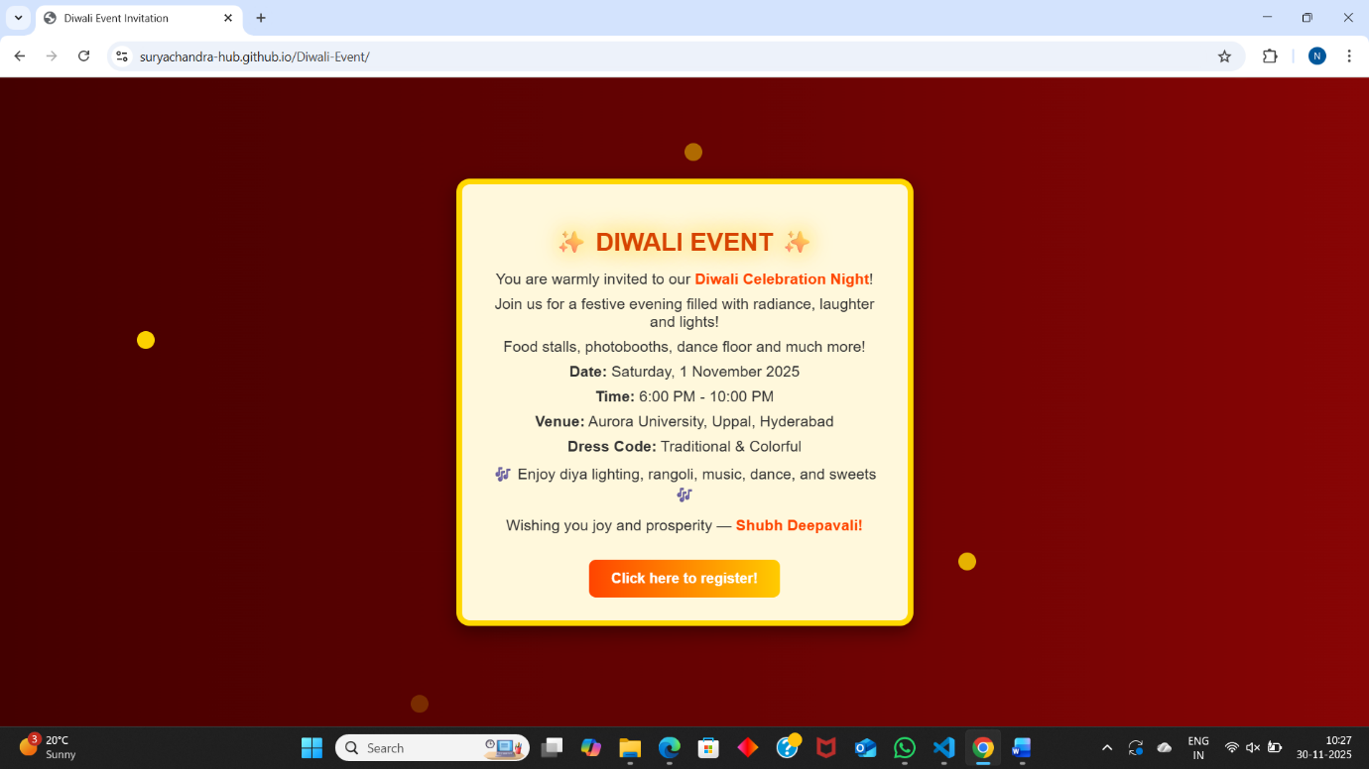
Figure 6.1.2 – Events Page (events.html)
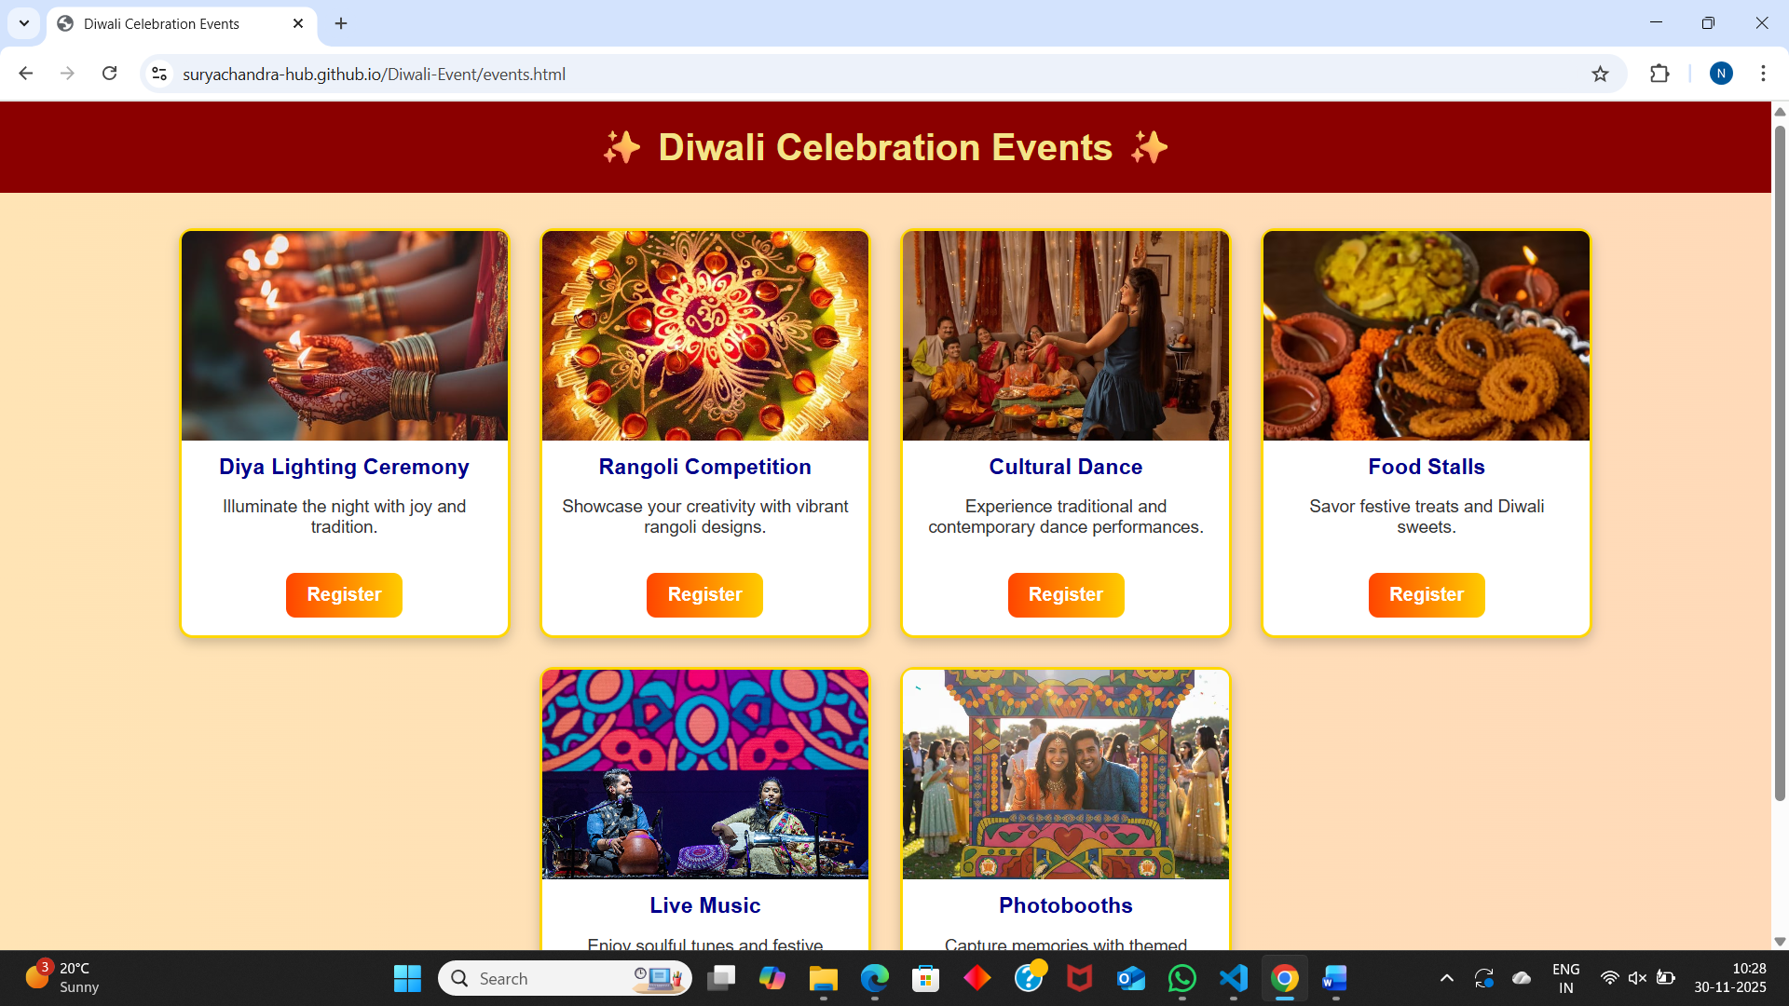

Figure 6.1.3 – Registration Page (register.html)
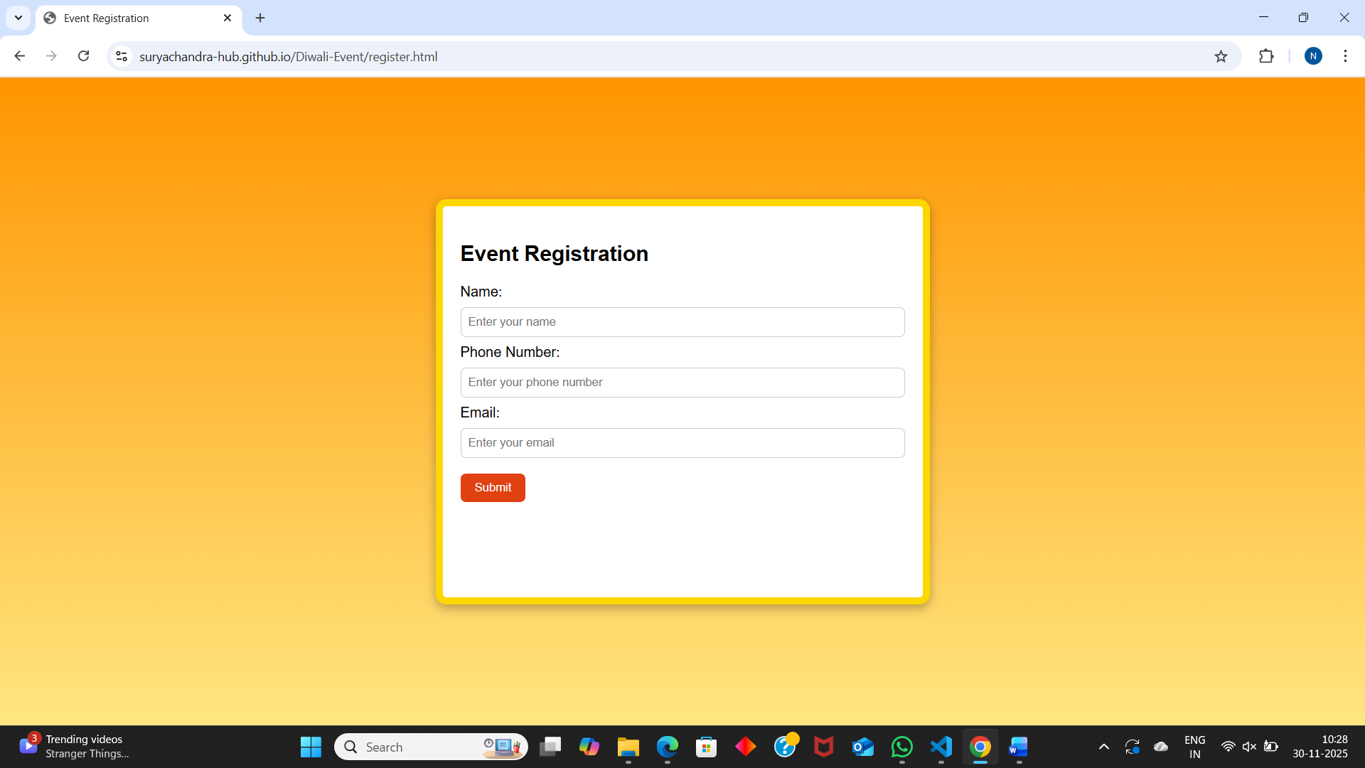
Figure 6.1.4 – Thank You Page (thankyou.html)
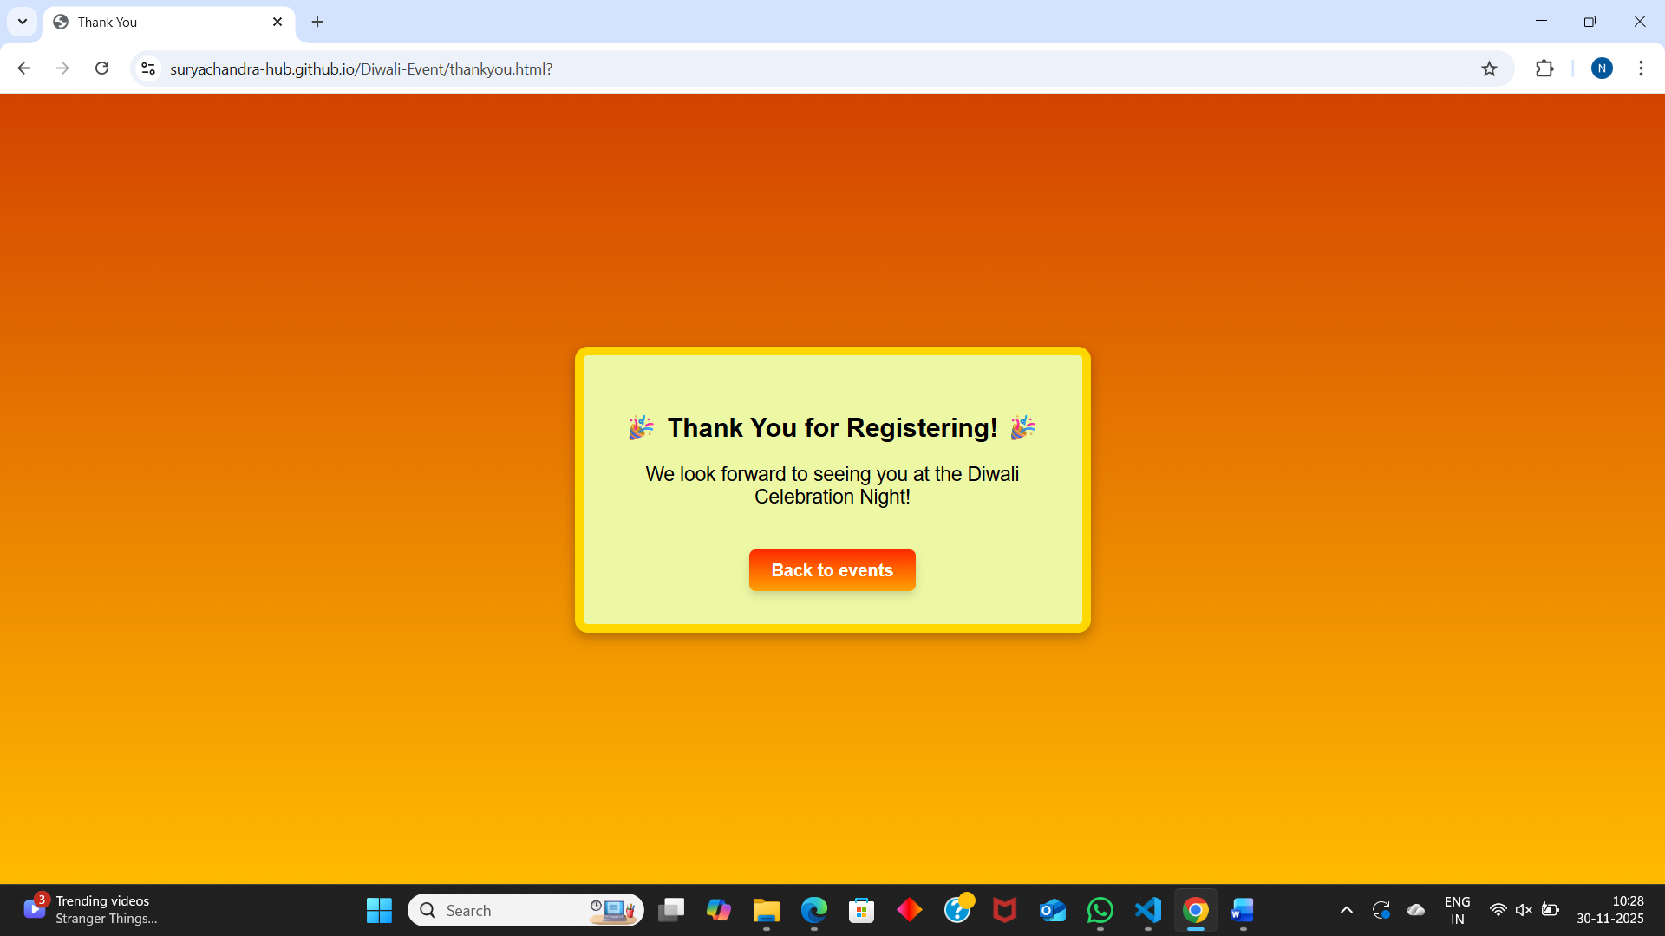
Figure 6.1.5 – GitHub Pages Deployment View
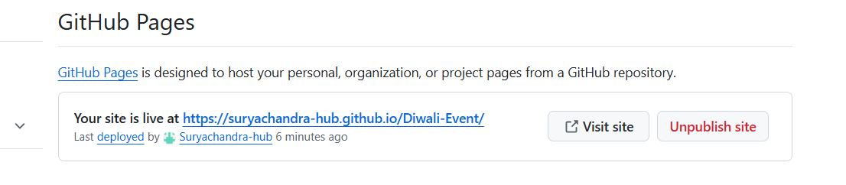
6.2 Discussion

The website demonstrated a clean and effective workflow starting from the invitation to final registration confirmation. The event listing page used card-based layout with hover interactions, which enhanced user engagement. The project successfully met its core objective: to create a functional event-management mini-application using HTML and CSS only, without JavaScript.

Using GitHub Pages added real-world deployment experience, enabling easy hosting, faster access, and version control. The test results suggest that the system is stable, visually pleasing, and useful as a basic event registration interface.

Additionally, the UI continuity across pages (color palette, typography, shadows, and card borders) ensured a professional and consistent user experience. Responsiveness was manually tested on mobile and laptop screens to ensure that layout elements adjusted smoothly without distortion.

6.3 Conclusion & Future Enhancement

In conclusion, the developed website fulfilled all requirements of the project using standard web technologies (HTML & CSS). It provided a smooth flow from invitation → events → registration → confirmation, successfully demonstrating core web development principles like layout design, styling, user interaction design, and deployment through GitHub Pages.

Future Enhancements

The project can be extended further by adding:

JavaScript validation for better form accuracy

A backend (PHP / Firebase / Node.js) to store user registrations

More event categories and pages

Dark mode / light mode theme

Auto email confirmation to the participant

These improvements would convert the simple website into a fully functional event-management system.
6.4 Innovation & Community Impact

The project uses a festive Diwali theme that can be reused for other celebrations and community gatherings by simply modifying text and colors. The design approach — lightweight, responsive, and easy to host — makes it suitable for small event organizers, colleges, and cultural committees.
Its simplicity ensures that even non-technical users can interact with the system smoothly.

This project demonstrates how basic web technologies can create practical solutions for real-life scenarios like event management, invitations, and participant registration.

7.Bibliography

- Web-Based Event Management Systems https://ieeexplore.ieee.org/document/9985774

- Cloud-Driven Event https://ijcrt.org/papers/IJCRT24A4126.pdf

- Critical Review of Online Event Systems https://ijies.net/finial-docs/finial-pdf/220624953.pdf

- Interactive Web Design for Cultural Events https://dl.acm.org/doi/fullHtml/10.1145/3701571.3703597

- Festive Event Portals https://www.subframe.com/tips/festival-website-design-examples

- Web Applications for Indian Culture https://www.jetir.org/papers/JETIRGW06076.pdf

