
TITLE OF THE PROJECT
A Project Report submitted in partial fulfillment of the requirements
for the award of the degree of

BACHELOR OF TECHNOLOGY
in
COMPUTER SCIENCE AND ENGINEERING

Submitted by
Name (Regd. No)
Name (Regd. No)
Name (Regd. No)
Name (Regd. No)

Under the esteemed guidance of
@Guide Name (Refer Website)
@Guide Designation



Department of Computer Science and Engineering
GITAM School of CSE, GITAM (Deemed to be University)
Hyderabad
2026

YEAR
Department of Computer Science and Engineering
GITAM School of CSE, GITAM (Deemed to be University)
Hyderabad

DECLARATION

I hereby declare that the project report entitled XXX is an original work done in the Department of Computer Science and Engineering, GITAM School of CSE, GITAM (Deemed to be University) submitted in partial fulfillment of the requirements for the award of B.Tech Degree in Computer Science and Engineering.

The work has not been submitted to any other college or University for the award of any degree or diploma.

Date:

Registration No(s) Name(s) Signature

Department of Computer Science and Engineering
GITAM School of CSE, GITAM (Deemed to be University)
Hyderabad

CERTIFICATE

This is to certify that the project report entitled “XXX” is a bonafide record of work carried out by Student Name (Regd. No.), Student Name(Regd. No.), Student Name(Regd. No.), Student Name(Regd. No.), students of this department submitted in partial fulfillment of requirements for the award of B.Tech Degree in Computer Science and Engineering.

Date :

Project Guide Head of the Department

ACKNOWLEDGEMENT

TABLE OF CONTENTS

S. No. | Description | Page No.
1. | Abstract | 1
2. | Introduction | 2
3. | Literature Review | 4
4. | Problem Identification & Objectives | 7
5. | Existing System | 10
6. | Proposed System | 12
7. | System Architecture | 15
8. | Tools/Technologies Used | 18
9. | Implementation & Results
10. | Conclusion | 21
11. | References | 22

Discussion Notes (not to be included in the report)
1. Abstract
A short paragraph describing the problem addressed and the solution proposed
2. Introduction
It focuses on various available systems and needs along with the justification of Title
3. Literature Review
A short review of previous papers published on the problem identified
4. Problem Identification & Objectives
A short paragraph on Problem Identification and what are the objectives defined to solve the issue (in bullet form)
5. Existing System
Details of Existing System and their drawbacks
6. Proposed System
Details of the Proposed System and how it improved over the existing system
7. System Architecture
Block Diagram and Description of the Entire Project Developed
8. Tools/Technologies Used
Details of various Tools/Technologies used and their significance in the project
9. Conclusion
10. References
Put the references in the format as available in the IEEE Paper

DOCUMENTATION SPECIFICATIONS

Size

- Documentation should preferably not exceed 25 pages(Capstone Project Introduction), not considering the prefacing materials.

- A4 is the recommended paper size.

Paper

- Use A4 (210mm x 297mm) bond un-ruled paper (80 GSM) for all dissertation copies submitted
- Page numbering starts after Table of Contents

- The documentation should be printed on one side only.

- Oversized figures and tables, if any, should be reduced to fit with the size of the documentation but the reduction should not be so drastic as to impair the clarity of their contents.

FORMAT FOR THE DOCUMENTATION

Font

- The font type should be Times New Roman for text throughout the document.

- The font size for the regular text in the document should be 12 point and normal print.

- The font size for chapter headings should be 14 point and bold print and all capitals.

- The font size for section headings should be 12 point and bold print and all capitals.

- The font size for subsection headings should be 12 point and bold print and
Title case
- The font size for References should be 11 point and normal print. Bold print is to be used for the volume of the journal, page nos. and year of publication; the latter to be kept within brackets. Journal/book name and title can be in italics

Line Spacing

- Use 1.5 spacing between the lines.

- Use one space between consecutive paragraphs.

- All paragraphs in the document must be left justified completely (including the first line).

- Provide single space between Chapter title and first sentence of a Chapter, and Last line of a section / sub-section and the title of the next section / sub- section.

- Use 1.5 spacing between the title of the section / sub-section and the text

- Use single space between the Last line of a section / sub-section and the figure

- Use single space between the Last line of a section / sub-section and title of the table.

- Use single space between the caption of the table and the table.

- Use single space between the table / caption of the figure and the next paragraph.

- Use one and half space in references and double space between references (see sample page 10).

Margins

- A margin of 2.5 cm (1 inch) is to be given on the binding edge while on the other side’s it is to be 1.5 cm. The text of the thesis, including headings, figures, tables, and notes, but excluding page numbers, must be accommodated within the page area.

Tables, Figures and Equations

- All tables (tabulated data) and figures (charts, graphs, maps, images, diagrams, etc.) should be prepared, wherever possible, on the same paper used to type the text and conform to the specifications outlined earlier. They should be inserted as close to the textual reference as possible (see sample pages 8 & 9). If borrowed from others, it should be acknowledged below the table, map, chart, figure, diagram etc.

- Tables, figures and equations should be numbered sequentially either throughout the document or Chapter-wise using Arabic numerals. They are referred to in the body of the text capitalizing the first letter of the word and number, as for instance, Table 17, Figure 24, Equation (33), or Table 5.3, Figure 3.11, Equation (4.16).

- If tables and figures are of only half a page or less, they may appear on the same page as text but separated above and below by double line spacing. Font size for title text should be the same as for the general text.

- Good quality Line Drawings/figures must be drawn using standard software that provides vector rather than bit-map graphics. Figures must be scalable. Images, Photographs, etc. must be scanned in resolution exceeding 200dpi with 256 grayscales for the monochrome images and 24 bit per pixel for the color images.

Page Numbering

- Page numbers for the preface/acknowledgements materials of the document shall be in small Roman numerals and should be centered at the bottom of the pages.

- Page numbers for the body of the thesis should be in Arabic numerals and should be centered at the bottom of the pages. The pagination should start with the first page of Chapter 1 and should continue throughout the text (including tables, figures, and appendices)

Every table heading be on top of the Table
Table 1.1 : Results of the table

And for Figure, ab bottom of the Figure

Figure 1 : Details of the Process


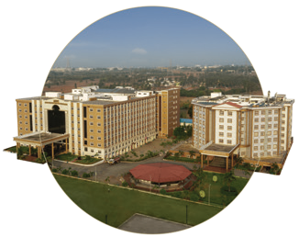
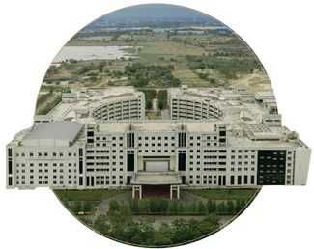
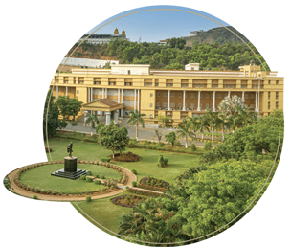
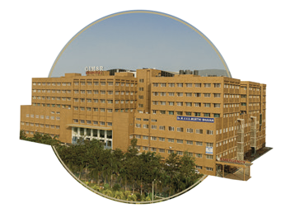

Bengaluru
NH 207, Nagadenehali, Doddaballapur Taluk, Bengaluru - 561203, Karnataka, India
Hyderabad
Rudraram, Patancheru mandal, Hyderabad - 502329, Telengana, India
Visakhapatnam
Gandhi Nagar, Rushikonda, Visakhapatnam- 530045, Andhra Pradesh, India
Bengaluru
Visakhapatnam
GIMSR Bengaluru City Office Hyderabad City Office GITAM Medical College Rd, No 5/1, First Floor, Prestige 6th floor, TP House, Cyber Gandhi Nagar, Rushikonda, Terraces, Union Street, Hills Colony, VIP Hills,
Visakhapatnam - 530045 Infantry Road, Bengaluru - Jaihind Enclave, Madhapur, Andhra Pradesh, India 560003 Karnataka, India Hyderabad - 500081,
Telangana, India
Hyderabad
GIMSR
Visakhapatnam

