SQL Practice Questions
CTAS • JOINs • Subqueries • Window Functions

1. Database Setup
Use the following MySQL 8+ setup. Run the SQL in order before attempting the questions.
CREATE DATABASE sql_practice;
USE sql_practice;
CREATE TABLE departments (
dept_id INT PRIMARY KEY,
dept_name VARCHAR(50),
location VARCHAR(50)
);
CREATE TABLE employees (
emp_id INT PRIMARY KEY,
emp_name VARCHAR(50),
dept_id INT,
manager_id INT NULL,
salary DECIMAL(10,2),
hire_date DATE,
FOREIGN KEY (dept_id) REFERENCES departments(dept_id)
);
CREATE TABLE customers (
customer_id INT PRIMARY KEY,
customer_name VARCHAR(50),
city VARCHAR(50)
);
CREATE TABLE orders (
order_id INT PRIMARY KEY,
customer_id INT,
order_date DATE,
amount DECIMAL(10,2),
status VARCHAR(20),
FOREIGN KEY (customer_id) REFERENCES customers(customer_id)
);
INSERT INTO departments VALUES
(1, 'IT', 'Chennai'),
(2, 'HR', 'Chennai'),
(3, 'Finance', 'Bangalore'),
(4, 'Sales', 'Hyderabad');
INSERT INTO employees VALUES
(101, 'Arun', 1, NULL, 75000, '2022-01-10'),
(102, 'Bala', 1, 101, 60000, '2023-03-15'),
(103, 'Charan', 1, 101, 65000, '2021-07-20'),
(104, 'Divya', 2, NULL, 55000, '2022-08-01'),
(105, 'Esha', 2, 104, 48000, '2024-02-12'),
(106, 'Farhan', 3, NULL, 70000, '2020-11-05'),
(107, 'Gokul', 3, 106, 52000, '2023-06-18'),
(108, 'Hema', 4, NULL, 62000, '2021-09-25'),
(109, 'Isha', 4, 108, 45000, '2024-01-08'),
(110, 'Jai', 4, 108, 50000, '2023-10-10');
INSERT INTO customers VALUES
(1, 'Kumar', 'Chennai'),
(2, 'Lakshmi', 'Bangalore'),
(3, 'Manoj', 'Chennai'),
(4, 'Nisha', 'Hyderabad'),
(5, 'Praveen', 'Coimbatore'),
(6, 'Ravi', 'Chennai');
INSERT INTO orders VALUES
(1001, 1, '2026-01-05', 2500, 'Completed'),
(1002, 1, '2026-02-10', 1800, 'Completed'),
(1003, 2, '2026-01-15', 3200, 'Completed'),
(1004, 3, '2026-02-01', 1500, 'Pending'),
(1005, 3, '2026-03-12', 4000, 'Completed'),
(1006, 4, '2026-01-20', 2100, 'Completed'),
(1007, 4, '2026-03-05', 2800, 'Cancelled'),
(1008, 5, '2026-02-18', 1700, 'Completed'),
(1009, 6, '2026-03-10', 3500, 'Completed'),
(1010, 6, '2026-03-20', 1200, 'Pending');

2. Practice Questions
1. [CTAS] Create a new table named high_salary_employees using CTAS. Store emp_id, emp_name, dept_id and salary for employees whose salary is greater than 60000.
Answer :
create table if not exists high_salary_employees as select * from employees where salary > 60000;
select * from high_salary_employees;
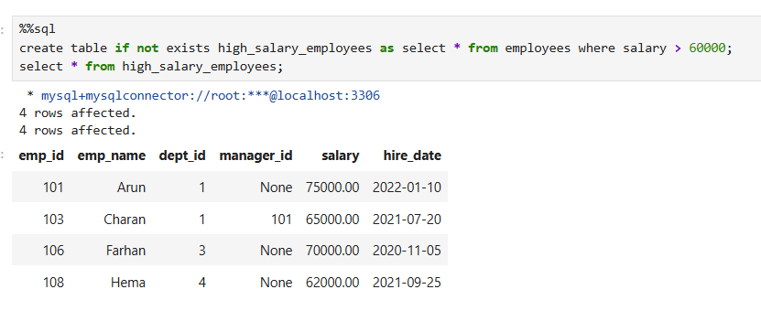
2. [CTAS] Create a table named chennai_customers using CTAS containing customers who are from Chennai.
Answer:
create table if not exists chennai_customers as select * from customers where city = 'Chennai';
select * from chennai_customers;
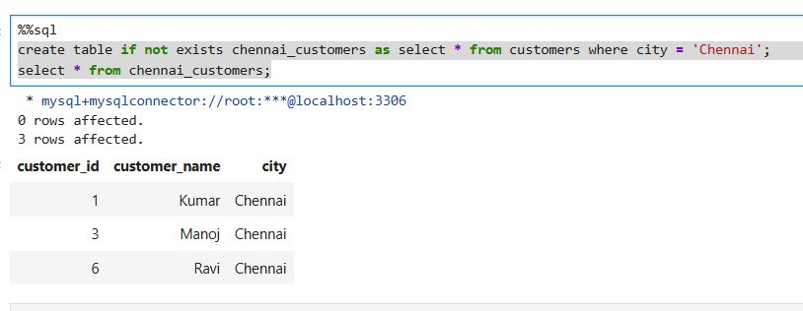

3. [CTAS] Create a table named department_salary_summary using CTAS. It should contain each dept_id and the average salary of employees in that department.
Answer:
create table if not exists department_salary_summary as
select dept_id, avg(salary) as avg_salary from employees group by dept_id;
select * from department_salary_summary;
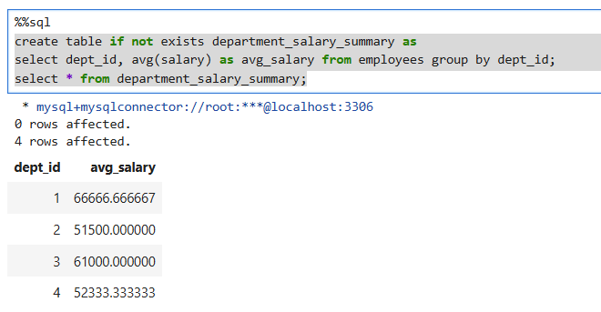
4. [CTAS] Create a table named completed_orders using CTAS containing only completed orders. Include order_id, customer_id, order_date and amount.
Answer:
create table if not exists completed_orders as select order_id, customer_id, order_date, amount from orders where status = "Completed";
select * from completed_orders;
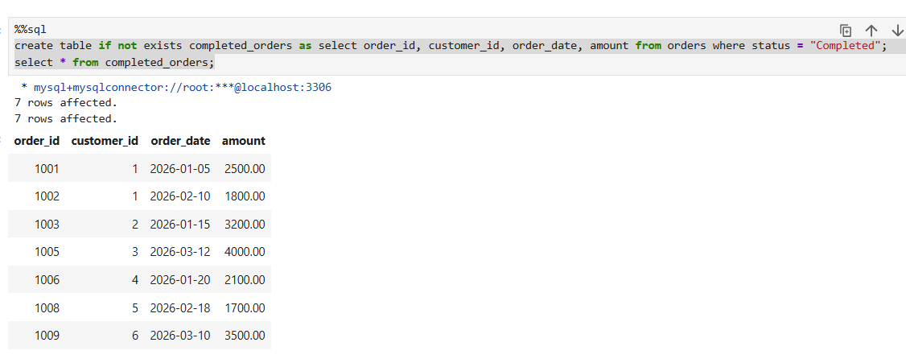

5. [JOIN] Write an INNER JOIN query to display employee name, department name and salary for every employee.
Answer:
select emp_name, dept_name, salary from employees e join departments d on e.dept_id = d.dept_id;
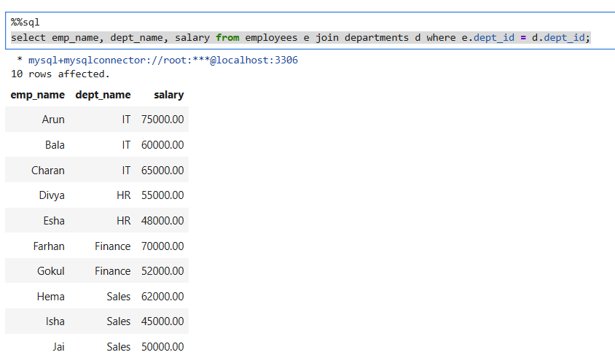
6. [JOIN] Write a LEFT JOIN query to display every department and the employees working in it. Departments with no employees should also appear.
Answer:
select d.dept_id, d.dept_name, e.emp_name from departments d left join employees e on e.dept_id = d.dept_id;
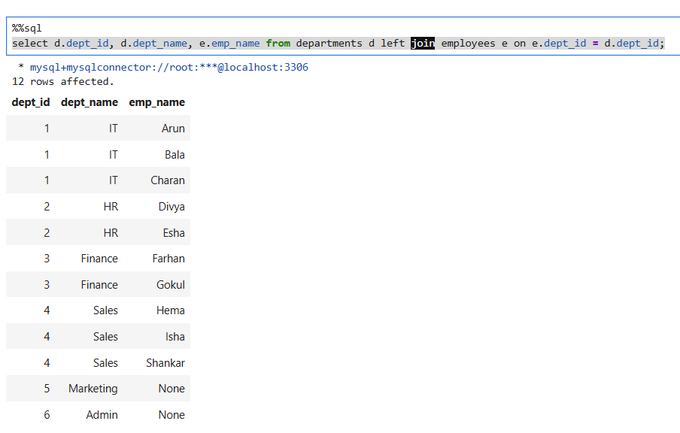
7. [JOIN] Write a query using JOINs to display customer name, order id, order date and order amount.
Answer:
select c.customer_name, o.order_id, o.order_date, o.amount from customers c inner join orders o on c.customer_id = o.customer_id
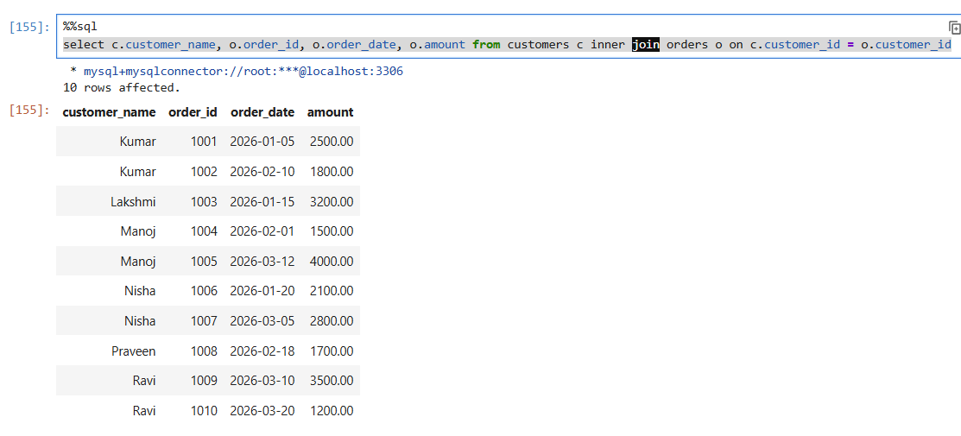
8. [JOIN] Write a query to find the total order amount for each customer. Display customer name and total amount. Include customers who have placed no orders.
Answer:
select c.customer_name, sum(o.amount) as total_amount from customers c left join orders o on c.customer_id = o.customer_id group by c.customer_name;
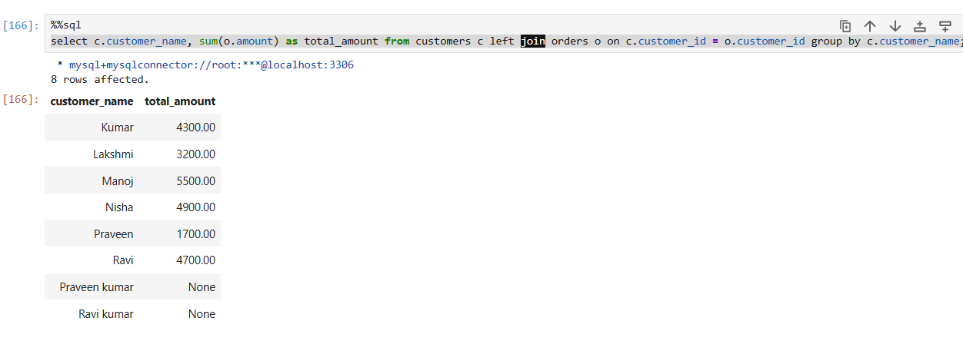

9. [JOIN] Write a self JOIN on the employees table to display each employee's name and their manager's name. Ignore employees who do not have a manager.
Answer:
select e.emp_name, m.emp_name as manager_name from employees e left join employees m on e.manager_id = m.emp_id;
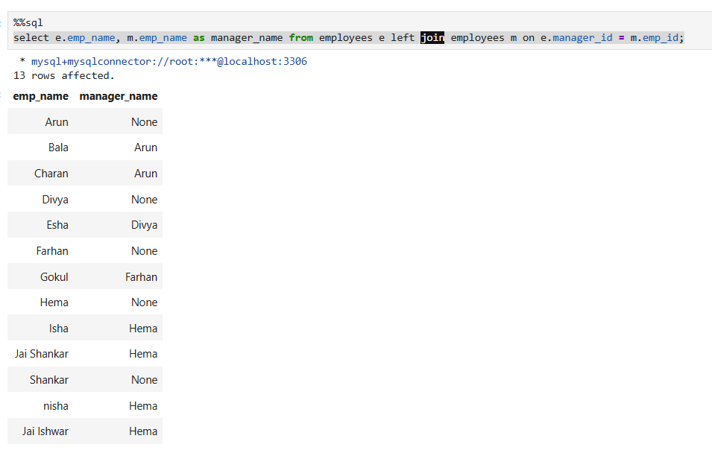
10. [JOIN] Find employees whose salary is greater than the average salary of their own department. Display employee name, department id and salary.
Answer:
select e.emp_name, e.dept_id, e.salary from employees e join (select dept_id, avg(salary) as avg_salary from employees group by dept_id) d
on e.dept_id = d.dept_id where e.salary > d.avg_salary
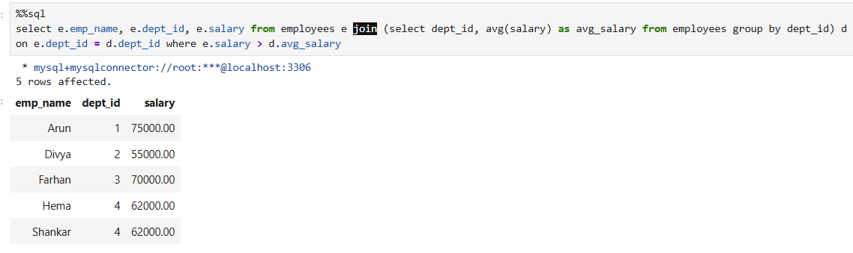
11. [SUBQUERY] Find the employee or employees who have the highest salary in the company using a subquery.
Answer:
select e.emp_id, e.emp_name, e.salary from employees e where e.salary = (select max(e1.salary) from employees e1)
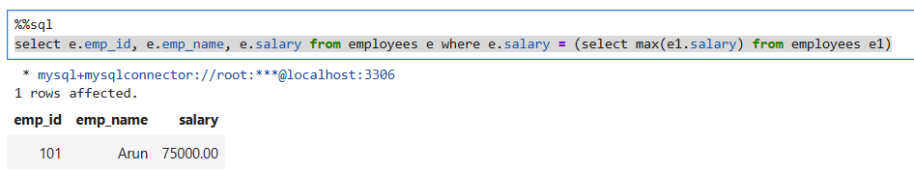
12. [SUBQUERY] Find all employees whose salary is greater than the overall average salary.
Answer:
select e.emp_id, e.emp_name, e.salary from employees e where e.salary > (select avg(e1.salary) from employees e1)
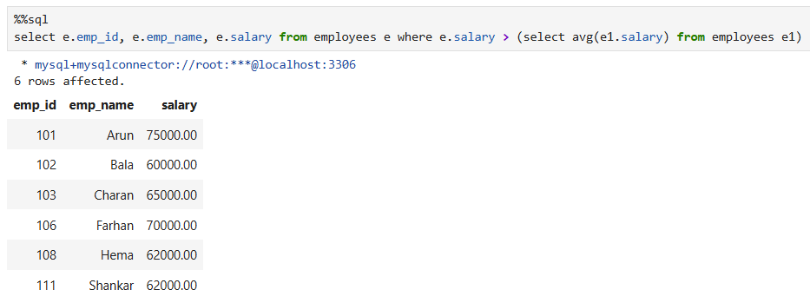

13. [SUBQUERY] Find customers who have placed at least one order using a subquery. Do not use JOIN.
Answer:
select c.customer_name from customers c where exists (select 1 from orders o1 where o1.customer_id = c.customer_id)
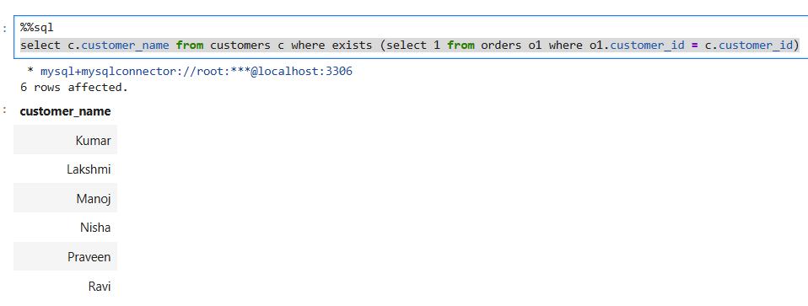

14. [SUBQUERY] Find the second-highest salary from the employees table using a subquery.
Answer:
select emp_name, salary from employees where salary = (select max(salary) from employees
where salary < (select max(salary) from employees ))
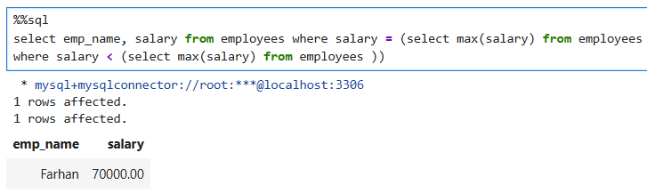

15. [WINDOW FUNCTION] Display each employee's salary along with the average salary of their department using AVG() OVER(PARTITION BY ...).
Answer:
select dept_id, emp_id, emp_name, salary,
avg(salary) over(partition by dept_id order by salary desc) as avg_salary from employees where dept_id != 'None';
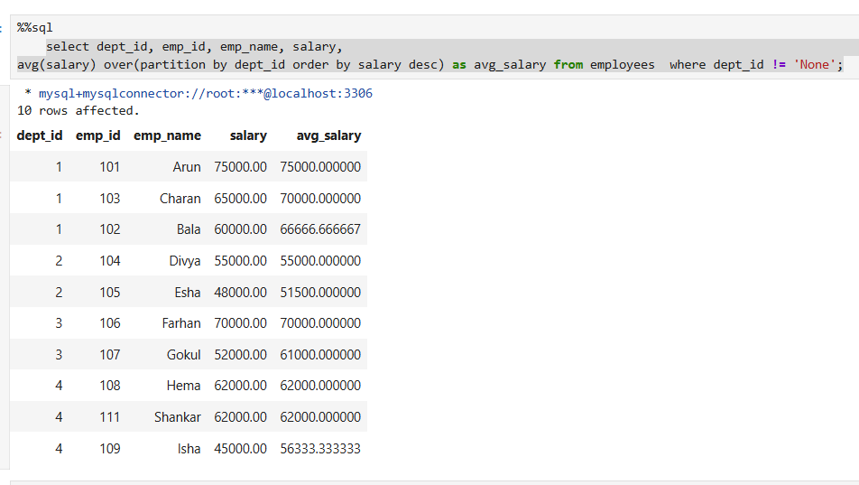
16. [WINDOW FUNCTION] Rank employees by salary from highest to lowest across the whole company using RANK(). Display employee name, salary and rank.
Answer:
select emp_id, emp_name, salary,
RANK() over(order by salary desc) as rank_salary from employees;
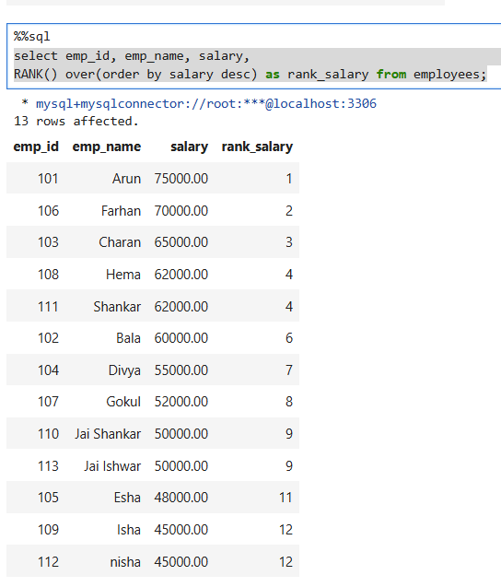
17. [WINDOW FUNCTION] Rank employees by salary within each department using DENSE_RANK(). Display employee name, dept_id, salary and department rank.
Answer:
select emp_name, dept_id, salary,
DENSE_RANK() over(partition by dept_id order by salary desc) as depat_rank from employees where dept_id !='None';
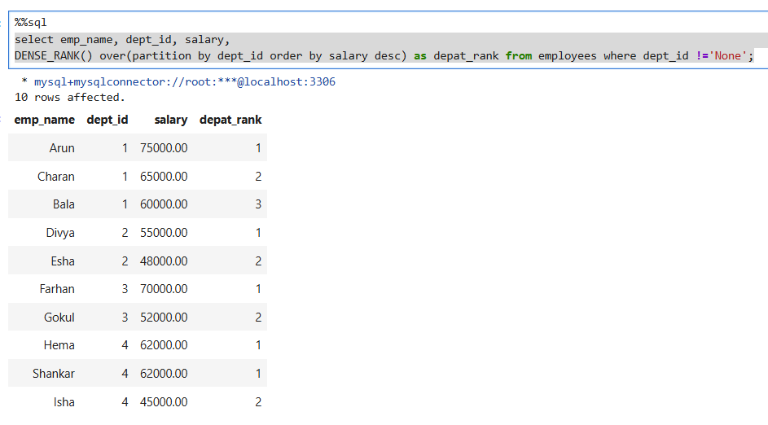
18. [WINDOW FUNCTION] For each customer order, display the order amount and the customer's previous order amount using LAG(). Order the rows by customer_id and order_date.
Answer:
select order_id, customer_id, order_date, amount, total_amount, prev_amount from (
select order_id, customer_id, order_date, amount, sum(amount) over(partition by customer_id order by customer_id, order_date)
as total_amount, LAG(amount,1, 0) over(partition by customer_id) as prev_amount from orders
) t
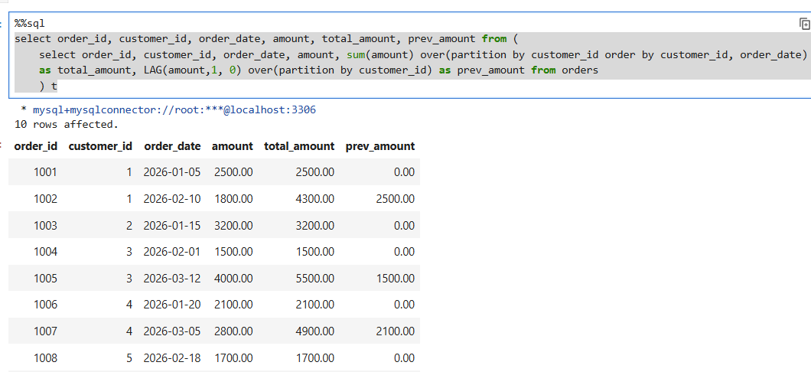
19. [WINDOW FUNCTION] Calculate a running total of order amount for each customer using SUM() OVER(PARTITION BY ... ORDER BY ...).
Answer:
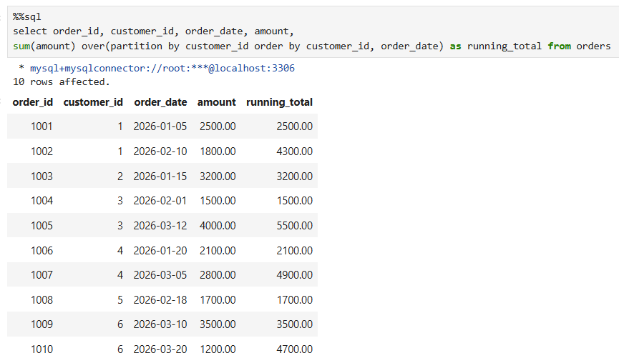
20. [MIXED] Find the top 2 highest-paid employees from each department. Use a window function and return employee name, dept_id, salary and rank.
Answer:
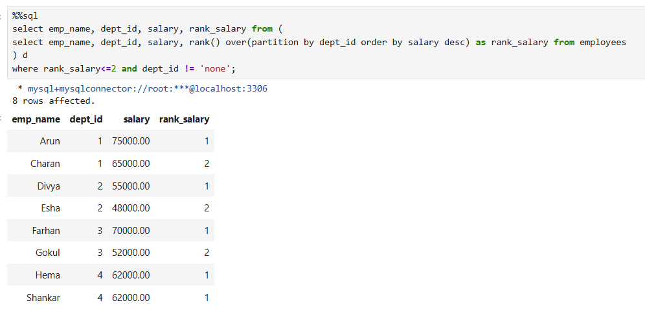

3. Recommended Order
Start with Questions 1–4 (CTAS), then 5–9 (JOINs), 10–14 (Subqueries), 15–19 (Window Functions), and finish with Question 20

