**Single Level**

Remote WebDriver – SuperClass

ChromiumDriver – SubClass

ChromiumDriver **extends** RemoveWebDriver

**Multi-Level**

Remote WebDriver – SuperClass

ChromiumDriver – SubClass1

ChromeDriver – SubClass2

ChromiumDriver **extends** RemoveWebDriver

ChromeDriver **extends** ChromiumDriver

**Hierarchical**

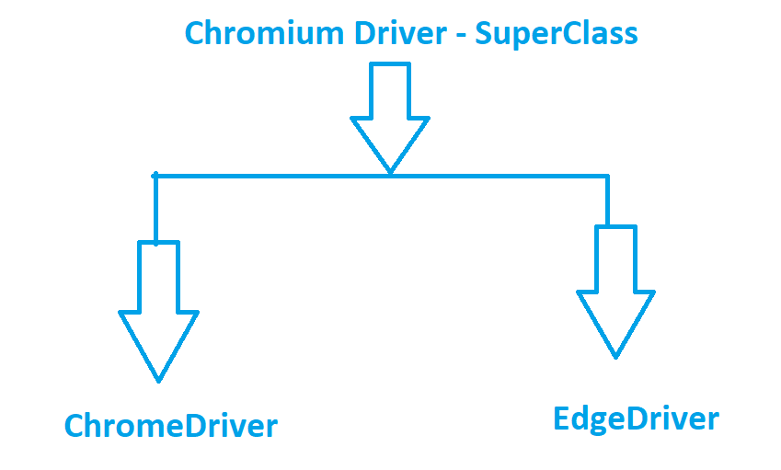

**SubClass 1 SubClass2**

ChromeDriver extends ChromiumDriver

EdgeDriver extends ChromiumDriver