LOCAL NETWORK CHAT APP

20I210

SURYAH DK

There are two files given in this project those are:

Server.py

Client.pyw

.pyw is also a type of python extension but there will be no command prompt console displayed.

The main idea of the project is to enable a free chatting server in a large area local network. This can be applied in some local network.

To use this software the server script must be run first in any type of computer but there must be only one script run in the whole network.

The client script can be run on how many ever computers needed and all the chats are displayed in a single prompt.

SAMPLE SCREENSHOTS:

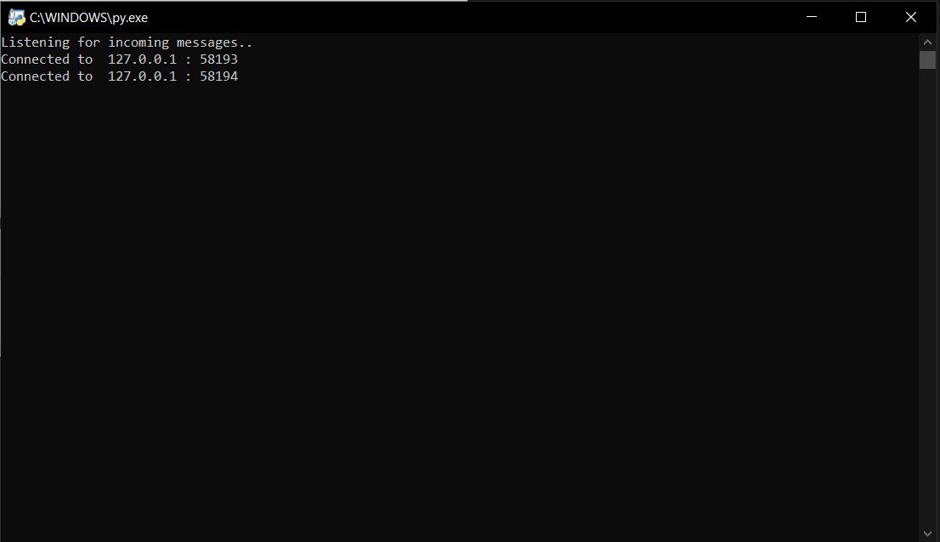

This is the image of the server running and currently there are two clients connected.

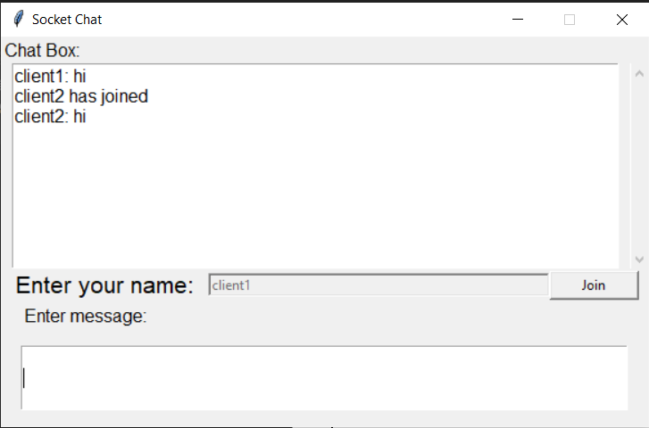

This is the image of client1 script who have joined first in the server.

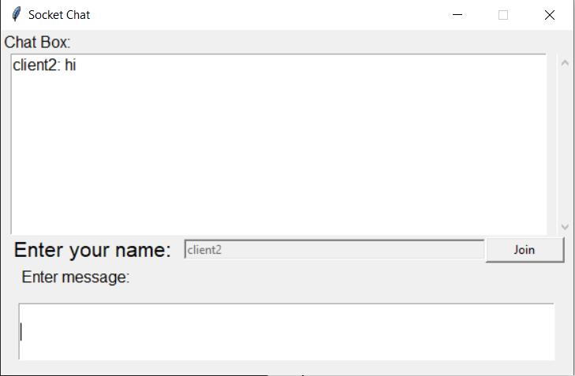

This is the image of client two who have joined later.