Project Design Phase

Solution Architecture

Project Name: Garage Management System

**Team ID**: LTVIP2025TMID31528

College Name: Ideal Institute Of Technology

# Introduction to Solution Architecture

Solution Architecture defines how a system will meet business needs through technology. It bridges the gap between business problems and software solutions by outlining structure, behavior, and implementation plans. For the Garage Management System assigned by Salesforce, the solution leverages Salesforce CRM to digitize and automate garage operations.

# Project Working Process – From Start to End

1.Requirement Gathering & Analysis: Identify common garage management challenges such as service tracking, inventory, and customer communication.  
2. Design Phase: Define Salesforce custom objects (e.g., Vehicles, Jobs, Customers, Parts) and workflows.  
3. Development Phase: Use Salesforce Lightning App Builder and Flow for implementation.  
4. Automation Setup: Configure Salesforce Flows and Process Builders for appointment scheduling, service updates, and alerts.  
5. Integration Phase: Add third-party APIs for WhatsApp notifications and payment gateways (e.g., Razorpay).  
6. Testing: Perform functional and user acceptance testing to validate each module.  
7. Deployment: Launch the system using Salesforce Experience Cloud for customer-facing interface.  
8. Monitoring & Reporting: Enable dashboards and analytics for performance tracking.  
9. Feedback & Improvement: Collect user feedback and update system for improved user experience.

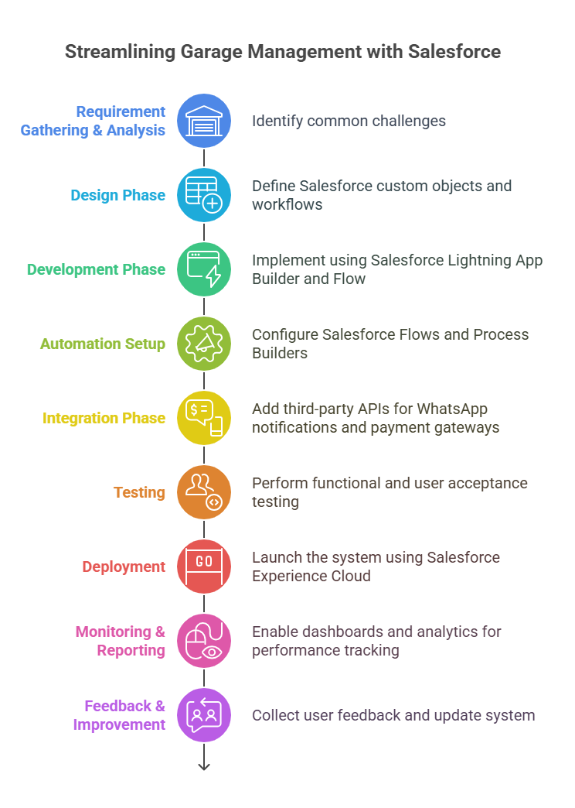

# Solution Architecture Components

|  |  |
| --- | --- |
| Component | Description |
| Frontend (UI) | Salesforce Experience Cloud – used for both garage staff and customer portals. |
| Backend (CRM) | Salesforce Platform – custom objects and logic to manage vehicles, services, and inventory. |
| Automation | Salesforce Flow and Process Builder for task automation and customer updates. |
| Database | Salesforce Object Database – stores structured garage-related data. |
| Communication | Integration with WhatsApp, Email, and SMS APIs using Salesforce Messaging features. |
| Payments | Integrated payment system using Razorpay or Stripe APIs for online billing. |
| Analytics | Salesforce Reports and Dashboards for real-time service monitoring and analysis. |

# Data Flow Description

1. Customer books service through portal.  
2. Salesforce records appointment and assigns mechanic.  
3. Updates are sent via WhatsApp/SMS automatically.  
4. Mechanic completes job and updates status.  
5. System generates bill and shares payment link.  
6. Owner dashboard shows all records and metrics.

# Architecture Overview

Below is a simplified architecture structure   
  
