**Suryakant Upadhyay**

**20220802043**

**SS lab assignment no – 5**

**------------------------------------------------------------------------------------------------------------------------**

# **Aim -** a) Shell Script to check whether a given number is a palindrome or not b) Shell Script to find the Sum of n numbers using for loop ------------------------------------------------------------------------------------------------------------------------

**1 - Shell Script to check whether a given number is a palindrome or not**

**What is palindrome number**

**= A palindrome is a number that remains the same when its digits are reversed. For example, 121 is a palindrome, but 123 is not. Code**

**=** #!/bin/bash

echo "Enter a number: " read number

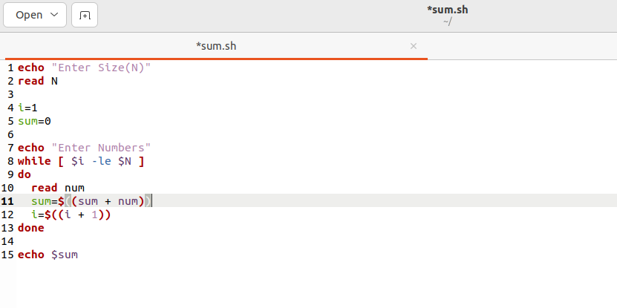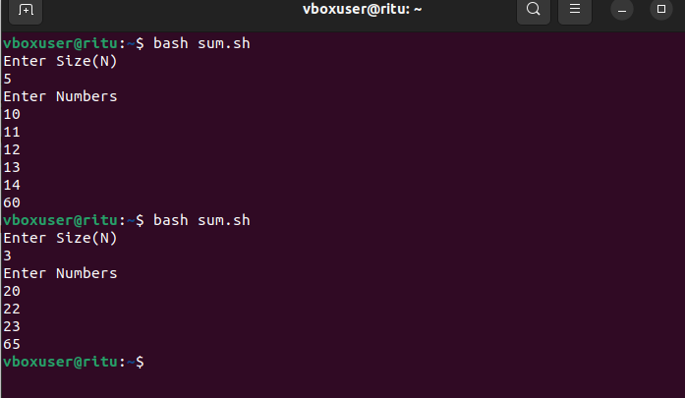

reverse=0 original=$number

while [ $number -ne 0 ] do remainder=$(( $number % 10 )) reverse=$(( $reverse * 10 + $remainder )) number=$(( $number / 10 )) done

if [ $original -eq $reverse ] then echo "$original is a palindrome." else echo "$original is not a palindrome." fi

**2 - Shell Script to find the Sum of n numbers using for loop**

# **Code -**

#!/bin/bash echo "Enter Size(N)" read N i=1 sum=0

echo "Enter Numbers" while [ $i -le $N ] do

read num sum=$((sum + num)) i=$((i + 1)) done echo $sum

