Entity Prep
=========
This entity prep program have two methods,
- Create Json files.
- Create Postgres tables
Source :
We need to provide json file for each entity in the specified location. And it will check the hbase table for the data and prepare new json file with the data.
Json files
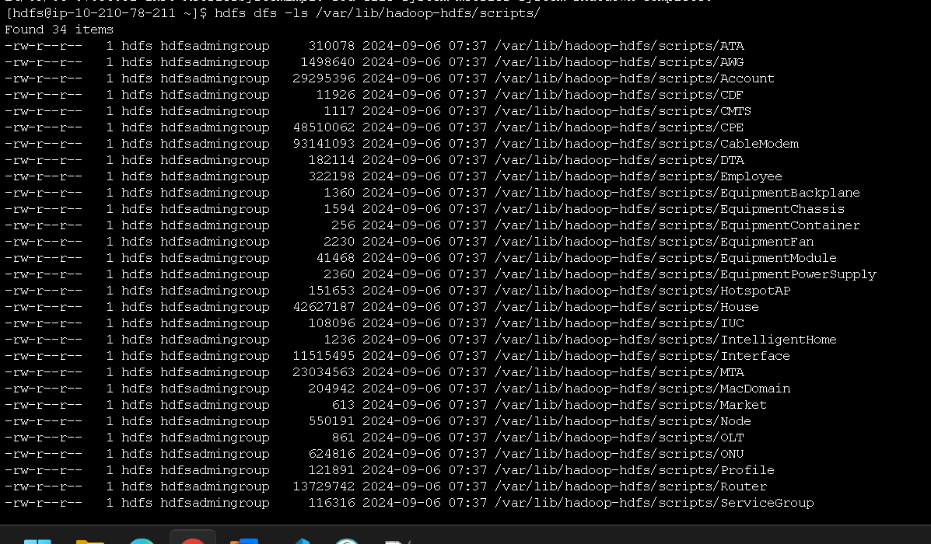

2, Creating Postgres tables.
Based on the json file (created by buildjsonfile method), the tables got created in postgres database.

