Create EC2 Instance (Kubernetes Management Host)

To Install AWS Cli

curl "https://awscli.amazonaws.com/awscli-exe-linux-x86_64.zip" -o "awscliv2.zip" -- install   
 ///aws cligoogle)

unzip awscliv2.zip

sudo ./aws/install

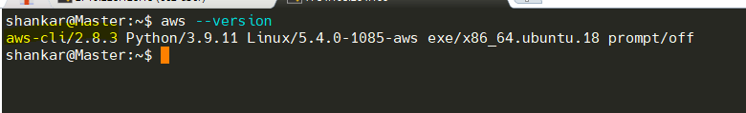

KUBECLT DOWNLOAD

curl -o kubectl https://amazon-eks.s3.us-west-2.amazonaws.com/1.21.2/2021-07-05/bin/linux/amd64/kubectl

chmod +x ./kubectl

mv ./kubectl /usr/local/bin OR mv ./kubectl /usr/bin –BASED on **echo $PATH**

kubectl version --short –client

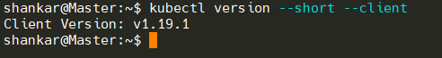

curl --silent --location "https://github.com/weaveworks/eksctl/releases/latest/download/eksctl_$(uname -s)_amd64.tar.gz" | tar xz -C /tmp

sudo mv /tmp/eksctl /usr/local/bin Or sudo mv /tmp/eksctl /usr/bin

eksctl version

AWS   
-------

Create an IAM Role and attache it to EC2 instance Management Host  
Note: create IAM user with programmatic access if your bootstrap system is outside of AWS  
IAM user should have access to  
IAM  
EC2  
VPC  
CloudFormation

---------------- Attach --- > Select Ec2 - Actions -security - IAM ROLE

eksctl create cluster --name bala1-cluster\

--region us-west-1\

--node-type t2.small\

eksctl create cluster --name surya1-cluster \

--region us-west-1\

--node-type t2.medium \

*****  
eksctl create cluster --name balaji-cluster \

--region ap-south-1 \

--node-type t2.medium \

*********

**eksctl delete cluster cloudfreak-cluster --region ap-south-1**

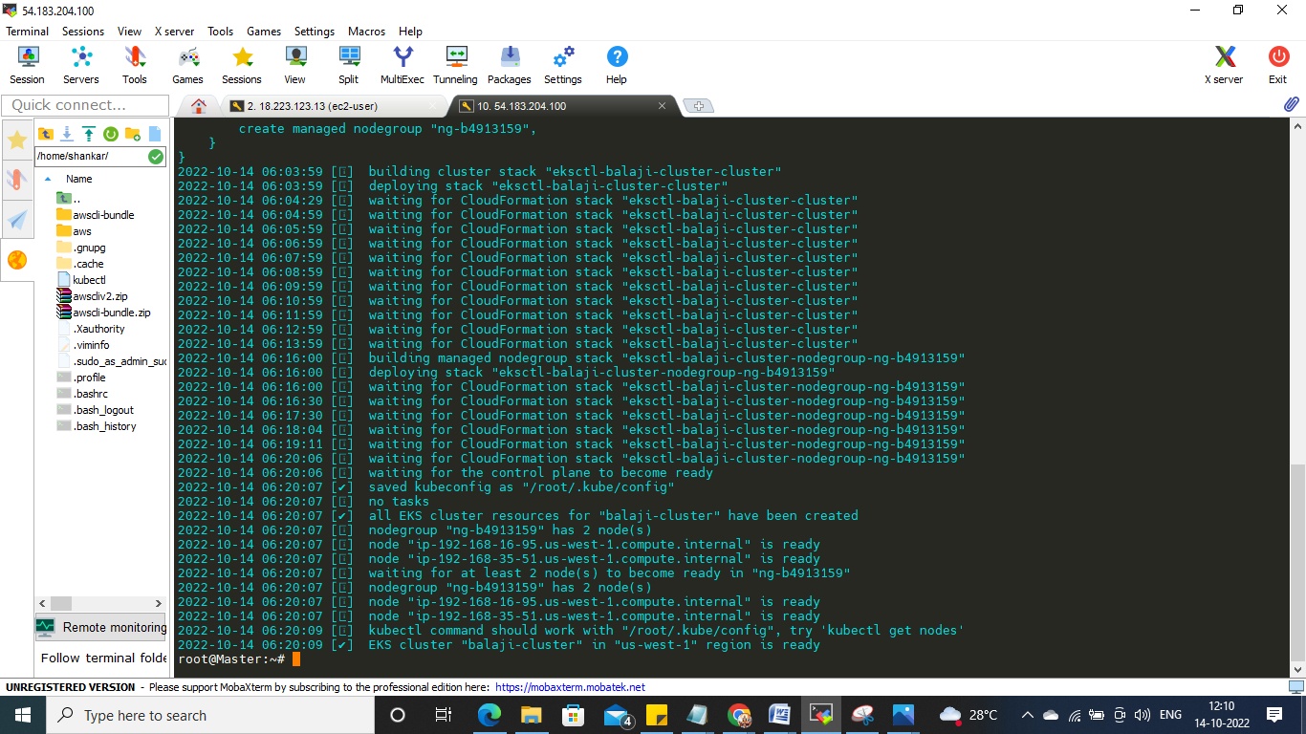

Deployment Service

|  |  |
| --- | --- |
| apiVersion: apps/v1  kind: Deployment  metadata:  name: regapp  labels:  app: regapp  spec:  replicas: 2  selector:  matchLabels:  app: regapp  template:  metadata:  labels:  app: regapp  spec:  containers:  - name: regapp  image: msuryam/regapp  imagePullPolicy: Always  ports:  - containerPort: 8080  strategy:  type: RollingUpdate  rollingUpdate:  maxSurge: 1  maxUnavailable: 1 | apiVersion: v1  kind: Service  metadata:  name: service  labels:  app: regapp  spec:  selector:  app: regapp  ports:  - port: 8080  targetPort: 8080  type: LoadBalancer |

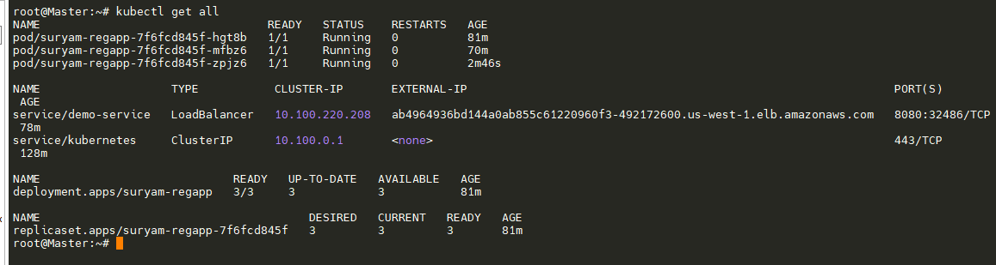

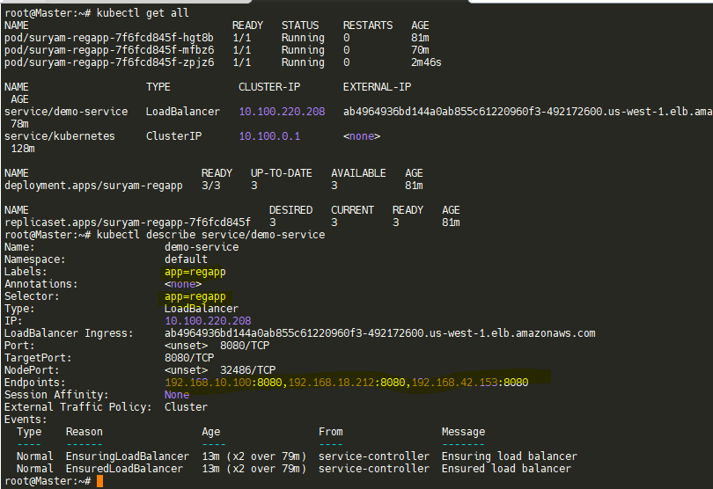

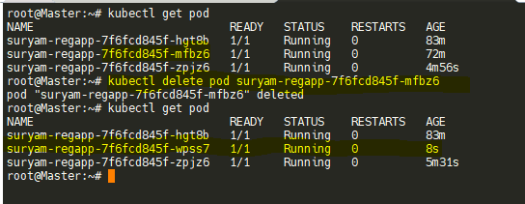

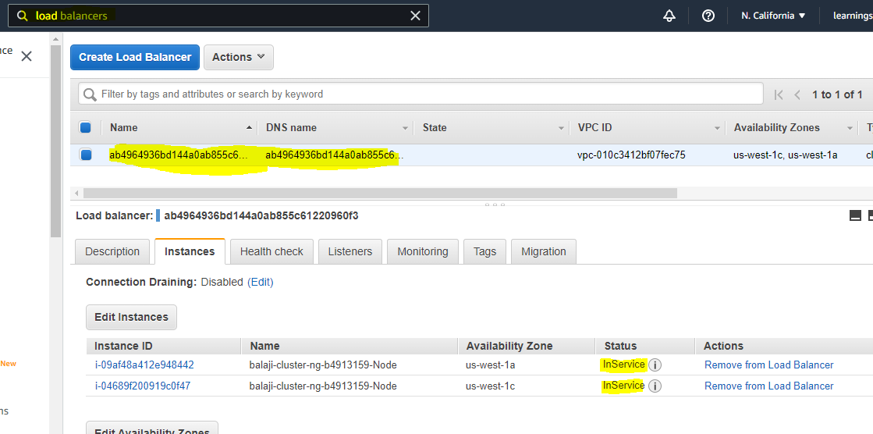

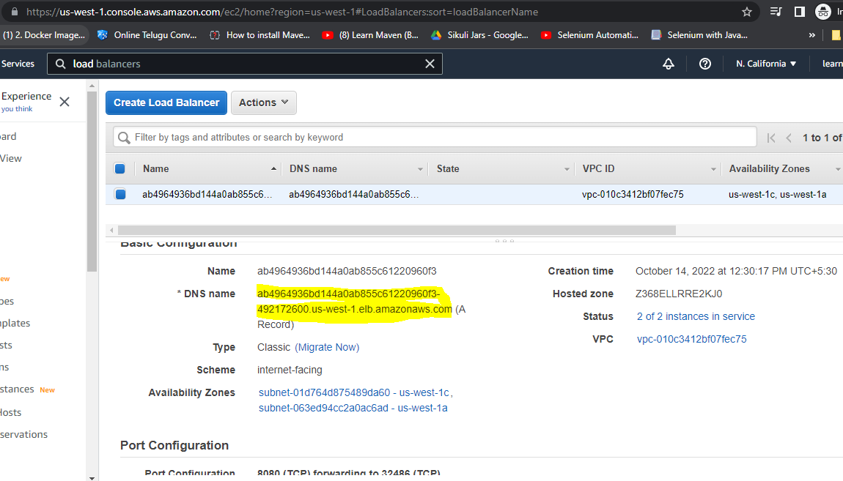

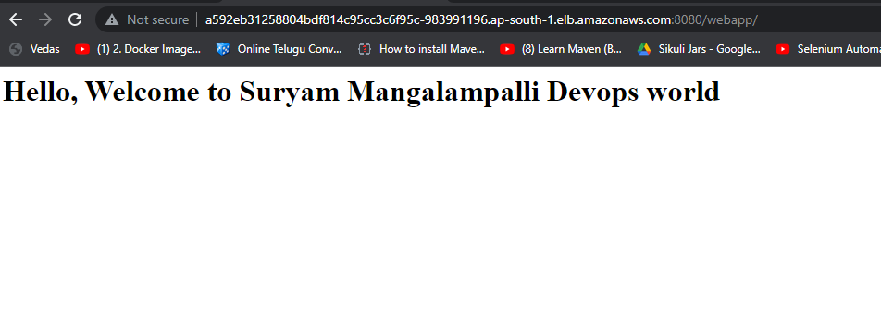

eksctl create cluster --name balaji-cluster \

--region us-west-1 \

--node-type t2.small

eksctl delete cluster balaji-cluster --region us-west-1