

CSE3006: Embedded System Design

FINAL PROJECT REPORT

Team Members:

- Suryansh Bhardwaj - 15BCE1047

Project Title: Automated Smart Light System

1. Objective of the Project

“Automated Smart Light System” project will help us to control the room lights automatically when a person is inside the house. This is an idea of Home Automation where light is controlled automatically without the need of user to go to the switch and turn on the light.

2. Summary of Working of the Project

The components required for the project are Arduino Uno, 2 IR Sensors, 1 PIR sensor, 1 channel relay, breadboard , AC Bulb and some jumper wires. The two IR sensors are used on the door for marking the entry and exit of the person. PIR It counts the number of visitors or persons in the room. When someone enters into the room counter will be incremented and the PIR sensor senses motion detection in the room.The bulb is connected to the AC voltage line and to the circuit via 1 channel relay. The light in the room (I.e. The bulb ) will be switched ON and when any one leaves or comes out of the room then the counter gets decremented.
The light will be switched OFF when all the persons or visitors leave from the room or there is no motion detection in the room. Arduino Uno will be involved in this work. For detecting the presence of human in different rooms I am using Passive Infrared Sensor (PIR Sensor). It is an pyro-electric sensor that measures infrared(IR) light radiating from objects in it’s field of view.

3. Use Case Diagram

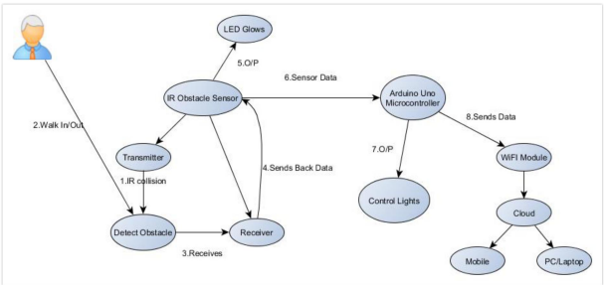

The picture depicts out the steps ranging from 1 to 7 that should be followed for proper functioning of the project.

Starting: Connecting the Transmitter to voltage to start the transmitter functioning.

- Person walks in or walks out.

- Detects Collision and sends it to the receiver.

- Receiver sends back the data to IR Obstacle Sensor

- Sensor Data is sent to Arduino Uno micro controller

- Micro Controller controls the room light and sends the data to wifi module.

- Wifi Module connects to cloud.

- From cloud we retrieve data to android apps and websites.

Explanation :
- IR Sensor :
  - IR sensor sends an receives the infrared beam. If the infrared beam hits an obstacle and then returns back to the receiver, then it detects an obstacle. We have two IR Sensors on both side suppose A and B. Now if A goes first and B goes second then it means that an object has entered the house and the counter gets incremented. If IR B goes first and then A gives the reading it means that the object has left the house and counter value gets decremented.
  - The sensors are placed on the door on each side and connected to arduino uno for further functions.

ii. PIR Sensor :
- PIR sensor is a pyro-electric sensor that it used to detect human motion in the project. It is Passive Infrared Sensor because it doesn’t emit the infrared waves but it only receives them from humans that’s why we don’t detect object movement but only human motion detection.
- PIR sensor senses the motion and sends the output to the relay which is connected to the bulb. The bulb lights up.

4. Hardware Diagram (Circuit Diagram)
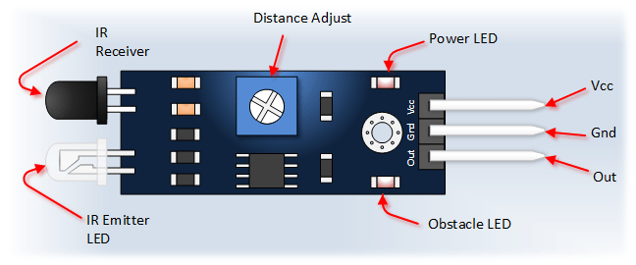
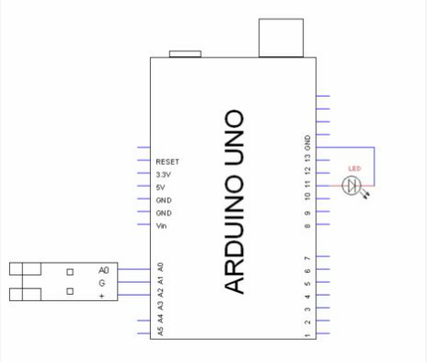

The IR sensor is a highly reliable means of detecting obstacles using reflected infra red light. It has great responsiveness and reliability. The module has an infra-red transmitter which lights up the surroundings and an infra red receiver which measures the amount of infra red that is reflected. If the reflected amount of light reaches above a certain threshold that means that light was reflected and so the signal pin is triggered (HIGH to LOW). We connect the sensor so that A0 on the sensor plugs into A0 on the Arduino, GND Pin connects to A1 on the Arduino and (+) Pin connects to A2 on the Arduino.

Limitations of this sensor :
- Cannot measure distance
- It can malfunction in very bright light i.e. sunlight

5. Software Used (Arduino IDE)

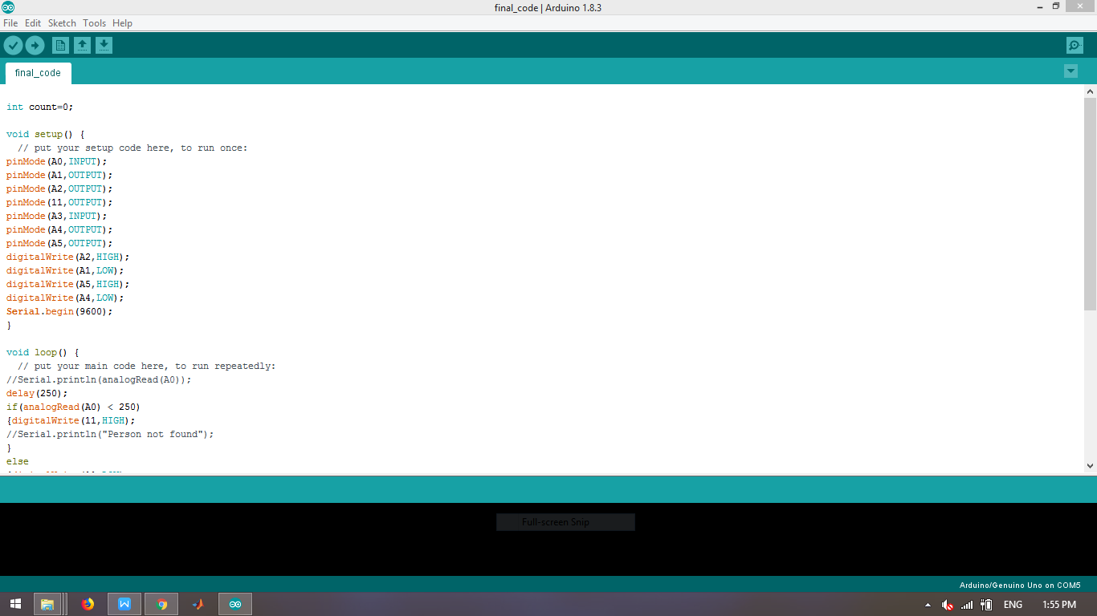

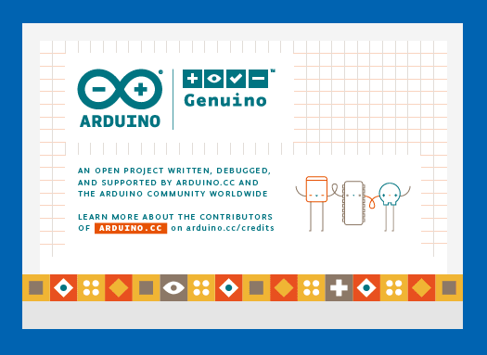

6. Software - Description and Operations

- The Arduino IDE runs on the computer and is used to write and upload computer code to the physical board. The Arduino IDE uses a simplified version of C++, making it easier to learn to program. The Arduino IDE contains a text editor for writing code, a message area, a text console, a toolbar with buttons for common functions and a series of menus. It connects to the Arduino and Genuino hardware to upload programs and communicate with them.

- Programs written using Arduino Software (IDE) are called sketches.

- These sketches are written in the text editor and are saved with the file extension .ino.

- We have the serial monitor on the top right of the application that provides us the interface where we can see our output.

- The toolbar buttons allow you to verify and upload programs, create, open, and save sketches, and open the serial monitor.

CODE :

//the time we give the sensor to calibrate (10-60 secs)
int calibrationTime = 10;
int count=0;
int c1=0;
int c2=0;
int flag=1;
//the time when the sensor outputs a low impulse
long unsigned int lowIn;

//the amount of milliseconds the sensor has to be low before we assume all motion has stopped
long unsigned int pause = 5000;

boolean lockLow = true;
boolean takeLowTime;

int pirPin = 3; //the digital pin connected to the PIR sensor's output
int ledPin = 13;
int relay = 6;

/////////////////////////////
//SETUP
void setup(){
pinMode(A0,INPUT);
pinMode(A1,OUTPUT);
pinMode(A2,OUTPUT);
pinMode(11,OUTPUT);
pinMode(A3,INPUT);
pinMode(A4,OUTPUT);
pinMode(A5,OUTPUT);
digitalWrite(A2,HIGH);
digitalWrite(A1,LOW);
digitalWrite(A5,HIGH);
digitalWrite(A4,LOW);
Serial.begin(9600);
pinMode(pirPin, INPUT);
pinMode(ledPin, OUTPUT);
digitalWrite(pirPin, LOW);

Serial.print("calibrating sensor ");
for(int i = 0; i < calibrationTime; i++){
Serial.print(".");
delay(1000);
}
Serial.println(" done");
Serial.println("SENSOR ACTIVE");
delay(50);
}

////////////////////////////
//LOOP
void loop(){
delay(250);
if(analogRead(A0) < 250)
{digitalWrite(11,HIGH);
}
else
{digitalWrite(11,LOW);
c1+=1;
if(c1>c2){
flag=1;
}
else if(flag==0 and count>0){
Serial.println("Person Exit");
count=count-1;
}

Serial.println("People Inside are :");
Serial.println(count);

}
if(analogRead(A3) < 250)
{digitalWrite(11,HIGH);
}
else
{digitalWrite(11,LOW);

c2+=1;
if(c2>c1){
flag=0;

count=count-1;}
else if(flag==1){
Serial.println("Person Entry");
count=count+1;
}
if(count>=0){
Serial.println(count); }
else
count=0;
}
if(digitalRead(pirPin) == HIGH) {
if (count>0){
digitalWrite(ledPin, HIGH);
Serial.println("Motion Detected Here! Alert !!");
Serial.print("Count = ");
Serial.println(count);
digitalWrite(relay,LOW); // Turns ON Relays 1

Serial.println("Light ON");

delay(2000); // Wait 2 seconds

digitalWrite(relay,HIGH); // Turns Relay Off

Serial.println("Light OFF");

delay(2000);
if(lockLow){
lockLow = false;
Serial.println("---");
Serial.print("motion detected at ");
Serial.print(millis()/1000);
Serial.println(" sec");
delay(50);
}
takeLowTime = true;
}
else {
Serial.println("Count<=0 but PIR Working");}
}

if(digitalRead(pirPin) == LOW){
digitalWrite(ledPin, LOW);

if(takeLowTime){
lowIn = millis(); //save the time of the transition from high to LOW
takeLowTime = false;
}
//if the sensor is low for more than the given pause, we assume that no more motion is going to happen
if(!lockLow && millis() - lowIn > pause){

lockLow = true;
Serial.print("motion ended at ");
Serial.print((millis() - pause)/1000);
Serial.println(" sec");
delay(50); //50 originally
}
}
}

7. RESULTS

The project was successfully implemented and all the things were working fine. The IR sensors were detecting fine and the PIR sensor was able to detect human motion till 6 meters of distance. The bulb lighted up whenever there were human motion and the number of people inside the house were greater than zero. Relay switch was working just fine.
OUTER LOOK :

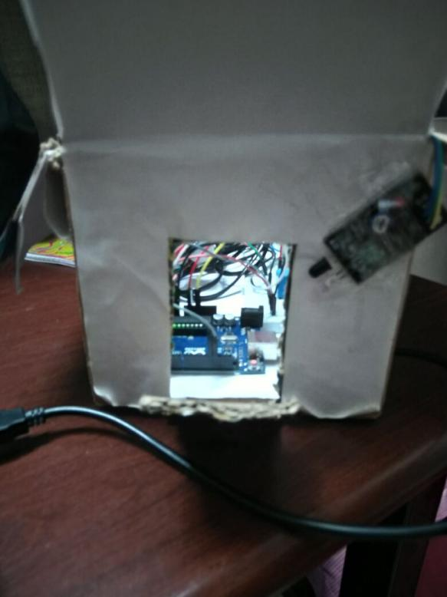
Image 2:

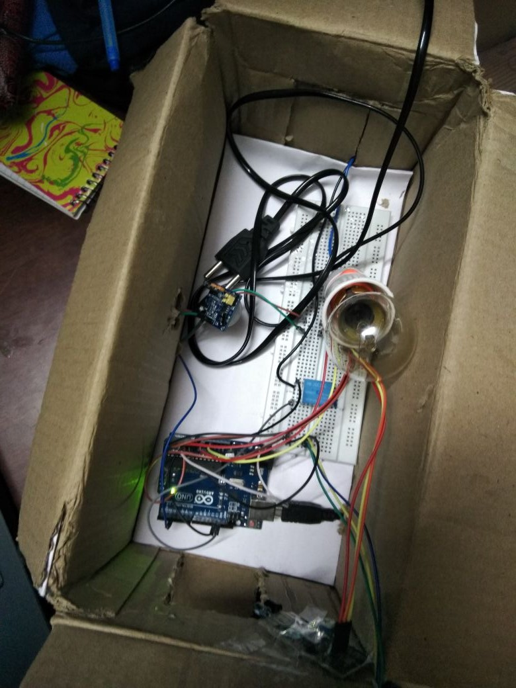

Image 3:
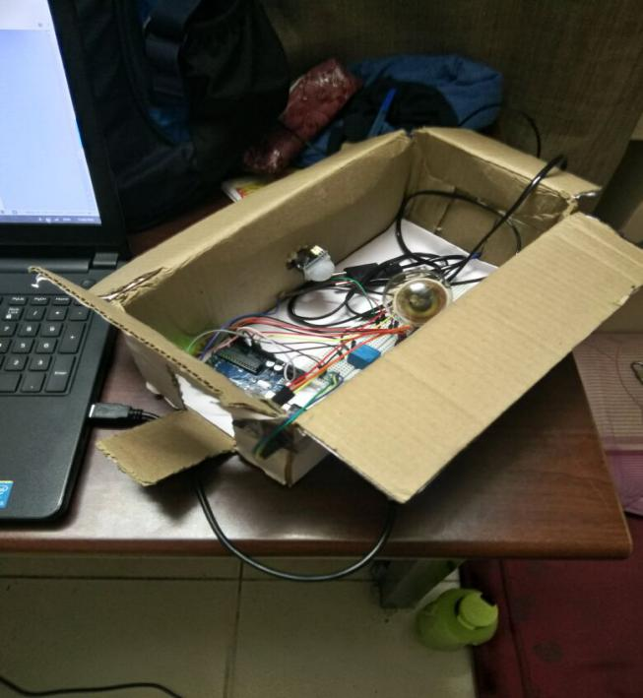

Image 4:

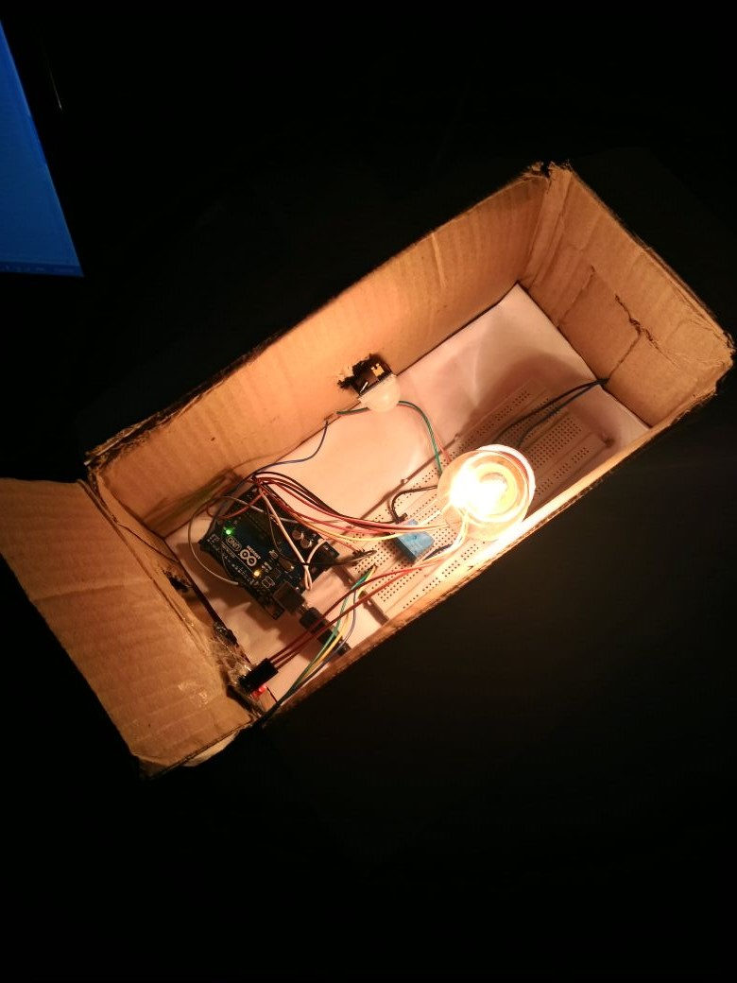

- Difficulties Faced and Ways to overcome difficulty

- Marking entry and exit of the object from one door.

To solve this I use two IR sensor to check if the person went in or went out. We have two IR Sensors on both side suppose A and B. Now if A goes first and B goes second then it means that an object has entered the house and the counter gets incremented. If IR B goes first and then A gives the reading it means that the object has left the house and counter value gets decremented.

- Connecting AC Bulb to Arduino Uno

We use AC Bulb wire and cut it open. There are two wires inside. One wire is connected to the relay switch and the other is connected to the common pin of the relay module. When the voltage is applied , the connection gets closed and the bulb lights up. The voltage is provided by the Arduino by giving one 5 V wire and one ground connection.

- PIR Sensor requires calibration

The PIR sensor before sensing the data requires some amount of time to calibrate the data and pick up a threshold of the environment. That’s why we provide 10 seconds of delay for calibration. The range of time required generally is 10-60 seconds.

9. Future Extension to the project

- Sending Data to online for analysis part (Real time graphs etc.) using Wifi Module and python programming language.

- Making bluetooth controlled mobile application for controlling the lights and sensors manually.

- Implementing the project on a tube light instead of a bulb.

- Implementing not only light but also fans, alarms using 2-3 channel relays.

