## **A MIDSEM REPORT**

## **ON**

**AUTOMATION AND OPTIMIZATION OF HOSTEL MESS**

## **BY**

**SURYANARAYANA KRISHNAN 2020A7PS0237U**

**CS**

#### AT



**BITS Pilani, Dubai Campus**

**Dubai International Academic City, Dubai**

**UAE**

**(JANUARY 2022 - PRESENT)**

**BITS Pilani, Dubai Campus**

**Dubai International Academic City, Dubai**

**UAE**

**Station:** BITS PILANI **Centre:** DUBAI

**Duration:** 27.01.2022 – PRESENT **Date of Start**: 27.01.2022

**Date of Submission**: 04-04-2022

**Title of the Project**: AUTOMATION AND OPTIMIZATION OF HOSTEL MESS

**ID No. / Name of the student**: 2020A7PS0237U

**Discipline of Student:** CS

**KEYWORDS:** Optimization, automation, Mess food, university canteen, management, food wastage, feedback

**Abstract**

Food wastage is a global concern. Approximately around one-third of the food produced every year i.e., 1.3 billion tonnes get wasted. In the UAE itself around 40% of food prepared is wasted. This study project aims to achieve a way to determine the number of students dining in the hostel mess in a short cycle based on previous weeks/month’s data.

The proposed model in this report will prove useful for the hostel staff to avoid food wastage drastically by improving the accuracy of food prepared against the number of students. The existing system involves estimating the number of students based on the previous days data which is manually recorded. This manual recording of data lacks automation. Also previous days data does very little to help as the menu changes and so does the day, students usually go out on Fridays changing the calculations. Having a system that records the multitude of students by means of a mfx reader which accepts both student ids and virtual ids on mobile phones will help alleviate all of the above issues. This easily accessible online system can help the hostel staff greatly.

**Signature of Student Signature of PS Faculty**

**Date: Date:**

**ACKNOWLEDGEMENTS**

First and foremost, I would like to convey my heartfelt thanks to Dr. R. Gomathi Bhavan, Associate Professor, EEE Department, BITS Pilani, Dubai campus, United Arab Emirates, for her invaluable assistance and support over the course of this Dissertation. I am really thankful to her for her wise counsel, valuable technical advice, and helpful recommendations.

I would like to offer my heartfelt appreciation and gratitude to Prof. Srinivasan Madapusi, Director of BITS Pilani, Dubai Campus, for his motivation, encouragement, and assistance in pursuing my dissertation.

Above all, I thank the Lord for providing me with the strength to complete this task to the best of my ability.

*Please sign here*

Suryanarayana Krishnan

2020A7PS0237U

**LIST OF FIGURES**

1. System shows students in boys hostel mess waiting for food

.

1. Students eating in girls hostel mess
2. YSOFT MFX reader
3. Image briefly explaining MIFARE
4. Flowchart displaying chain of events.
5. Steps followed from the moment MFX reader detects id.
6. System implementation steps
7. Complete GUI breakdown

**Contents**

***Abstract***

***Acknowledgement***

***List of Figures***

1. INTRODUCTION

**2. RELATED WORK**

3. SYSTEM DESIGN

3.1 hardware

3.1.1 MFX READER

3.1.2 STUDENT ID CARD

3.2 SOFTWARE

3.2.1 WEB SERVER

**4. System Implementation**

4.1 MFX Reader

4.2 Web Development

4.3 MySQL Database

4.4 Graphical user interface (GUI)

5**. Conclusion**

***References***

**CHAPTER 1**

**INTRODUCTION**

Birla institute of technology has 4 branches in Pilani, Dubai, goa, Hyderabad respectively. This report is written keeping in mind the Dubai campus. BITS Dubai campus provides undergraduate as well has MBA courses. Students enrolled in any of the courses can opt to live in the hostel which is present on campus. There are a total of 6 hostel blocks, 2 for girls (G, H) and 4 for boys. More than 600 students and staff live in the hostels provided by our institution. Although there are separate mess halls for girls and boys, food is prepared in the boy’s hostel mess.

Preparing food for more than 600 people have its own challenges such as arranging raw materials, estimating food quantity, preparing food according to the student needs and also identifying the rush hours so as to keep up with the needs. Due to unpredictability of the number of students that eat mess food during different times of the day over the course of a semester for a certain menu, a lot of uncertainty is there regarding the preparation of food. Also due to the vast diversity of students living in the hostel, menu expectations vary. Every year after the student council elections is completed, the elected council decides upon a menu which is then implemented for the entire year. This process needs to be optimized by constant feedback system which will be an integral part of our proposed model by means of a feedback form. This form will be linked to the database by means of PHP.

Sometimes excess food prepared goes to waste or there is a shortage due to sudden increase in the number of students. Although some uncertainty will always be there but with proper data collection it can be reduced. Data will be collected over a short period of time i.e., a month depending on the menu by means of a MFX reader manufactured by YSOFT. Furthermore, the collected data will be recorded and synced in a structured query language (SQL) database by means of a Hypertext Preprocessor (PHP) based portal providing easy access to the mess staff.

The existing system involves manually recording the number of students by counting the dishes, causing various discrepancies such as faulty estimation of number of students for a day based on the previous day, very tedious and automation lacking process. This report proposes a solution specifically designed to tackle all the above mentioned problems in the form of a portal accessible to the mess staff. This portal collects data regarding the frequency of students by means of a MFX reader which is capable of detecting MIFARE enabled student id cards along with virtual mobile cards. Once the collected data is entered into the database, queries can be initiated which helps in analyzing the data and helps accurately predict the number of students eating mess food for a certain menu on a certain day at a specific time. Also helps in analyzing and finding patterns regarding the peak traffic period using which the mess staff can prepare the food in appropriate batches.

This type of design facilitates the creation of more accurate and comprehensive student attendance reports. It eliminates the need for data to be stored in a database, and it allows staff members to easily access and manage the data. Having a well-designed dining facility is also important to encourage students to stay.

The design of dining facilities can also help create an environment that is conducive to learning. Food is a natural part of people's lives, and having a well-designed dining facility will allow students and staff to connect and share a meal. Aside from being more efficient, having a well-designed dining facility can also help boost a university's brand.

It should be well-designed to accommodate the varying needs of students, especially those who are new to the university. Having a variety of meals and a distinct environment can help ease the transition for students.

This report is arranged as follows: Chapter 1 is introduction which gives a brief history and technical details about the hostel mess and also talks about the relevancy and need for this project. Chapter 2 discusses the abstract of similar work gathered during literature survey. This model is unique in its way to combine the power of web application with daily life problems encountered in preparing food. Chapter 3 describes the system’s design and the components it will feature along with information about the relevant technologies both hardware and software used in doing so. Chapter 4 continues the discussion in chapter 3 by elaborating the possible ways of implementing the proposed model. It has mainly 4 parts briefly explaining the implementation of each component.

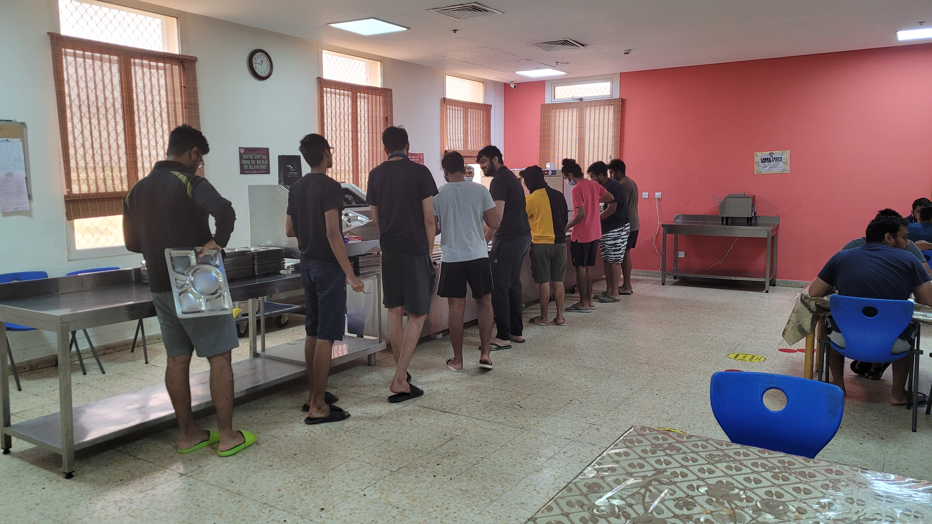

Fig 1 Shows students in boys hostel mess waiting for food.

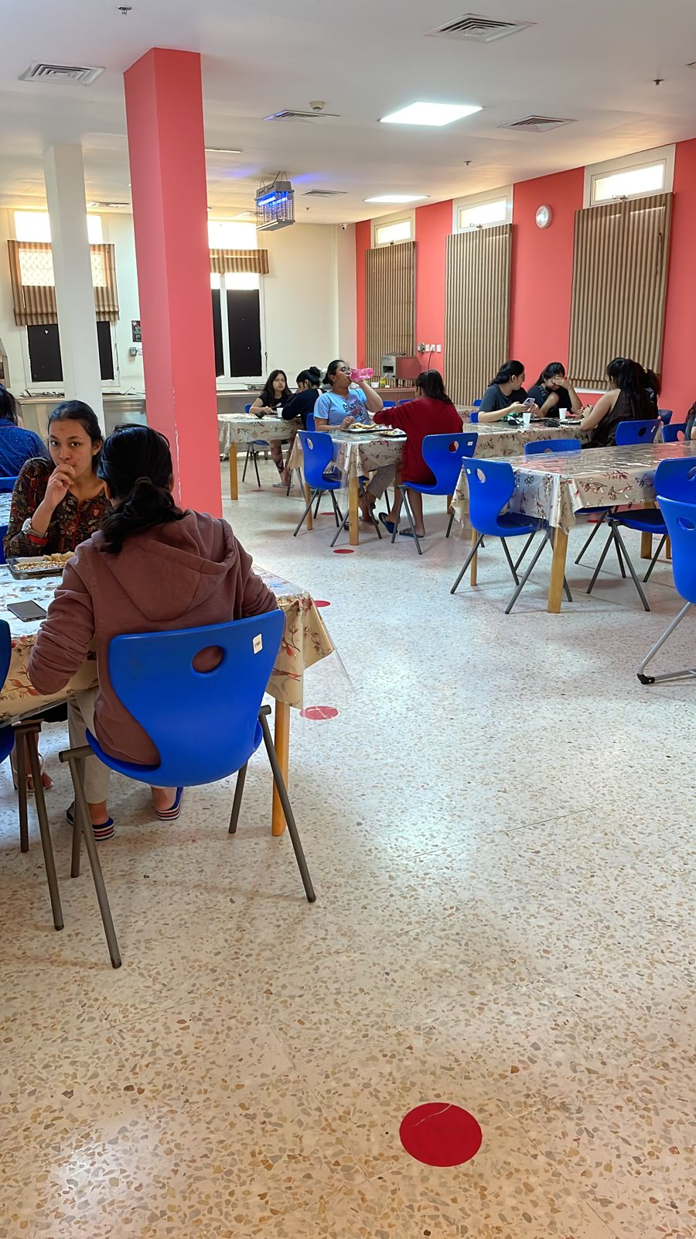

Fig 2 students eating in girls hostel mess

**CHAPTER 2**

**RELATED WORK**

Ref [1] describes an attendance system which uses facial recognition to automate the process of taking and marking attendance. Face recognition is accomplished using image processing techniques in this study. The processed picture is compared to the current stored record, and attendance is recorded accordingly in the database. Ref [2] also refers to an attendance system but using Radio Frequency Identification (RFID) technology which is similar to MIFARE. Furthermore, this system includes essential online capabilities for convenient record keeping, which are available not only to lecturers but also to relevant academic administration staffs for the purpose of monitoring students' development. Ref [3] depicts adaptation of the web-based system architecture in the development of an online attendance system. This article addresses the construction of a new Online Attendance System as an upgrade to the previously created Attendance Register System for Malaysia's higher educational institutions. Ref [4] is another research paper using Radio Frequency Identification (RFID) technology and Arduino to cater automated attendance. Ref [8] describes a smart food fare system which automates billing and serving of orders. Using debit cards or QR codes through authorized payment gateway applications, manual billing is avoided and automated invoicing is accounted for. After the trail of food items is completed, the user must pick which stuff to consume based on a price and a scanner and QR Code for each item in the canteen. This method eliminates bill waste, so indirectly protecting trees and saving the environment. Ref [9] by Y Zhao analyzed CK college canteens in food hygiene and freshness of raw materials, food preservation, tableware disinfection, sanitation workers health problems of various levels, and other methods. The main measures proposed are: perfecting the supervision and management system, implementing food safety-related systems; personnel safety awareness training, designing personnel incentive mechanisms, and personnel supervision, reward, and punishment systems; and personnel safety awareness training, design personnel incentive mechanisms, and personnel supervision, reward, and punishment systems. To minimize costs and boost profits, improve hardware facilities, popularize information construction, and change the operating mode. According to Karen Karatkiewiczk, having a well-designed dining facility is very important for a university to attract and retain its students. She also noted that having a good dining hall can help create a conducive learning environment Ref [10]. The concept of the proposed model can be utilized by schools, colleges, and small and medium-sized organizations for meal planning on a daily and monthly basis It allows the management to generate reports related to the food consumption and planning. Use of this Canteen Management System lets the customer to monitor each individual's food consumption levels, reducing food waste and accounting issues, as well as providing a paperless transaction function Ref [11]. Ref [12] describes an ideal school canteen management system which involves connecting an electronic device to a software, that automates work like maintenance of employee records and generation of reports. Ref [13] by Bisong-Abang Anthonia O enables the end users to register online, read and select the food from the e-menu card and order food online by just selecting the food that the user want to have. The results after selecting the food from the E-menu card will directly appear in the screen near the chef who is going to cook the food for you. The system is the combination of android, iOS, as well as web application The goal of this study is to establish a catering quality scale for Chinese universities. Food safety management includes kitchen safety, storage wellbeing, and food hygiene. This method will involve extracting various quality indicators from the literature and using the Delphi method to analyze them Ref [14].

By conducting a literature survey, the above related work was compiled. The proposed system in this report is very unique in its method to combine both student multitude estimation for a specific time for a specific menu along with student feedback form. These measures are key for the hostel staff in determining the estimation of food to be prepared and dishes for menu. None of the above discussed reports/projects possess both these features along with the convenience of just a single tap using student id card or virtual mobile based cards. Existing systems use RFID whereas this model advocates the use of MIFARE as it is tailor made for usage in BITS university whose student id cards possess this ability. Ideally these measures should help manage and automate food preparation in an optimized fashion.

**CHAPTER 3**

**SYSTEM DESIGN**

The design of the proposed system has been evaluated and compared with other web-based systems. There were also comparisons made between the various technologies used in the system and their corresponding structures. In addition, various research activities related to the system's development have been conducted to help improve the system's performance. For creating and querying data, most databases employ structured query language (SQL).

3.1 HARDWARE

3.1.1 MFX READER

Through the user's cell phone, this truly contactless reader validates safe identity (Android or iOS). With two-factor authentication, it's the easiest, most cost-effective, and fastest way to allow access. The reader does not save any personal information, guaranteeing data compliance while also boosting efficiency and productivity. It's the most recent addition to the USB Reader family, and it reads both mobile phones and ID cards. With two-factor authentication, it's the easiest, most cost-effective, and fastest way to allow access.

There are several sorts of access cards available, each with its own set of access technologies. Many of these are supported by the MFX mobile and card readers such as s HID, MIFARE, LEGIC etc.

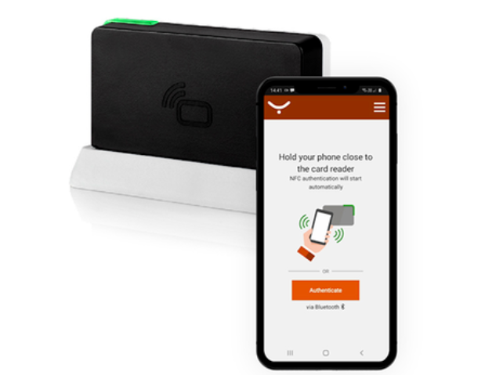

Fig 3 YSOFT MFX reader

3.1.2 STUDENT ID CARD

Student of id cards of Bits Pilani use MIFARE technology for various purposes such as log in/out of library, smart printer etc. ID cards can also store money for using the smart printer and other campus expenses.

MIFARE was first presented in 1994 as a contactless card technology. It was originally designed to be used for transportation permits, but its technical capabilities rapidly made it one of the most widely used smart cards for data storage and access control. NXP Semiconductors develops all MIFARE cards, which operate at a frequency of 13.56MHz.

MIFARE technology has the advantage of allowing for multiple application usage that other cards do not. Also, the cards need not to be put into a reader; they only have to be available within the reader's range.

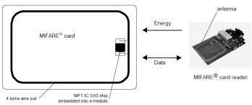

Fig 4 Explains the Mifare ID card and reader diagram structure

3.2 SOFTWARE

3.2.1 WEB SERVER

The word "web server" refers to technology (application) that aids in the distribution of publicly accessible content via the Internet. It facilitates web site functioning by accepting requests from the user's browser and replying with HTML documents (Web pages) and files. The data collector module, a database, and the graphical user interface (GUI) pages that enable online interactions with system users to enable the system's dynamic capabilities using CSS and JAVASCRIPT compose the web server.

The data reporter sends information to the data collector which further stores the data in respective columns and rows in the database accordingly. Database is a logically ordered collection of structured data kept digitally in a computer system. To make computing and information querying efficient, data in the most popular types of databases in use today is often described in rows and columns in a sequence of tables. A database management system (DBMS) is generally in charge of a database. Data regarding number of students consuming mess food may then be accessed, managed, updated, regulated, and organized with ease. For creating and querying data, most databases employ structured query language (SQL).

The GUI component is developed for our portal by means of CSS. It is a style sheet that allows you to separate presentation from content, including layout, colors, and fonts. This division can increase information accessibility and provide you greater degree of control over the display qualities you specify. The developed GUI is part of a responsive webpage by means of JAVASCRIPT and linked to the existing database using PHP. PHP is a server-side software program that supports HTML. It's being used to manage interactive content and databases, and it's suitable for a variety of databases, including MySQL, PostgreSQL, Oracle, Sybase, Informix, and Microsoft SQL Server.

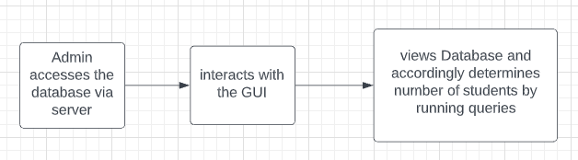

Fig 5 Flowchart displaying chain of events

**CHAPTER 4**

**SYSTEM IMPLEMENTATION**

The system implementation will be carried out based on the system design described before. The complete system installation process flow is depicted.

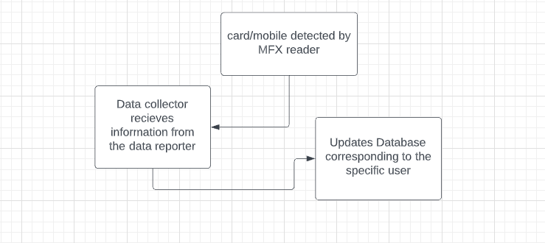

Fig 6 Steps followed from the moment MFX reader detects id

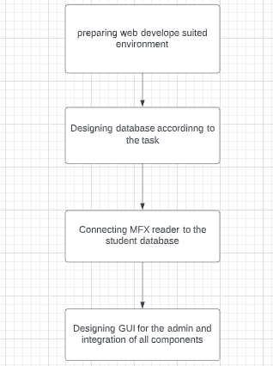

Fig 7 System implementation steps

4.1 MFX Reader

Our proposed system involves a MFX reader which can be installed near the plate racks so that students can record their presence while taking plates. These readers are connected to a hub by means of a LAN port as it needs internet access to connect with the data reporter.

4.2 Web Development

The web application will be developed in accordance with XAMPP server. This allows hosting web server on the local host and allows scripting using PHP. A database is also hosted along with the server by means of XAMPP.

4.3 MySQL Database

This web-based system is connected to a database. The database mainly consists of 4 columns namely roll no., breakfast, lunch and dinner for each day. These data are first collected from the MFX reader by the Data Reporter element, and then sent to the Data Collector, which is in charge of saving the information in the database. A collection of pre-defined SQL queries is also encoded into basic functionalities, enabling for quick data insertions, updates, and retrievals for web page display. Access to this database is only available to the developer and the admin i.e., the mess staff.

A separate table will also be created for storing the feedback form data submitted by students on the web page. This valuable data combined with traffic statistics can be efficiently be used for determining an ideal menu.

4.4 Graphical user interface (GUI)

GUI needs to be designed keeping in mind the user i.e., the hostel mess staff and also students who want to access the webpage for submitting feedback form. The admin shall be provided with pre-defined functions for helpful display of data. A navigation bar will be provided to segregate these needs along with a separate view for displaying the latest mess menu. Bootstrap is a good collection to use for implementing the above-mentioned GUI components. Bootstrap provides preexisting libraries and different components which can be seamlessly integrated with this project.

Fig 8 Complete GUI breakdown

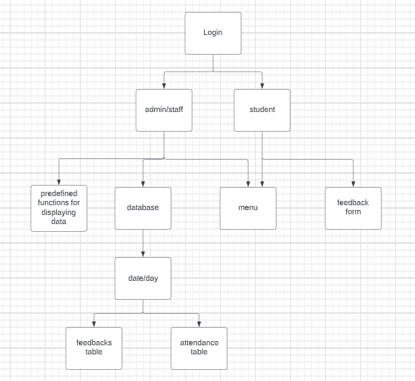

**CHAPTER 5**

**CONCLUSION**

The designed Web-based digital mess system, which uses MFX technology, will not only considerably enhance the present manual tracking procedure, particularly in a university mess setting, but will also minimize food wastage and, ideally, make the estimating process more efficient and accurate. The technology encourages students to use their mobile phones to flash their student cards/virtual ids to the MFX reader, which is a semiautomated method of collecting data regarding student traffic.

It is predicted that by adopting this system food wastage can be reduced significantly while also involving feedbacks from the students to develop an ideal menu for everyone. By hosting this web-based portal the possibilities for human error and manual work is reduced greatly. Since it uses student id cards and virtual ids for data collection it becomes hassle free and convenient. Using a SQL based database has numerous advantages such as running different queries for analyzing data and easy representation.

This approach of food amount estimation depending on the number of students present for the same menu in the past is unquestionably more accurate than the existing technique, which uses data from the previous day. The data is automatically transmitted to an online server, eliminating data loss, and the data is easily available to mess personnel as long as they have internet connection.

***REFERENCES***

1] <https://ieeexplore.ieee.org/abstract/document/8728399>

2] <https://ieeexplore.ieee.org/abstract/document/6287164>

3] <https://ieeexplore.ieee.org/abstract/document/6417619>

4] <https://www.researchgate.net/profile/Nabeel-Ali-10/publication/322862382_Attendance_and_Information_System_Using_RFID_and_Web-Based_Application_for_Academic_Sector/links/5a733cf7aca2720bc0dbb3aa/Attendance-and-Information-System-Using-RFID-and-Web-Based-Application-for-Academic-Sector.pdf>

5] <https://en.wikipedia.org/wiki/MIFARE>

6] <https://www.ysoft.com/en/mfxmobile>

7] <https://www.researchgate.net/figure/Mifare-Card-Communications-1_fig1_267847024>

8]<https://www.researchgate.net/publication/355807427_Smart_Food_fare_Canteen_Automation_of_bills_and_serving>

9] <https://www.globethesis.com/?t=2347330542454347>

10] <https://www.progressiveae.com/optimizing-student-dining-facilities/>

11] <https://www.timechecksoftware.com/latest-news/time-checks-canteen-management-system/>

12] <https://www.posbrands.com/blog/school-canteen-management-system/>

13]<https://portal.bazeuniversity.edu.ng/student/assets/thesis/20210226154356999512575.pdf>

14] <https://www.mdpi.com/2071-1050/14/3/1281/pdf>