**DEPARTMENT OF INFORMATION SCIENCE & ENGINEERING**



***Project Based Learning Report on***

“MINI BANK MANAGEMENT SYSTEM”

**BACHELOR OF ENGINEERING**

**in**

**INFORMATION SCIENCE AND ENGINEERING**

**By**

**Suryansh Shrivastava - 1BY19IS167**

*Under the Guidance of*

**Gireesh babu C.N**

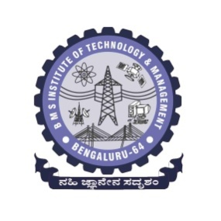

**BMS INSTITUTE OF TECHNOLOGY& MANAGEMENT**

BENGALURU-560064

2020-21

**BMS INSTITUTE OF TECHNOLOGY& MANAGEMENT**

YELAHANKA, BENGALURU- 560064

**DEPARTMENT OF INFORMATION SCIENCE & ENGINEERING**

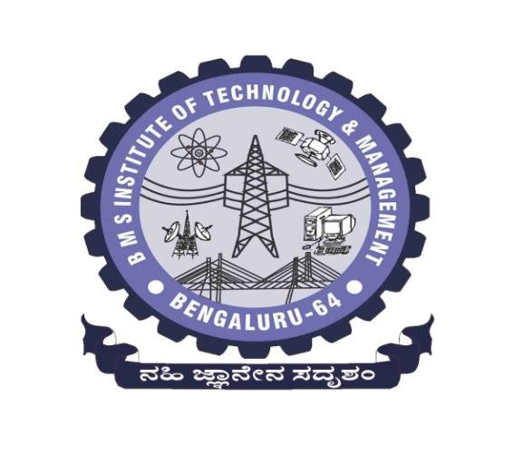

**CERTIFICATE**

This is to certify that the project based learning entitled “ Mini Bank Management System ” is a Bonafede work carried out by **Mr. Suryansh Shrivastava** during the academic year 2020-21. It is certified that all corrections/suggestions indicated for the Internal Assessment have been incorporated in the report deposited in the departmental library.

Signature of the guide Signature of the Coordinator Signature of the HOD

Gireesh Babu CN Prof Swetha M S/Dr. Geeta Patil Dr.Pushpa S K

**Synopsis :-**

Bank Management System is a Project built with the help of Java Swing, which delivers basic financial activities which a bank performs day to day such as Creating Accounts , Deposit , providing Loans etc .

**Functionality Covered in the Project** :-

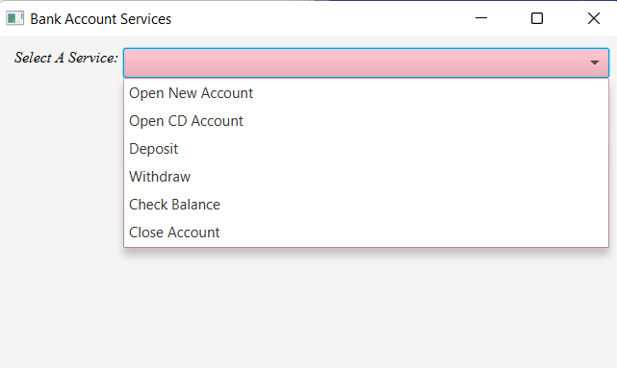

1. **Open New Account** :- Creates a new Bank Account in the bank with initial deposit and a account number .

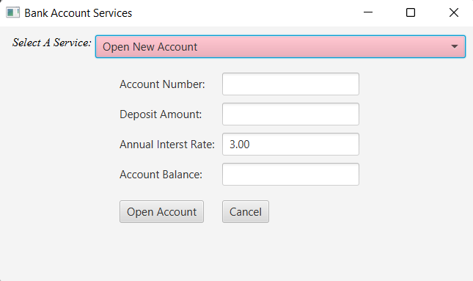

1. **Open a Certificate of Deposit account(Mutual Funds)** :- Creates a CD account which gives timely return based on interest . 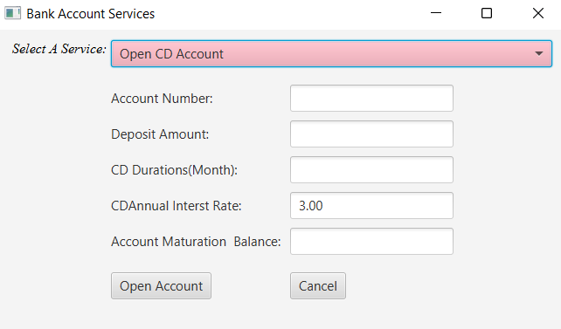
2. **Deposit to Account** :- Deposits amount to the given account number .

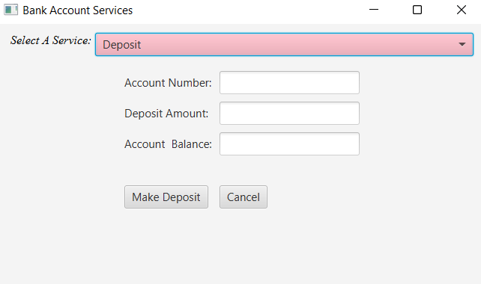

1. **Withdraw from Account :-** Withdraws money from the given account number

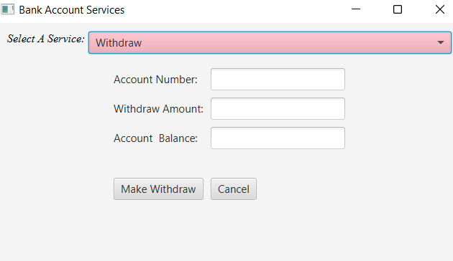

1. **Check Balance :-** Provides with the current balance of the account

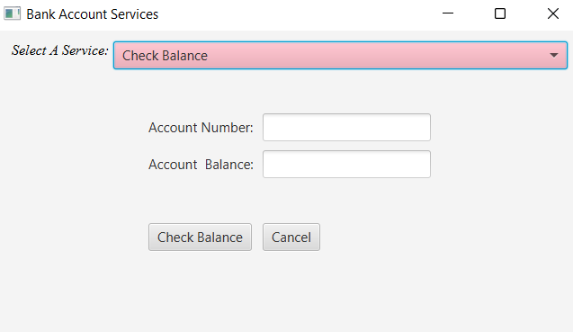

1. **Close Account :-** Terminates the account

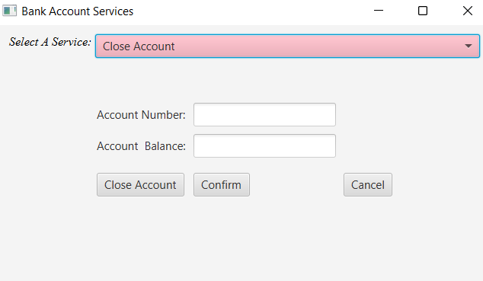

**Full Project Code :-**

Github URL :- https://github.com/Suryansh555/BankManagementSytem/tree/main