**Project 4 Report**

This project’s goal is to handle “requests” to a server. Each request will be a file name. The server determines the type and the size for the given file. Requests are read in from stdin (using cin.getline() in C++) with one file name given on each line of input. Two different architectures were implemented to accomplish the above objective. The default architecture is a Serial Architecture, which is a single process with no threads. The other architecture is a Multi-Threaded Architecture which uses the number of threads provided on the command line (The range is from 1 to 15). All tests were performed on an Intel i7 7700 quad-core processor on linux.wpi.edu on the /dev/ directory. The following results were obtained from Serial Architecture version while performing the following shell commands:

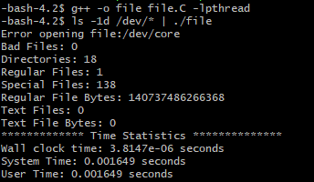

The following graph illustrates the Program performance vs Maximum number of threads when the Multi-Threaded Architecture was run on /dev/ directory.

The decreasing trendline for the Wall clock time shows that Maximum number of threads for a process is inversely proportional to the wall clock time taken by the process to carry out the above objective.