
DAYANANDA SAGAR COLLEGE OF ENGINEERING
(An Autonomous Institute affiliated to Visvesvaraya Technological University (VTU), Belagavi, Approved by AICTE and UGC, Accredited by NAAC with 'A' grade & ISO 9001-2015 Certified Institution)
Shavige Malleshwara Hills, Kumaraswamy Layout, Bengaluru - 560 111. India

DEPARTMENT | ARTIFICIAL INTELLIGENCE AND MACHINE LEARNING
Semester: VII Course Title: Data Security & Privacy Lab Course Code: 22AI73
PROGRAM QUESTION | Build a virus simulation tool — safe, educational, and non-malicious — to help you understand how malware might behave in a system, and how defenders can detect or prevent it.
STUDENT NAMES | Suryanshu Dhargave |  | USN | 1DS22AI055
LAB  MARKS | Program Execution (10) | Source Code (10) | Result (5) | Innovation/ Extra Features (5) | Total
TOOLS USED | Visual Studio Code
MAP COURSE OUTCOME | CO1
MAP PROGRAM OUTCOME | PO1,PO2, PO3, PO4, PO5
MAP PROGRAM SPECIFIC OUTCOME | PSO1, PSO2
UML / SEQUENCE DIGRAM | 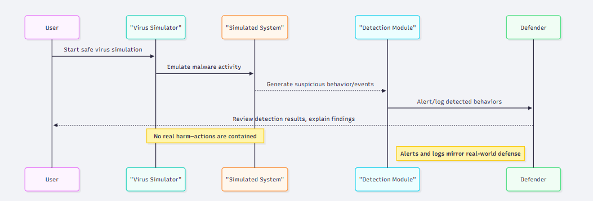
COURSE COORDINATOR | Dr ARUNA M G & Prof ENSTEIH SILVIA

Code for Program 3:

Build a virus simulation tool — safe, educational, and non-malicious — to help you understand how malware might behave in a system, and how defenders can detect or prevent it.

import streamlit as st, networkx as nx, random, pandas as pd
from dataclasses import dataclass, field

S,I,P,Q = "Susceptible","Infected","Patched","Quarantined"
class Simulation:
G: nx.Graph; node_attrs: dict = field(default_factory=dict); time_step: int = 0; history: list = field(default_factory=list)
def reset(self, inf, seed):
random.seed(seed)
self.node_attrs = {n:S for n in self.G.nodes()}
for s in random.sample(list(self.G.nodes()), min(inf, self.G.number_of_nodes())): self.node_attrs[s]=I
self.time_step, self.history = 0, [self.snapshot()]
def snapshot(self): return {"t": self.time_step, **{k:self.node_attrs.values().count(k) for k in [S,I,P,Q]}}

def step(sim, pt, pp, pq):
sim.time_step +=1; new={}
for n,s in sim.node_attrs.items():
if s==I:
new.update({nb:I for nb in sim.G.neighbors(n) if sim.node_attrs[nb]==S and random.random()<pt})
if random.random()<pq: new[n]=Q
elif s==S and random.random()<pp: new[n]=P
sim.node_attrs.update(new); sim.history.append(sim.snapshot()); return sim

st.title("🛡️ Malware Simulator")
topo,n,inf,pt,pp,pq,seed = st.selectbox("Topology", ["Random","Scale-free"]), st.slider("Nodes",10,100,30), st.slider("Init Infected",1,10,2), st.slider("Transmit Prob.",0.0,1.0,0.1), st.slider("Patch Prob.",0.0,0.5,0.05), st.slider("Quarantine Prob.",0.0,1.0,0.5), st.number_input("Seed",0,999999,42)
G = nx.erdos_renyi_graph(n,0.1,seed) if topo=="Random" else nx.barabasi_albert_graph(n,2,seed)

if "sim" not in st.session_state or st.button("Reset"):
sim=Simulation(G); sim.reset(inf,seed); st.session_state.sim=sim
else: sim=st.session_state.sim

if st.button("Step"):
sim=step(sim,pt,pp,pq); st.session_state.sim=sim

st.line_chart(pd.DataFrame(sim.history).set_index("t")[[S,I,P,Q]])
st.dataframe(pd.DataFrame({"Node": list(sim.node_attrs.keys()), "State": list(sim.node_attrs.values())}))

RESULT:
