
DAYANANDA SAGAR COLLEGE OF ENGINEERING
(An Autonomous Institute affiliated to Visvesvaraya Technological University (VTU), Belagavi, Approved by AICTE and UGC, Accredited by NAAC with 'A' grade & ISO 9001-2015 Certified Institution)
Shavige Malleshwara Hills, Kumaraswamy Layout, Bengaluru - 560 111. India

DEPARTMENT | ARTIFICIAL INTELLIGENCE AND MACHINE LEARNING
Semester: VII Course Title: Data Security & Privacy Lab Course Code: 22AI73
PROGRAM QUESTION | Build a Vulnerability Analyser Tool in Python that can scan source code files (any programming language) for common security vulnerabilities or bad coding patterns.
STUDENT NAMES | Suryanshu Dhargave |  | USN | 1DS22AI055
LAB  MARKS | Program Execution (10) | Source Code (10) | Result (5) | Innovation/ Extra Features (5) | Total
TOOLS USED | Visual Studio Code
MAP COURSE OUTCOME | CO1
MAP PROGRAM OUTCOME | PO1,PO2, PO3, PO4, PO5
MAP PROGRAM SPECIFIC OUTCOME | PSO1, PSO2
UML / SEQUENCE DIGRAM | 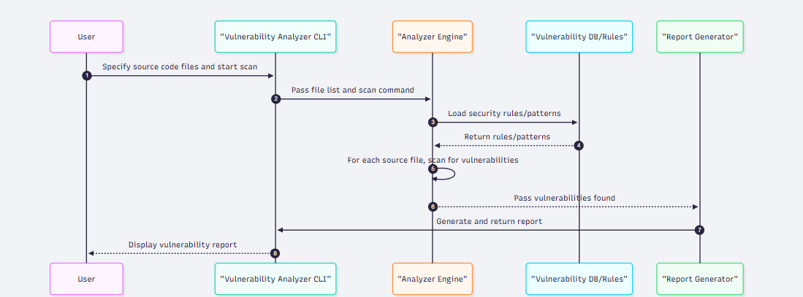
COURSE COORDINATOR | Dr ARUNA M G & Prof ENSTEIH SILVIA

Code for Program 4:

4) Build a Vulnerability Analyser Tool in Python that can scan source code files (any programming language) for common security vulnerabilities or bad coding patterns.

import streamlit as st, tempfile, json, re
from pathlib import Path
import pandas as pd
class Rule:
def __init__(self, id, name, pattern, severity, fix):
self.name = name
self.pattern = re.compile(pattern, re.IGNORECASE | re.MULTILINE)
self.severity, self.fix = severity, fix
def matches(self, text): return list(self.pattern.finditer(text))
class Scanner:
def __init__(self, rules): self.rules = rules
def scan_file(self, path):
try: text = path.read_text(encoding="utf-8", errors="ignore")
except: return []
lines = text.splitlines()
res = []
for r in self.rules:
for m in r.matches(text):
line = text.count("\n", 0, m.start()) + 1
snippet = lines[line-1] if 0 <= line-1 < len(lines) else ""
res.append({"severity": r.severity, "line": line, "rule_name": r.name,
"snippet": snippet.strip(), "recommended_fix": r.fix})
return res
rules = [
Rule("R001", "Use of eval/exec", r"\b(eval|exec)\(", "HIGH", "Avoid eval/exec."),
Rule("R002", "Hardcoded secrets", r"(api[_-]?key|password|secret)\s*=\s*['\"].+['\"]", "CRITICAL", "Use env vars."),
Rule("R003", "Weak hash algorithm", r"\b(md5|sha1)\(", "HIGH", "Use SHA-256, bcrypt, etc."),
]
if files:
with tempfile.TemporaryDirectory() as tmpdir:
for f in files:
p = Path(tmpdir) / f.name
p.write_bytes(f.read())
findings += Scanner(rules).scan_file(p)
if findings:
st.success(f"Found {len(findings)} issues.")
st.dataframe(pd.DataFrame(findings))
st.download_button("Download JSON Report", json.dumps(findings, indent=2), "findings.json", "application/json")
else: st.info("No issues found.")

RESULT:
