
DAYANANDA SAGAR COLLEGE OF ENGINEERING
(An Autonomous Institute affiliated to Visvesvaraya Technological University (VTU), Belagavi, Approved by AICTE and UGC, Accredited by NAAC with 'A' grade & ISO 9001-2015 Certified Institution)
Shavige Malleshwara Hills, Kumaraswamy Layout, Bengaluru - 560 111. India

DEPARTMENT | ARTIFICIAL INTELLIGENCE AND MACHINE LEARNING
Semester: VII Course Title: Data Security & Privacy Lab Course Code: 22AI73
PROGRAM QUESTION | Phishing Website Detection using Python: Use a dataset of phishing and legitimate websites. Train a simple ML model using scikit-learn to classify URLs based on features like length, presence of @, https, etc.
STUDENT NAMES | Suryanshu Dhargave |  | USN | 1DS22AI055
LAB  MARKS | Program Execution (10) | Source Code (10) | Result (5) | Innovation/ Extra Features (5) | Total
TOOLS USED | Visual Studio Code
MAP COURSE OUTCOME | CO1
MAP PROGRAM OUTCOME | PO2, PO3, PO4, PO5
MAP PROGRAM SPECIFIC OUTCOME | PSO1, PSO2
UML / SEQUENCE DIGRAM | 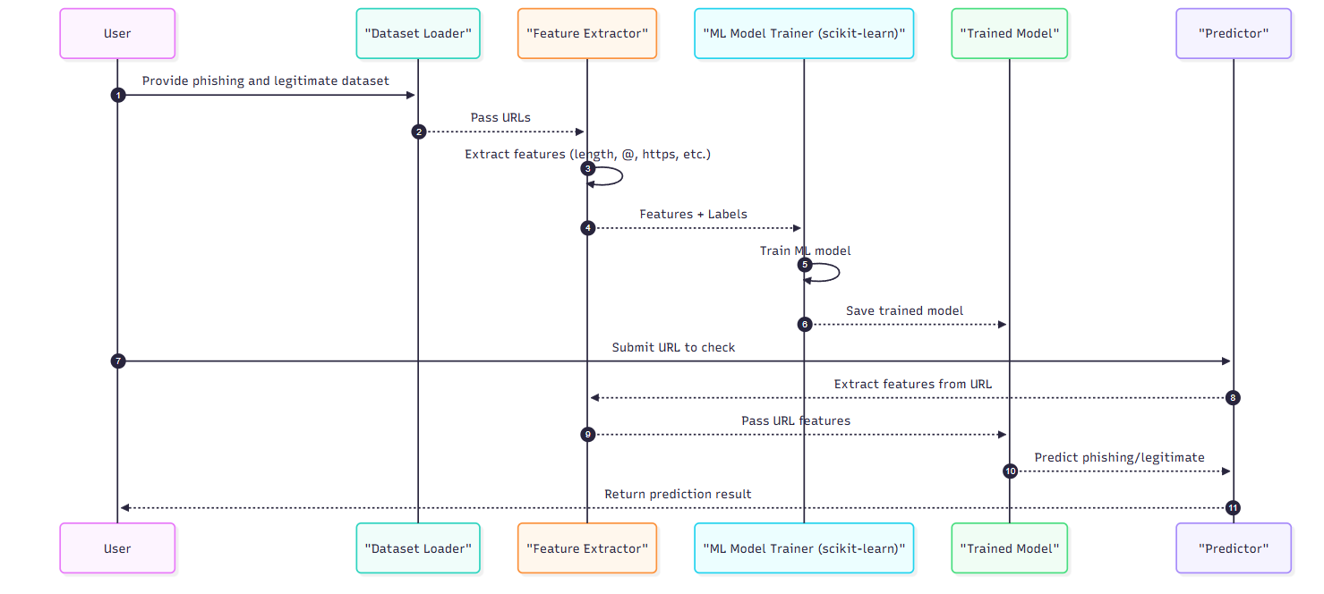
COURSE COORDINATOR | Dr ARUNA M G & Prof ENSTEIH SILVIA

Code for Program 5:

5) Phishing Website Detection using Python: Use a dataset of phishing and legitimate websites. Train a simple ML model using scikit-learn to classify URLs based on features like length, presence of @, https, etc

import streamlit as st, pandas as pd
from sklearn.model_selection import train_test_split
from sklearn.linear_model import LogisticRegression
from sklearn.metrics import accuracy_score

def extract_features(url):
return {"url_length": len(url), "has_at": int("@" in url), "has_https": int(url.startswith("https")),
"num_dots": url.count("."), "has_hyphen": int("-" in url)}

@st.cache_data
def load_data():
data = {"url": ["http://example.com", "https://secure-login.com", "http://phishing.com@evil.com",
"http://paypal.login.verify.com", "https://google.com", "http://192.168.0.1/login",
"https://microsoft.com", "http://update-your-bank.com"],
"label": [0, 0, 1, 1, 0, 1, 0, 1]}
df = pd.DataFrame(data)
features = df["url"].apply(lambda x: pd.Series(extract_features(x)))
return pd.concat([df, features], axis=1)

@st.cache_resource
def train_model(df):
X, y = df[["url_length", "has_at", "has_https", "num_dots", "has_hyphen"]], df["label"]
model = LogisticRegression().fit(*train_test_split(X, y, test_size=0.3, random_state=42)[:2])
acc = accuracy_score(y, model.predict(X))
return model, acc

st.title("🔎 Phishing Website Detector")
df = load_data()
model, acc = train_model(df)
st.sidebar.info(f"Model accuracy: {acc*100:.2f}%")

url_input = st.text_input("Enter URL:")
if st.button("Check URL") and url_input.strip():
X_new = pd.DataFrame([extract_features(url_input)])
pred = model.predict(X_new)[0]
st.error("🚨 Phishing Site!") if pred else st.success("✅ Legitimate Site!")
with st.expander("🔍 Features"): st.json(X_new.to_dict(orient='records')[0])

RESULT:

