
DAYANANDA SAGAR COLLEGE OF ENGINEERING
(An Autonomous Institute affiliated to Visvesvaraya Technological University (VTU), Belagavi, Approved by AICTE and UGC, Accredited by NAAC with 'A' grade & ISO 9001-2015 Certified Institution)
Shavige Malleshwara Hills, Kumaraswamy Layout, Bengaluru - 560 111. India
DEPARTMENT | ARTIFICIAL INTELLIGENCE AND MACHINE LEARNING
Semester: VII Course Title: Data Security & Privacy Lab Course Code: 22AI73
PROGRAM QUESTION | Hash Functions and Obfuscation:a)Implement common hash functions (e.g., SHA-256, MD5) using Python's hashlib. Input: A string or file. Output: Its hash value.
STUDENT NAME | Suryanshu Dhargave |  | USN | 1DS22AI055
LAB  MARKS | Program Execution (10) | Source Code (10) | Result (5) | Innovation/ Extra Features (5) | Total
TOOLS USED | Visual Studio Code
MAP COURSE OUTCOME | CO1
MAP PROGRAM OUTCOME | PO2, PO3, PO5, PO9, PO11
MAP PROGRAM SPECIFIC OUTCOME | PSO1, PSO2, PSO3
UML / SEQUENCE DIGRAM | 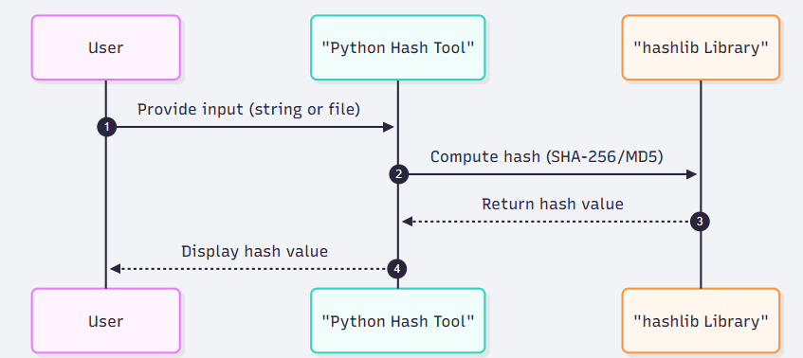
COURSE COORDINATOR | Dr ARUNA M G & Prof ENSTEIH SILVIA

Code for Program 7:

7) Hash Functions and Obfuscation:a)Implement common hash functions (e.g., SHA-256, MD5) using Python's hashlib. Input: A string or file. Output: Its hash value.
b) Explore obfuscation techniques

import streamlit as st, hashlib, base64
def hash_text(text, algo): return hashlib.new(algo, text.encode()).hexdigest()
def hash_file(file, algo): return hashlib.new(algo, file.read()).hexdigest()
def obfuscate_code(code):
encoded = base64.b64encode(code.encode()).decode()
return f'import base64\nexec(base64.b64decode("{encoded}").decode())'
st.title("🔐 Hash & Code Obfuscator")
choice = st.sidebar.radio("Select Mode", ["Hash Generator", "Code Obfuscator"])
if choice == "Hash Generator":
input_type = st.radio("Input type", ["Text", "File"])
if input_type == "Text":
txt = st.text_area("Enter text")
if st.button("Generate Hash") and txt:
st.write("MD5:", hash_text(txt, "md5"))
st.write("SHA-256:", hash_text(txt, "sha256"))
else:
f = st.file_uploader("Upload file")
if f and st.button("Generate File Hash"):
st.write("MD5:", hash_file(f, "md5"))
f.seek(0)
st.write("SHA-256:", hash_file(f, "sha256"))
else: # Code Obfuscator
code = st.text_area("Paste Python code")
if st.button("Obfuscate") and code.strip():
st.subheader("🔎 Original Code"); st.code(code, language="python")
st.subheader("🕵️ Obfuscated Code"); st.code(obfuscate_code(code), language="python")

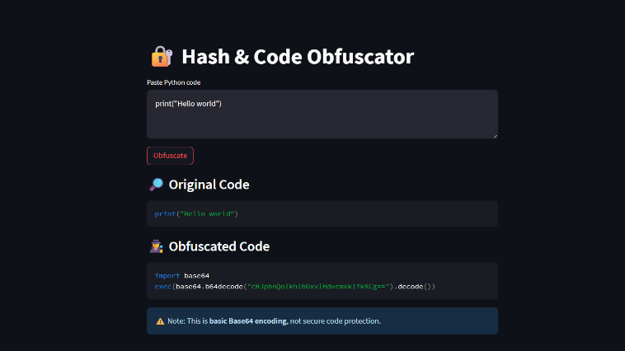
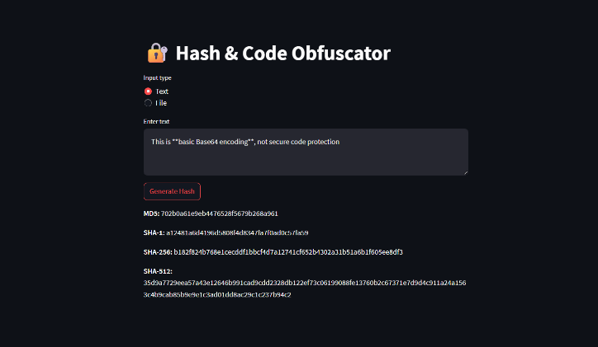
RESULT:

