
DAYANANDA SAGAR COLLEGE OF ENGINEERING
(An Autonomous Institute affiliated to Visvesvaraya Technological University (VTU), Belagavi, Approved by AICTE and UGC, Accredited by NAAC with 'A' grade & ISO 9001-2015 Certified Institution)
Shavige Malleshwara Hills, Kumaraswamy Layout, Bengaluru - 560 111. India

DEPARTMENT | ARTIFICIAL INTELLIGENCE AND MACHINE LEARNING
Semester: VII Course Title: Data Security & Privacy Lab Course Code: 22AI73
PROGRAM QUESTION | Implement digital signature generation and verification using RSA,Use cryptography or PyCrypto libraries. b) Simulate authentication and authorization using a web application
STUDENT  NAME | Suryanshu Dhargave |  | USN | 1DS22AI055
LAB  MARKS | Program Execution (10) | Source Code (10) | Result (5) | Innovation/ Extra Features (5) | Total
TOOLS USED | Visual Studio Code
MAP COURSE OUTCOME | CO1
MAP PROGRAM OUTCOME | PO1, PO2, PO3, PO5, PO6, PO7, PO9, PO10, PO11
MAP PROGRAM SPECIFIC OUTCOME | PSO1, PSO2, PSO3
UML / SEQUENCE DIGRAM | 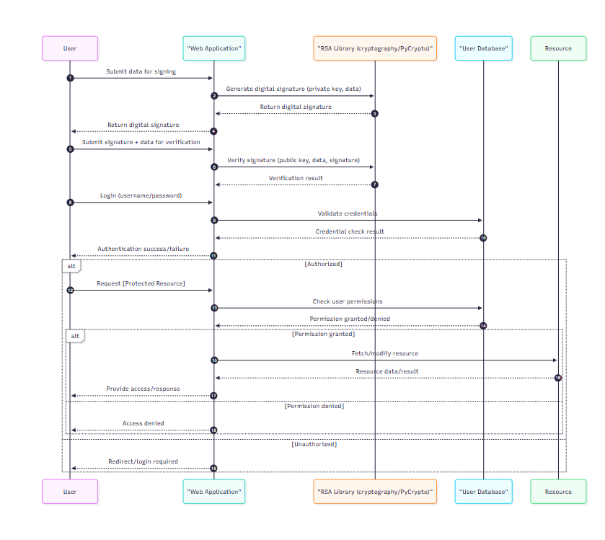
COURSE COORDINATOR | Dr ARUNA M G & Prof ENSTEIH SILVIA

Code for Program 8:

8) Implement digital signature generation and verification using RSA. Use cryptography or PyCrypto libraries. b) Simulate authentication and authorization using a web application

import streamlit as st
import jwt
from cryptography.hazmat.primitives import hashes
from cryptography.hazmat.primitives.asymmetric import rsa, padding
import datetime

SECRET_KEY = "your-secret-key"

if 'state' not in st.session_state:
st.session_state.update({'private_key': None, 'public_key': None, 'signature': None, 'token': None, 'users': []})

st.title("Digital Signatures & Auth Demo")
option = st.sidebar.selectbox("Choose", ["Digital Signatures", "Auth & Authorization"])

if option == "Digital Signatures":
if st.button("Generate RSA Keys"):
key = rsa.generate_private_key(public_exponent=65537, key_size=2048)
st.session_state.update({'private_key': key, 'public_key': key.public_key()})
st.success("Keys generated!")

if st.session_state.private_key:
msg = st.text_area("Message to sign")
if st.button("Sign"):
st.session_state.signature = st.session_state.private_key.sign(
msg.encode(), padding.PSS(mgf=padding.MGF1(hashes.SHA256()), salt_length=padding.PSS.MAX_LENGTH), hashes.SHA256())
st.success("Signed!")

verify = st.text_area("Verify message")
if st.button("Verify") and st.session_state.signature:
try:
st.session_state.public_key.verify(
st.session_state.signature, verify.encode(),
padding.PSS(mgf=padding.MGF1(hashes.SHA256()), salt_length=padding.PSS.MAX_LENGTH),
hashes.SHA256())
st.success("Valid signature!")
except:
st.error("Invalid signature!")

else:
with st.expander("Register User"):
u = st.text_input("Username")
p = st.text_input("Password", type="password")
c = st.text_input("Confirm", type="password")
if st.button("Register"):
if p != c:
st.error("Mismatch")
elif any(x['username'] == u for x in st.session_state.users):
st.error("Exists")
else:
st.session_state.users.append({'username': u, 'password': p})
st.success("Registered!")

RESULT:
