
DAYANANDA SAGAR COLLEGE OF ENGINEERING
(An Autonomous Institute affiliated to Visvesvaraya Technological University (VTU), Belagavi, Approved by AICTE and UGC, Accredited by NAAC with 'A' grade & ISO 9001-2015 Certified Institution)
Shavige Malleshwara Hills, Kumaraswamy Layout, Bengaluru - 560 111. India

DEPARTMENT | ARTIFICIAL INTELLIGENCE AND MACHINE LEARNING
Semester: VII Course Title: Data Security & Privacy Lab Course Code: 22AI73
PROGRAM QUESTION | 9) a) dentifying and Classifying PII Data: Given a dataset, students will write a script to classify data into types (structured/unstructured), states (in-transit, at-rest, in-use), and highlight PII elements.  b)Anonymization with k-Anonymity: Use a sample dataset with PII (like healthcare data). Apply k anonymity using Python or tools like ARX. Evaluate re-identification risk before and after anonymization
STUDENT NAMES | Suryanshu Dhargave |  | USN | 1DS22AI055
LAB  MARKS | Program Execution (10) | Source Code (10) | Result (5) | Innovation/ Extra Features (5) | Total
TOOLS USED | VS Code
MAP COURSE OUTCOME | CO2
MAP PROGRAM OUTCOME | PO1, PO2, PO3, PO5
MAP PROGRAM SPECIFIC OUTCOME
  PSO1, PSO2
UML / SEQUENCE DIGRAM | 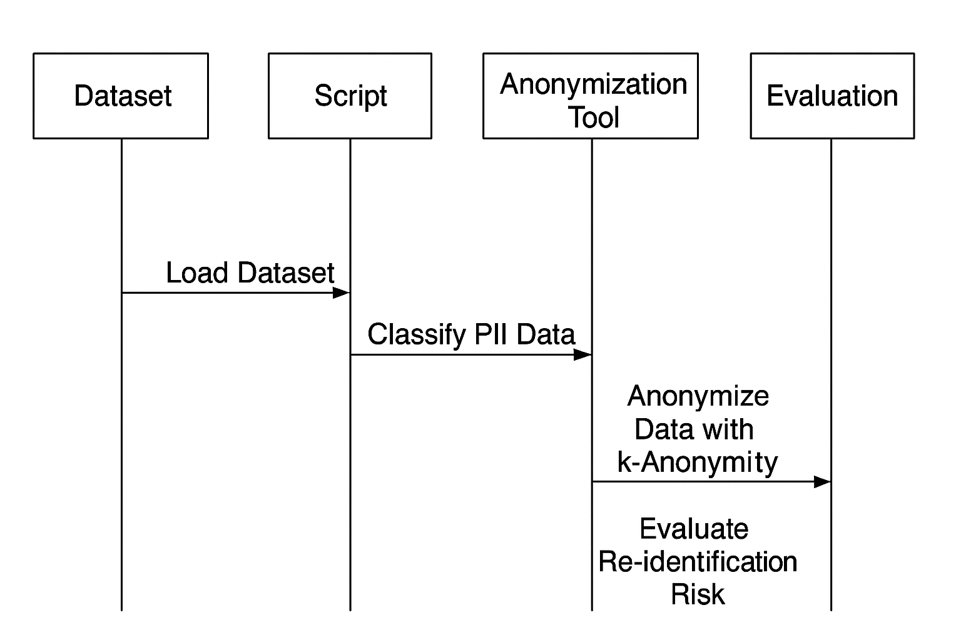
COURSE COORDINATOR | Dr ARUNA M G & Prof ENSTEIH SILVIA

Program 9:
import streamlit as st
import pandas as pd
import numpy as np

# ------------------------------
# Helper functions
# ------------------------------

def generalize_zip(zipcode, level):
if pd.isna(zipcode): return zipcode
s = str(zipcode)
return s[:2] + "*" * (len(s)-2) # always 56**** style

def generalize_age(age, bin_size):
if pd.isna(age): return age
start = (age // bin_size) * bin_size
return f"{start}-{start+bin_size-1}"

def equivalence_classes(df, qis):
grouped = df.groupby(qis).size().reset_index(name="count")
merged = df.merge(grouped, on=qis, how="left")
return merged, grouped

def reidentification_risk(df, qis):
if not qis: return {"min_eq_size": 0, "avg_eq_size": 0, "naive_risk": 1.0, "unique_fraction": 1.0}
_, grouped = equivalence_classes(df, qis)
if grouped.empty: return {"min_eq_size": 0, "avg_eq_size": 0, "naive_risk": 1.0, "unique_fraction": 1.0}
min_size = int(grouped["count"].min())
avg_size = float(grouped["count"].mean())
naive_risk = 1.0 / min_size if min_size > 0 else 1.0
unique_frac = (grouped["count"] == 1).sum() / len(df)
return {"min_eq_size": min_size, "avg_eq_size": avg_size, "naive_risk": naive_risk, "unique_fraction": unique_frac}

def l_diversity_check(df, qis, sensitive, l):
merged = df.groupby(qis)[sensitive].nunique().reset_index(name="distinct")
failing = merged[merged["distinct"] < l]
return {"total_classes": len(merged), "failing_classes": len(failing), "failing_fraction": len(failing)/len(merged) if len(merged)>0 else 0}

def t_closeness_check(df, qis, sensitive, t):
global_dist = df[sensitive].value_counts(normalize=True)
failing = 0
grouped = df.groupby(qis)
for _, group in grouped:
class_dist = group[sensitive].value_counts(normalize=True)
all_idx = global_dist.index.union(class_dist.index)
gd = global_dist.reindex(all_idx, fill_value=0)
cd = class_dist.reindex(all_idx, fill_value=0)
tvd = 0.5 * (gd - cd).abs().sum()
if tvd > t:
failing += 1
return {"num_classes": len(list(grouped)), "failing_classes": failing, "failing_fraction": failing/len(list(grouped)) if len(list(grouped))>0 else 0}

def apply_differential_privacy(df, numeric_cols, epsilon):
df2 = df.copy()
scale = 1.0 / epsilon
for col in numeric_cols:
if col in df2.columns:
noise = np.random.laplace(0, scale, size=len(df2))
df2[col+"_dp"] = (df2[col]+noise).round().astype(int)
return df2

# ------------------------------
# Streamlit UI
# ------------------------------

st.set_page_config(page_title="Stepwise PII Anonymizer", layout="wide")
st.title("🔐 Stepwise PII Anonymizer Demo")

# Dataset upload / generation
uploaded_file = st.file_uploader("Upload CSV dataset", type=["csv"])
size = st.sidebar.slider("Number of rows for sample dataset", 10, 1000, 20)

if uploaded_file:
df = pd.read_csv(uploaded_file)
else:
np.random.seed(42)
df = pd.DataFrame({
"Name": [f"Person_{i+1}" for i in range(size)],
"Age": np.random.randint(20,80,size),
"Gender": np.random.choice(["M","F"], size),
"Zip": np.random.choice(["56001","56002","56003","56004","56005"], size),
"Diagnosis": np.random.choice(["Flu","Diabetes","COVID","Healthy"], size)
})

st.subheader("📄 Original Dataset")
st.dataframe(df.head(10))

# Sidebar selections
available_cols = df.columns.tolist()
quasi_identifiers = st.sidebar.multiselect("Select Quasi-Identifiers", available_cols, default=[c for c in ["Age","Gender","Zip"] if c in available_cols])
sensitive_attr = st.sidebar.selectbox("Select Sensitive Attribute", available_cols, index=available_cols.index("Diagnosis") if "Diagnosis" in available_cols else 0)
numeric_cols = st.sidebar.multiselect("Numeric Columns for Differential Privacy", available_cols, default=[c for c in ["Age"] if c in available_cols])

k = st.sidebar.slider("k-anonymity (k)", 2, 10, 3)
l = st.sidebar.slider("l-diversity (l)", 1, 5, 2)
t = st.sidebar.slider("t-closeness (t)", 0.0, 1.0, 0.25, step=0.05)
epsilon = st.sidebar.slider("ε (Differential Privacy)", 0.1, 5.0, 1.0, step=0.1)

# ------------------------------
# Stepwise Anonymization
# ------------------------------

if st.button("🔒 Apply Stepwise Anonymization"):

st.subheader("Step 0: Original Risk")
st.json(reidentification_risk(df, quasi_identifiers))

# ---------------- K-anonymity ----------------
df_k = df.copy()
if "Zip" in quasi_identifiers:
df_k["Zip_g"] = df_k["Zip"].apply(lambda z: generalize_zip(z, 4))
if "Age" in quasi_identifiers:
df_k["Age_g"] = df_k["Age"].apply(lambda a: generalize_age(a, 5))
k_cols = ["Age_g" if "Age" in quasi_identifiers else None,
"Zip_g" if "Zip" in quasi_identifiers else None] + [q for q in quasi_identifiers if q not in ["Age","Zip"]]
k_cols = [c for c in k_cols if c]
st.subheader("Step 1: After k-Anonymity")
st.dataframe(df_k.head(10))
st.json(reidentification_risk(df_k, k_cols))

# ---------------- L-diversity ----------------
st.subheader("Step 2: L-Diversity Check")
l_stats = l_diversity_check(df_k, k_cols, sensitive_attr, l)
st.json(l_stats)

# ---------------- T-closeness ----------------
st.subheader("Step 3: T-Closeness Check")
t_stats = t_closeness_check(df_k, k_cols, sensitive_attr, t)
st.json(t_stats)

# ---------------- Differential Privacy ----------------
df_dp = apply_differential_privacy(df_k, numeric_cols, epsilon)
st.subheader("Step 4: After Differential Privacy")
st.dataframe(df_dp.head(10))

st.success("✅ Stepwise Anonymization Completed")

Output :
