Toyota U.S. Dealer Network Expansion Report
From state-level EV clustering to city-level entry screening,
capacity regression, and phased profit scenarios
This report consolidates the full second-stage workflow built on top of the clustering study:
(1) integrating state-level clustering outputs into the city-level modelling table,
(2) engineering features and building a city classifier for dealer presence,
(3) predicting dealer counts for candidate cities, and
(4) translating the resulting network opportunity into near-term and long-term revenue and profit scenarios.
Prepared from the project files, modelling outputs, and screenshots shared during the analysis workflow.
17 March 2026
• The clustering study identified Cluster 1 as the main mature-EV target segment and Cluster 0 as the main secondary expansion segment.
• State-level clustering outputs were merged into the city-level table and used as new modelling inputs, producing a master dataset of roughly 31k city-state observations.
• After group-based train/validation/test splitting and leakage removal, the final Stage 1 classifier used city capacity variables plus the reduced state cluster indicator to screen cities with a high probability of supporting a Toyota dealership.
• For Stage 2, dealer-count prediction was restricted to cities with dealer_count > 0. Feature engineering showed that city-capacity variables alone performed best. The final tuned model was a Random Forest regressor using log_population, log_density, and incorporated.
• The final recommendation pool contained 1,563 candidate city rows and 1,577 long-run recommended new dealerships, with California, Florida, Texas, Illinois, and Ohio appearing among the largest state-level opportunity pools.
• A one-year rollout of the full long-run target was not financially realistic. A phased 10-year rollout produced a more credible investment profile: early years are cost-heavy, but base and optimistic scenarios become profit-accretive over time.

Contents
- 1. Objective and workflow
- 2. Data integration: from state clustering to a city-level modelling table
- 3. Stage 1 classification model for dealership presence
- 4. Stage 2 regression model for dealership count
- 5. Final state recommendations and map interpretation
- 6. Short-term and long-term profit scenarios
- 7. Conclusions and managerial implications

1. Objective and Workflow
The purpose of the second-stage analysis was to convert a state-level EV market segmentation study into an actionable Toyota network expansion framework.
The work proceeded in four connected steps. First, the outputs from the clustering study were converted into state-level indicators and merged back into the city-level input table.
Second, a classification model was built to identify cities with a high probability of supporting at least one Toyota dealer.
Third, a count model was trained on cities that already had dealers in order to estimate how many dealers a city could plausibly sustain.
Finally, the resulting recommendation set was translated into annual rollout and multi-year profit scenarios.
- Clustering insight layer: use state clusters and cluster summary scores to distinguish mature, emerging, niche, and rural EV markets.
- City entry screening: predict whether a city should plausibly host a Toyota dealer.
- Capacity estimation: for cities with dealer_count > 0, estimate the number of dealers supportable by the local market.
- Rollout and finance layer: aggregate recommendations and phase them into short-run and long-run expansion scenarios.
2. Data Integration: From State Clustering to a City-Level Modelling Table
The first-stage clustering report identified five reduced state market structures.
The analysis characterised Cluster 1 as mature EV markets with strong demand, high urbanisation, and advanced infrastructure; Cluster 0 as the main emerging segment; Cluster 2 as an urban outlier; Cluster 3 as an infrastructure-heavy niche; and Cluster 4 as low-adoption rural markets.
These state-level results were not kept as a separate strategic memo only; instead, they were operationalised as modelling features and merged into the city-level dataset.
2.1 State-level clustering outputs added to the modelling table
Added field | Meaning | Role in modelling
cluster_reduced | Reduced state cluster after consolidation of the clustering results | Categorical market-structure signal
demand_score | State EV demand fundamentals score | Part of state prioritisation and FE diagnostics
supply_score | Charging infrastructure provision score | Part of state prioritisation and FE diagnostics
pressure_score | Infrastructure pressure / utilisation score | Part of state prioritisation and FE diagnostics
growth_potential_score | Combined demand-pressure opportunity score | Strategic expansion signal
state_priority_score | Composite state ranking score | Compact state-level prioritisation feature
market_type | Interpretive state label (e.g., Mature EV markets, Emerging EV markets) | Business interpretation
expansion_priority_band | High / Medium / Low / Non-target band | Strategic presentation and rollout interpretation

After the state-level attributes were generated, they were merged into the city-level dataset together with detailed city characteristics and current dealer counts.
The purpose of this merge was to produce a single city-state modelling table in which every row described both a local city market and the broader state market context.
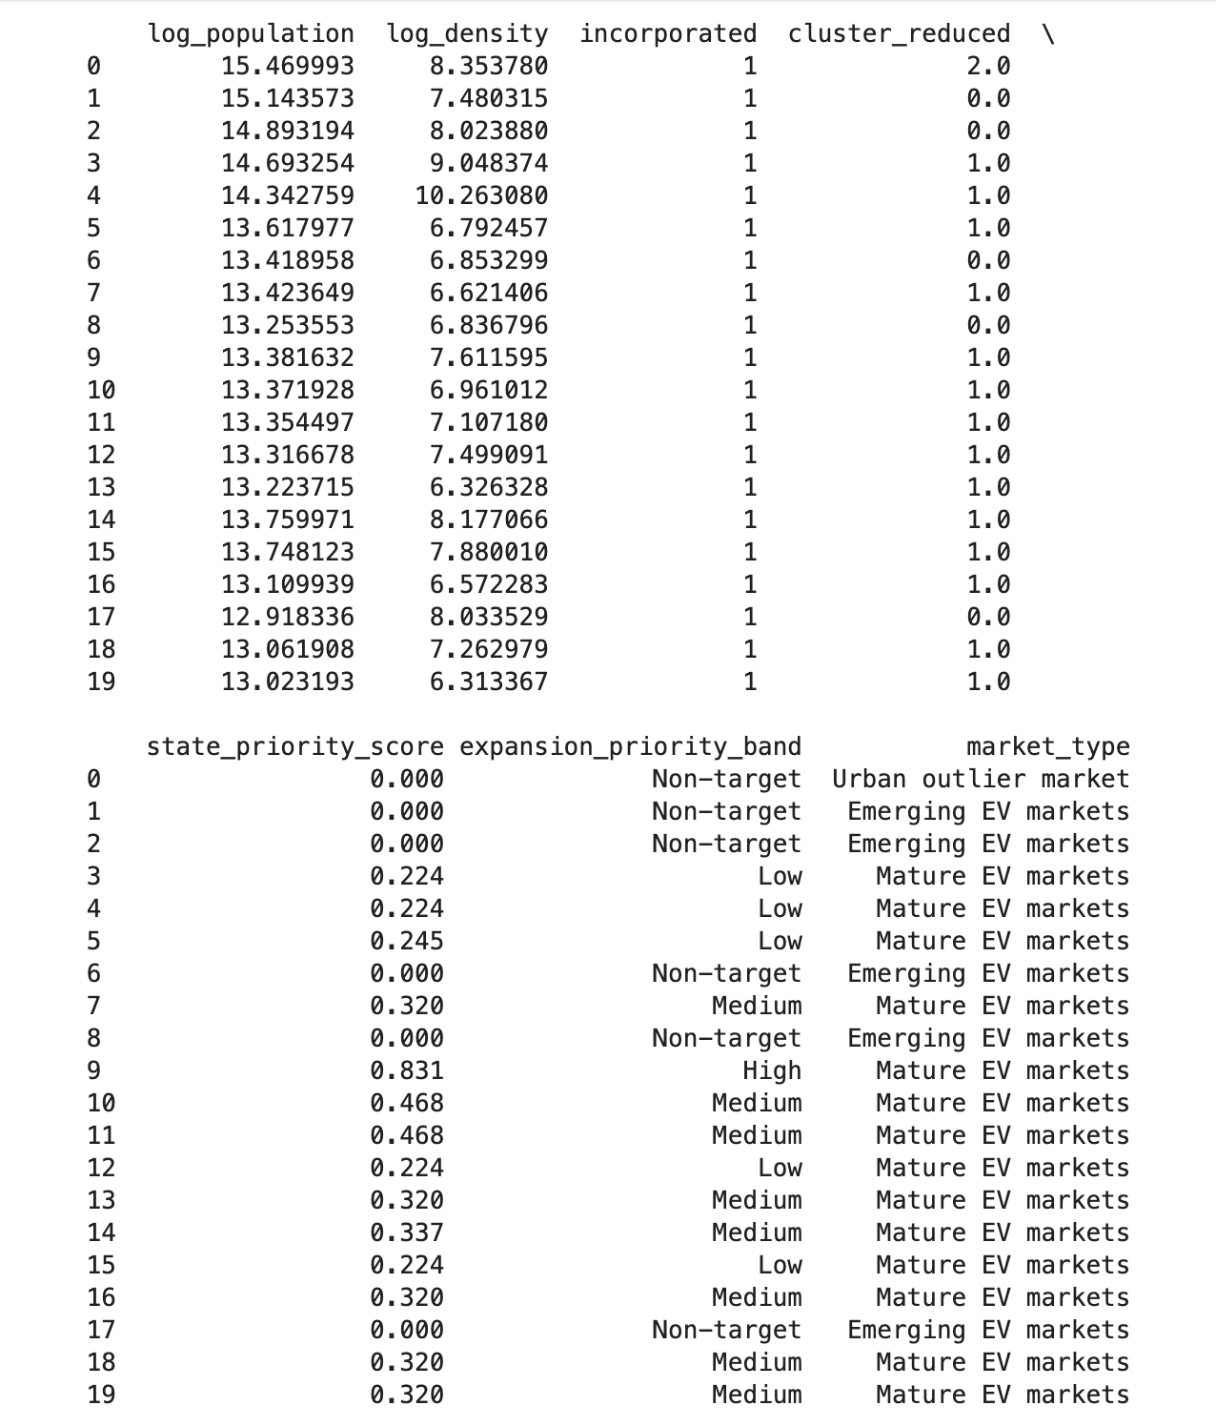
Figure 1. Example preview of the merged city-state modelling table after adding clustering-derived state indicators.
2.2 Data cleaning and merge checks
- The merge was keyed by city and state, rather than by city name only, because many U.S. city names are duplicated across states.
- Puerto Rico was dropped from the modelling stage because the state-level clustering table covered 51 states/jurisdictions while Puerto Rico remained unmatched in the cluster variables.
- A city-state grouped split was used in all subsequent modelling steps so that the same city did not appear across train, validation, and test sets.
The final city-state modelling table used for supervised learning contained approximately 30,976 rows after excluding Puerto Rico, with about 1,037 positive dealer rows.
This immediately implied two constraints for the modelling strategy: strong class imbalance in the classification task and a highly skewed dealer-count distribution in the regression task.
3. Stage 1 Classification Model for Dealership Presence
3.1 Target definition and model equation
Stage 1 asked a binary market-entry question: should a city plausibly host at least one Toyota dealership?
The target variable was defined from the observed dealer count:
y_i = 1(dealer_count_i > 0)
A probabilistic classifier was then fitted to estimate the probability that a city supports dealer presence:
p_i = P(y_i = 1 | x_i)
The final implementation used a logistic regression classifier with class weighting and a tuned decision threshold.
The probability model can be written as:
logit(p_i) = β0 + β' x_i ; predict dealer presence if p_i >= τ
The threshold τ was not fixed at 0.5. Instead, it was searched on the validation set using a business-oriented rule: maximise precision subject to recall being at least 0.75.
This choice prioritised practical targeting while still requiring the model to capture most positive cities.
3.2 Feature engineering and leakage control
- City-capacity variables were transformed using logarithms: log_population and log_density.
- Binary administrative indicators such as military and incorporated were kept as structured categorical signals.
- State-level clustering outputs were added to test whether market structure improves city-level entry screening.
- A direct state-match style variable was removed after it created near-perfect performance, indicating information leakage rather than genuine predictive signal.
Feature diagnostics also showed that the four state summary scores (demand, supply, pressure, and growth potential) were highly correlated.
That made them useful for interpretation, but not ideal to include together in a compact city-entry model.
As a result, Stage 1 compared three increasingly rich feature sets rather than immediately fitting the full state score block.
3.3 Candidate feature versions and tuning results
Version | Features | Threshold | Val ROC-AUC | Val PR-AUC | Test PR-AUC | Test F1
V1_city_only | log_population, log_density, military, incorporated | 0.78 | 0.9572 | 0.4962 | 0.5346 | 0.4387
V2_city_plus_cluster | V1 + cluster_reduced | 0.77 | 0.9582 | 0.4978 | 0.5421 | 0.4339
V3_full | V2 + state score block | 0.78 | 0.9588 | 0.5020 | 0.5415 | 0.4361

All three Stage 1 variants produced strong discrimination once leakage had been removed, with test ROC-AUC around 0.95 and PR-AUC around 0.54.
Version 2 was selected as the final classifier because it preserved the clear signal from the reduced state cluster while avoiding the redundancy and interpretability cost of the full score block.
In other words, the final classifier used a compact set of city capacity variables plus a broad state market-structure variable, which matched the intuition from the clustering study.
The final Stage 1 interpretation is therefore: city size and density matter, but dealer entry is also shaped by broad state market maturity.
This is consistent with the initial clustering results, where mature EV markets and the main emerging segment were identified as the most relevant strategic targets.
4. Stage 2 Regression Model for Dealership Count
4.1 Target definition and model equation
Stage 2 addressed a different problem. After identifying candidate cities for entry, the next question was not whether a city should have a dealership, but how many dealerships it could plausibly sustain.
To avoid mixing cities with structural zero demand and cities with realised dealer presence, Stage 2 was estimated only on cities with dealer_count > 0.
c_i = dealer_count_i, estimated only for observations with c_i > 0
The modelling target can therefore be viewed as an estimate of conditional capacity:
E[c_i | x_i, c_i > 0]
Two regression families were compared. A Poisson regressor was used as a count-data baseline, while a Random Forest regressor was used as a flexible nonlinear benchmark.
The final count model was chosen by validation RMSE, with test RMSE and test R² used as out-of-sample checks.
4.2 Stage 2 feature engineering
The Stage 2 feature engineering exercise was intentionally separate from Stage 1.
A variable that is useful for deciding whether to enter a city is not necessarily the best variable for predicting the number of dealerships once the city is already served.
Three feature versions were compared:
- A_city_capacity: log_population, log_density, incorporated
- B_plus_cluster: A + cluster_reduced
- C_plus_cluster_priority: B + state_priority_score
Feature version | Model | Val RMSE | Test RMSE | Test R² | Decision
A_city_capacity | RandomForestRegressor | 0.1818 | 0.3144 | 0.5225 | Selected by validation RMSE
B_plus_cluster | RandomForestRegressor | 0.1828 | 0.3133 | 0.5260 | Near-tie but slightly worse on validation
C_plus_cluster_priority | RandomForestRegressor | 0.1992 | 0.3033 | 0.5557 | Best raw test fit, not selected
A_city_capacity | PoissonRegressor | 0.2427 | 0.4156 | 0.1660 | Count baseline

The feature engineering result was important: the best validation fit came from the simplest city-capacity version.
This means that dealer-count capacity is driven mainly by local market size and density, not by the broader state segmentation variables that mattered in Stage 1.
That contrast between Stage 1 and Stage 2 is economically meaningful. Stage 1 behaves like an entry problem; Stage 2 behaves like a capacity problem.
4.3 Final tuning results
Model | Key parameters | Val RMSE | Test RMSE | Test R² | Conclusion
Best Poisson | alpha = 0.01 | 0.2337 | 0.3898 | 0.266 | Useful baseline, materially weaker
Best Random Forest | n_estimators = 200, max_depth = None, min_samples_leaf = 5, max_features = 0.5 | 0.1773 | 0.3218 | 0.500 | Final Stage 2 model

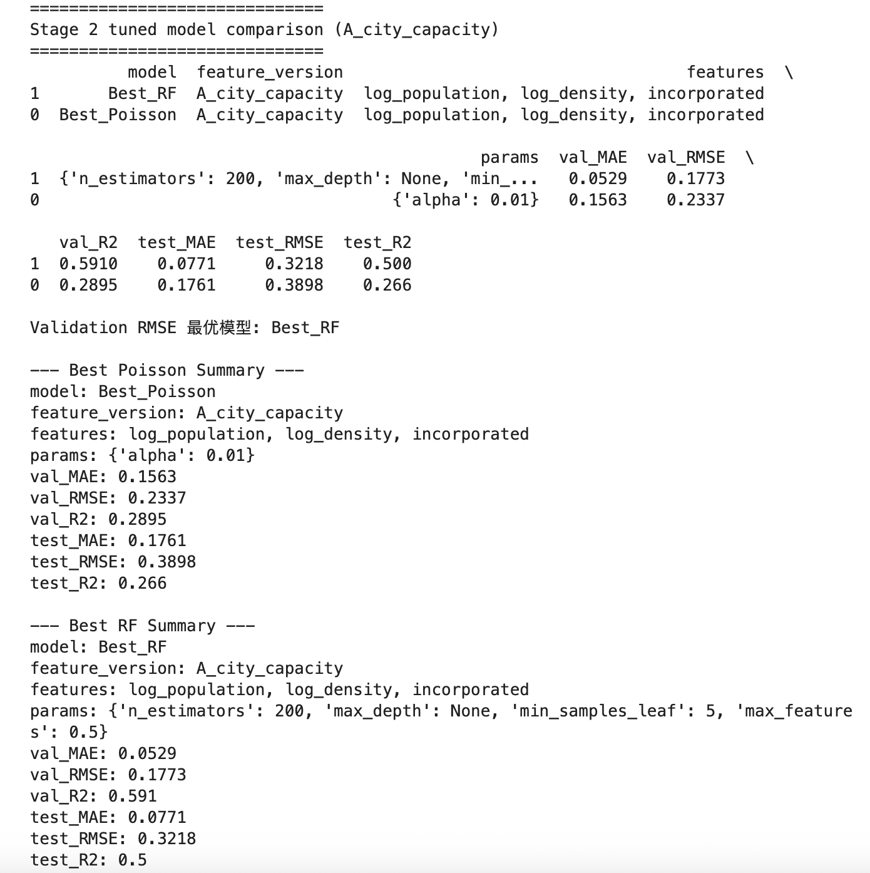
Figure 2. Screenshot of the final Stage 2 tuned model comparison based on A_city_capacity features.
After tuning, the Random Forest regressor remained clearly superior to the Poisson baseline.
It achieved both lower validation RMSE and substantially higher explanatory power on the test set.
This was the final evidence for selecting a tree-based nonlinear capacity model rather than a simple count regression.
4.4 Feature importance and interpretation
Feature importance checks on the final Random Forest showed a highly concentrated signal structure.
Population was overwhelmingly dominant, density added only a small amount of extra signal, and incorporated contributed almost nothing.
This finding aligned perfectly with the Stage 2 feature engineering result: dealer-count prediction in already served cities is mainly a city-capacity problem.
Measure | log_population | log_density | incorporated
Grouped MDI importance | 0.912 | 0.087 | 0.001
Permutation importance | 0.1895 | 0.0025 | 0.0004

5. Final State Recommendations and Map Interpretation
The final recommendation layer combined the tuned Stage 1 classifier with the tuned Stage 2 Random Forest regressor.
For each city with no current Toyota dealer, the classifier estimated a high-probability entry set; for those candidate cities, the count model generated a recommended number of new dealerships.
The final recommendation table contained 1,563 candidate city rows and 1,577 long-run recommended new dealerships.
State | Candidate cities | Recommended new dealers | Avg Stage 1 prob. | Avg Stage 2 predicted count
California | 218 | 219 | 0.903 | 1.026
Florida | 128 | 130 | 0.896 | 1.033
Texas | 105 | 106 | 0.892 | 1.012
Illinois | 103 | 103 | 0.866 | 1.012
Ohio | 86 | 87 | 0.870 | 1.016
Minnesota | 59 | 60 | 0.886 | 1.021
New Jersey | 50 | 50 | 0.879 | 1.081
Michigan | 46 | 47 | 0.904 | 1.041
Wisconsin | 45 | 45 | 0.862 | 1.002
Utah | 41 | 43 | 0.898 | 1.046

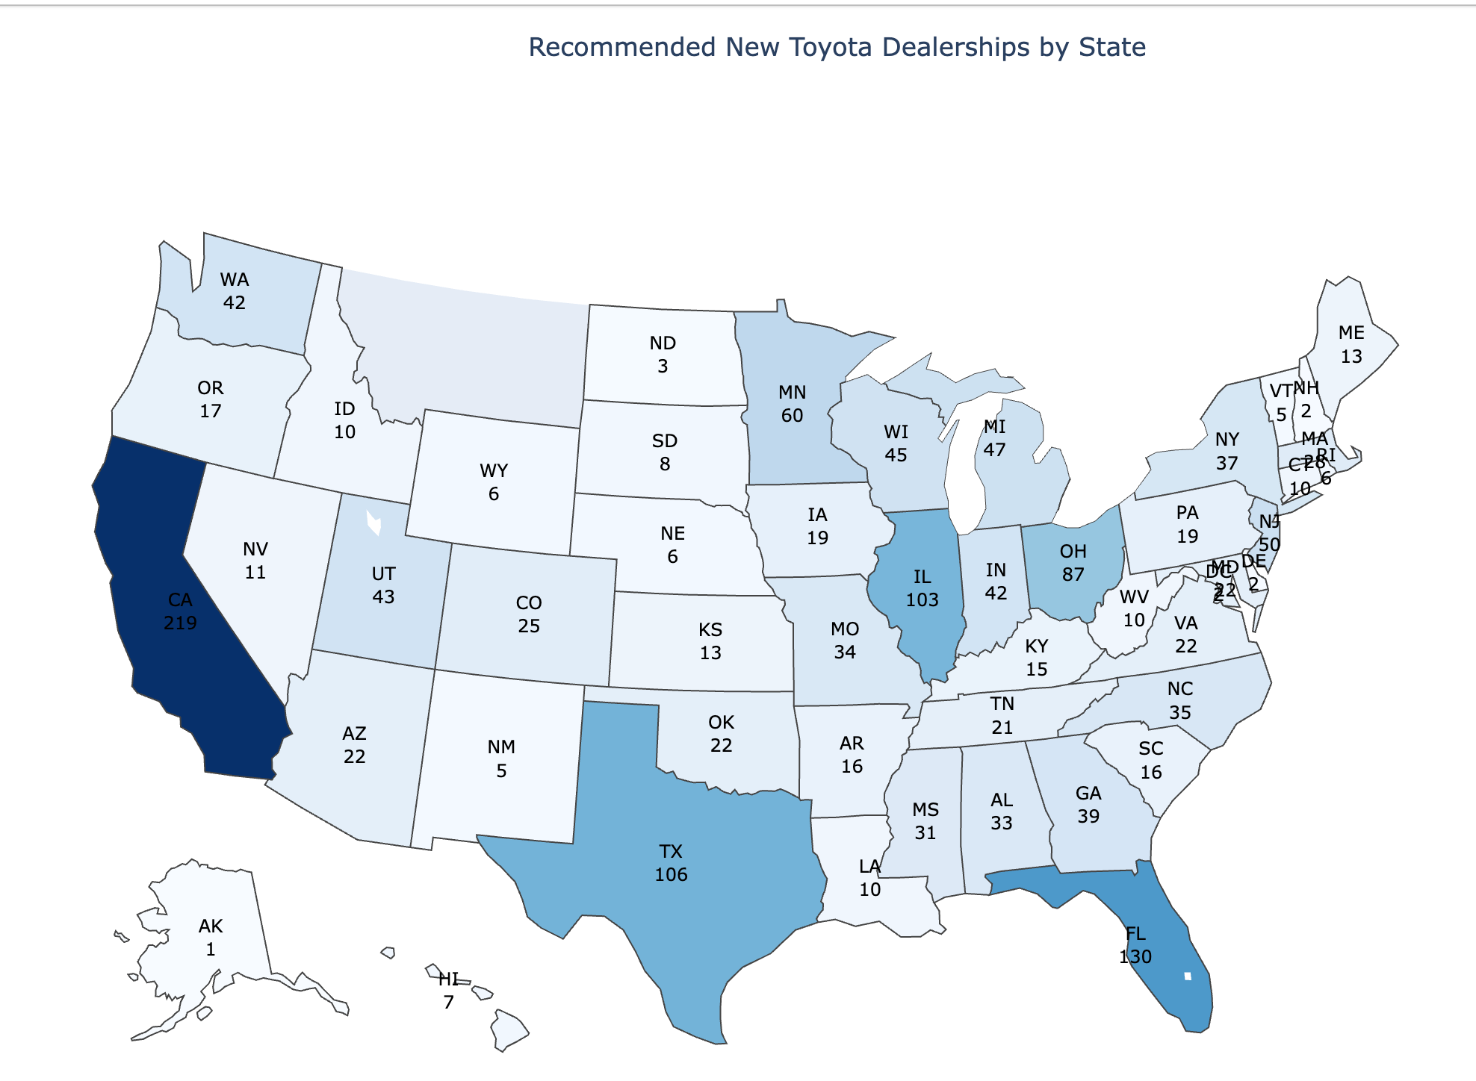
Figure 3. State-level map of long-run recommended new Toyota dealerships. Labels show state abbreviations and recommended additions.
The map broadly agreed with the original clustering logic, but it was not a simple restatement of the cluster ranking.
California remained dominant, which is fully consistent with the clustering study and the policy interpretation of mature EV markets.
However, large states such as Texas and Florida also ranked highly because the final two-stage model combines state-level strategic readiness with city-level capacity.
This means that the final state map should be interpreted as a spatial distribution of executable expansion capacity, not merely as a restatement of the original cluster order.
6. Short-Term and Long-Term Profit Scenarios
The recommendation table does not include time.
Therefore, the 1,577 recommended new dealerships are best interpreted as a long-run target pool rather than a one-year opening plan.
This distinction proved crucial. A short-run scenario that tried to push too many dealerships into one year produced losses because rollout costs dominated the first-year contribution.
A more realistic framing was to treat the model output as a long-run target and then phase it gradually into annual rollout cohorts.
6.1 Next-year rollout cap scenario
Before building the long-run path, a capped one-year rollout was analysed as a feasibility check.
Instead of forcing all 1,577 recommendations into one year, annual rollout was capped at 100, 150, and 200 dealerships across the conservative, base, and optimistic cases respectively.
Scenario | Planned rollout | Realised new dealers | Incremental units | % of TMNA YTD sales | Net incremental op. profit
Conservative | 100 | 80.0 | 5,040 | 40.75% | -148.9 m
Base | 150 | 127.5 | 14,025 | 113.40% | -152.0 m
Optimistic | 200 | 180.0 | 30,420 | 245.97% | -79.6 m

The one-year feasibility check showed that even a realistic cap still leaves the first-year outcome near or below break-even, because new dealerships face heavy launch costs and partial first-year utilisation.
This reinforced the idea that the expansion program should be judged as a multi-year investment rather than a one-year profit project.
6.2 Ten-year phased rollout model
The final scenario framework therefore treated the 1,577 recommended dealerships as a long-run network target and phased them into a ten-year rollout.
Rollout shares were front-light and back-heavy, reflecting the expectation that network build-out should accelerate only after the first cohorts have matured and operating experience has accumulated.
Each annual cohort followed a ramp-up profile in which first-year sales were below mature-dealer levels, second-year sales improved further, and from year three onward the cohort was treated as fully mature.
Incremental units_t = Σ_cohorts (opened_dealers_cohort × mature_units_per_dealer × ramp_factor(age))
Net incremental profit_t = gross incremental profit_t − rollout_cost_t
Cumulative profit_t = Σ_{k <= t} net incremental profit_k
Scenario | Total realised dealers (10y) | Final-year revenue | Final-year net profit | Cumulative revenue (10y) | Cumulative net profit (10y)
Conservative | 1341 | 7.90 bn | 252.5 m | 34.85 bn | 91.3 m
Base | 1418 | 9.85 bn | 717.2 m | 44.11 bn | 2.30 bn
Optimistic | 1499 | 12.21 bn | 1.21 bn | 55.58 bn | 4.60 bn

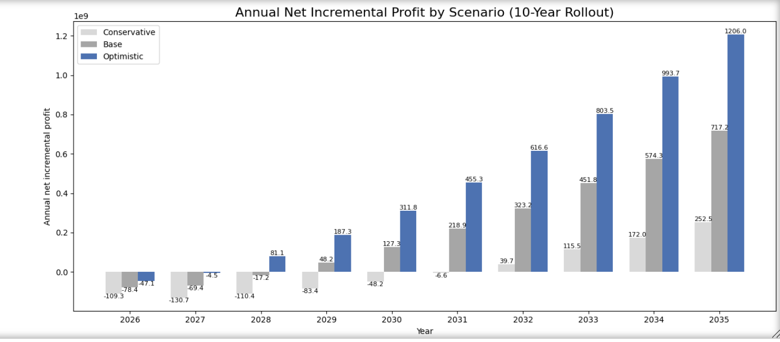
Figure 4. Annual net incremental profit by scenario under a 10-year rollout.
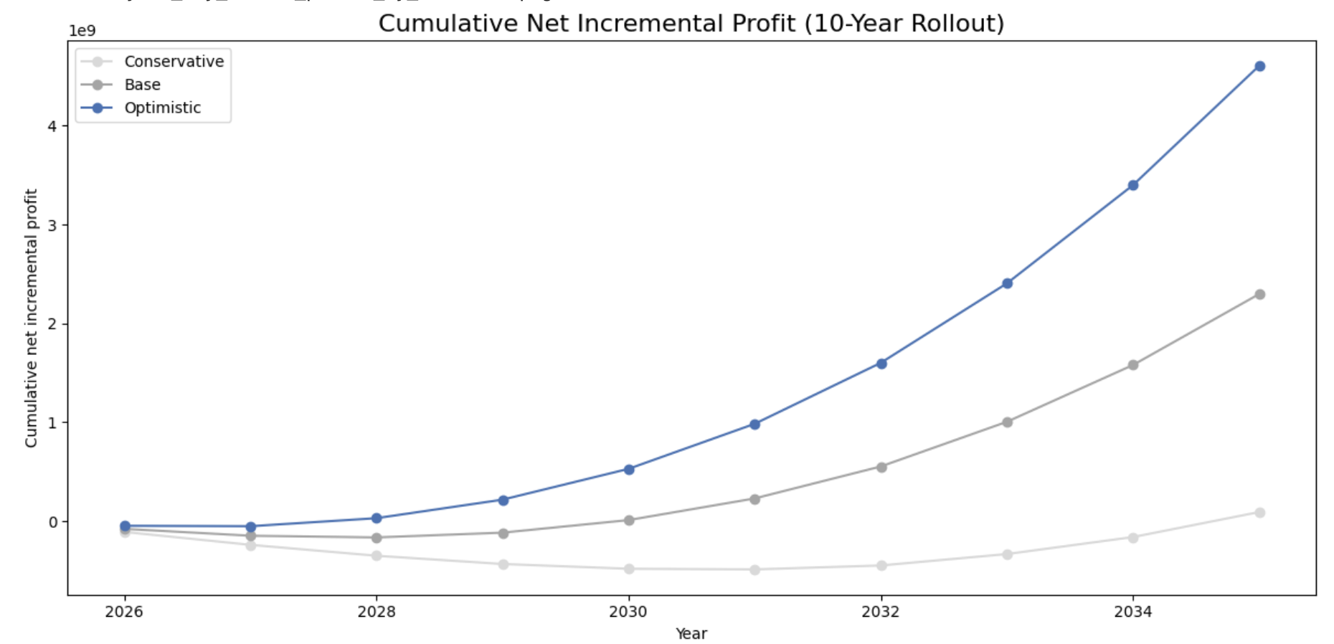
Figure 5. Cumulative net incremental profit by scenario under a 10-year rollout.
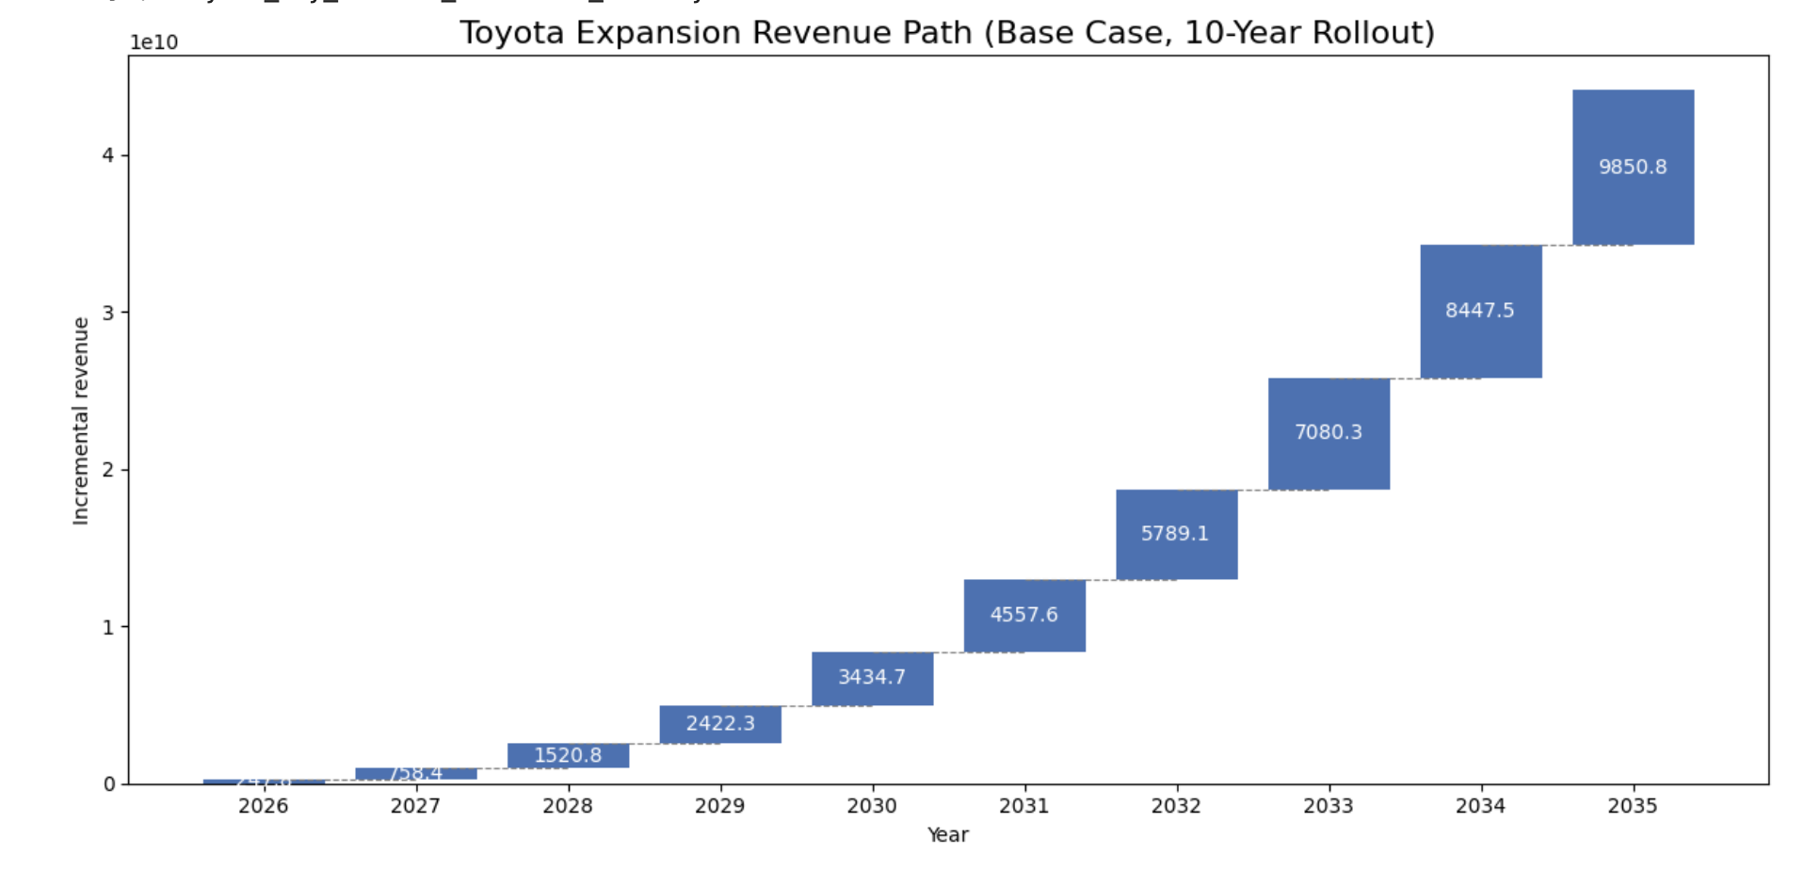
Figure 6. Base-case revenue path under the 10-year rollout.
The ten-year results create a coherent strategic story.
Under the conservative case, annual and cumulative profit remain subdued for much longer, implying a slow-payback expansion path.
Under the base case, the program behaves like a classic investment-then-harvest project: early years are cost-heavy, the middle years cross into positive cumulative territory, and later years become strongly profit-accretive.
Under the optimistic case, earlier cohort maturity, higher dealer productivity, and better cost control produce a much steeper cumulative payoff profile.
7. Conclusions and Managerial Implications
- The clustering study was successfully converted from a descriptive strategic segmentation into actionable modelling inputs.
- State-level market structure mattered for dealership entry screening, but not for dealership-count capacity once a city was already served.
- The final Stage 1 model is best interpreted as a city-entry filter; the final Stage 2 model is best interpreted as a city-capacity estimator.
- The resulting recommendation set should be viewed as a long-run expansion target pool rather than a one-year rollout instruction.
- A phased ten-year implementation path is economically more credible than a one-year expansion attempt and produces an interpretable investment-and-harvest profile.
From a business perspective, the most important message is that the value of network expansion depends not only on where Toyota expands but also on how quickly it scales, how fast new dealers ramp up, and how tightly rollout costs are controlled.
The modelling workflow therefore supports both strategic market prioritisation and implementation planning.

