Department of Computer Science and Engineering
(AI & ML)
B. Tech. CSE - 5th Semester
Aug – Dec 2026
AIML Section D | Academic Year 2026–2027
UE23CS351A
DATABASE MANAGEMENT SYSTEMS (DBMS)

PROJECT REPORT on

Cricket Player Performance & Selection Intelligence System

Submitted by:
PES1UG24AM210 | P. Jaya Surya | AIML D
PES1UG24AM189 | P. S. Sai Sreyaesh | AIML D

Class of Prof. RAGHU B A
Lab Faculty: DEVNA SUMESH

Abstract
The Cricket Player Performance & Selection Intelligence System is a database-driven web application for organizing and analyzing cricket statistics to support player evaluation and selection. MySQL stores structured information about players, teams, matches, venues, innings, and batting and bowling performances. MongoDB stores flexible scouting reports and observations. The Next.js application provides player views, selection analytics, reports, scouting workflows, and role-protected administration. The project demonstrates relational design and integrity constraints, SQL data operations and analytics, MongoDB document operations and aggregation, authentication, and database-backed application integration. The report presents the model, implementation evidence, query demonstrations, application structure, and evaluation criteria.
Table of Contents
Sl. No | Topic | Page No.
1. | Introduction | 4
2. | User Requirements Specification – Tech Stack | 4
3. | E-R Model | 5
4. | Relational Model | 7
5. | SQL DDL Statements | 9
6. | SQL DML Statements | 20
7. | NoSQL / Vector Database Commands | 42
8. | Results | 47
9. | Next.js – Project Tree Structure | 49
10. | Application Code and Demo Screenshots | 50
11. | Evaluation Rubrics – Completion Status | 62

1. Introduction

Problem Statement
Cricket selection committees need to compare players across formats, venues, opponents and playing conditions. Career totals alone can hide context-specific strengths and weaknesses. This project provides a centralized database-driven system to store cricket records and generate performance reports that support informed player evaluation.

Objectives and Scope
The project organizes player, team, match, venue, innings, batting, bowling, dismissal and role data; supports analysis across ODI and T20I matches; maintains scouting reports; and presents player information and analytical reports through a web application. It is a decision-support system, not a live-scoring or betting application.
• Manage player profiles, team and match information, venues and weather.
• Record batting and bowling performance and dismissal details.
• Analyze player performance by format, opponent, venue and match conditions.
• Demonstrate SQL operations and advanced database concepts alongside MongoDB document operations.
• Provide an authenticated web interface for player analytics and scouting workflows.

2. User Requirements Specification – Tech Stack

Functional Requirements
• Browse players and performance information.
• Display batting analytics, selection views and advanced SQL reports.
• Create, view, edit, search, filter and delete scouting reports.
• Authenticate users and enforce administrator and analyst access rules.
• Validate input and maintain referential and domain integrity.

Frontend Technologies
Next.js, React and TypeScript provide application pages, reusable interface components and typed client code. Tailwind CSS is used for interface styling.

Backend Technologies
Next.js API routes handle application requests, validation and database operations. Node.js runs server-side code. The mysql2/promise and MongoDB Node.js drivers connect to the two databases. JWT supports sessions and bcrypt hashes passwords.

Database Technologies
MySQL stores structured cricket and account data in cricket_selection. MongoDB stores flexible scouting-report documents in cricket_selection_nosql, principally in the scouting_reports collection.

Development Tools
The project materials identify Visual Studio Code, MySQL Workbench, mongosh, Git and GitHub. MongoDB is also described as running locally or through Docker.

Justification of Technology Choices
The relational model fits the linked player, match, innings and performance records and supports keys, constraints, joins and analytical SQL. A Next.js/React interface provides the web views while its API routes connect the interface to the databases. TypeScript supports typed application code; JWT and bcrypt are used for session handling and password hashing.

Justification for MongoDB
Scouting observations can vary between reports, so document storage offers a flexible structure. MongoDB complements MySQL by managing scouting reports while MySQL remains the source for structured player and match records. The application checks player existence in MySQL before scouting-report writes. Vector search is not evidenced as implemented in the supplied project materials; it is described as a possible future enhancement.

3. E-R Model

List of Entities
The conceptual model contains the following entities: Player, Team, Match, Venue, Weather, Innings, Player Role, Batting Performance, Bowling Performance, Dismissal, Opponent and Users. The supplied ER model does not identify any weak entity.

List of Non-Simple Attributes
The supplied ER model represents the listed entity attributes as individual scalar fields. No composite or multivalued attributes are specified in the model.

ER Diagram Snapshot
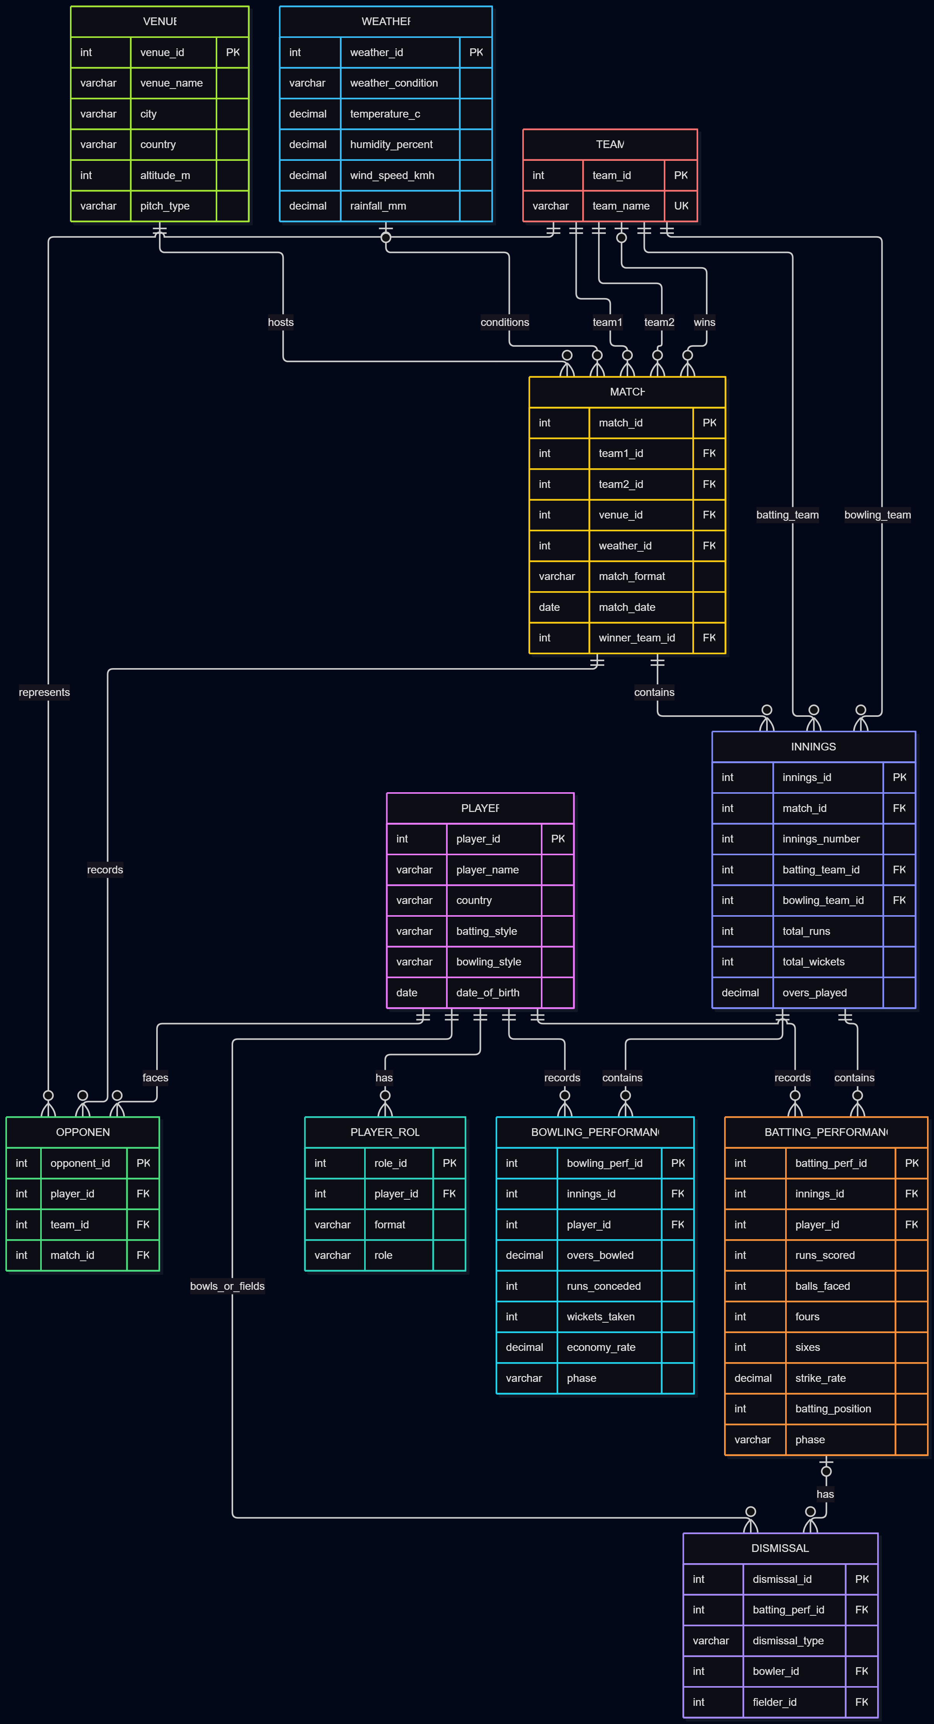
Figure 3.1. Entity–relationship model of the cricket selection database.
The ER diagram models links from teams, venue and weather to matches; matches to innings; innings to batting and bowling records; and players to roles and performances. Dismissal and opponent records reference the related player, performance, team and match data.

4. Relational Model

Relations and Entity Mapping
The relations map directly to the entities listed in the ER model. The project documentation identifies 12 MySQL tables and no separate associative relation outside the entity list.

Relational Schema
Relation | Key summary
player | player_id PK
team | team_id PK; team_name UNIQUE
match | match_id PK; team1_id, team2_id, venue_id, weather_id, winner_team_id FK
venue | venue_id PK
weather | weather_id PK
innings | innings_id PK; match_id, batting_team_id, bowling_team_id FK
player_role | role_id PK; player_id FK; UNIQUE(player_id, format)
batting_performance | batting_perf_id PK; innings_id, player_id FK
bowling_performance | bowling_perf_id PK; innings_id, player_id FK
dismissal | dismissal_id PK; batting_perf_id, bowler_id, fielder_id FK
opponent | opponent_id PK; player_id, team_id, match_id FK; UNIQUE(player_id, team_id, match_id)
users | user_id PK; email UNIQUE

Schema Diagram
Figure 4.1. Relational schema and key relationships, represented in the supplied ER diagram.
The schema includes 12 tables, 19 documented foreign-key relationships and 2 views. The opponent relation records player–team–match associations. The supplied documentation does not designate a separate non-entity relation.

5. SQL DDL Statements
The MySQL database is named cricket_selection. DDL evidence in the source report shows database selection, table and constraint inspection, and schema creation. The schema defines primary keys, foreign keys, unique constraints, CHECK constraints, defaults and indexes. The full table definitions are evidenced by the preserved screenshots from the original report.

Database and Table Structure
USE cricket_selection;
SHOW TABLES;
DESC player;
The schema contains 12 tables: player, team, match, venue, weather, innings, player_role, batting_performance, bowling_performance, dismissal, opponent and users.

Keys, Constraints and ALTER Operations
The project schema includes primary keys on each table; foreign keys connecting match, innings and performance data; unique constraints on team names and user email addresses; and composite unique constraints on player_role and opponent. CHECK restrictions cover match formats, distinct teams, nonnegative performance values and other documented ranges. The SQL demonstration script shows CREATE TABLE, ALTER TABLE and DROP TABLE for a temporary sql_operations_demo table. The report describes example commands only where indicated; the temporary table is not represented as a permanent application table.
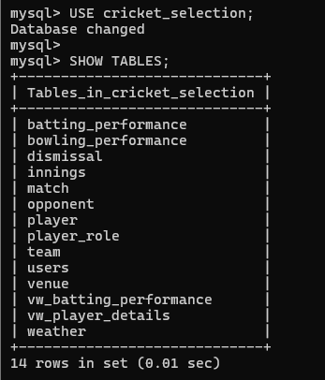
Figure 5.1. Preserved MySQL schema or DDL evidence from source report page 7.
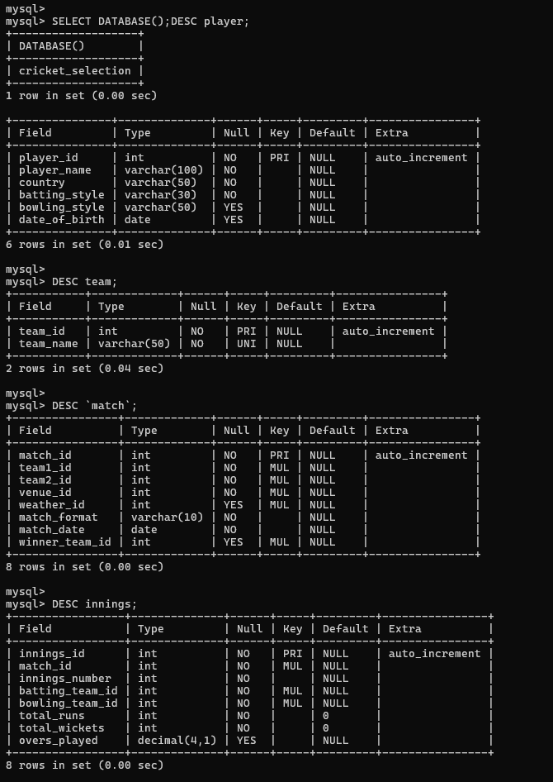
Figure 5.2. Preserved MySQL schema or DDL evidence from source report page 8.
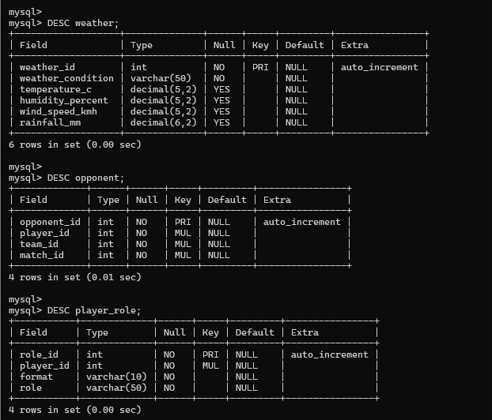
Figure 5.3. Preserved MySQL schema or DDL evidence from source report page 9.
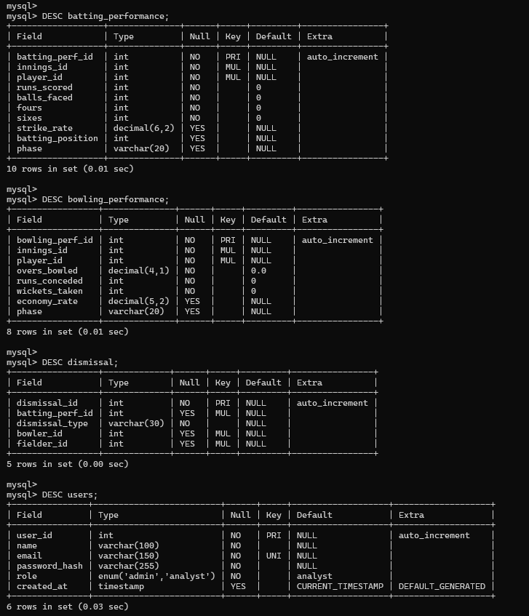
Figure 5.4. Preserved MySQL schema or DDL evidence from source report page 10.
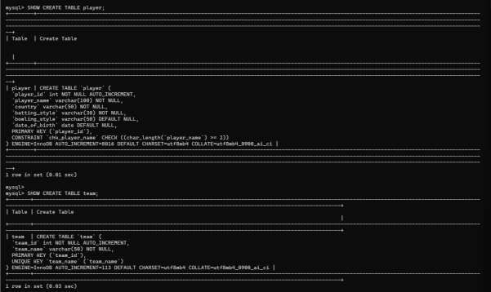
Figure 5.5. Preserved MySQL schema or DDL evidence from source report page 11.
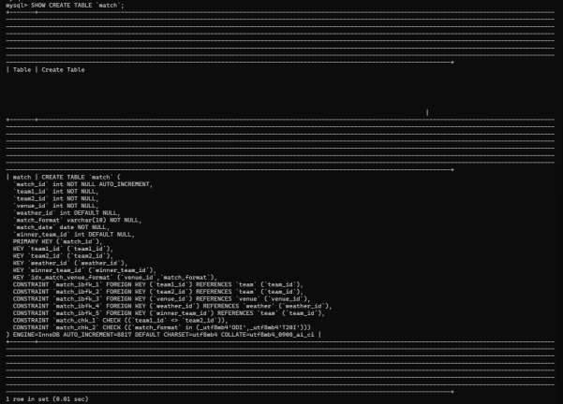
Figure 5.6. Preserved MySQL schema or DDL evidence from source report page 11.
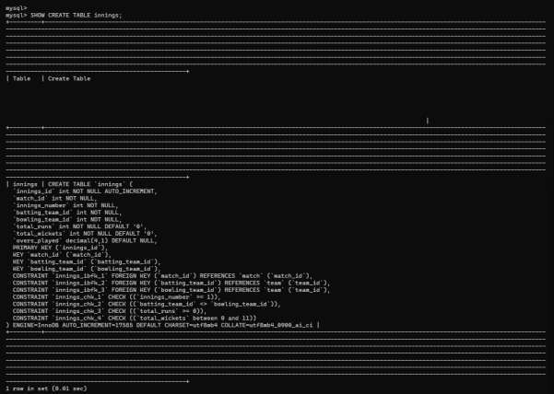
Figure 5.7. Preserved MySQL schema or DDL evidence from source report page 12.
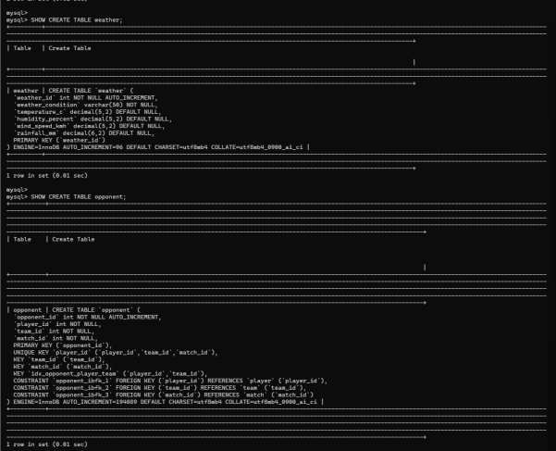
Figure 5.8. Preserved MySQL schema or DDL evidence from source report page 13.
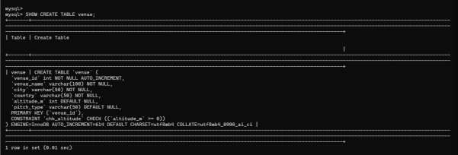
Figure 5.9. Preserved MySQL schema or DDL evidence from source report page 13.
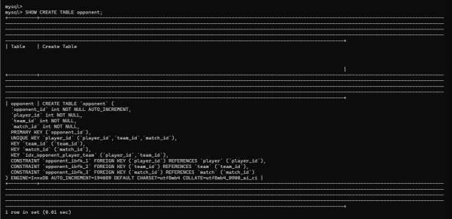
Figure 5.10. Preserved MySQL schema or DDL evidence from source report page 14.
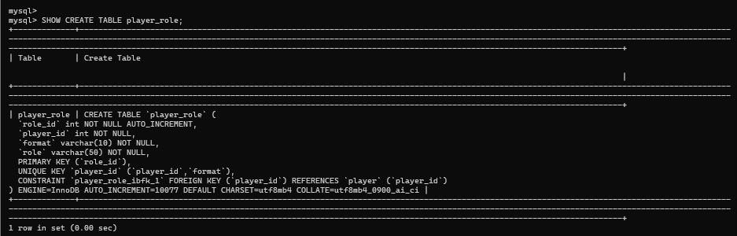
Figure 5.11. Preserved MySQL schema or DDL evidence from source report page 14.
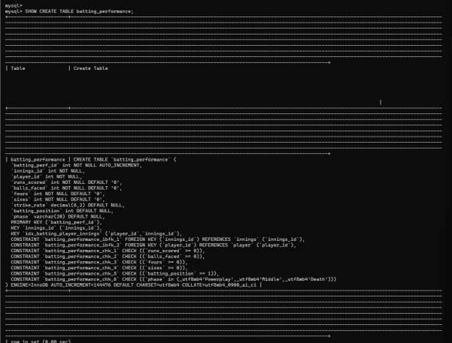
Figure 5.12. Preserved MySQL schema or DDL evidence from source report page 15.
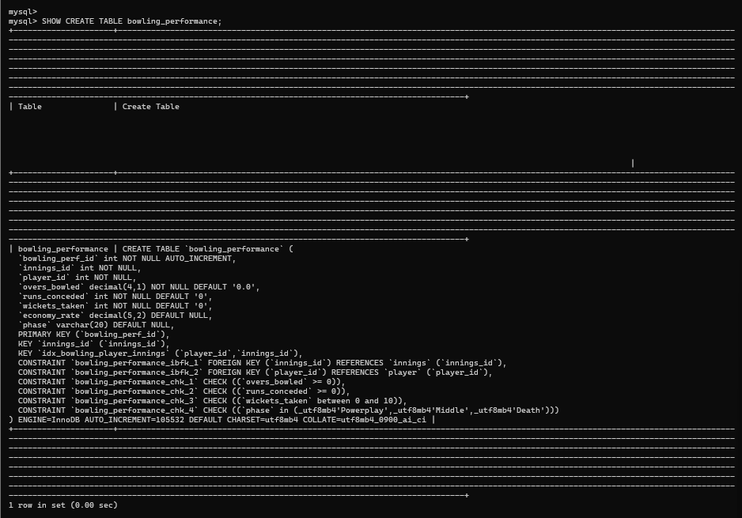
Figure 5.13. Preserved MySQL schema or DDL evidence from source report page 15.
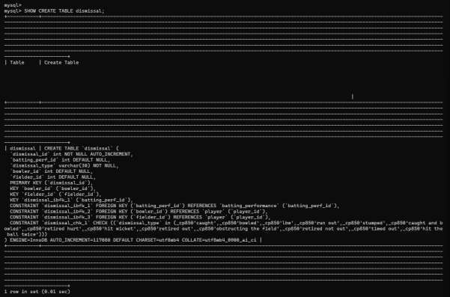
Figure 5.14. Preserved MySQL schema or DDL evidence from source report page 16.
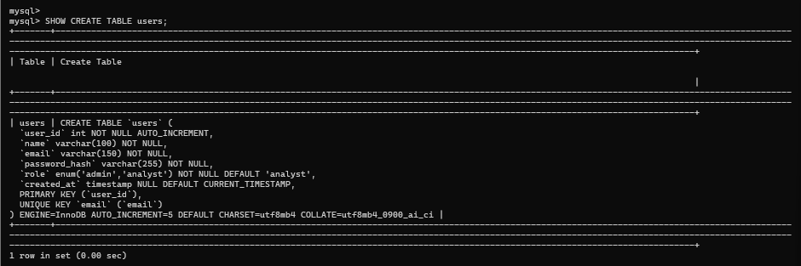
Figure 5.15. Preserved MySQL schema or DDL evidence from source report page 16.

6. SQL DML Statements
The project demonstrates INSERT, UPDATE, DELETE and SELECT operations, filtering, ordering, limits, aggregates, GROUP BY and HAVING, joins, a subquery, views, a stored procedure, a trigger, indexes and transaction concepts. SQL files in the project folder provide the documented examples below; the original report screenshots are retained after the relevant query groups.

INSERT, UPDATE and DELETE
INSERT INTO sql_operations_demo (demo_id, demo_name, score) VALUES (1, 'Player A', 75);
UPDATE sql_operations_demo SET score = 90 WHERE demo_id = 1;
DELETE FROM sql_operations_demo WHERE demo_id = 2;
The accompanying script explicitly labels sql_operations_demo as a temporary demonstration table that was created, altered and dropped during the live demonstration.

SELECT, WHERE, DISTINCT, ORDER BY and LIMIT
SELECT * FROM sql_operations_demo;
The project screenshots show query execution against the cricket database; the example above illustrates the documented query concepts without asserting a particular result set.

Aggregate Functions, GROUP BY and HAVING
SELECT p.player_id, p.player_name, COUNT(*) AS innings_recorded,
SUM(bp.runs_scored) AS total_runs, AVG(bp.runs_scored) AS average_runs
FROM player p JOIN batting_performance bp ON p.player_id = bp.player_id
GROUP BY p.player_id, p.player_name HAVING SUM(bp.runs_scored) > 5000
ORDER BY total_runs DESC;

JOIN Operations and Subqueries
SELECT p.player_name, i.match_id, bp.runs_scored, bp.balls_faced
FROM player p JOIN batting_performance bp ON p.player_id = bp.player_id
JOIN innings i ON bp.innings_id = i.innings_id
ORDER BY bp.runs_scored DESC LIMIT 10;
SELECT player_id, player_name FROM player WHERE player_id IN (
SELECT player_id FROM batting_performance GROUP BY player_id
HAVING SUM(runs_scored) > 5000);

Views, Stored Procedure and Trigger
The supplied SQL files define vw_batting_performance and vw_player_details, the GetPlayerBattingStats procedure, and the trg_validate_batting_performance BEFORE INSERT trigger. The trigger rejects negative runs, balls faced, fours or sixes. The procedure accepts a player-name input and returns batting totals.
CALL GetPlayerBattingStats('Virat Kohli');

Indexes, EXPLAIN and Transactions
The database design notes document composite indexes idx_batting_player_innings, idx_bowling_player_innings, idx_match_venue_format and idx_opponent_player_team, in addition to primary-key, foreign-key and unique indexes. Index screenshots in the source report are retained below. The source report includes an indexes and EXPLAIN heading and a transactions/ACID discussion. The README also identifies CTEs and window-function ranking with RANK(). No user-defined SQL function is documented in the supplied scripts.
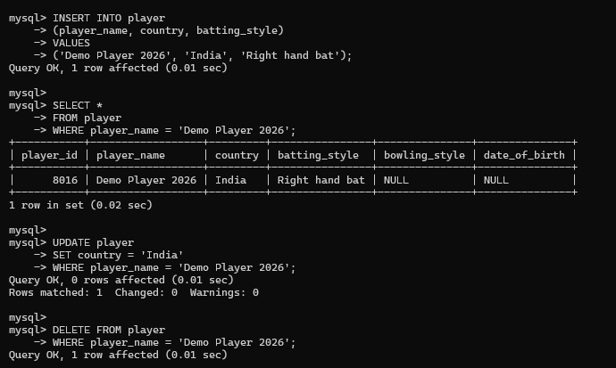
Figure 6.1. Preserved SQL operation, analytics or result evidence from source report page 17.
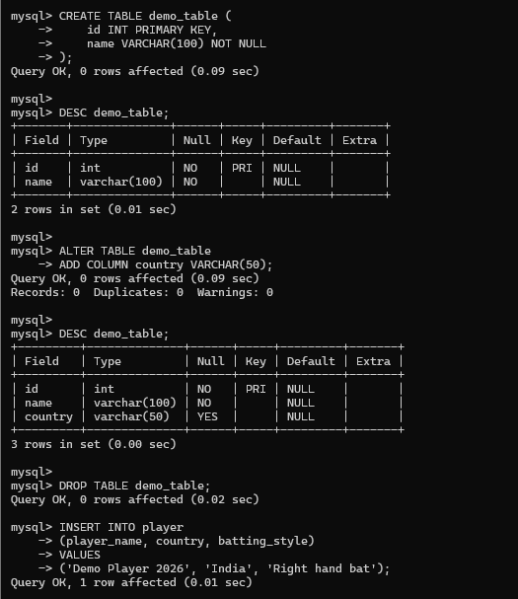
Figure 6.2. Preserved SQL operation, analytics or result evidence from source report page 17.
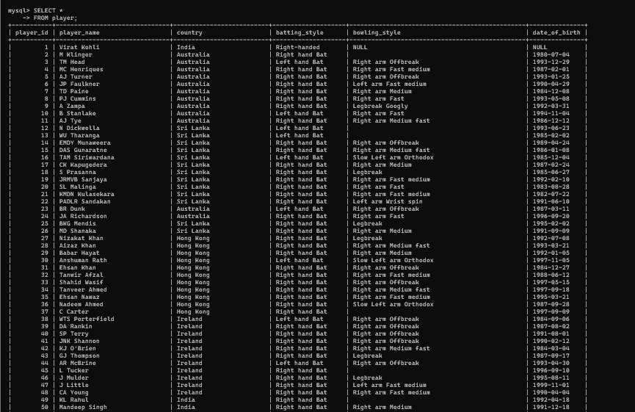
Figure 6.3. Preserved SQL operation, analytics or result evidence from source report page 18.
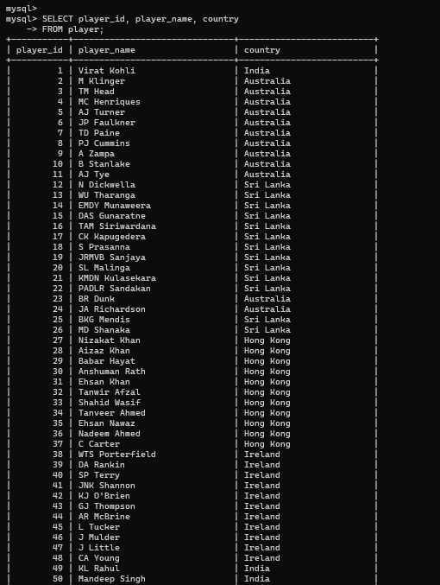
Figure 6.4. Preserved SQL operation, analytics or result evidence from source report page 19.
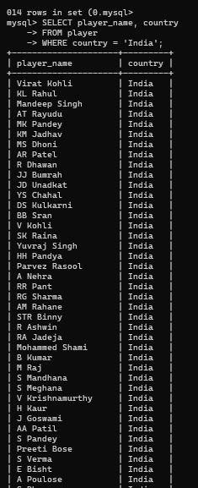
Figure 6.5. Preserved SQL operation, analytics or result evidence from source report page 20.
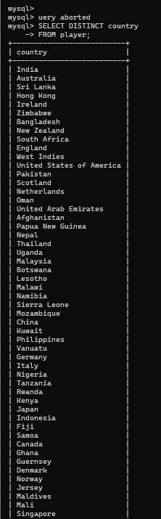
Figure 6.6. Preserved SQL operation, analytics or result evidence from source report page 21.
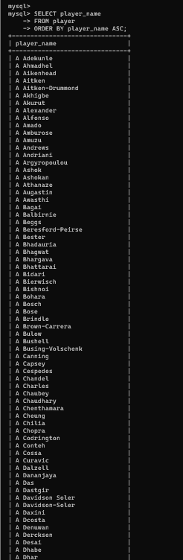
Figure 6.7. Preserved SQL operation, analytics or result evidence from source report page 22.
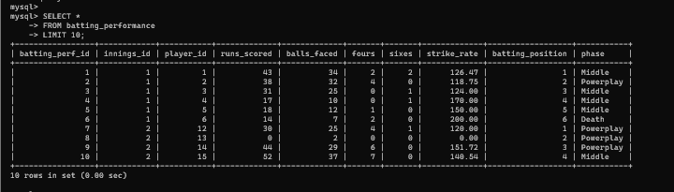
Figure 6.8. Preserved SQL operation, analytics or result evidence from source report page 22.
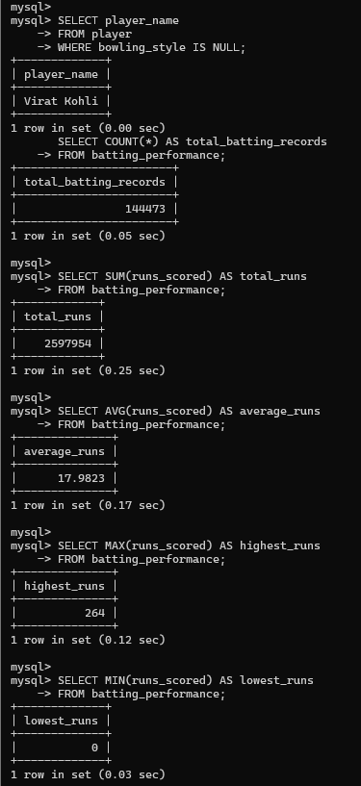
Figure 6.9. Preserved SQL operation, analytics or result evidence from source report page 23.
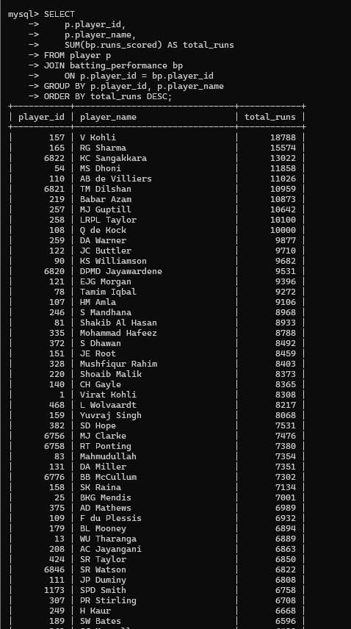
Figure 6.10. Preserved SQL operation, analytics or result evidence from source report page 24.
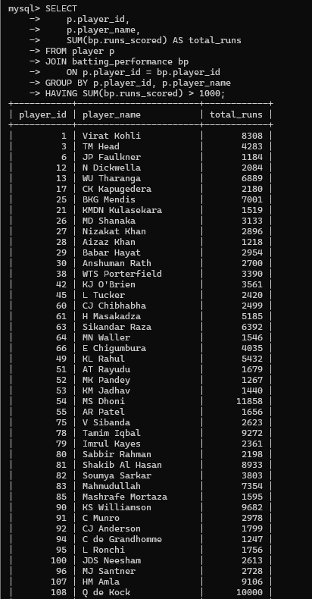
Figure 6.11. Preserved SQL operation, analytics or result evidence from source report page 25.
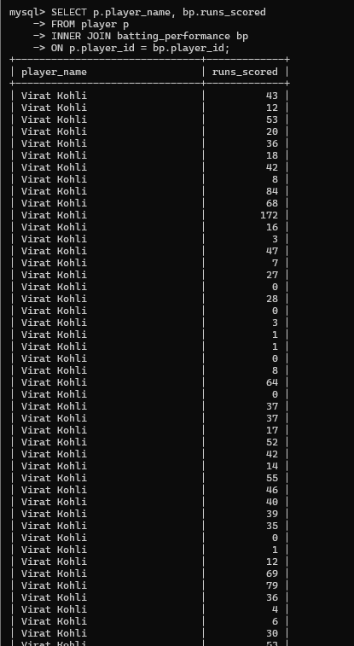
Figure 6.12. Preserved SQL operation, analytics or result evidence from source report page 26.
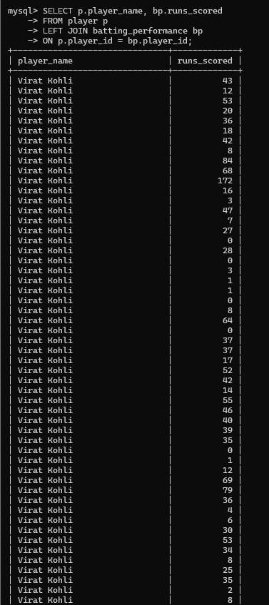
Figure 6.13. Preserved SQL operation, analytics or result evidence from source report page 27.
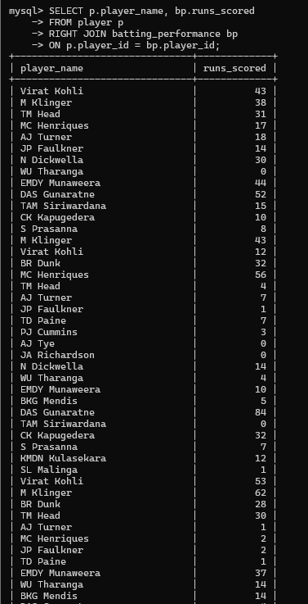
Figure 6.14. Preserved SQL operation, analytics or result evidence from source report page 28.
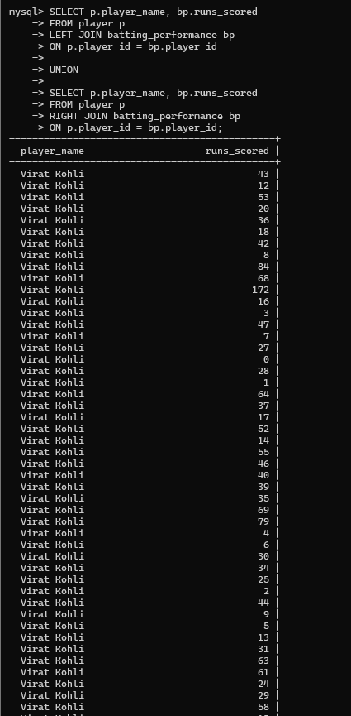
Figure 6.15. Preserved SQL operation, analytics or result evidence from source report page 29.
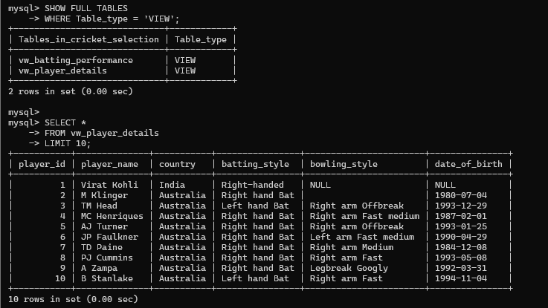
Figure 6.16. Preserved SQL operation, analytics or result evidence from source report page 30.
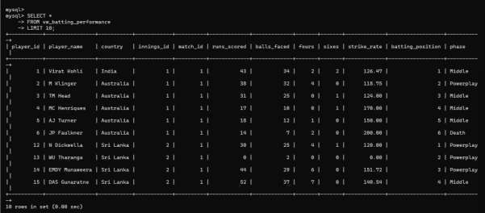
Figure 6.17. Preserved SQL operation, analytics or result evidence from source report page 30.
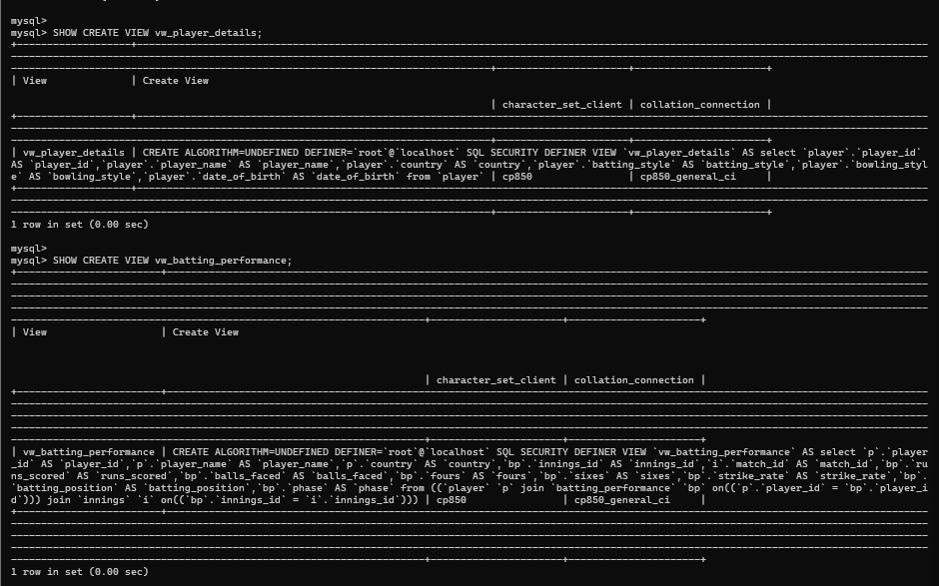
Figure 6.18. Preserved SQL operation, analytics or result evidence from source report page 31.
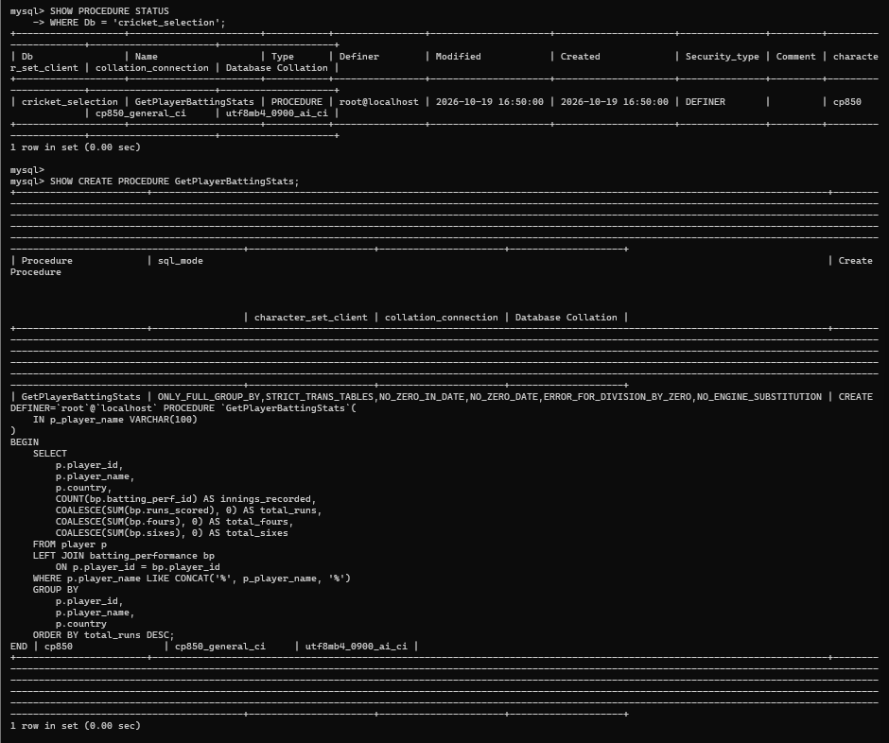
Figure 6.19. Preserved SQL operation, analytics or result evidence from source report page 31.
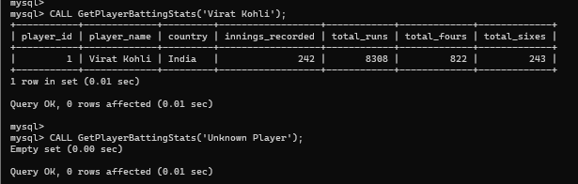
Figure 6.20. Preserved SQL operation, analytics or result evidence from source report page 32.
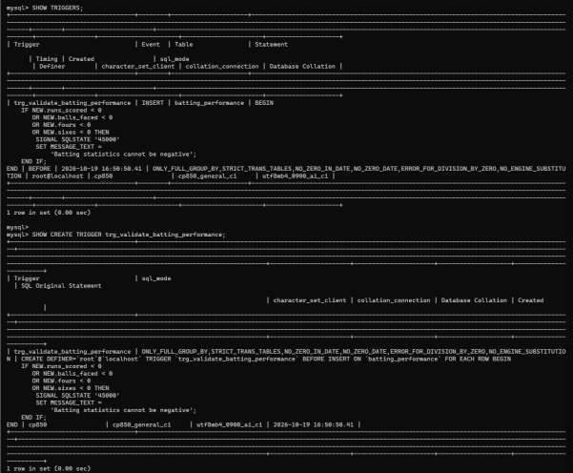
Figure 6.21. Preserved SQL operation, analytics or result evidence from source report page 32.
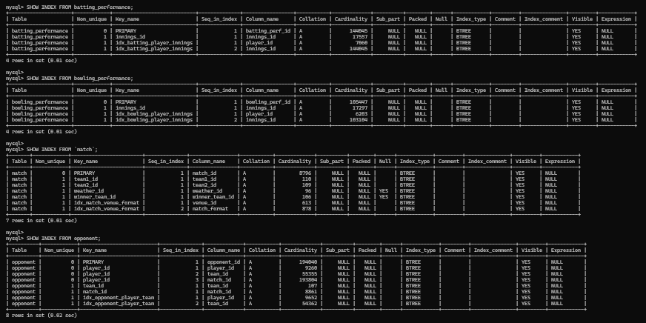
Figure 6.22. Preserved SQL operation, analytics or result evidence from source report page 33.
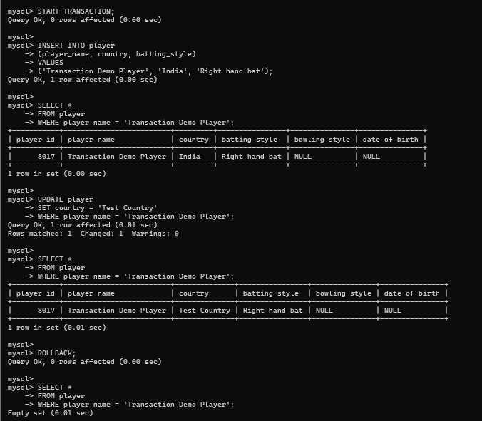
Figure 6.23. Preserved SQL operation, analytics or result evidence from source report page 33.
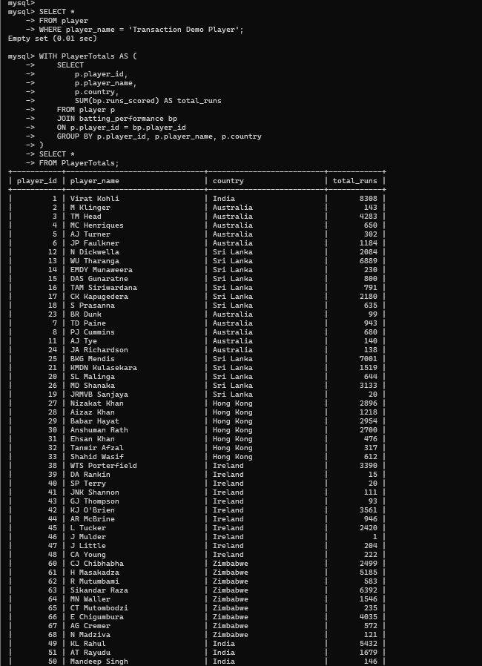
Figure 6.24. Preserved SQL operation, analytics or result evidence from source report page 34.

7. NoSQL / Vector Database Commands
MongoDB database cricket_selection_nosql stores scouting reports in the scouting_reports collection. The source report demonstrates database selection, collection inspection and document operations. The application supports report CRUD and an aggregation that groups records by recommendation. The supplied materials do not establish a vector database or semantic vector search implementation.

Database Selection and Collection Inspection
use cricket_selection_nosql
show collections
db.scouting_reports.find().limit(5).pretty()

Document Operations and Aggregation
The project reports insertion, retrieval, update and deletion operations on scouting reports, alongside an aggregation demonstration. The original mongosh screenshots are retained as implementation evidence.
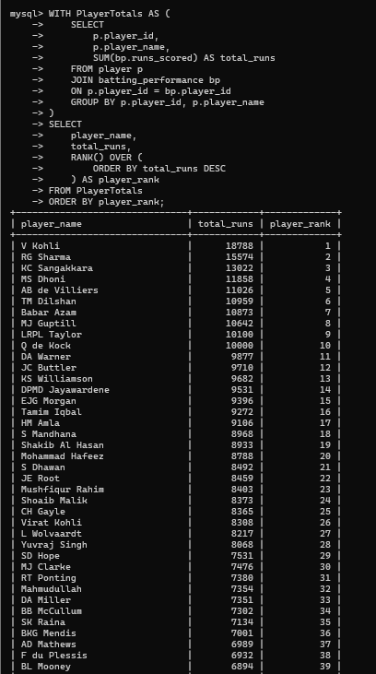
Figure 7.1. Preserved MongoDB command or aggregation evidence from source report page 35.
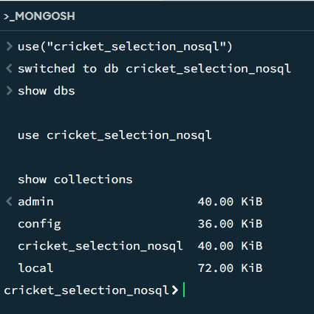
Figure 7.2. Preserved MongoDB command or aggregation evidence from source report page 36.
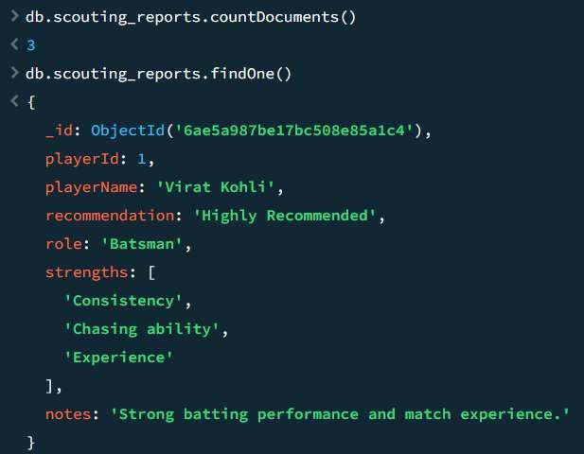
Figure 7.3. Preserved MongoDB command or aggregation evidence from source report page 36.
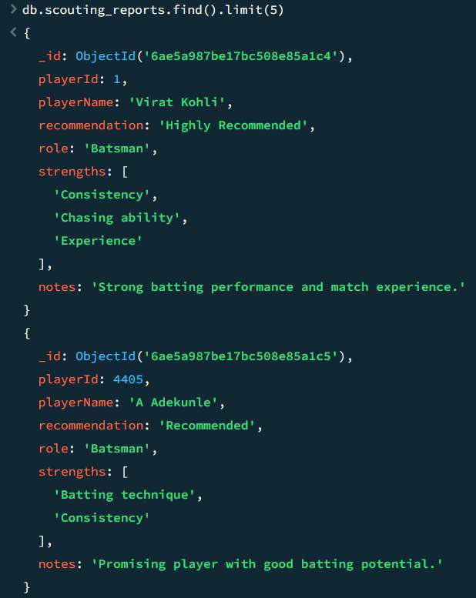
Figure 7.4. Preserved MongoDB command or aggregation evidence from source report page 37.
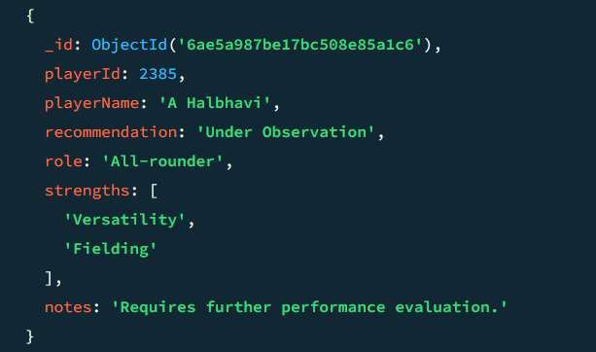
Figure 7.5. Preserved MongoDB command or aggregation evidence from source report page 37.

8. Results
The source report provides MySQL table and query screenshots, MongoDB command evidence, and web application demonstrations. Together they document database structures, analytics outputs, scouting operations and application behavior. The selected result figures below reuse original project screenshots.
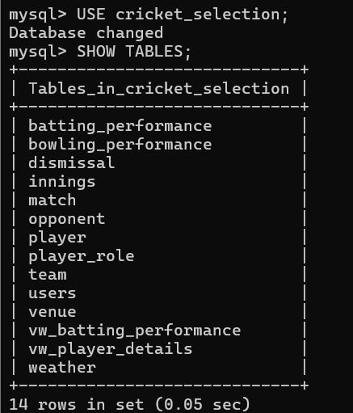
Figure 8.1. MySQL table structure evidence.
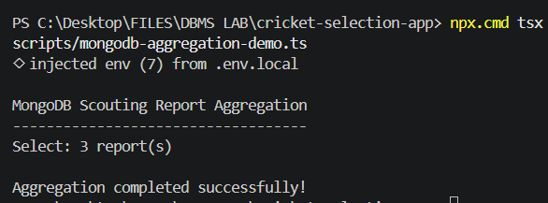
Figure 8.2. MongoDB scouting-report aggregation evidence.

Result Interpretation
The MySQL model organizes cricket data across 12 tables and provides two views for reusable player and batting-performance queries. SQL reports support comparative performance analysis. MongoDB stores flexible scouting information and groups reports by recommendation. The web interface presents player, selection, analytics and scouting workflows. The figures are evidence from the supplied report and project folder; this document does not infer unshown query values.

9. Next.js – Project Tree Structure
The following tree lists the main application, API, database connection, authentication, SQL, scripts and documentation paths present in the project directory. Build output, dependencies and environment files are excluded.
cricket-selection-app/
├── app/
│ ├── page.tsx
│ ├── PlayerSelection.tsx
│ ├── login/page.tsx
│ ├── admin/users/page.tsx
│ ├── scouting-reports/page.tsx
│ └── api/
│ ├── admin/users/route.ts
│ ├── advanced-reports/route.ts
│ ├── auth/login/route.ts
│ ├── auth/logout/route.ts
│ ├── players/route.ts
│ ├── reports/route.ts
│ ├── scouting-reports/route.ts
│ └── selection/route.ts
├── lib/
│ ├── auth.ts
│ ├── db.ts
│ ├── mongodb.ts
│ └── requireAdmin.ts
├── sql/
│ ├── sql-operations-demo.sql
│ └── advanced/{views,stored-procedure,trigger}.sql
├── scripts/
│ ├── create-users.ts
│ ├── mongodb-aggregation-demo.ts
│ └── test-mongodb.ts
├── docs/
│ ├── database-design.md
│ ├── data-dictionary.md
│ ├── database-technology.md
│ ├── ER_Diagram.md
│ └── screenshots/
├── proxy.ts
├── next.config.ts
└── package.json
Database connection settings are read through environment variables. The report does not reproduce environment-file contents or credentials.

10. Application Code and Demo Screenshots
The original PDF’s application and demonstration images are preserved here with captions. They show the application interface and project evidence; the exact screenshots are reproduced without replacing them with recreated images.
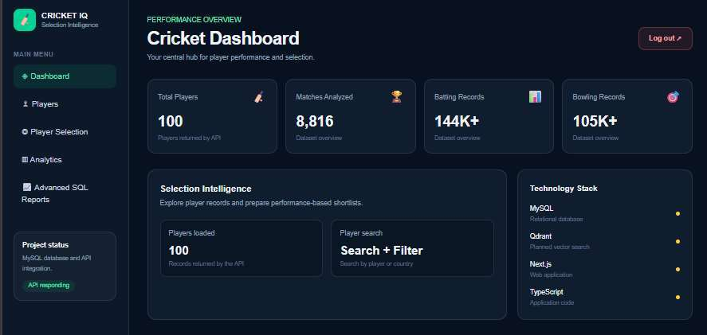
Figure 10.1. Application code or demo screenshot preserved from source report page 38.
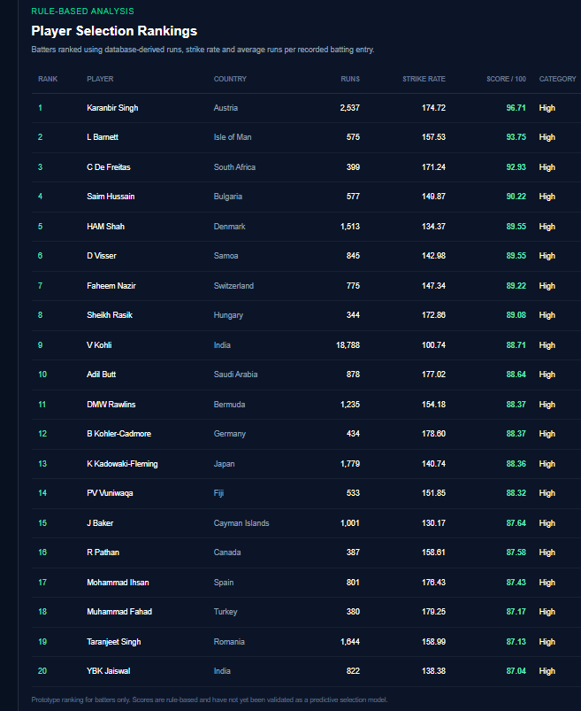
Figure 10.2. Application code or demo screenshot preserved from source report page 39.
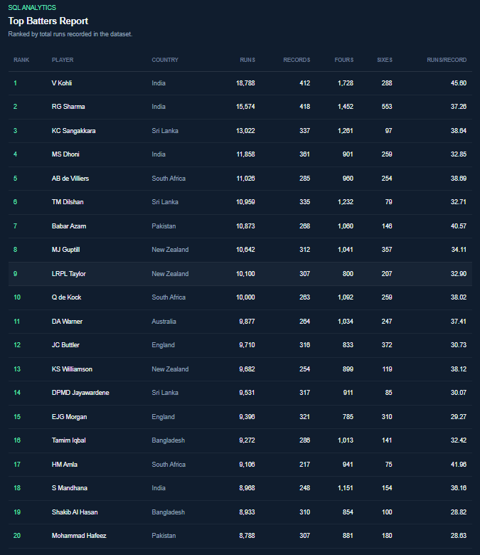
Figure 10.3. Application code or demo screenshot preserved from source report page 40.
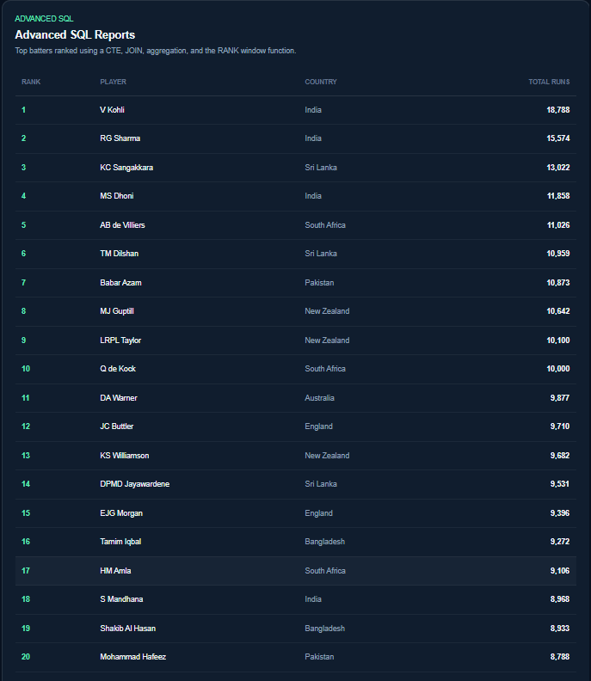
Figure 10.4. Application code or demo screenshot preserved from source report page 41.
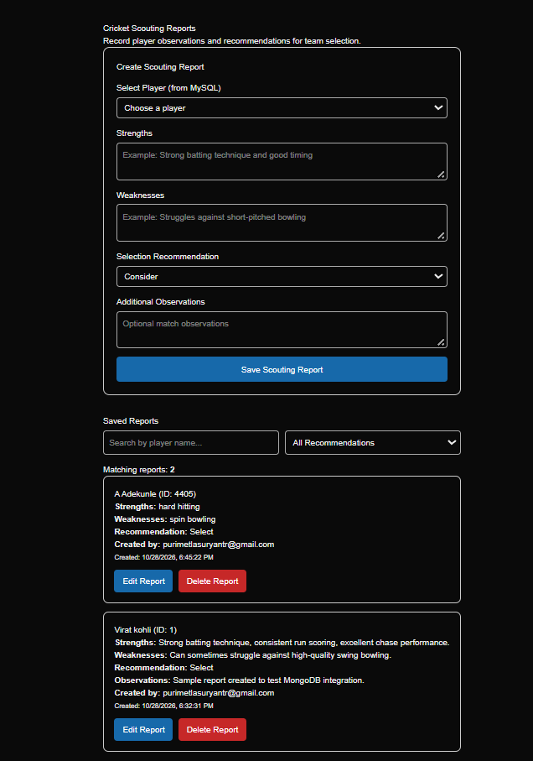
Figure 10.5. Application code or demo screenshot preserved from source report page 42.
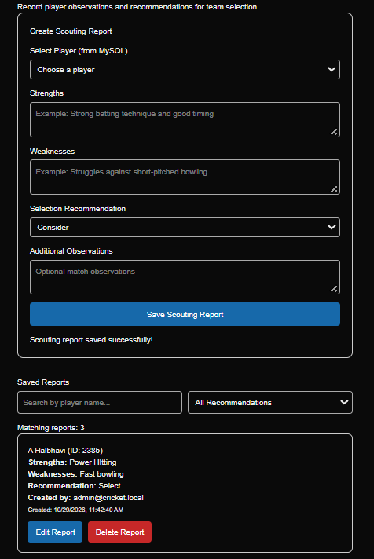
Figure 10.6. Application code or demo screenshot preserved from source report page 43.
Figure 10.7. Application code or demo screenshot preserved from source report page 44.
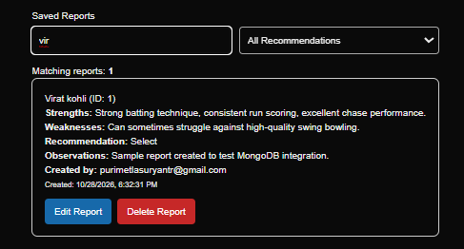
Figure 10.8. Application code or demo screenshot preserved from source report page 44.
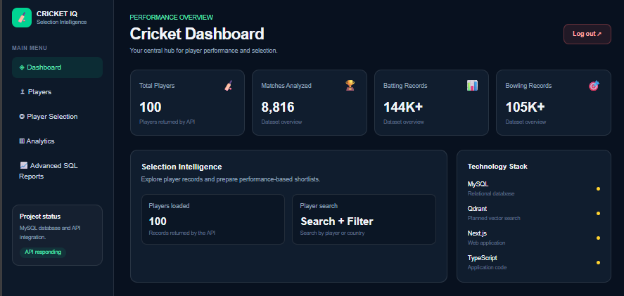
Figure 10.9. Application dashboard.
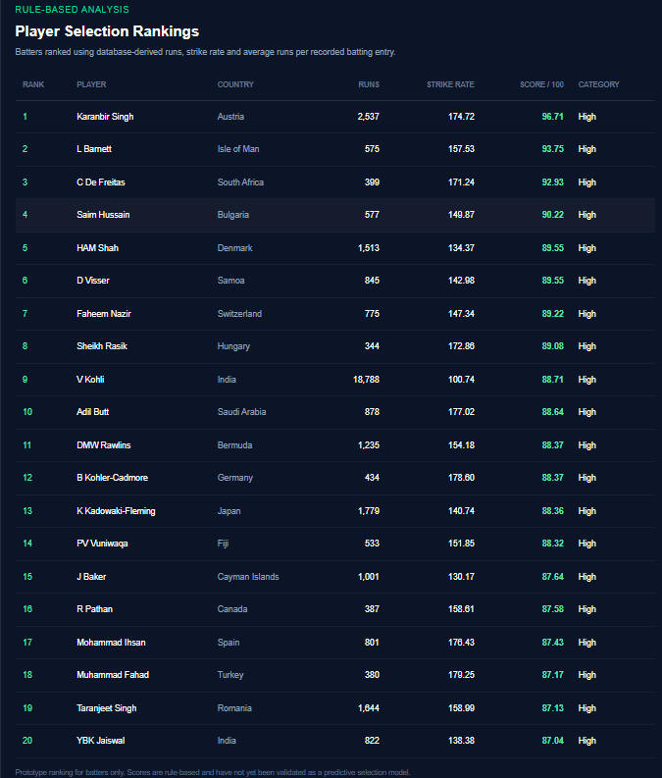
Figure 10.10. Player selection.
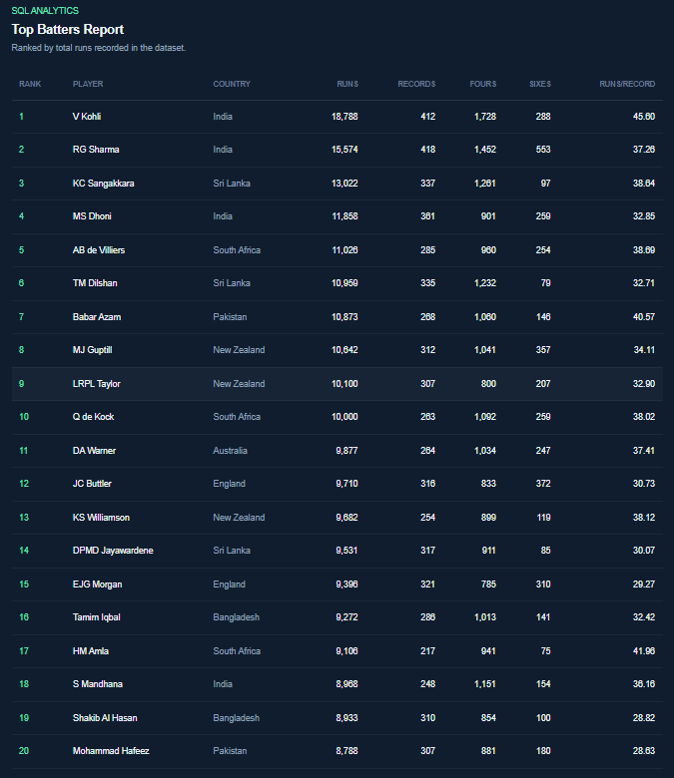
Figure 10.11. Player performance analytics.
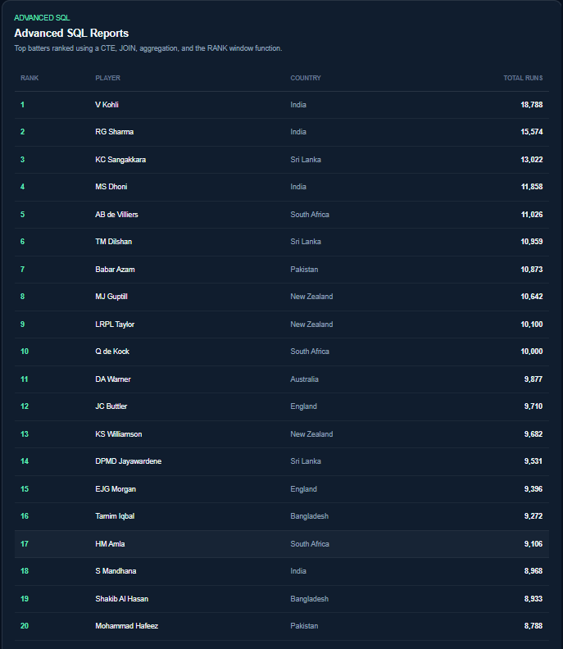
Figure 10.12. Advanced SQL reports.
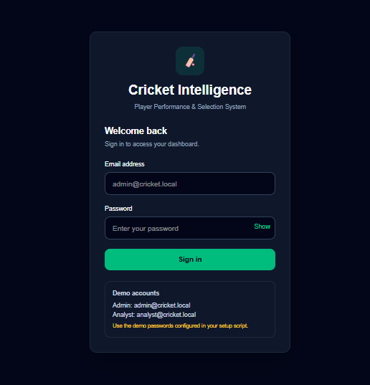
Figure 10.13. Authentication page.
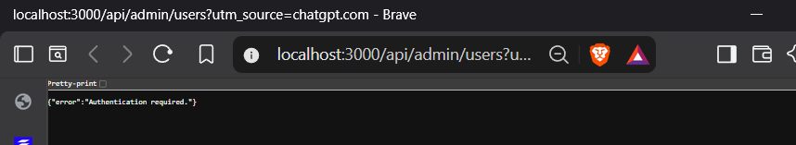
Figure 10.14. Role-based access demonstration.
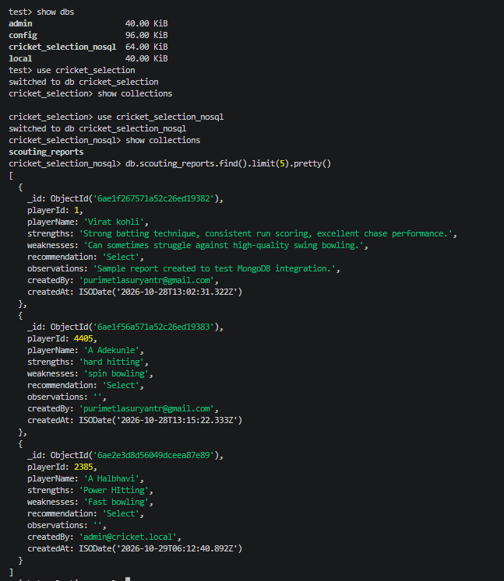
Figure 10.15. MongoDB scouting reports.

11. Evaluation Rubrics – Completion Status
The rubric categories below follow the official template. The status cells are left for faculty evaluation.
# | Criteria | Distribution | Status
1 | Database Design | ER diagram; relational schema with keys, relationships and constraints
2 | Database Creation | SQL implementation; NoSQL database creation; technology justification
3 | SQL Operations and Queries | DML; nested queries; joins and analytics
4 | Advanced Database Concepts | Views; procedure; trigger; indexes; MongoDB operations and aggregation
5 | Web Application and Database Integration | Next.js interface; backend/API and database integration
6 | Authentication and Authorization | Authentication, admin and analyst roles, protected API operations
7 | Documentation, Git/GitHub, Demonstration, Testing, and Originality | Documentation, source control, demonstration, testing and contributions

