PES University – Dept. of CSE-AI&ML
Lab 1: Requirements Engineering & UML Use-Case Modelling

Smart Lab Equipment & Slot Reservation Portal

1. Requirements Table

ID | Type | Description | Priority | Acceptance Criteria | Rationale
FR-001 | Functional | The system shall allow authenticated students to view real-time equipment availability and reserve a maximum 2-hour slot up to 7 days in advance. | High | Available slots can be reserved successfully; double-booking and reservations over 2 hours are prevented. | To provide controlled equipment booking and prevent scheduling conflicts.
FR-002 | Functional | The system shall verify the calibration status of equipment before allowing a student to reserve it. | High | Only equipment with valid calibration status can be reserved. | To ensure students use properly calibrated equipment.
FR-003 | Functional | The system shall prevent multiple students from reserving the same equipment for the same time slot. | High | An already reserved equipment slot cannot be reserved by another student. | To prevent double-booking and scheduling conflicts.
FR-004 | Functional | The system shall record equipment returns and enforce disciplinary rules for late returns. | High | Late returns are detected and the applicable disciplinary rule is enforced. | To ensure equipment is returned on time and remains available for other students.
FR-005 | Functional | The system shall allow lab technicians to update equipment status and calibration information. | High | Technicians can update equipment and calibration details, and the updated information is displayed. | To maintain accurate equipment availability and calibration information.
NFR-001 | Non-Functional | The system shall process concurrent slot reservation requests within 200 ms with strict database-level lock isolation. | HIgh | Reservation requests meet the 200 ms target without race conditions or double-booking. | To ensure fast and reliable reservation processing during peak usage.
NFR-002 | Non-Functional | The system shall authenticate users before allowing access to reservation and equipment-management functions. | High | Unauthenticated users cannot access protected functions. | To prevent unauthorized access to the system

2.UML Use-Case Diagram
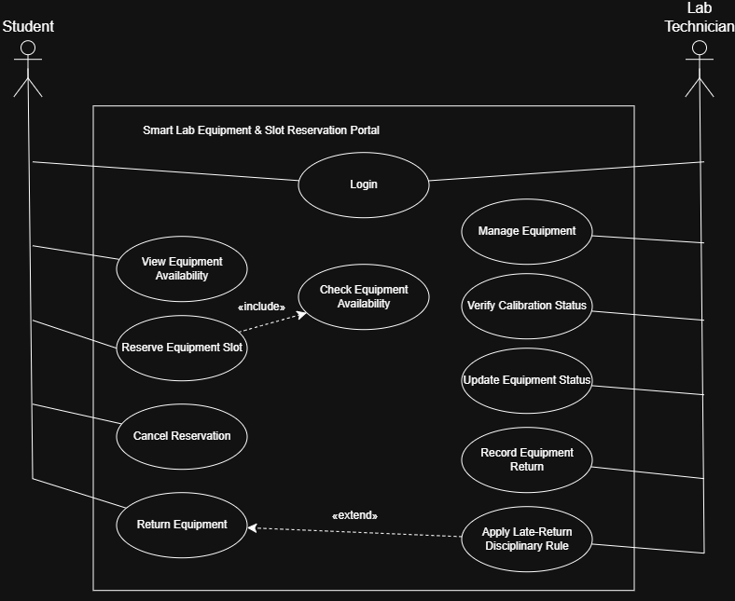
3. Use-Case Flow Specification
Use Case: Reserve Equipment Slot
Actor : Student

Preconditions:
1. The student is authenticated in the system.
2. The required equipment exists in the system.
3. The equipment has valid calibration status.
4. The requested reservation slot is within the allowed booking period.

Postconditions:
1. The reservation is successfully stored in the system.
2. The selected equipment slot is locked.
3. A reservation confirmation/token is generated.
4. The equipment cannot be double-booked for the reserved slot.

Main Success Scenario:
1. Student logs into the system.
2. Student views the available lab equipment.
3. Student selects the required equipment.
4. System checks the equipment's calibration status.
5. System displays available reservation slots.
6. Student selects a suitable slot.
7. System verifies that the selected slot is available.
8. Student confirms the reservation.
9. System creates the reservation and locks the selected slot.
10. System generates a reservation confirmation/token.

Alternate Flow: Equipment Slot Already Reserved:
- Student selects a reservation slot.
- System detects that the selected slot has already been reserved.
- System rejects the reservation request.
- System displays other available slots.
- Student selects another available slot and continues with the reservation.

