**Project Title:** **Azure Storage – Working with Blob – Using Azure Portal.**

**Project Description:** Create a Block Blob and try out the following tasks onto it.

Task – 1: Acquiring a Lease onto it.

Task – 2: Create a snap shot of it.

Task – 3: Providing a blob access to a given IP with specific SAS, for a

Given Date & Time duration.

Creation of blockblob and providing access to given ip address.

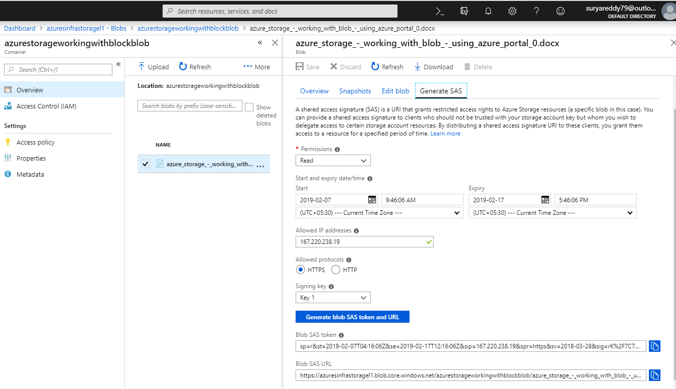

Final output:

The document is able to download and access with the given IP address.

