AI-BASED DIABETES PREDICTION SYSTEM

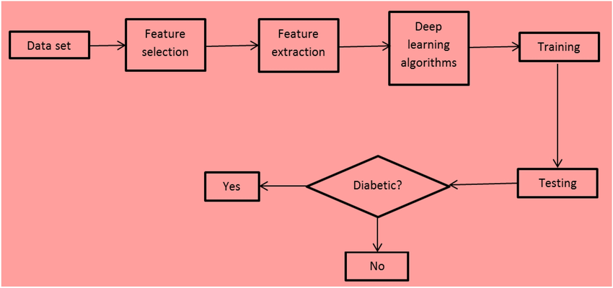

1. Data Collection and Preprocessing:

* Data Sources:

Collect relevant medical data, which may include patient demographics, medical history, lifestyle factors, and biomarkers like blood glucose levels, insulin usage, and HbA1c measurements. These data sources can include electronic health records (EHRs), wearable devices, and patient surveys.

* Data Preprocessing:

Clean and preprocess the data to handle missing values, outliers, and data inconsistencies. Normalize or standardize numerical features, encode categorical variables, and perform feature scaling as needed.

2. Feature Engineering:

* Domain Knowledge:

Collaborate with healthcare professionals to identify and engineer relevant features. These might include features related to diet, physical activity, family history, and other diabetes risk factors.

* Temporal Data Handling:

If you have time-series data (e.g., continuous glucose monitoring), consider feature extraction techniques to capture patterns over time.

3. Model Selection:

* Choose Algorithms:

Select appropriate machine learning and deep learning algorithms based on the nature of your data and problem. For diabetes prediction, algorithms like logistic regression, decision trees, random forests, gradient boosting, neural networks (e.g., LSTM), and hybrid models can be considered.

* Ensemble Techniques:

Implement ensemble techniques to combine multiple models for improved accuracy and robustness.

4. Model Training:

* Training Data:

Split your data into training, validation, and test sets. Use the training data to train your model and the validation set to optimize hyperparameters and prevent overfitting.

* Hyperparameter Tuning:

Employ techniques like grid search, random search, or Bayesian optimization to fine-tune model hyperparameters.

5. Model Evaluation:

* Performance Metrics:

Evaluate the model's performance using appropriate metrics such as accuracy, precision, recall, F1-score, ROC-AUC, and calibration plots.

* Interpretability:

Use techniques like SHAP values or LIME to provide insights into how the model makes predictions, especially in healthcare settings where interpretability is crucial.

6. Deployment:

* API or Web Interface:

Develop an API or web interface for easy integration with healthcare systems or user-friendly access for clinicians and patients.

* Security and Privacy:

Implement robust security measures to protect patient data and ensure compliance with healthcare regulations (e.g., HIPAA in the United States).

7. Continuous Monitoring and Updating:

* Performance Monitoring:

Continuously monitor the model's performance in a real-world healthcare environment. Set up alerts for performance degradation or changes in data distribution.

* Data Updates:

Periodically retrain the model with new data to adapt to changing patient populations and medical practices.

8. User Interaction:

* Clinician Interface:

Provide healthcare professionals with a user-friendly interface that displays patient risk scores and explanations for model predictions.

* Patient Engagement:

If applicable, develop a patient-facing application or platform to educate and engage patients in diabetes management and prevention.

9. Compliance and Ethical Considerations:

* Ethical Review:

Ensure that your system complies with ethical guidelines and regulations for healthcare AI applications.

* Transparency:

Maintain transparency in how the system makes predictions and handles patient data.

10. Collaboration with Healthcare Professionals:

* Medical Expertise:

Collaborate closely with healthcare experts, endocrinologists, and other relevant professionals throughout the design and development process to ensure clinical relevance and safety.