**Automated Resource management system**

**Objective**

ARMS integrates a forecasting tool with a resource planning tool and a resource balancing tool providing an end-to-end automated resource management solution for the organisation.

**Introduction**

Accurate demand forecasting combined with resource planning is critical to a company’s performance and profitability. This paper describes ARMS (automated resource management system), an integrated system developed for the customer service operations to help with the operational/tactical planning and deployment of the company’s 20,000-strong field engineer workforce. OR techniques are used throughout the system, including ARIMA for forecasting, constraint satisfaction for problem modelling, heuristic search for problem solving thus demonstrating the value and relevance of OR in solving today’s business problems.

The need for automating resource management, herein referred to as RM, is well recognised and has been the subject of considerable research and development. The case for automating RM is motivated by the drive to maximise profits, improve quality of service (QoS) and reduce costs.

Successful automation of RM requires that the aforementioned tenets be fully automated. Indeed operations research and artificial intelligence methods have been employed to automate some aspects of RM. For example the autoregressive integrated moving-average i.e. ARIMA model has been successfully employed in forecasting jobs. Constraint satisfaction [15and heuristic search methods have been applied to resource allocation problems. In this paper we describe work we have done in developing an automated resource management system called ARMS, to automate the planning and deployment of field engineers within the customer service division.

* Engineers are multi-skilled and they can perform several tasks requiring different competencies and capabilities. There are currently nine different ‘‘skills’’ defined for the purposes of RM with each engineer having one or more of these skills depending on past training and/or experience. The resource manager can focus specific engineers to work on activities of a particular skill or type.

• Engineers have the flexibility to move around between relatively small geographical areas called ‘‘patches’’. A customer service team (CST) usually is responsible for several patches and the resource manager has the responsibility to resource each patch adequately by moving engineers from neighbouring patches or by altering their working pattern to be explained next.

• Engineers have different working patterns. They can work full day or half a day. They may also be available to come and work on overtime on voluntary basis. Furthermore, they have several business related absences or meetings scheduled which, if necessary, could be cancelled to increase availability in certain geographical areas or on specific dates.

**Problem Statement**

In today’s semiconductor industry, both the pure-play and independent device manufacturer (IDM) foundries are constantly and rigorously competing for market share. The acknowledged benefit for customers who partner with these foundries includes a reduced cost-of-ownership, along with the underwritten agreement of meeting or exceeding an aggressive time-to-market schedule.

**Existing System**

The manual process of managing the resources and its software and hardware

Disadvantages

* More manual process
* No robustness
* Cannot utilizes the dependency resources properly.
* More human required in maintaining
* Leads to unknown operations
* Less in productivity
* More cost

**Proposed System**

ARMS integrates a forecasting tool with a resource planning tool and a resource balancing tool providing an end-to-end automated resource management solution for the organisation.

Advantages

* Overcomes all the disadvantages
* Speed in processing
* Resource can be dynamically utilized
* Less human required
* Gives loose coupling of the resources
* Distributed system

**Overview**

Systems, methods, and devices to provide simple adaptive automated resource management of a resource system (such as but not limited to electricity, natural gas, water, data, bandwidth allocation, access to information, etc.) on a local basis, based on automatically detecting, measuring and combining time-varying resource provider preferences, resource market conditions, resource supply source conditions, environmental conditions and resource system impact on the environment, together with resource user locations, user priorities and preferences, and information about other conditions that may be relevant to the operation of the resource management system in order to optimize performance of the resource system to better meet or approach defined goals, and to measure and display the results achieved by the resource management system compared against those goals.

A system consisting of a human operator or group of operators and a machine, by means of which the operator performs a task involving, for example, the production of material goods, the management of some type of operation, or the processing of information. Human labor in a man-machine system is based on interaction according to received information with both the object of labor or control and the machine through the mediation of control elements.

Interest in man-machine systems arose in the mid-20th century, when systems of various kinds became with increasing frequency the objects of technical planning and design. The effectiveness of these systems, which included those for the control of production, transportation, communications, and space flights, was largely determined by the activity of the human operators. The combination of human abilities and capabilities of a machine or complex of technological devices significantly increases the effectiveness of control. Although there is a joint performance of control functions by the human operator and machine, each of the two components of the system is governed in its work by its own unique rules. The effectiveness of the system as a whole is determined by the extent to which characteristic features of the operator and machine, both limitations and potentials, are identified and taken into account when building the system. These features are most fully identified in the process of coordinating the external, that is, technological, means of action and the internal means of action, that is, means inherent to the operator. Coordination includes the construction of information and conceptual models.

Libraries can use Electronic Resource Management as a standalone solution

or as an integrated part of Sierra: Innovative’s trusted integrated library

management platform. As a standalone system, libraries can enjoy the

benefits of ERM’s ability to maintain resources, track licenses, and manage

coverage data. Whether fully integrated or standalone, ERM is tailor-made to take advantage of a “Quick Start” implementation program that includes over 400 ready-to-use resource records.

**System Design**

Systems design is the process of defining the [architecture](https://en.wikipedia.org/wiki/Systems_architecture" \o "Systems architecture), modules, interfaces, and [data](https://en.wikipedia.org/wiki/Data" \o "Data) for a [system](https://en.wikipedia.org/wiki/System" \o "System) to satisfy specified [requirements](https://en.wikipedia.org/wiki/Requirement" \o "Requirement). Systems design could be seen as the application of [systems theory](https://en.wikipedia.org/wiki/Systems_theory" \o "Systems theory) to [product development](https://en.wikipedia.org/wiki/Product_development" \o "Product development). There is some overlap with the disciplines of [systems analysis](https://en.wikipedia.org/wiki/Systems_analysis" \o "Systems analysis), [systems architecture](https://en.wikipedia.org/wiki/Systems_architecture" \o "Systems architecture) and [systems engineering](https://en.wikipedia.org/wiki/Systems_engineering" \o "Systems engineering).

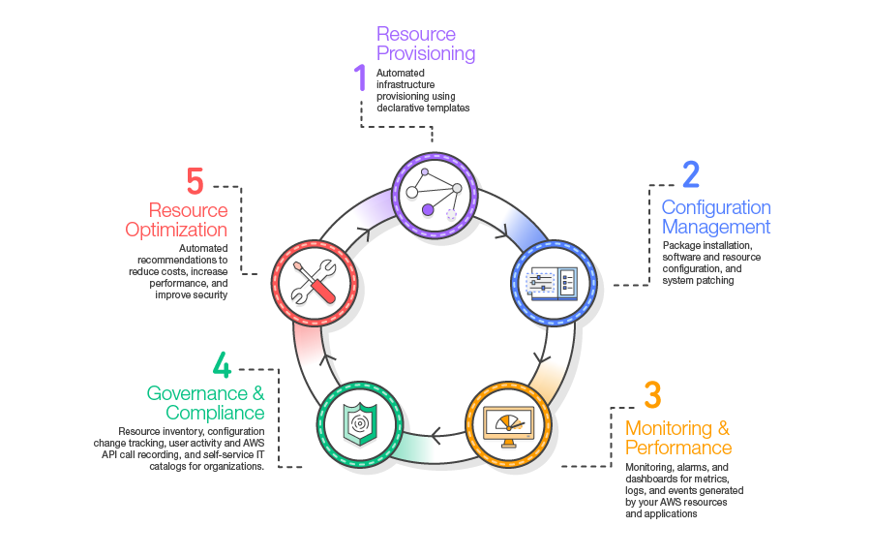

**Modules**

* Forecasting: The ability to forecast the demand of work.
* Analysis: The ability to analyse resource and job profiles and identify either over or under resource utilisation. A resource profile refers to a particular collection of location (i.e. area), skill and availability (i.e. time) data. A job profile on the other hand refers to attributes of the job such as priority, start and end dates, job type and so on. Analysis comprises resource planning and scheduling. Resource planning involves profiling where resource profiles are adapted with a view to matching configuration of skills, availability and locations of the resources to the skills, timing and locations of the jobs making up a particular workload. Resource scheduling is concerned with assigning resources to actual jobs and identifying explicit execution times for those jobs. Resource planning is an essential pre-cursor to successful resource scheduling.
* Execution: The ability to execute the output of the analysis—in terms of dispatching jobs to resources, making requests for extra resources in case of over resource utilisation. Successful automation of RM requires that the aforementioned tenets be fully automated. Indeed operations research and artificial intelligence methods have been employed to automate some aspects of RM. For example the autoregressive integrated moving-average i.e. ARIMA model has been successfully employed in forecasting job . Constraint satisfaction and heuristic search methods have been applied to resource allocation problems. In this paper we describe work we have done in developing an automated resource management system called ARMS, to automate the planning and deployment of field engineers within the customer service division of British Telecommunications plc (BT).

• Forecasting demand for several activity types (e.g. provision, repair, maintenance work).

• Planning the volumes, skills and geographical locations of engineers required in order to service that demand in the next current up to 6 months.

• Deploying field engineers for tomorrow in the best possible manner so that incoming and existing work can be optimally scheduled by the companys automated workforce scheduling system

**User**

* Can see the 6 months update or upgrade notification.
* Can add the main resource
* Can add the sub resource
* Manage the resource to re utilizing

**Admin**

* Add the employee detail
* Add the main resource
* Add the sub resource
* View the transaction

**ER-Diagram**

ph

enam

mrname

mrid

AuditTrail

has

Main Resource

has

Sub Resource

prese

perfo

Transaction

Employee

eid

pass

rname

image

rid

idate

sname

rid

ename

eid

fid

time

eid

aid

**1**

**1**

**1**

**1**

**Data Flow Diagram**

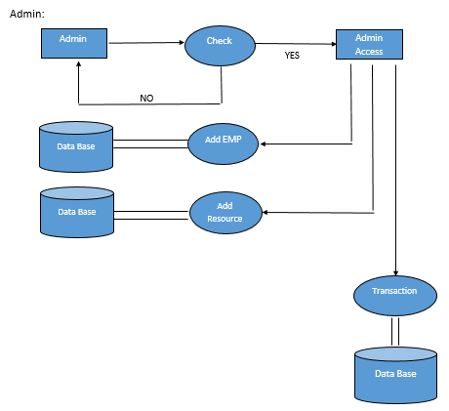

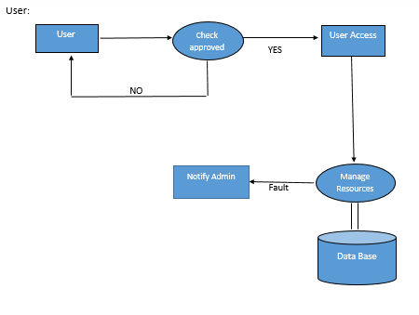

**Table Design/Attributes**

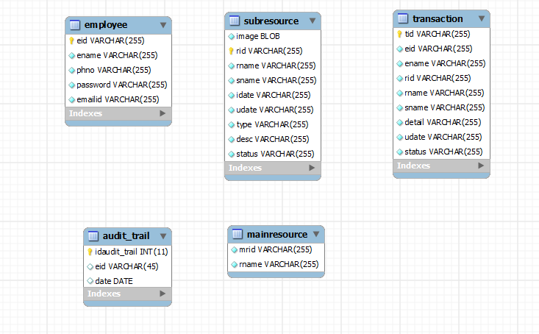

**REQUIREMENT SPECIFICATION**

A software requirements definition is an abstract description of the services which the system should provide and the constraints under which the system must operate.

• System requirements may be either functional or non-functional requirements.

**4.1 Functional Requirements**

In software engineering, a functional requirement defines a function of a software system or its component. A function is described as a set of inputs, the behavior, and outputs. Functional requirements may be calculations, technical details, data manipulation and processing.

• Administrator login

• Uploading data

• User registration

• User login

• Searching

• Ranking results based on likes and comments

**4.2 Non-Functional Requirements**

The feasibility of the project is analyzed in this phase and business proposal is put forth with a very general plan for the project and some cost estimates.

Three key considerations involved in the feasibility analysis are

• **Economical Feasibility**: This study is carried out to check the economic impact that the system will have on the organization

• **Technical Feasibility**: This study is carried out to check the technical feasibility, that is, the technical requirements of the system.

• **Social Feasibility**: The aspect of study is to check the level of acceptance of the system by the user. This includes the process of training the user to use the system efficiently.

**Requirement Specification**

* **Hardware Requirement Specification:**

• Hardware: Dual Core

• Hard Disk: 50 GB

• Speed: 1.4 GHz

• RAM: 1GB

• Key Board: Standard Keyboard

• Touch Pad: Button Mouse

• Monitor: LED

 **Software Requirement Specification:**

• Operating System : Windows

• IDE : Net Beans 7.3.1

• Technology : Java and J2EE

• Web Server : Tomcat

• Web Technologies : Html, JavaScript, CSS

• Java Version : JDK1.7

• Database : My SQL

**TECHNOLOGY AND TOOLS DESCRIPTION**

**NetBeans IDE Frame Work**

In computer programming, a software framework is an abstraction in which software providing generic functionality can be selectively changed by additional user – written code, thus providing application specific software. A software framework is a universal, reusable software platform used to develop applications, products and solutions.

A software framework includes support programs, compilers, code libraries, tool sets and application programming interface that bring together all different components to enable development of a project or solutions.



NetBeans is an integrated development environment (IDE) for developing primarily with Java, but also with other languages, in particular PHP,C/C++, and HTML5. It is also an application platform framework for Java desktop applications and others.

NetBeans IDE is written in Java and can run on Windows, OS X, Linux, Solaris and other platforms supporting a compatible JVM. The NetBeans Platform allows applications to be developed from a set of modular software components called modules.

Applications based on the NetBeans Platform (including the NetBeans IDE itself) can be extended by third party developers. NetBeans IDE is an open-source integrated development environment. NetBeans IDE supports development of all Java application types (Java SE(including JavaFX), Java ME, web, EJB and mobile applications) out of the box. Among other features are an Ant based project system, Maven support,refactorings, version control.

All the functions of the IDE are provided by modules. Each module provides a well defined function, such as support for the Java language, editing, or support for the CVS versioning system, and SVN. NetBeans contains all the modules needed for Java development in a single download, allowing the user to start working immediately.

**Tomcat 6.0 web server**

Tomcat is an open source web server developed by Apache Group. Apache Tomcat is the servlet container that is used in the official Reference Implementation for the Java Servlet and JavaServer Pages technologies. The Java Servlet and JavaServer Pages specifications are developed by Sun under the Java Community Process. Web Servers like Apache Tomcat support only web components while an application server supports web components as well as business components (BEAs Weblogic, is one of the popular application server).To develop a web application with jsp/servlet install any web server like JRun, Tomcat etc to run your application.



Figure 1.3 tomcat webserver

**TESTING**

The inspiration driving is to find defaults in the errand. The testing is the explanation behind attempting to discover every lack or deficiency in a working things. It gives the best way to check the suitability of sections, sub-assemblies and a completed thing. It is the method of working with the arrangement of confirming that the item framework meets its chucks and the customer covets and does not miss the mark in an unacceptable way. There are characteristic sorts of test. Every test category discourses a precise testing need.

**8.1 Types of Testing**

1. Unit
2. Integration
3. Functional
4. System
5. White-Box
6. Black-Box
7. Acceptance

**8.1.1 Unit Testing of System**

Testing fuses the sketch of examinations that endorse that the inner venture reason is working truly, and that program inputs extensive yields. All inside code and branches ought to be insisted. It is utilization to test the individual programming unit of an application. Unit testing is done before breaker. It is the central testing that depends heaps of its change and is intruding.

Unit testing guarantees that each exceptional strategy for a occupational system perform correctly to the recorded purposes of interest and covers obviously depicted inputs and output result.

This performs indispensable tests part by part level and test a specific occupational framework, application, structure course of action. Unit testing is for the most part decided as mutual code and unit test of the thing lifecycle.

* **Test plan and method**
  + It will be performed physically and practical and will be composed in point of interest.
* **Objectives**
* Field accesses essentially work properly.
* Folios must be triggered from the recognized link.
* The entrance display, responses must not be late.
* **Features**
* Link’s should take to the correct page.
* Confirm that the accesses are of the format.
* No same entries should be allowed.

**TEST CASES**

|  |  |
| --- | --- |
| Name of the test |  |
| Test Description |  |
| Sample Input |  |
| Expected Output |  |
| Actual result/Remarks |  |
| Passed (?) |  |

|  |  |
| --- | --- |
| Name of the test |  |
| Test Description |  |
| Sample Input |  |
| Expected Output |  |
| Actual result/Remarks |  |
| Passed (?) |  |

|  |  |
| --- | --- |
| Name of the test |  |
| Test Description |  |
| Sample Input |  |
| Expected Output |  |
| Actual result/Remarks |  |
| Passed (?) |  |

**8.1.2 Integration Testing of System**

Integration testing is needed to test urged programming sections to grasp whether they truly continue running as one structure. Exchange off particularly away to uncover the matters that climb up the mix of pieces. Event driven and it more worried with the critical aftereffect of screens or fields. This tests show that paying little personality that the pieces were solely satisfaction, as displayed by tastefully unit testing.

The mix of sections is correct and solid. Programming testing is the testing of two or more made programming parts on a single stage to go on disillusionments brought on by crossing point misshapenings. Attempt of testing is to watch that parts or programming application e.g. pieces in a thing framework or programming application at the association level to interface without lurch.

Mix testing is deliberate to test joined programming portions to make sagacity of whether they continue running as one framework. Combination testing is especially away to uncover the issues that rise up out of the mix of sections.

Testing is more stressed with the basic consequence of screens fields. Combination tests display that in spite of the way that the sections were solely gratification, as showed up by viably unit testing. Programming blend testing is the coordination testing of two or more joined programming sections on a lone stage to make frustrations realized by interface disfigurements.

The task that compromise test is to watch that parts or programming application, e.g. fragments in an item framework or programming application at the association level to interface without bungle.

**Test Results:** This test cases is passed successfully. No defects met.

|  |  |
| --- | --- |
| Name of the test |  |
| Test Description |  |
| Sample Input |  |
| Expected Output |  |
| Actual result/Remarks |  |
| Passed (?) |  |

Table 8.10 Integration Of all Unit Testing

**8.1.3 Functional Testing** **of system**

Functional tests gives exact establishes that limits make an effort showed by the occupational and specific necessities, framework certification, and customer manual. Affiliation and availability of functional test is revolved around necessities, key limits, or uncommon trials. Besides, effective allowance identifying with perceive occupational process stream, datafields, predefined structures, and techniques must be measured for testing. Additional perceived and the convincing estimation of current tests is determined.

**8.1.4 System Testing**

This testing ensures that the entire fused programming structure meets necessities. It tests a setup to ensure known obvious results. An instance of structure testing is the setup arranged structure blend test. System testing relies on upon technique focusing on pre-driven strategy associations and blend centers.

**8.1.5 White-Box Testing of System**

White box testing is a annoying in which the invention analyzer has data of internal mechanisms, structure and product. It is additionally used to test parts that can't be come to from a discovery level.

**8.1.6 Black-Box Testing of System**

Black-Box testing is the attempting the item with unknown data of the internal working, structure or lingo of the module attempted. Disclosure test, most diverse sorts of tests, must be made from an indisputable basis record.

**8.1.7 Acceptance Testing**

This testing is a risky period of interest by the end client. It additionally assurances that the framework experiences the utilitarian prerequisites.

Test Results: All the trials said above passes effectively. No deformities experienced.

**Conclusion**

The automated resource management leads to utilize all the resource properly. The update and upgrade date and time along with the employee can be kept track. The admin keeps control of all the resource and the resources can be mapped to any main resource which leads to not wasting the resource any time hence this increases the productivity.

**Coding Stored Procedure**

﻿﻿<%@ page import="java.sql.*,databaseconnection.*" %>

<%@page contentType="text/html" pageEncoding="UTF-8"%>

<!DOCTYPE html>

<html>

<head>

<meta http-equiv="Content-Type" content="text/html; charset=UTF-8">

<title>JSP Page</title>

</head>

<body>

<%

String rid=request.getParameter("rid");

String rname=request.getParameter("rname");

//out.print(username1);

String udate=request.getParameter("udate");

String status=request.getParameter("status");

int i=1;

if(i==0)

{

Connection con1=null;

Statement st=null;

ResultSet rs=null;

int id=0;

try

{

PreparedStatement ps1=null;

con1=databasecon.getconnection();

st=con1.createStatement();

rs=st.executeQuery("call simpleproc(?,?)");

ps1.setString(1,rname);

while(rs.next())

{

rs.getString("mid");

session.setAttribute("id",id);

}

}

catch(Exception e)

{

out.println(e.getMessage());

}

}

Connection conn=null;

PreparedStatement ps=null;

try

{

Class.forName("com.mysql.jdbc.Driver");

conn = DriverManager.getConnection("jdbc:mysql://localhost:3306/arms","root", "123");

//conn=databasecon.getconnection();

ps=conn.prepareStatement ("UPDATE subresource SET `rname` = ?, `udate` = ?, `status` = ? where `rid` = ?");

ps.setString(1,rname);

ps.setString(2,udate);

ps.setString(3,status);

ps.setString(4,rid);

int x=ps.executeUpdate();

if(x==0)

{

response.sendRedirect("amanageresource.jsp?message=fail");}

else

{

response.sendRedirect("amanageresource.jsp?message=success");

}

}

catch(Exception e)

{

out.println(e.getMessage());

}

%>

</body>

</html>

**References**

Knox, Tim, “Digital Graphiti, Inc. Selected To Develop Web-Based E-Government System For The City of Huntsville, Alabama” February 25, 2002.

http://www.digitalgraphiti.com. 4 Kullhem, Charles A. Telephone interview with author. Montgomery Ala, April 8, 2002.

[1] http://en.wikipedia.org/wiki/Human_resource_ management_system Books:

[2] James Goodwill, PURE Java Server Pages 3rd Edition

[3] Larne Pekowsky, Java Server Pages 2nd Edition

[4] Simon Brown, Sam Dalton, Daniel Jepp, Dave Johnson, Pro JSP 3rd Edition

[5] Thearon Willis, SQL Server 2000 2nd Edition