End-to-End CI/CD Pipeline on AWS

Project Overview
This project demonstrates a complete DevOps CI/CD pipeline using Jenkins, AWS, SonarQube, Nexus Repository, Docker, and Ansible.
The pipeline automates:
- Source Code Checkout
- Build Automation
- Unit Testing
- Static Code Analysis
- Artifact Management
- Docker Image Creation
- Deployment to Staging
- Integration Testing
- Production Deployment

The objective is to reduce manual deployment effort, improve software quality, and enable faster releases.

Architecture
Developer
|
v
GitHub Repository
|
v
Jenkins Pipeline
|
+------------------+
| |
v v
SonarQube Maven Build
(Code Quality) Unit Tests
| |
+--------+---------+
|
v
Nexus Repository
(Artifact Storage)
|
v
Docker Build
|
v
Docker Registry
|
v
Ansible Deploy
|
v
Production Server

Step 1: Create AWS Infrastructure:
To implement this project, I created four EC2 instances in AWS:
Instance Name | Purpose | Instance Type
Jenkins Server | CI/CD pipeline automation | t3.micro
SonarQube Server | Code quality analysis | t3.small
Nexus Server | Artifact repository management | t3.small
Application Server | Application deployment | t3.micro

Network Configuration
Security groups were configured with the following ports:
Service | Port
SSH | 22
Jenkins | 8080
SonarQube | 9000
Nexus | 8081
Application | 8080

Jenkins:
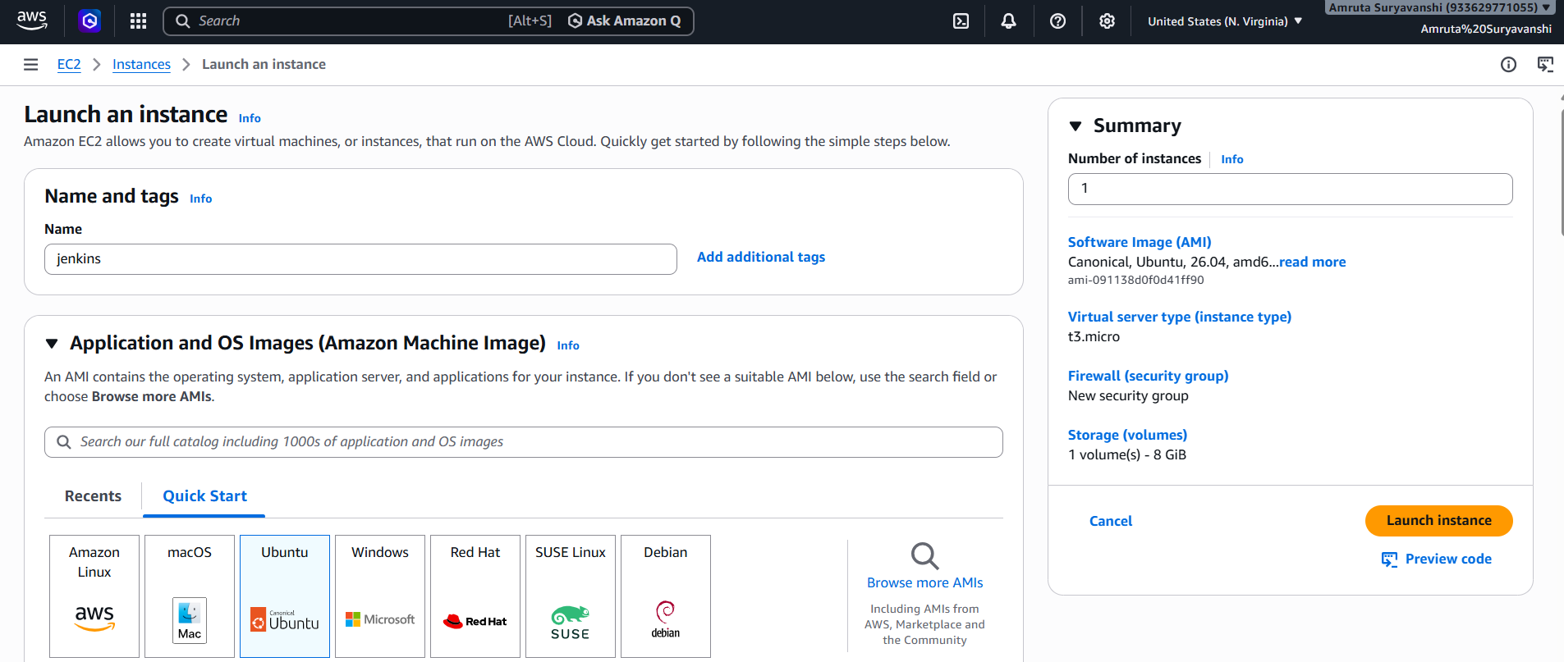
Create another same 3 instances for sonarqube (t3 small), nexus (t3 small),
Application Server (t3 micro).
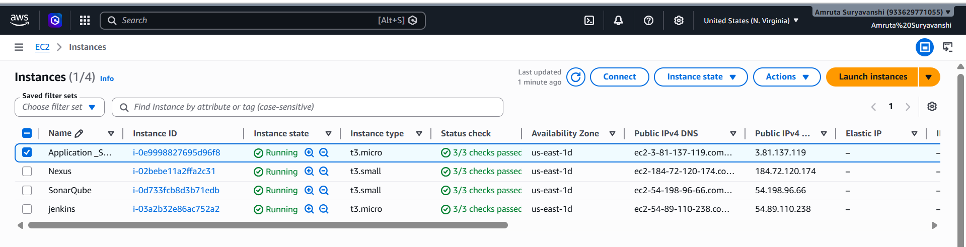
Step 2: Install Jenkins Server
- Update System Packages
sudo apt update && sudo apt upgrade –y

- Install JDK
sudo apt install openjdk-21-jdk -y

- Verify the installation was successful
java –-version

- Add the Jenkins Repository Keys
sudo mkdir -p /usr/share/keyrings
sudo wget -O /usr/share/keyrings/jenkins-keyring.asc \
https://pkg.jenkins.io/debian-stable/jenkins.io-2023.key
echo "deb [signed-by=/usr/share/keyrings/jenkins-keyring.asc] https://pkg.jenkins.io/debian-stable binary/" | sudo tee /etc/apt/sources.list.d/jenkins.list > /dev/null

- Install and Enable Jenkins
sudo apt update
sudo apt install jenkins –y
sudo systemctl enable jenkins
sudo systemctl start jenkins
verify that the service is running normally
sudo systemctl status Jenkins
- Open:
http://public-ip:8080
Get password:
sudo cat /var/lib/jenkins/secrets/initialAdminPassword
Install suggested plugins.
Additional plugins:
- Maven Integration
- Pipeline
- Docker
- Git
- SonarQube Scanner
- Slack Notification
- SSH Agent
- Ansible
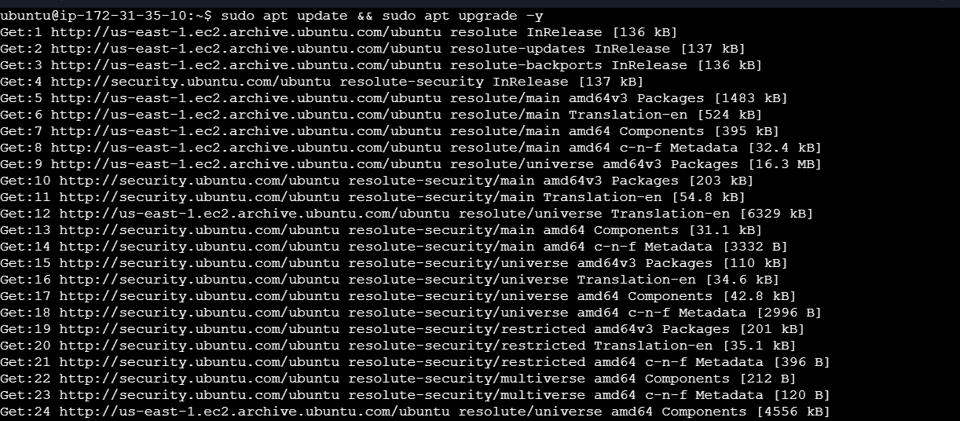
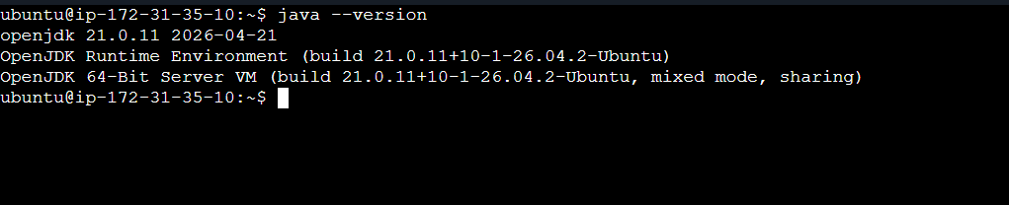

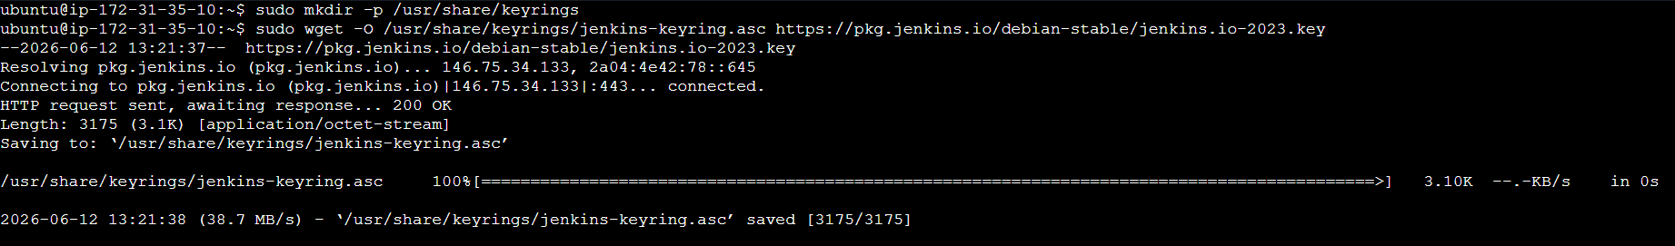
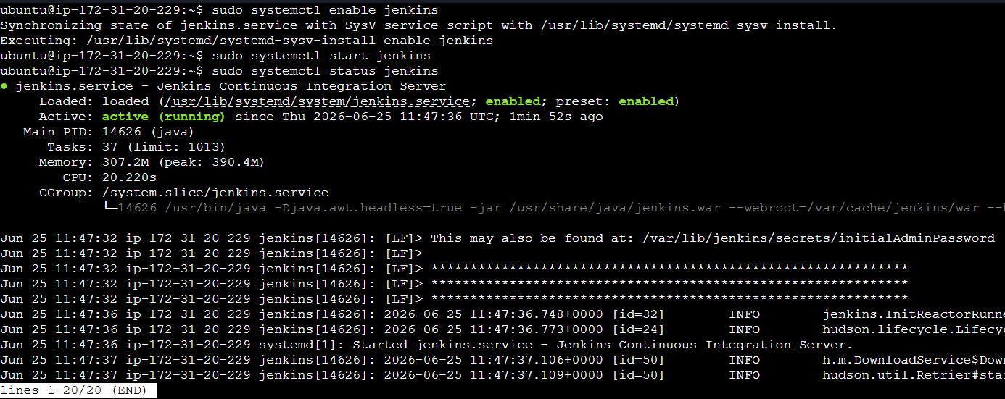
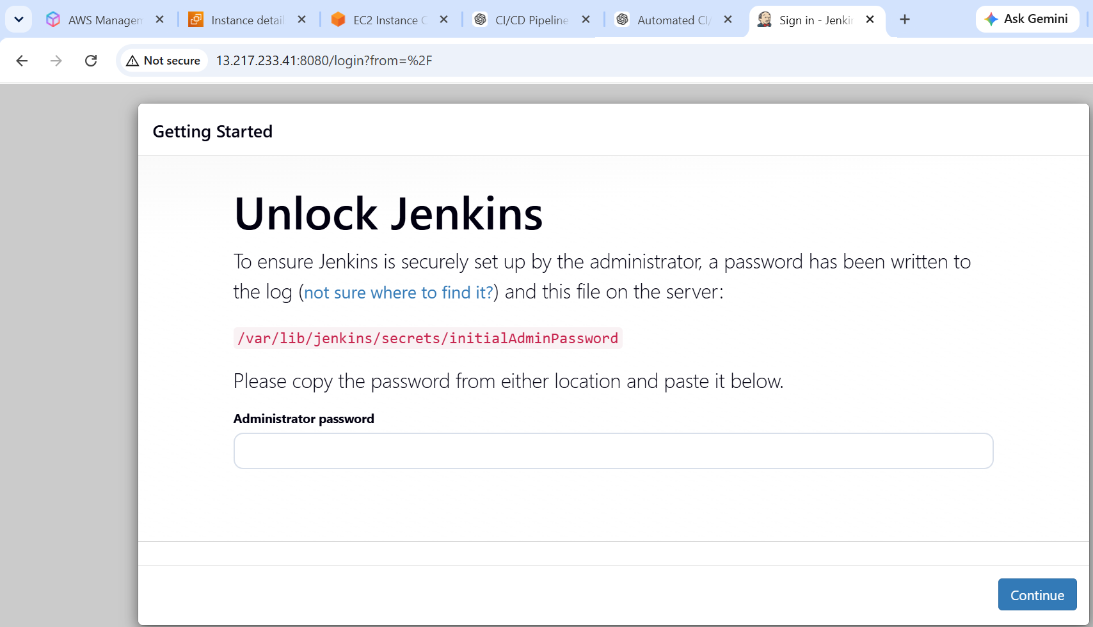
Install Git
sudo apt install git –y
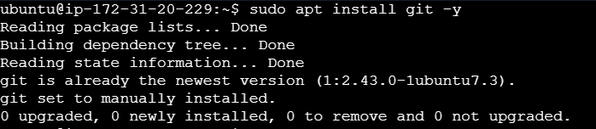
Install Maven
sudo apt install maven –y
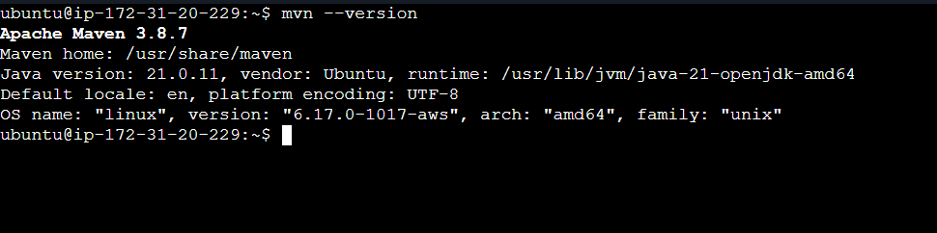
Install Docker
sudo apt update
sudo apt install docker.io –y
sudo usermod -aG docker ubuntu
sudo usermod -aG docker Jenkins
sudo systemctl enable docker
sudo systemctl start docker
sudo systemctl status docker
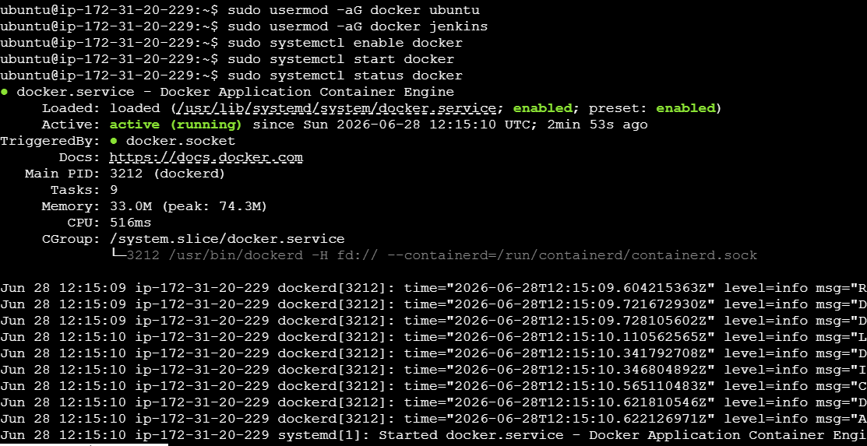
Install Ansible
sudo apt install ansible –y
ansible –version
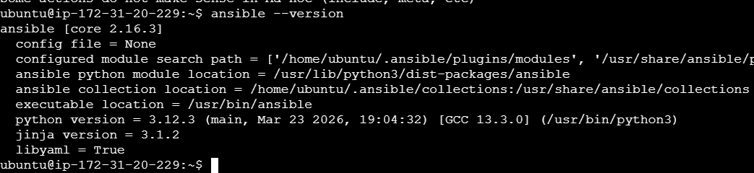
Now install Sonarqube on Sonarqube server
( Need to install Java and docker on sonarqube server as well install as per above commands and instructions)
Once java and docker are successfully installed on sonarqube server next step is to install sonarqube
Install Sonarqube
sudo docker run -d --name sonarqube -p 9000:9000 sonarqube:lts-community
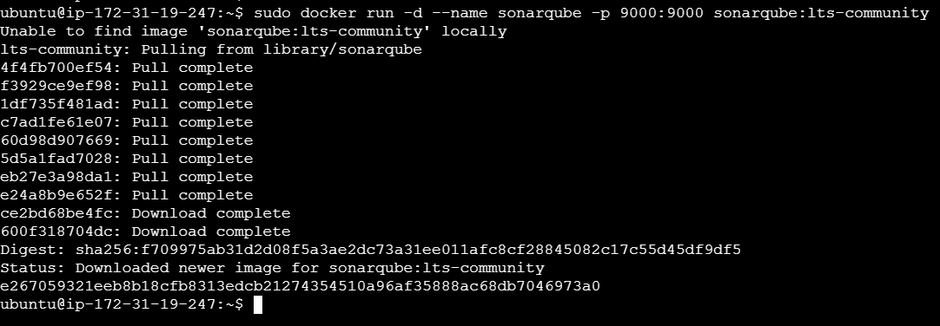
Access Sonarqube using following URL
http://<sonarqube-public-ip>:9000
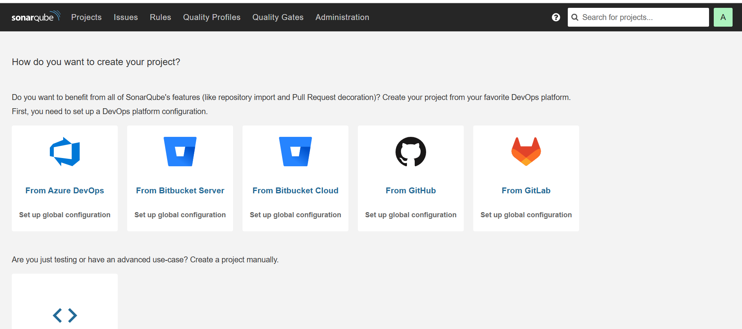

Now u need to create token in sonarqube
To Generate Token:
Administration
→ Security
→ Users
→ Generate Token

Install Nexus on Nexus server
( Need to install Java and docker on Nexus server as well install as per above commands and instructions)
Install Nexus
docker run -d -p 8081:8081 --name nexus sonatype/nexus3
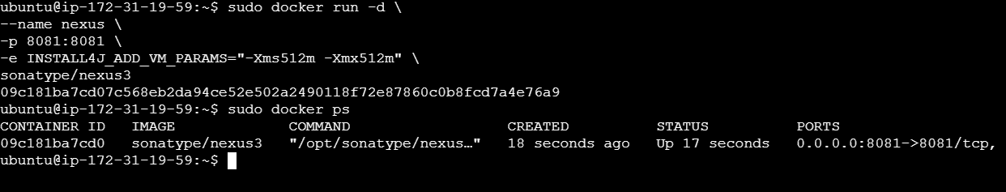
Access Nexus using following URL
http://<nexus-public-ip>:8081
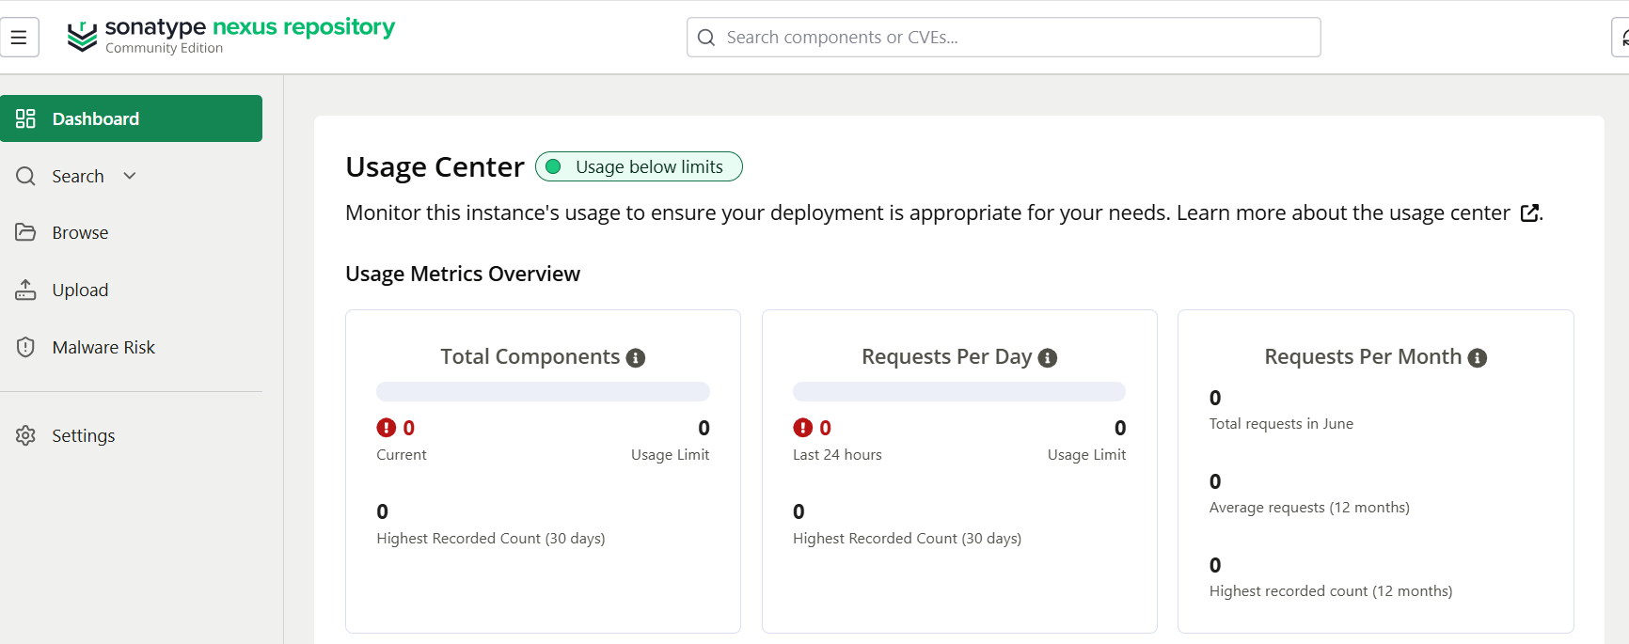
For project code check following github repository
https://github.com/SuryavanshiAmruta/Devops_project_1.git
check following screenshots for final output:
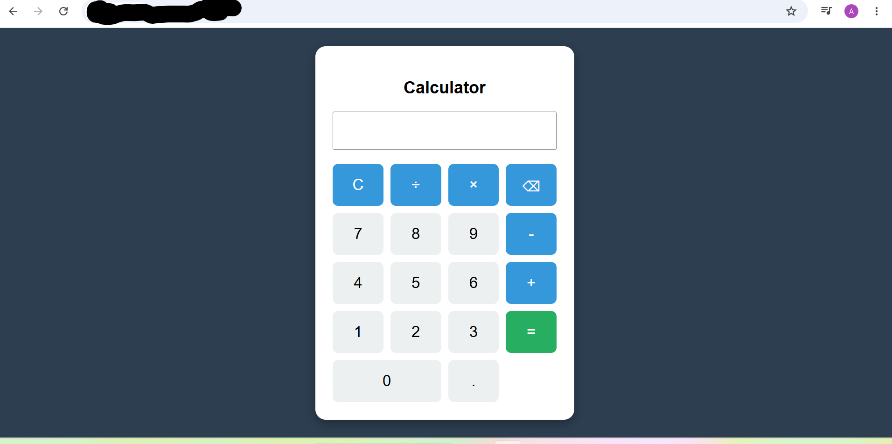

Nexus Repository:
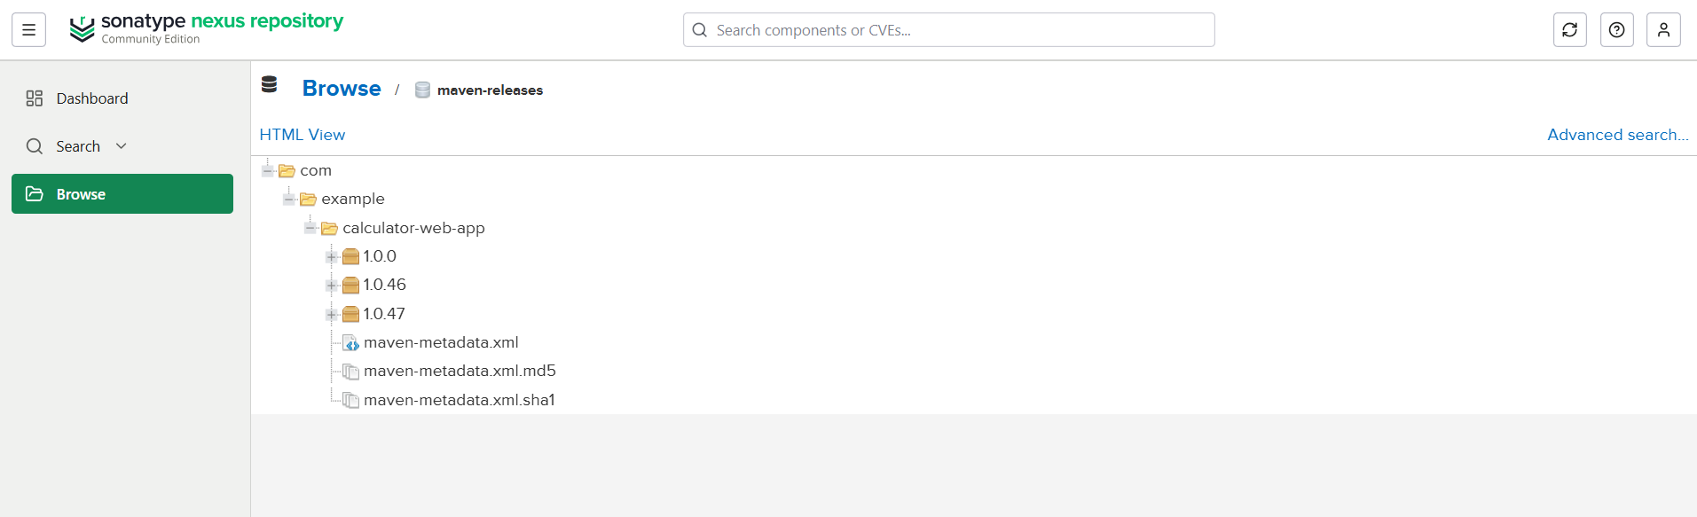

Sonaqube:
