Department of
Artificial Intelligence & Machine Learning
B.Tech III Semester Academic Year 2026-2027
Database Management Systems (25B11CS001)
Capstone Stone Project Documentation


ADITYA UNIVERSITY
Surampalem, Kakinada District
Andhra Pradesh-533437



SCHOOL OF COMPUTING

Department of Artificial Intelligence & Machine Learning

CERTIFICATE

This is to certify that the Cornerstone project work entitled “University Academic Management System” is submitted by
K TRIPURA | (26B21AI054)
M BHAGYA SATYA SRI | (26B21AI068)
P SURYA VARSHITHA | (26B21AI089)
M VEERESH | (26B21AI092)

In partial fulfilment of the requirements for the award of the B.Tech. degree in Artificial Intelligence & Machine Learning for the academic year 2026-2027.

Project Guide Head of the Department
Mrs G.L. Narasamba Vanguri, M. Tech, (Ph.D.) Dr K. Naga Bhargavi, M. Tech, Ph.D.,
Assistant Professor, Associate Professor,
Department of AIML Department of AIML

UNIVERSITY ACADEMIC MANAGEMENT SYSTEM
A DBMS Capstone Project Report submitted in partial fulfilment of the requirements for the award of the degree of

BACHELOR OF TECHNOLOGY
in

ARTIFICIAL INTELLIGENCE AND MACHINE LEARNING

Submitted By

KILAPRTHI TRIPURA - 26B21AI054
MALLESWARAPU BHAGYA SATYA SRI – 26B21AI068
PADALA SURYA VARSHITHA – 26B21AI089
MANTINA VEERESH – 26B21AI092

Under the esteemed guidance of
Mrs. G.L.Narasamba Vanguri M.Tech, (Ph.D.)

Assistant Professor


DEPARTMENT OF ARTIFICIAL INTELLIGENCE AND MACHINE LEARNING

ADITYA UNIVERSITY
(Formerly Aditya Engineering College (A))
Aditya Nagar, ADB Road, Surampalem, Andhra Pradesh, India

2026 – 2027


Aditya Nagar, ADB Road, Surampalem, Andhra Pradesh, India
DEPARTMENT OF ARTIFICIAL INTELLIGENCE AND MACHINE LEARNING

CERTIFICATE

This is to certify that the DBMS Capstone Project report entitled “University Academic Management System” is being submitted by K TRIPURA (Roll No. 26B21AI054), M BHAGYA SATYA SRI (Roll No. 26B21AI068), P SURYA VARSHITHA (Roll No. 26B21AI089) and M VEERESH (Roll No. 26B21AI092) in partial fulfilment of the requirements for the award of the B.Tech. degree in Artificial Intelligence and Machine Learning. The work documented in this report was carried out as part of the Capstone Project for the course Database Management Systems (2501IT05) during the academic year 2026–2027, and records the database design, implementation, and documentation undertaken by the team.

Project Guide Head of the Department
Mrs. G.L. Narasamba Vanguri, M. Tech, (Ph.D.) Dr. K. Naga Bhargavi, M. Tech, Ph.D.
Associate professor Associate Professor & HOD

External Examiner

DECLARATION

We hereby declare that the DBMS Capstone Project entitled “University Academic Management System” is a genuine work carried out by us. The database design, SQL implementation, queries and documentation presented in this report are our own work, completed under the guidance of Mrs. G. L.Narasamba Vanguri, Department of Artificial Intelligence and Machine Learning, Aditya University, Surampalem. We further declare that this work has not been submitted, in full or in part, for the award of any degree of this or any other educational institution.

Project Associates

K TRIPURA (26B21AI054)
M BHAGYA SATYA SRI (26B21AI068)
P SURYA VARSHITHA (26B21AI089)
M VEERESH (26B21AI092)

Date: 14 September 2026 Place: Surampalem

ACKNOWLEDGEMENT

It is with immense pleasure that we express our indebted gratitude to our project guide Mrs. G. L.Narasamba Vanguri, Department of Artificial Intelligence and Machine Learning, who guided us throughout the capstone project. We are thankful for the constant encouragement and valuable suggestions received at every review stage.
We are grateful to Dr. K. Naga Bhargavi, Head of the Department, for inspiring us and for arranging the facilities and resources needed for this project.
We extend our sincere thanks to the Management, Dr. M. Sreenivasa Reddy, Deputy Pro-Chancellor, Dr. M. B. Srinivas, Vice-Chancellor, and Dr. A. Ramesh, Pro Vice-Chancellor (Engineering & Sciences), for providing an excellent academic environment.
Not to forget, we thank the Teaching and Non-Teaching Staff, our parents and our friends, who have directly or indirectly supported us in completing this project on time.

Project Associates

K TRIPURA (26B21AI054)
M BHAGYA SATYA SRI (26B21AI068)
P SURYA VARSHITHA (26B21AI089)
M VEERESH (26B21AI092)

ADITYA UNIVERSITY
Surampalem
Department of Computer Science and Engineering

DBMS CAPSTONE PROJECT


Project Documentation Report
Project Title: University Academic Management System
Submitted by:
Course: Database Management System (DBMS) Course Code: DBMS
Faculty Coordinator:
Academic Year: 2026–27
Date of Submission: 14 September 2026
GitHub Repository Link: University Academic Management System — GitHub Repository

S.No | Student Name | Roll Number
1 | K TRIPURA | 26B21AI054
2 | M BHAGYA SATYA SRI | 26B21AI068
3 | P SURYA VARSHITHA | 26B21AI089
4 | M VEERESH | 26B21AI092

ABSTRACT


The University Academic Management Database Application is designed to automate and manage academic activities within a university through a centralized relational database. The system stores and manages information related to students, departments, faculty, courses, student phone numbers, enrollments, and examination results. The database minimizes redundancy, maintains data integrity through primary and foreign keys, and supports efficient retrieval of academic information using SQL queries. The design is normalized up to Third Normal Form (3NF), helping reduce update anomalies and improve consistency. The proposed system provides a structured foundation for student management, faculty management, course management, enrollment processing, result management, and academic reporting.

TABLE OF CONTENTS

Chapter | Title | Page No.
 | Certificate | i
 | Declaration | ii
 | Acknowledgement | iii
 | Project Documentation Report | iv
1 | ABSTRACT | v
 | List of Figures | vii
 | List of Tables | vii
2 | INTRODUCTION | 1
 | 2.1 Background | 1
 | 2.2 Purpose of the Database | 1
3 | PROBLEM STATEMENT | 1
4 | OBJECTIVES | 1
5 | TOOLS & TECHNOLOGIES USED | 2
6 | DATABASE DESIGN | 2
 | 6.1 Identified Entities | 2
 | 6.2 Entity Attributes | 2
 | 6.3 ER Diagram | 4
 | 6.4 Relationships & Cardinality | 5
 | 6.5 Relational Database Schema | 5
 | 6.6 Normalization | 7
7 | DATABASE IMPLEMENTATION | 8
 | 7.1 DDL — Database and Table Creation | 8
 | 7.2 Sample Data — DML. | 10
 | 7.3 Constraints & Data Integrity | 10
 | 7.4 SQL Operations & Queries | 11
 | 7.5 Sample Outputs / Screenshots | 12
8 | MODULES & FUNCTIONALITIES | 14
9 | GITHUB REPOSITORY & TEAM RESPONSIBILITIES | 14
10 | ENHANCEMENTS & FUTURE IMPROVEMENTS | 15
11 | CONCLUSION | 15
12 | REFERENCES | 15
 | APPENDIX | 16
 | A. Complete SQL Script | 16
 | B. Additional Screenshots / Outputs | 16

LIST OF FIGURES
LIST OF TABLES

Figure No. | Title of the Figure | Page No.
6.3 | ER Diagram | 4
Figure 1 | Faculty records with department details / JOIN query output | 12
Figure 2 | Student results with course details / JOIN query output | 12
Figure 3 | Department-wise student count / GROUP BY query output | 13
Figure 4 | Grade-wise student count / GROUP BY query output | 13

Table No. | Title of the Table | Page No.
5 | TOOLS & TECHNOLOGIES USED | 2
6.1 | Identified Entities | 2
6.2 | Entity Attributes | 2
6.4 | Relationships & Cardinality | 5
6.5 | Relational Database Schema | 5
7.2 | Sample Data — DML. | 11
7.3 | Constraints & Data Integrity | 11
7.4 | SQL Operations & Queries | 12
8 | MODULES & FUNCTIONALITIES | 15
9 | GITHUB REPOSITORY & TEAM RESPONSIBILITIES | 15

INTRODUCTION

Background

University academic systems handle large amounts of structured information related to students, departments, faculty, courses, enrollments, and examination results. A relational database is required to store this information consistently and to maintain relationships between the different records. In this project, the academic domain is represented using seven related tables: Department, Student, Student_Phone, Faculty, Course, Enrollment, and Results. The schema separates data into appropriate entities and uses keys and constraints to reduce duplication and protect data integrity. SQL queries are then used to retrieve, update, aggregate, and analyse the stored information.

Purpose of the Database

The database provides a centralized structure for managing department details, student information, student phone numbers, faculty details, course information, enrollment records, and examination results. It can support university staff and administrators who need to retrieve student and course information, maintain faculty and department records, manage enrollments, record examination results, and generate academic summary information. The relationships between the tables allow related information to be accessed through SQL joins and subqueries instead of maintaining disconnected records.

PROBLEM STATEMENT
Traditional manual academic record keeping can lead to duplicate student information, inconsistent records and difficulty in managing enrollments and examination results.
The proposed system centralizes department, student, faculty, course, enrollment and result information into a single relational database.
The system provides structured data management, referential integrity, validation and SQL-based reporting for efficient university academic operations.

OBJECTIVES
- Objective 1: Design a relational schema containing seven related academic entities.
- Objective 2: Implement primary keys, foreign keys, NOT NULL, UNIQUE, CHECK, and DEFAULT constraints for data integrity.
- Objective 3: Populate the database with representative department, student, faculty, course, enrollment, and result records.
- Objective 4: Demonstrate SQL retrieval, updates, joins, aggregate functions, GROUP BY/HAVING, and subqueries.
- Objective 5: Document the database design, implementation, sample data, queries, and team responsibilities.

TOOLS & TECHNOLOGIES USED

Category | Tool / Technology Used
Database Server | SQ-compatible relational database
Query / Admin Tool | SQL client / SQL environment
Front-end (if any) | Not specified in the uploaded SQL files
Operating System | Not specified in the uploaded files
Version Control | GitHub

DATABASE DESIGN

Identified Entities

S.No | Entity Name | Description
1 | Department | Stores department identification, department name, HOD information, and establishment year.
2 | Student | Stores student identity, personal details, contact information, date of birth, address, email, and department assignment.
3 | Student_Phone | Stores student phone numbers associated with individual students.
4 | Faculty | Stores faculty details, qualification, phone, email, and department assignment.
5 | Course | Stores course information, course name, credits, semester, department, and faculty assignment.
6 | Results | Stores examinations result information, marks obtained, total marks, grade, exam date and the related enrollment

Entity Attributes

Entity | Attribute | Data Type | Key (PK/FK/—) | Attribute Type
Department | dept_id | NUMBER | PK | Simple
Department | dept_name | VARCHAR2(100) | — | Simple
Department | hod_id | NUMBER | FK | Simple
Department | established_year | NUMBER(4) | — | Simple
Student | student_id | NUMBER | PK | Simple
Student | first_name | VARCHAR2(50) | — | Simple
Student | last_name | VARCHAR2(50) | — | Simple
Student | dob | DATE | — | Simple
Student | email | VARCHAR2(100) | — | Simple
Student | address | VARCHAR2(200) | — | Simple
Student | dept_id | NUMBER | FK | Simple
Student_Phone | student_id | NUMBER | PK, FK | Simple
Student_Phone | phone_number | VARCHAR2(15) | PK | Simple

Entity | Attribute | Data Type | Key (PK/FK/—) | Attribute Type
Faculty | faculty_id | NUMBER | PK | Simple
Faculty | faculty_name | VARCHAR2(100) | — | Simple
Faculty | qualification | VARCHAR2(100) | — | Simple
Faculty | phone | VARCHAR2(15) | — | Simple
Faculty | email | VARCHAR2(100) | — | Simple
Faculty | department_id | NUMBER | FK | Simple
Course | course_id | NUMBER | PK | Simple
Course | course_name | VARCHAR2(100) | — | Simple
Course | credits | NUMBER | — | Simple
Course | semester | NUMBER | — | Simple
Course | faculty_id | NUMBER | FK | Simple
Course | department_id | NUMBER | FK | Simple
Enrollment | enrollment_id | NUMBER | PK | Simple
Enrollment | student_id | NUMBER | FK | Simple
Enrollment | course_id | NUMBER | FK | Simple
Enrollment | semester | VARCHAR2(20) | — | Simple
Enrollment | enrollment_date | DATE | — | Simple
Results | result_id | NUMBER | PK | Simple
Results | enrollment_id | NUMBER | FK | Simple
Results | marks_obtained | NUMBER(5,2) | — | Simple
Results | total_marks | NUMBER(5,2) | — | Simple
Results | grade | CHAR(2) | — | Simple
Results | exam_date | DATE | — | Simple

ER Diagram
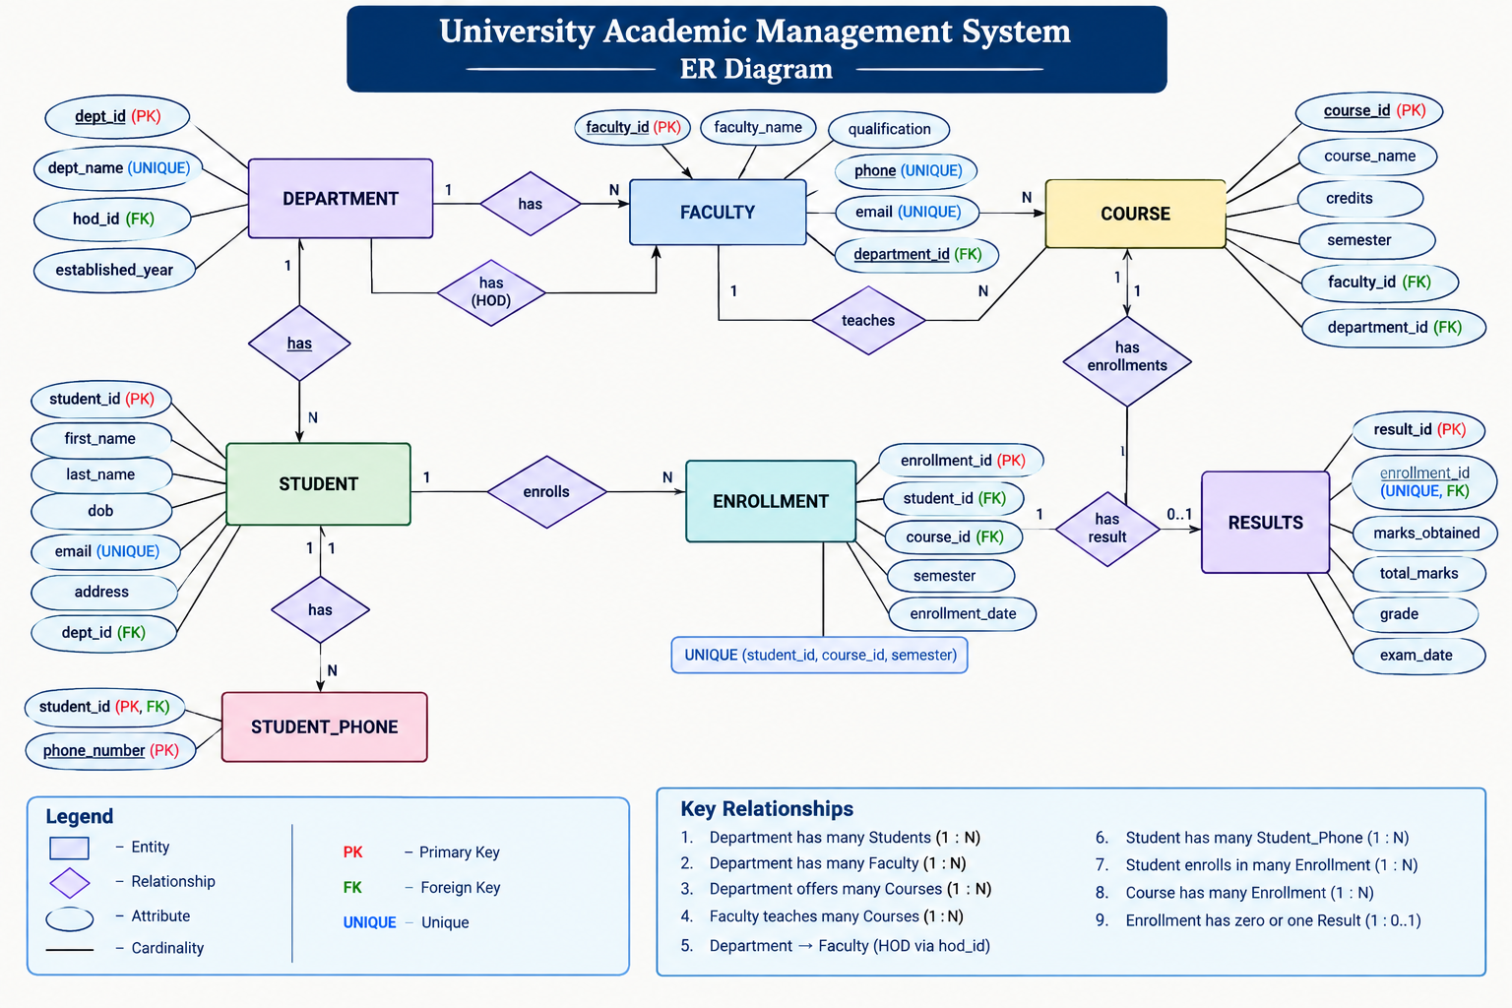

Relationships & Cardinality

Entity 1 | Relationship | Entity 2 | Cardinality (1:1 / 1:N / M:N)
Department | has | Student | 1:N
Department | has | Faculty | 1:N
Department | offers | Course | 1:N
Faculty | teaches | Course | 1:N
Student | has | Student_Phone | 1:N
Student | enrolls in | Course | M:N
Student | has | Enrollment | 1:N
Course | has | Enrollment | 1:N
Enrollment | has | Results | 1:1

Relational Database Schema

Table Name | Column Name | Data Type | PK/FK/— | Constraints
Department | dept_id | INT | PK | PRIMARY KEY, AUTO_INCREMENT
Department | dept_name | VARCHAR(100) | — | NOT NULL, UNIQUE
Department | established_year | YEAR | — | —
Department | hod_id | INT | — | —
Student | student_id | INT | PK | PRIMARY KEY, AUTO_INCREMENT
Student | first_name | VARCHAR(50) | — | NOT NULL
Student | last_name | VARCHAR(50) | — | NOT NULL
Student | dob | DATE | — | —
Student | email | VARCHAR(100) | — | UNIQUE, NOT NULL
Student | address | TEXT | — | —
Student | dept_id | INT | FK | FOREIGN KEY → Department(dept_id)
Student_Phone | id | INT | PK | PRIMARY KEY, AUTO_INCREMENT
Student_Phone | student_id | INT | FK | NOT NULL, FOREIGN KEY → Student(student_id)
Student_Phone | phone | VARCHAR(15) | — | —
Faculty | faculty_id | INT | PK | PRIMARY KEY, AUTO_INCREMENT
Faculty | first_name | VARCHAR(50) | — | NOT NULL
Faculty | last_name | VARCHAR(50) | — | NOT NULL
Faculty | designation | VARCHAR(50) | — | —
Faculty | email | VARCHAR(100) | — | UNIQUE, NOT NULL
Faculty | dept_id | INT | FK | FOREIGN KEY → Department(dept_id)

Table Name | Column Name | Data Type | PK/FK/— | Constraints
Course | course_id | INT | PK | PRIMARY KEY, AUTO_INCREMENT
Course | course_name | VARCHAR(100) | — | NOT NULL
Course | course_code | VARCHAR(20) | — | UNIQUE, NOT NULL
Course | credits | INT | — | CHECK (credits BETWEEN 1 AND 6)
Course | dept_id | INT | FK | FOREIGN KEY → Department(dept_id)
Course | faculty_id | INT | FK | FOREIGN KEY → Faculty(faculty_id)
Enrollment | enrollment_id | INT | PK | PRIMARY KEY, AUTO_INCREMENT
Enrollment | student_id | INT | FK | NOT NULL, FOREIGN KEY → Student(student_id)
Enrollment | course_id | INT | FK | NOT NULL, FOREIGN KEY → Course(course_id)
Enrollment | semester | VARCHAR(20) | — | —
Enrollment | enrollment_date | DATE | — | —
Enrollment | — | — | — | UNIQUE (student_id, course_id, semester)
Results | result_id | INT | PK | PRIMARY KEY, AUTO_INCREMENT
Results | enrollment_id | INT | FK | UNIQUE, NOT NULL, FOREIGN KEY → Enrollment(enrollment_id)
Results | marks_obtained | DECIMAL(5,2) | — | CHECK (marks_obtained >= 0)
Results | total_marks | DECIMAL(5,2) | — | DEFAULT 100
Results | grade | CHAR(2) | — | —
Results | exam_date | DATE | — | —

Normalization
UNF → 1NF → 2NF → 3NF

UNF: A single academic record might contain Student_ID, Student_Name, Department_Name, Course_ID, Course_Name, Faculty_Name, multiple phone numbers, and multiple result values in one record. Repeating groups and repeated department/faculty information create redundancy.
1NF: Repeating groups are removed and each attribute contains atomic values. Multi-valued phone numbers are stored in the Student_Phone table, and each course enrollment is represented as a separate row.
2NF: Partial dependencies on a composite key are removed. Student-specific attributes depend on Student_ID, course-specific attributes depend on Course_ID, and enrollment-specific attributes depend on Enrollment_ID.
3NF: Transitive dependencies are removed. Department details are stored in Department rather than repeated in Student, Faculty, and Course. Faculty details are stored in Faculty rather than repeated in Course. Result details are linked to Enrollment through Results.

DATABASE IMPLEMENTATION

DDL — Database and Table Creation
-- Drop tables if they exist
DROP TABLE IF EXISTS Results;
DROP TABLE IF EXISTS Enrollment;
DROP TABLE IF EXISTS Course;
DROP TABLE IF EXISTS Student_Phone;
DROP TABLE IF EXISTS Student;
DROP TABLE IF EXISTS Faculty;
DROP TABLE IF EXISTS Department;

-- 1. DEPARTMENT TABLE
CREATE TABLE Department (
dept_id NUMBER PRIMARY KEY,
dept_name VARCHAR2(100) NOT NULL UNIQUE,
hod_id NUMBER,
established_year NUMBER(4),

CONSTRAINT chk_department_year
CHECK (established_year BETWEEN 1800 AND 2100)
);

-- 2. STUDENT TABLE (Atomic attributes, 1NF/2NF/3NF compliant) CREATE TABLE Student (
student_id NUMBER PRIMARY KEY,
first_name VARCHAR2(50) NOT NULL,
last_name VARCHAR2(50) NOT NULL,
dob DATE,
email VARCHAR2(100) NOT NULL UNIQUE,
address VARCHAR2(200),
dept_id NUMBER NOT NULL,

CONSTRAINT fk_student_department
FOREIGN KEY (dept_id)
REFERENCES Department(dept_id)
);

-- 3. STUDENT_PHONE TABLE
CREATE TABLE Employee (
student_id NUMBER NOT NULL,
phone_number VARCHAR2(15) NOT NULL,

CONSTRAINT pk_student_phone
PRIMARY KEY (student_id, phone_number),

CONSTRAINT fk_phone_student FOREIGN KEY (student_id)
REFERENCES Student(student_id)
ON DELETE CASCADE,

CONSTRAINT chk_phone_format CHECK (LENGTH(phone_number) >= 10)
);

-- 4. FACULTY TABLE

CREATE TABLE Faculty (
faculty_id NUMBER PRIMARY KEY,
faculty_name VARCHAR2(50) NOT NULL,
qualification VARCHAR2(30),
phone VARCHAR2(10),
email VARCHAR2(60),
department_id NUMBER NOT NULL,

CONSTRAINT fk_faculty_department
FOREIGN KEY (department_id)
REFERENCES Department(dept_id),

CONSTRAINT uq_faculty_phone
UNIQUE (phone),

CONSTRAINT uq_faculty_email
UNIQUE (email)
);

-- 5. COURSE TABLE
CREATE TABLE Course (
course_id NUMBER PRIMARY KEY,
course_name VARCHAR2(60) NOT NULL,
credits NUMBER,
semester NUMBER,
faculty_id NUMBER NOT NULL,
department_id NUMBER NOT NULL,

CONSTRAINT ck_course_credits
CHECK (credits BETWEEN 1 AND 5),

CONSTRAINT ck_course_semester
CHECK (semester BETWEEN 1 AND 8),

CONSTRAINT fk_course_faculty_01
FOREIGN KEY (faculty_id)
REFERENCES Faculty(faculty_id),

CONSTRAINT fk_course_department_01
FOREIGN KEY (department_id)
REFERENCES Department(dept_id)
);

-- 6.ENROLLMENT TABLE

CREATE TABLE Enrollment (
enrollment_id NUMBER GENERATED BY DEFAULT AS IDENTITY PRIMARY KEY,
student_id NUMBER NOT NULL,
course_id NUMBER NOT NULL,
semester VARCHAR2(20),
enrollment_date DATE,

CONSTRAINT uq_enrollment
UNIQUE (student_id, course_id, semester),

CONSTRAINT fk_enrollment_student
FOREIGN KEY (student_id)
REFERENCES Student(student_id),

CONSTRAINT fk_enrollment_course
FOREIGN KEY (course_id)
REFERENCES Course(course_id)
);

--7. RESULTS TABLE

CREATE TABLE Results (
result_id NUMBER GENERATED BY DEFAULT AS IDENTITY PRIMARY KEY,
enrollment_id NUMBER UNIQUE NOT NULL,
marks_obtained NUMBER(5,2) NOT NULL,
total_marks NUMBER(5,2) DEFAULT 100 NOT NULL,
grade CHAR(2),
exam_date DATE,

CONSTRAINT ck_results_marks_nonnegative
CHECK (marks_obtained >= 0),

CONSTRAINT ck_results_total_positive
CHECK (total_marks > 0),

CONSTRAINT ck_results_marks_within_total
CHECK (marks_obtained <= total_marks),

CONSTRAINT fk_results_enrollment

FOREIGN KEY (enrollment_id)
REFERENCES Enrollment(enrollment_id)
);

Sample Data — DML.

Table | No. of Records | Sample Data / Screenshot Reference
Department | 1 | dml.sql — Department seed records
Faculty | 1 | dml.sql — Faculty seed records
Student | 10 | dml.sql — Student seed records
Student_Phone | 10 | dml.sql — Student phone seed records
Course | 10 | dml.sql — Course seed records
Enrollment | 10 | dml.sql — Enrollment seed records
Results | 10 | dml.sql — Result seed records

Constraints & Data Integrity

Constraint / Validation | Applied On | Purpose | Evidence / Screenshot
PRIMARY KEY | Department, Faculty, Student, Student_Phone, Course, Enrollment, Results | Uniquely identifies each record and prevents duplicate key values. | ddl.sql
FOREIGN KEY | Faculty, Student, Course, Student_Phone, Enrollment, Results | Maintains valid relationships between related tables. | ddl.sql
NOT NULL | Required fields across tables | Prevents missing values in required attributes. | ddl.sql
CHECK | Course.credits; Results.marks_obtained | Restricts invalid or out-of-range values. | ddl.sql
DEFAULT | Results.total_marks | Provides a default value when not explicitly supplied. | ddl.sql
UNIQUE | Department.dept_name; Faculty.email; Student.email; Course.course_code; Enrollment (student_id, course_idsemester); Results.enrollment_id | Prevents duplicate values where uniqueness is required. | ddl.sql

SQL Operations & Queries
.

S.No | Operation / Query | Purpose | SQL Query / Screenshot Ref.
1 | Basic SELECT — all departments | Retrieve department records. | queries.sql Q1
2 | Basic SELECT — all students | Retrieve student records. | queries.sql Q2
3 | Basic SELECT — all faculty | Retrieve faculty records. | queries.sql Q3
4 | Basic SELECT — all courses | Retrieve course records. | queries.sql Q4
5 | Filtered SELECT — students by department | Find students belonging to a specific department. | queries.sql Q5
6 | Filtered SELECT — courses with more than 3 credits | Find courses having more than 3 credits. | queries.sql Q6
7 | ORDER BY — students by name | Display students in alphabetical order. | queries.sql Q7
8 | ORDER BY — courses by credits | Display courses in descending order of credits. | queries.sql Q8
9 | SELECT with condition — students with email | Retrieve student IDs, names, and email addresses. | queries.sql Q9
10 | JOIN — department and students | Display departments along with their students. | queries.sql Q10
11 | JOIN — faculty and department | Display faculty along with their departments. | queries.sql Q11
12 | JOIN — courses and department | Display courses along with their departments. | queries.sql Q12
13 | JOIN — courses and faculty | Display courses along with their assigned faculty. | queries.sql Q13
14 | JOIN — enrollment details | Display enrollment ID, student details, course, semester, and enrollment date. | queries.sql Q14
15 | JOIN — student result details | Display student names, courses, marks, total marks, grades, and exam dates. | queries.sql Q15

Sample Outputs / Screenshots

Figure 1: Faculty records with department details / JOIN query output
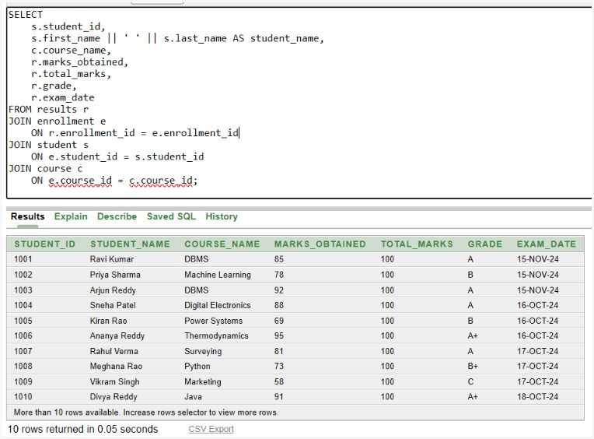

Figure 2: Student results with course details / JOIN query output
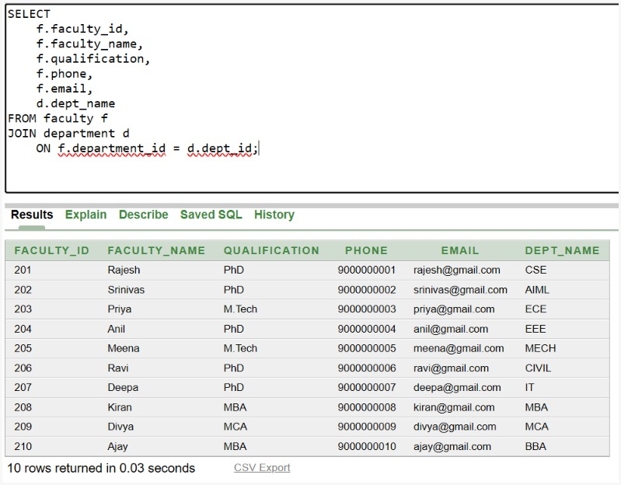
Figure 3: Department-wise student count / GROUP BY query output

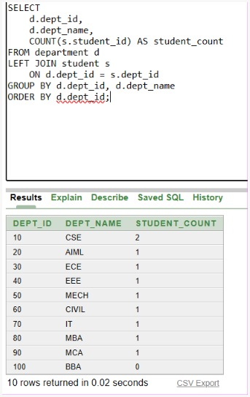

Figure 4: Grade-wise student count / GROUP BY query output

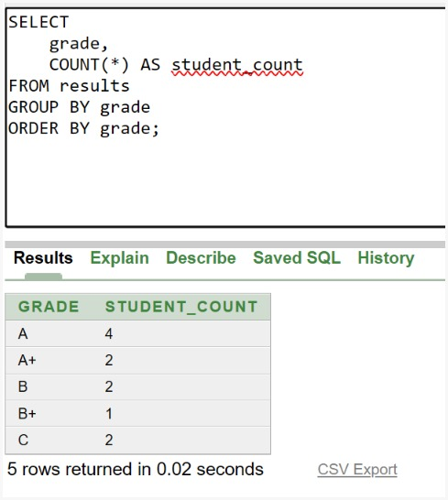


MODULES & FUNCTIONALITIES

S.No | Module Name | Functionality
1 | Department Management | Stores and organizes department details including department name, establishment year, and HOD information.
2 | Student Management | Maintains student personal details, contact information, address, date of birth, and department association.
3 | Faculty Management | Maintains faculty details and their association with departments, including designation and official email.
4 | Course Management | Stores course information including course name, course code, credits, department, and assigned faculty.
5 | Enrollment Management | Manages student course registrations, semester details, and enrollment dates.
6 | Result Management & Analysis | Stores examination results including marks, total marks, grades, and exam dates, and supports academic analysis using SQL queries.

GITHUB REPOSITORY & TEAM RESPONSIBILITIES
Repository Link: University Academic Management System — GitHub Repository

Student Name | Roll Number | Role / Responsibility | Contribution Status
K TRIPURA | 26B21AI054 | Designed relational database schema and defined keys & constraints | Completed
M BHAGYA SATYA SRI | 26B21AI068 | Designed ER diagram and defined entities & relationships | Completed
P SURYA VARSHITHA | 26B21AI089 | Wrote SQL queries including JOIN, aggregate, GROUP BY and HAVING queries | Completed
M VEERESH | 26B21AI092 | Compiled project documentation, sample data and screenshots | Completed

ENHANCEMENTS & FUTURE IMPROVEMENTS

Future improvements to the University Academic Management System can include stronger transaction controls, user authentication and role-based access, advanced academic reporting and dashboards, automated result and grade calculations, audit logging, stored procedures and triggers where supported, indexing for frequently queried columns, and a front-end interface for students, faculty, and administrators. These are proposed enhancements and are not implemented features in the current submission.

CONCLUSION

The University Academic Management System successfully models the main academic entities and their relationships using a relational database structure. The DDL defines seven tables with primary keys, foreign keys, NOT NULL, UNIQUE, CHECK, and DEFAULT constraints. The DML script supplies representative records for departments, faculty, students, student phone details, courses, enrollments, and examination results. The query script demonstrates selection and filtering, sorting, joins, aggregate functions, GROUP BY/HAVING, and conditional queries. The project therefore meets its core objectives of relational design, data integrity, sample-data population, and practical SQL analysis. The team also divided the work across ER/schema design, database implementation, SQL query development, and documentation and screenshot compilation.

REFERENCES
- Uploaded project DDL script: ddl.sql.
- Uploaded project DML/sample-data script: dml.sql.
- Uploaded SQL query script: queries.sql.
- Aditya University — DBMS Capstone Project documentation template.
- GitHub repository: University Academic Management System (project repository).

APPENDIX

Complete SQL Script
The final SQL implementation is supplied through the uploaded project files:
• ddl.sql — database table definitions, primary keys, foreign keys, and constraints.
• dml.sql — sample data for all seven tables: Department, Faculty, Student, Student_Phone, Course, Enrollment, and Results.
• queries.sql — representative SQL operation––––––––zs, joins, filtering, sorting, aggregate functions, GROUP BY/HAVING, and academic analysis queries.
Repository: University Academic Management System — GitHub Repository

Additional Screenshots / Outputs
Additional evidence can include SQL execution screenshots showing table creation, sample data, customer/account retrieval, balance updates, aggregate results, joins, GROUP BY/HAVING results, and subquery outputs. No execution screenshots were included in the uploaded source files, so this section is intentionally left for the team to add its actual screenshots.

