**Data Analysis Report: Stock Market Performance of Major Companies**

**Report Date:** 14th July 2024  
**Analysis Period:** 1st April 2016 to 1st April 2020

**1. Introduction**

This report analyses the stock market performance of six major companies: Amazon, Apple, Google, Microsoft, NVIDIA, and Tesla. The analysis covers the period from April 1, 2016, to April 1, 2020. Key metrics include closing prices, volume traded, and percentage changes in prices and volumes.

**2. Key Metrics Summary**

* **Last Day Total Volume:** 138,214,100
* **Lowest Price in the Period:** $24.75
* **Highest Price in the Period:** $2,185.95
* **Total Volume in the Period:** 95,308,388,100

**3. Company-Specific Analysis (as of 1st April 2020)**

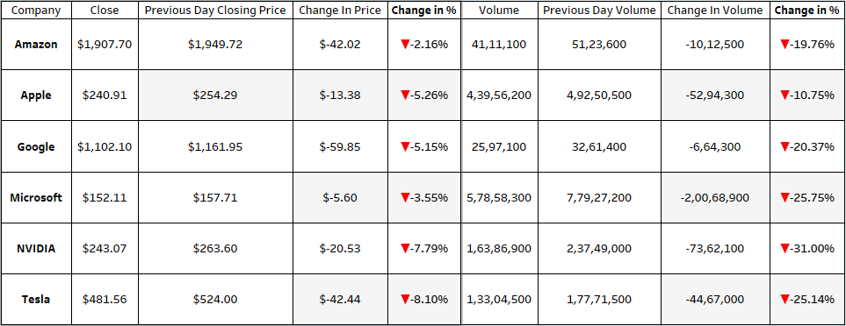

**4. Volume Analysis**

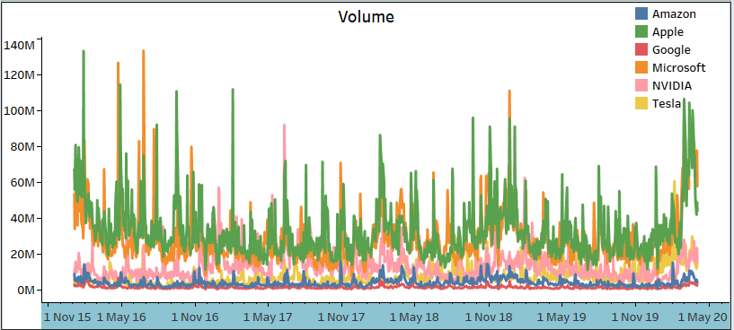

The volume chart shows the trading volumes for each company from November 2015 to April 2020. Amazon has consistently had the highest trading volumes among the six companies, with noticeable spikes at various points during the period.

**5. Price Percent Change**

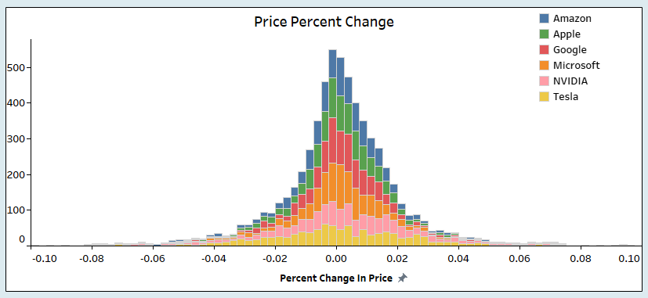

The histogram of price percent changes reveals that most price changes are centred around zero, with a normal distribution for all companies. This suggests that the majority of price movements are minor, with fewer instances of extreme changes.

**6. Moving Average Analysis (Open Price)**

The moving average chart displays the MA50, MA200, and open price for Amazon, Apple, Google, Microsoft, NVIDIA, Tesla over the selected period.

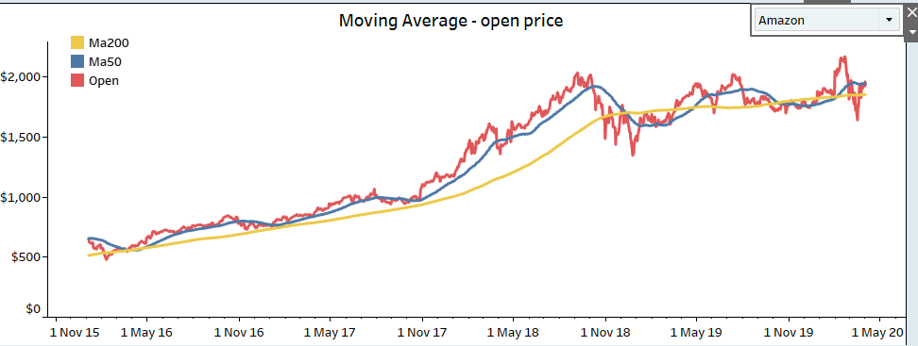The chart indicates that Amazon's stock price has generally trended upward, with periodic corrections and consolidations.

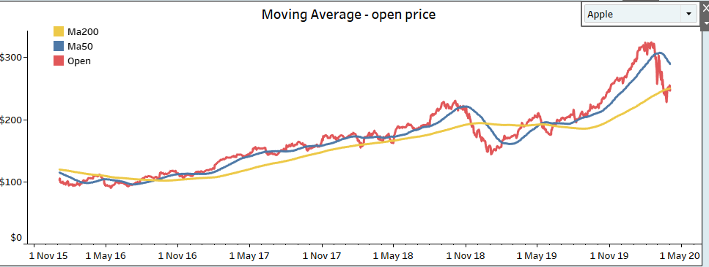

Apple’s stock price has generally been increasing over time, with the 200-day moving average (Ma200) indicating a longer-term bullish trend. Short-term trends are influenced by the 50-day moving average (Ma50).

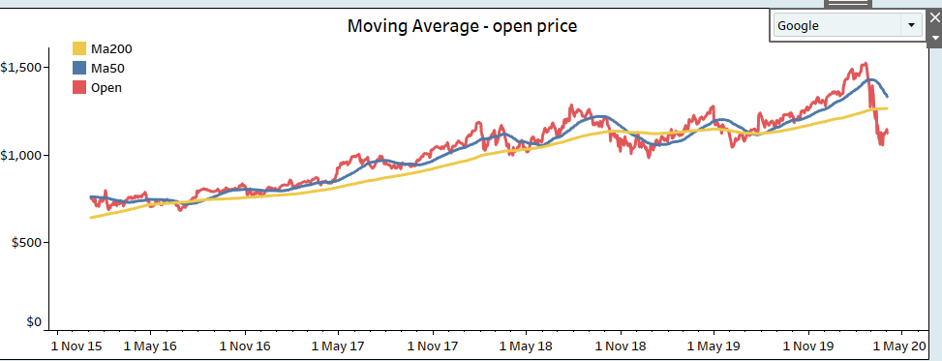

Similar patters have been noticed for Google.

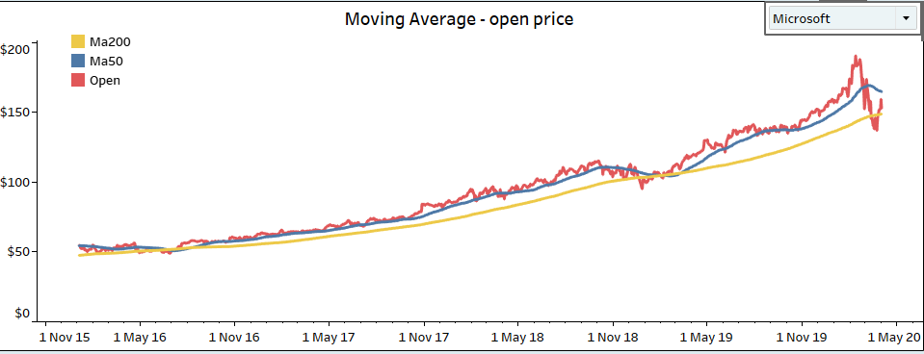

The graph shows Microsoft stock’s smooth upward trend over time, with moving averages (Ma200 and Ma50) without any significant fluctuations.

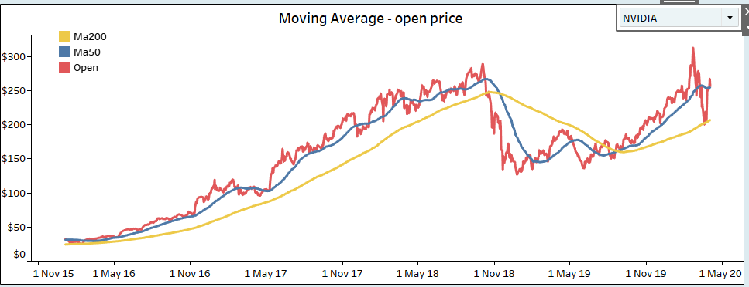

The graph of NVIDIA stock shows an upward trend over time. Notably, there are two significant crossovers between the moving averages (Ma200 and Ma50):

1. **November 2018:**

Ma50 crosses below Ma200.This crossover could be interpreted as a potential sell signal.

1. **March/April 2019:**

Ma50 crosses above Ma200.This crossover might be seen as a potential buy signal.

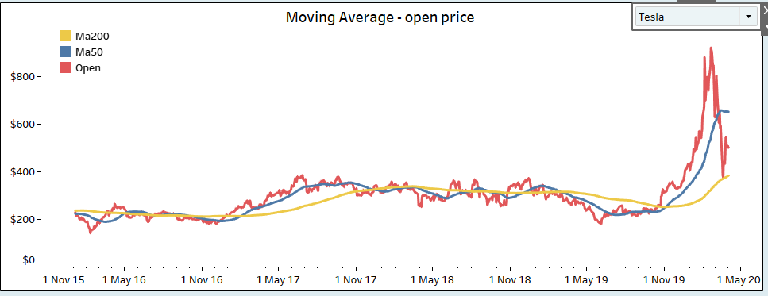

The graph of Tesla stock shows an upward trend over time, with significant volatility. Notably, around February to March 2020, there was a sharp increase in the open price.

**7. Detailed Findings**

* **Amazon:**
  + **Price Drop:** -2.16%
  + **Volume Drop:** -19.76%
  + **Observation:** Amazon experienced a significant drop in both trading volume and price on the last day.
* **Apple:**
  + **Price Drop:** -5.26%
  + **Volume Drop:** -10.75%
  + **Observation:** Apple saw a considerable decrease in volume and a significant drop in price.
* **Google:**
  + **Price Drop:** -5.15%
  + **Volume Drop:** -20.37%
  + **Observation:** Google showed a substantial decline in both volume and price.
* **Microsoft:**
  + **Price Drop:** -3.55%
  + **Volume Drop:** -25.75%
  + **Observation:** Microsoft had a notable drop in both volume and price.
* **NVIDIA:**
  + **Price Drop:** -7.79%
  + **Volume Drop:** -31.00%
  + **Observation:** NVIDIA faced the largest percentage drop in volume and a significant price decrease.
* **Tesla:**
  + **Price Drop:** -8.10%
  + **Volume Drop:** -25.14%
  + **Observation:** Tesla experienced a major decline in both volume and price.

**8. Conclusion**

The analysed data indicates that all six companies experienced significant drops in both stock prices and trading volumes on the last day of the analysis period. NVIDIA and Tesla were particularly affected, showing the largest percentage declines in both price and volume. The overall trend for the period shows Amazon with the highest trading volumes, while the price movements for all companies follow a generally upward trend with periodic corrections.

This analysis provides a comprehensive view of the stock performance of these major companies over the specified period, offering insights into their trading behaviours and market trends.