 DATA ANALYSIS REPORT

**Problem Statement**

The primary objective of this analysis is to understand the patterns in Uber pickups across different regions of New York City, identify peak times and days for rides, and analyse the activity of different Uber bases. This information will help in optimizing operational strategies, improving customer satisfaction, and maximizing profits. The analysis also aims to provide insights into demand fluctuations and identify potential areas for business growth and customer engagement.

**Analysis**

1. **Number of Uber Pickups over the Period:**

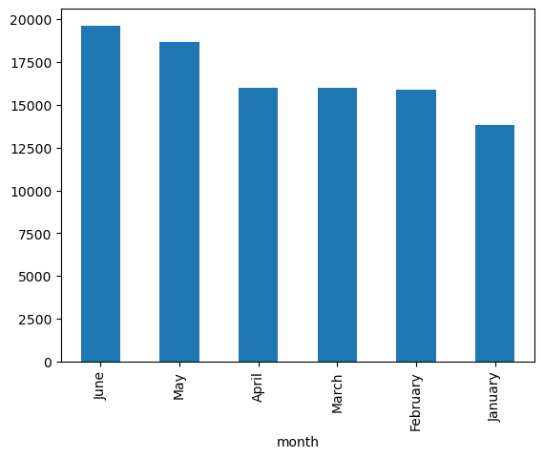 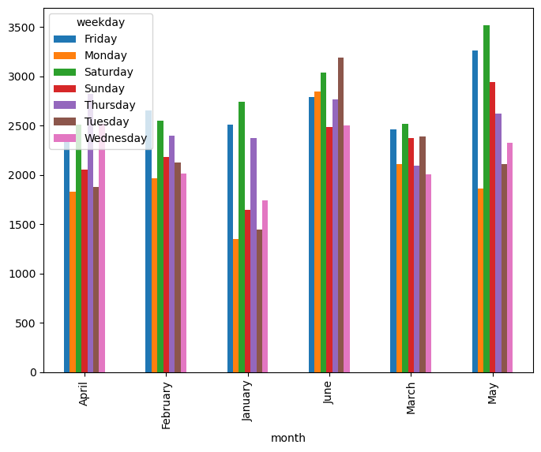

* **April to May Surge:** Significant growth in Uber bookings observed between April and May.
* **Stable Demand (Feb to Apr):** Minimal change in bookings, indicating steady demand.
* **Overall Growth (Jan to Jun):** Average increase of 1,000 bookings per month, rising from 13,000 in January to 19,000 in June.
* **Highest Activity Days**: Fridays consistently show the highest number of pickups each month.
* **Weekend Activity**: Saturdays and Sundays also show high pickup numbers, particularly in May.
* **Steady Weekday Growth**: All weekdays show a steady increase in pickups over the months, with significant peaks in May.
* **Conclusion:** Steady increase in Uber usage throughout the first half of the year.

1. **Hourly Rush on Weekdays:**

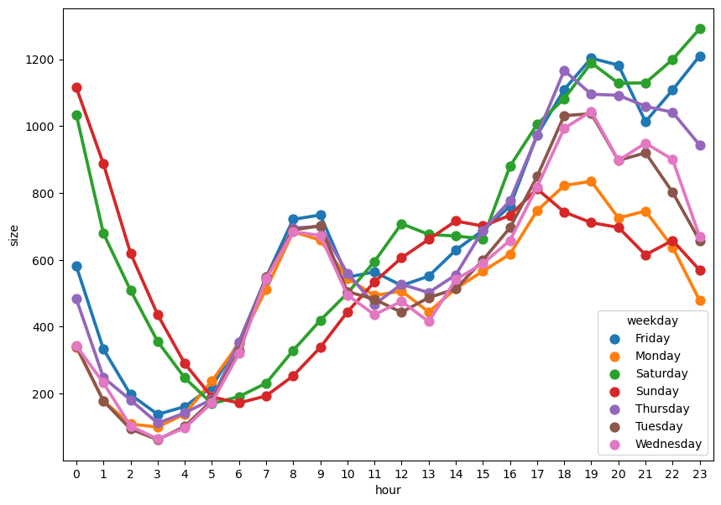

* **Weekdays (Monday to Friday)**: Clear morning (8:00 - 9:00 AM) and evening (5:00 - 7:00 PM) rush hours, with the highest activity on Friday evenings.
* **Weekends (Saturday and Sunday)**: More even distribution of activity throughout the day, with notable peaks in the evening.

1. **Activity of Uber Base Numbers**:

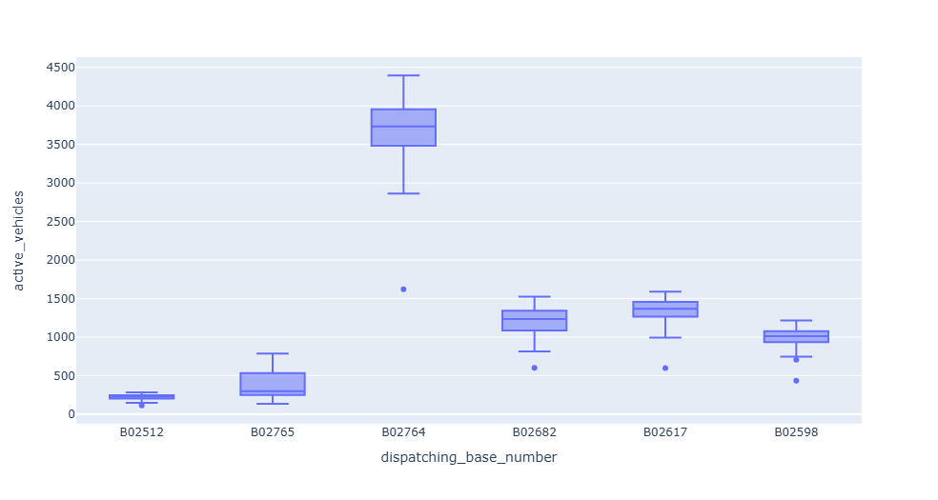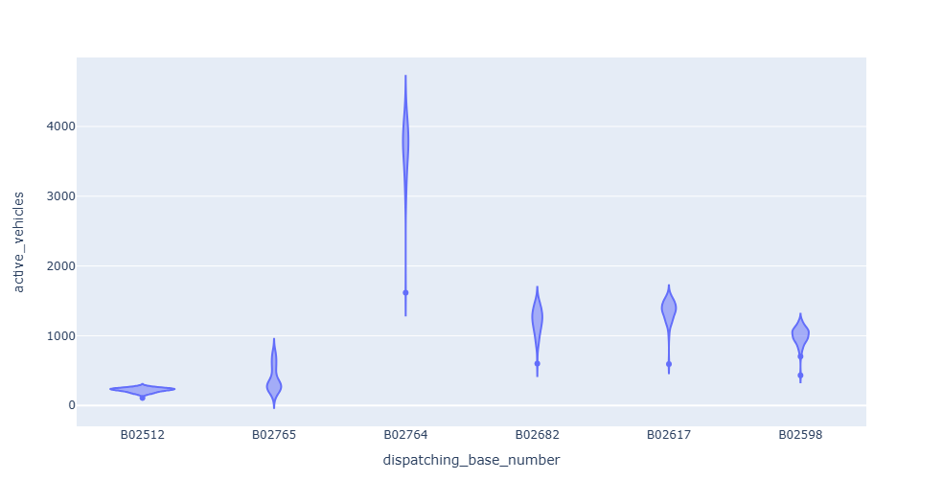

* **B02764** stands out with the highest number of active vehicles and the widest distribution, indicating it is the most active base among those listed.
* **B02512** has the lowest number of active vehicles with the least variability.
* **B02765**, **B02682**, **B02617**, and **B02598** have moderate activity levels with varying degrees of variability and occasional outliers.

1. **Rush in Different Areas of New York:**

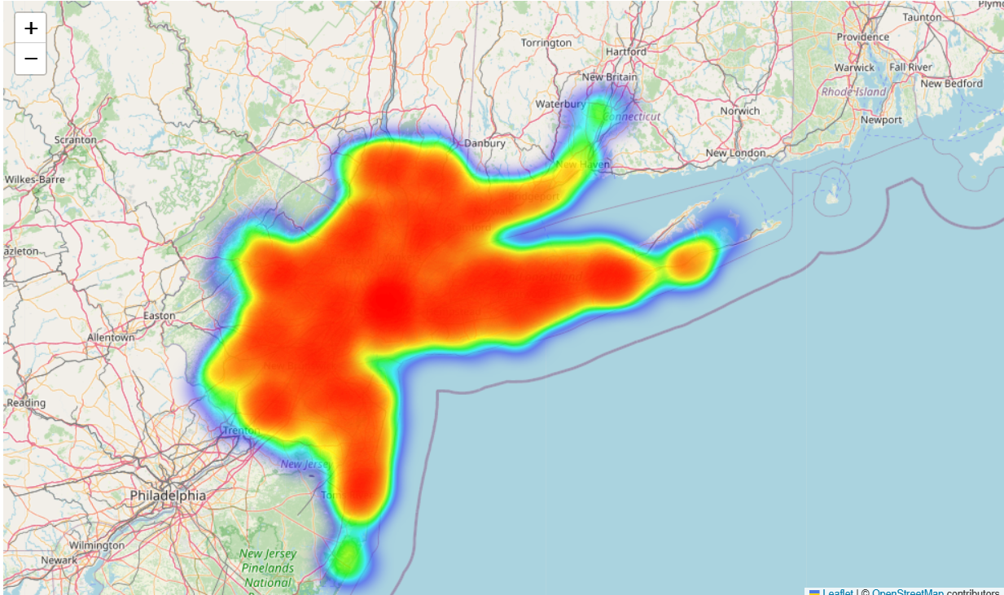

* **Manhattan**, particularly the southern and central parts, shows a high concentration of rides, suggesting it is a major hotspot for Uber services
* Other areas like **Brooklyn** and parts of **New Jersey** also show significant activity, although not as dense as Manhattan.
* The demand decreases as we move away from Manhattan, especially towards the suburbs and less urbanized areas.
* The **Long Island** area also shows moderate activity, possibly due to a mix of residential and commercial usage.

1. **Detailed Hourly Rush Analysis:**

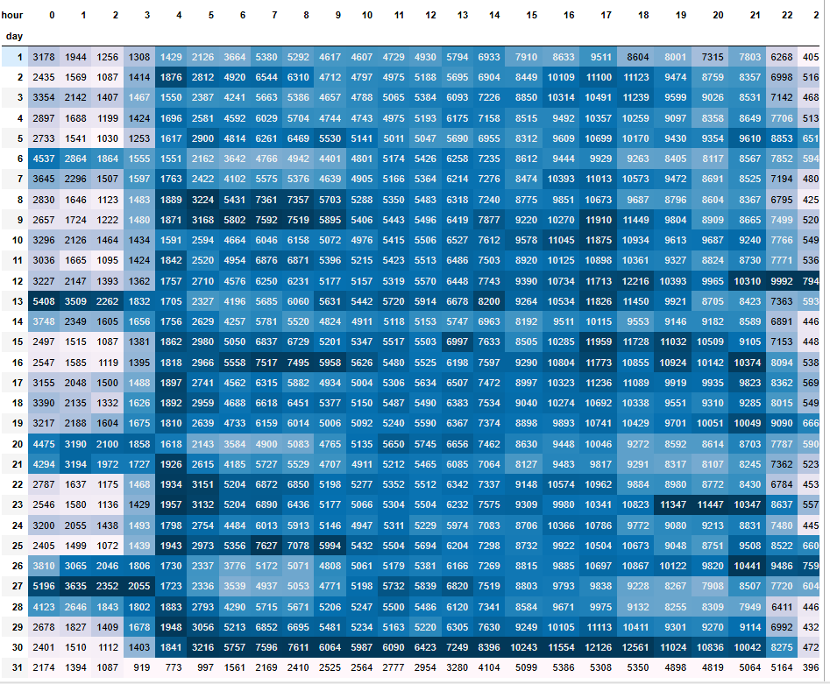

* **Morning Peak (7 AM - 10 AM):** High demand, peaking around 8-9 AM, indicating morning commutes.
* **Midday (11 AM - 2 PM):** Steady ride counts, suggesting consistent daytime demand.
* **Evening Peak (4 PM - 7 PM):** Another surge in rides, peaking around 6-7 PM, aligned with evening commutes.
* **Late Night (10 PM - 2 AM):** Increased activity, particularly on weekends, likely due to nightlife.
* **Weekday vs. Weekend:** Higher ride counts during weekdays, with more even distribution on weekends.

**Recommendations**

* **Incentivize Weekday Rides:**

Introduce discounts or loyalty programs to boost weekday ridership, especially during off-peak hours. This could help balance demand throughout the week and increase overall ride numbers.

* **Target High-Demand Areas:**

Increase the availability of Uber vehicles in high-demand areas like Manhattan and Brooklyn, particularly during peak hours. This could improve customer satisfaction by reducing wait times.

* **Optimize Fleet Distribution:**

Reallocate resources from less active bases (like B02512) to more active ones or areas with growing demand. This can help maximize vehicle utilization and revenue.

* **Promote Weekend Offers:**

Leverage the trend of higher weekend activity by offering special promotions or better availability in places which have the most crowd during the weekend. This could further increase weekend ridership and revenue.

**Conclusion**

The data analysis of Uber pickups in New York City reveals significant trends and patterns that can be leveraged to optimize operations and enhance customer satisfaction. By addressing the identified peak times, high-demand areas, and underutilized bases, Uber can improve its service efficiency and profitability. The recommendations provided aim to capitalize on these insights, ensuring a more balanced and robust service offering throughout the week and across different regions.